Supplementary Information
No QTc Prolongation with Semaglutide: A Thorough QT Study in Healthy Subjects
V Demmel¹, A Sandberg-Schaal², JB Jacobsen², G Golor³, J Pettersson² and A Flint²
¹nabios GmbH, Munich, Germany
²Novo Nordisk A/S, Søborg, Denmark
³PAREXEL International GmbH, Early Phase Clinical Unit, Berlin, Germany

Supplemental Results
With regard to QTc outliers, few were observed using the QTcL and QTcF correction methods, as for the QTcI correction interval. For QTcL, there were 2 versus 12 outliers for semaglutide versus placebo across doses (0.5, 1.0 and 1.5 mg) and outlier type (QTc interval > 450, 480 or 500 ms, or QTc interval increases from baseline > 30 or 60 ms). For QTcF, there were 5 versus 4 outlier events. Conversely for QTcB, more subjects treated with semaglutide than with placebo had an increase from baseline > 30 ms at all 3 dose levels (70 versus 13 events across doses).

Tables

Supplementary Table S1. Time-matched Uncorrected QT Differences between Baseline-subtracted Semaglutide 1.5 mg and Placebo During the 48 Hours After Dosing
 | Estimated treatment difference semaglutide – placebo  N = 76 each group | (90% CI) | P value
0 hour | –16.5 | (–21.5; -11.5) | < 0.0001
12 hours | –16.6 | (–21.6; -11.5) | < 0.0001
18 hours | –22.3 | (–27.4; –17.3) | < 0.0001
24 hours | –21.9 | (–26.6; –17.2) | < 0.0001
25 hours | –21.1 | (–26.2; –15.9) | < 0.0001
26 hours | –22.5 | (–27.3; –17.8) | < 0.0001
27 hours | –21.5 | (–26.2; –16.8) | < 0.0001
30 hours | –15.0 | (–19.7; –10.3) | < 0.0001
36 hours | –19.7 | (–23.9; –15.5) | < 0.0001
42 hours | –24.6 | (–29.6; –19.7) | < 0.0001
48 hours | –22.7 | (–26.7; –18.7) | < 0.0001
P values are for a one-sided test of a mean difference > 10 ms.
CI, confidence interval; N, number of subjects contributing to the analysis.
Supplementary Table S2. Time-matched QTcL Differences between Baseline-subtracted Semaglutide 1.5 mg and Placebo During the 48 Hours After Dosing
 | Estimated treatment difference semaglutide – placebo  N = 76 each group | (90% CI) | P value
0 hour | –3.5 | (–6.8; -0.2) | < 0.0001
12 hours | –4.1 | (-7.5; -0.7) | < 0.0001
18 hours | –6.1 | (–9.6; –2.6) | < 0.0001
24 hours | –4.6 | (–7.9; –1.4) | < 0.0001
25 hours | –4.6 | (–7.9; –1.3) | < 0.0001
26 hours | –6.1 | (–9.2; –2.9) | < 0.0001
27 hours | –5.6 | (–8.9; –2.3) | < 0.0001
30 hours | –4.6 | (–7.6; –1.6) | < 0.0001
36 hours | –6.5 | (–9.8; –3.2) | < 0.0001
42 hours | –7.4 | (–10.8; –3.9) | < 0.0001
48 hours | –5.4 | (–8.3; –2.6) | < 0.0001
P values are for a one-sided test of a mean difference > 10 ms.
CI, confidence interval; N, number of subjects contributing to the analysis; QTcL, QT interval corrected for heart rate by linear regression.

Supplementary Table S3. Time-matched QTcF Differences between Baseline-subtracted Semaglutide 1.5 mg and Placebo During the 48 Hours After Dosing
 | Estimated treatment difference semaglutide – placebo  N = 76 each group | (90% CI) | P value
0 hour | 0.2 | (–3.0; 3.4) | < 0.0001
12 hours | –0.7 | (–3.9; 2.6) | < 0.0001
18 hours | –1.6 | (–5.0; 1.8) | < 0.0001
24 hours | 0.0 | (–3.3; 3.3) | < 0.0001
25 hours | –0.3 | (–3.5; 3.0) | < 0.0001
26 hours | –1.3 | (–4.4; 1.8) | < 0.0001
27 hours | –1.1 | (–4.4; 2.2) | < 0.0001
30 hours | –1.3 | (–4.2; 1.7) | < 0.0001
36 hours | –2.5 | (–5.8; 0.9) | < 0.0001
42 hours | –2.5 | (–6.0; 0.9) | < 0.0001
48 hours | –0.4 | (–3.4; 2.5) | < 0.0001
P values are for a one-sided test of a mean difference > 10 ms.
CI, confidence interval; N, number of subjects contributing to the analysis; QTcF, QT interval corrected for heart rate using Fridericia’s formula.¹⁵
Supplementary Table S4. Time-matched QTcB Differences between Baseline-subtracted Semaglutide 1.5 mg and Placebo During the 48 Hours After Dosing
 | Estimated treatment difference semaglutide – placebo  N = 76 each group | (90% CI) | P value
0 hour | 8.8 | (4.9; 12.7) | 0.3008
12 hours | 7.9 | (3.9; 11.9) | 0.1891
18 hours | 9.0 | (5.0; 12.9) | 0.3322
24 hours | 11.0 | (6.8; 15.1) | 0.6537
25 hours | 10.4 | (6.3; 14.5) | 0.5631
26 hours | 9.5 | (5.5; 13.6) | 0.4243
27 hours | 9.2 | (4.7; 13.7) | 0.3829
30 hours | 6.3 | (2.4; 10.3) | 0.0654
36 hours | 6.4 | (2.7; 10.2) | 0.0584
42 hours | 8.7 | (4.7; 12.7) | 0.2930
48 hours | 11.1 | (7.5; 14.8) | 0.6948
P values are for a one-sided test of a mean difference > 10 ms.
CI, confidence interval; N, number of subjects contributing to the analysis; QTcB, QT interval corrected for heart rate using Bazett’s formula.¹⁹

Supplementary Table S5. Pharmacokinetic endpoints of semaglutide at steady state
Endpoint | Semaglutide  0.25 mg  (N = 82)ª | Semaglutide  0.5 mg  (N = 81) | Semaglutide  1.0 mg  (N = 80)ª | Semaglutide  1.5 mg  (N = 76)
AUC_{0-168h} (nmol⋅h/L) | 1589 (18.0) | 3081 (20.0) | 6077 (20.0) | 9928 (18.0)
AUC_{0-48h} (nmol⋅h/L) | 479 (20.0) | 917 (22.0) | 1795 (23.0) | 2962 (19.0)
C_{max} (nmol/L) | 11.9 (19.3) | 22.1 (20.7) | 42.7 (20.9) | 72.6 (20.8)
t_{max} (h) | 26 (12−48) | 27 (12−48) | 27 (12−48) | 27 (12−48)
C_{trough} (nmol/L) | 7.5 (19.0) | 15.5 (20.3) | 31.4 (20.0) | 51.0 (18.2)
Data are presented as geometric means (CV), except for t_{max}, which is presented as median (range).
AUC, area under the concentration-time curve; CI, confidence interval; C_{max}, maximum plasma concentration; C_{trough}, trough plasma concentrations; CV, coefficient of variation in %; N, number of subjects contributing to the analysis; t_{max}, time to C_{max}.
ªFor analyses of AUC_{0-168h} and C_{trough}, there were 81 subjects in the semaglutide 0.25 mg group and 79 subjects in the 1.0 mg group.

Supplementary Table S6. Semaglutide dose proportionality pharmacokinetic endpoints
Endpoint | Number of observations | Estimate for 2^{β}  (95% CI) | P value
AUC_{0-168h} (nmol⋅h/L) | 317 | 2.02 (2.00; 2.04) | 0.047
AUC_{0-48h} (nmol⋅h/L) | 319 | 2.01 (1.99; 2.04) | 0.33
C_{max} (nmol/L) | 319 | 2.00 (1.97; 2.03) | 0.90
Sensitivity analysisª
AUC_{0-168h} (nmol⋅h/L) | 289 | 2.01 (2.00; 2.03) | 0.07
AUC_{0-48h} (nmol⋅h/L) | 291 | 2.00 (1.98; 2.02) | 0.82
C_{max} (nmol/L) | 291 | 1.99 (1.97; 2.01) | 0.40
The endpoint was logarithmically transformed and analyzed in a linear regression model with logarithmic transformed dose as regressor and subject as a random effect.
AUC, area under the concentration-time curve; CI, confidence interval; C_{max}, maximum plasma concentration.
ªExcluded 7 subjects who were suspected of being noncompliant with the dosing schedule.

Supplementary Table S7. Summary of adverse events
 | Semaglutide N = 83 |  |  | Placebo N = 83
 | N | (%) | E | N | (%) | E
Adverse events | 69 | (83.1) | 559 | 65 | (78.3) | 213
Serious events | 1 | (1.2) | 1 | 0 | (0.0) | 0
Events leading to withdrawal | 2 | (2.4) | 8 | 4 | (4.8) | 8
Severity
Severe | 0 | (0.0) | 0 | 1 | (1.2) | 1
Moderate | 51 | (61.4) | 157 | 24 | (28.9) | 41
Mild | 63 | (75.9) | 402 | 59 | (71.1) | 171
Outcome
Recovered
Outcome  Recovered | 69 | (83.1) | 559 | 65 | (78.3) | 213
E, number of events; N (%), number and percentage of subjects with adverse events.

Figures
Supplementary Figure S1. Correlation between the uncorrected QT and QTc intervals versus the RR interval
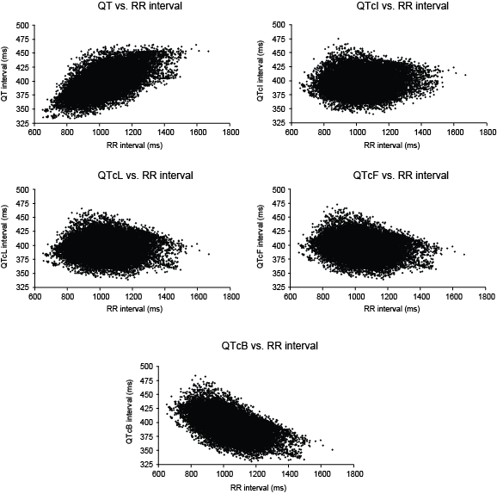

Supplementary Figure S2. Mean baseline-adjusted and placebo-subtracted heart rate for the 0.5, 1.0 and 1.5 mg doses of semaglutide
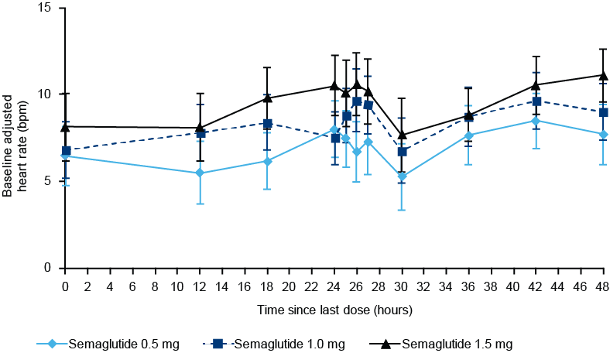

Data are mean baseline-adjusted and placebo-subtracted differences in heart rate with error bars representing the corresponding two-sided 90% confidence intervals.
bpm, beats per minute.

