Meta-Analysis of Sulfonylurea Therapy on Long-Term Risk of Mortality and Cardiovascular Events Compared to Other Oral Glucose-Lowering Treatments

W. Ryan Powell, Cindy L. Christiansen, Donald R. Miller

SUPPLEMENTAL MATERIAL

S1. MEDLINE search terms
(diabetes mellitus, type 2[mh] OR (diabet*[tiab] AND (“non-insulin dependent”[tiab] OR type-2[tiab] OR "type II"[tiab] OR "type 2"[tiab])))
AND (sulfonylurea compounds [mh] OR sulfonylurea*[tiab] OR sulphonylurea*[tiab] OR glipizide[tiab] OR glyburide [tiab] OR glimepiride[tiab] OR glibenclamide[tiab])
AND English[lang]
NOT (animal[mh] NOT human[mh])
NOT (letter[pt] OR comment[pt] OR editorial[pt])
AND Humans[mh]
AND ("controlled clinical trial"[pt] OR "randomized controlled trial"[pt] OR "comparative study"[pt] OR "case control studies"[mh] OR "cohort studies"[mh])

S2. Studies included in the series of meta-analyses
1. Berkowitz, SA, Krumme AA, Avorn J, et al. Initial choice of oral glucose-lowering medication for diabetes mellitus: a patient-centered comparative effectiveness study. JAMA Intern Med 2014;174(12):1955–1962.
2. Corrao G, Romio SA, Zambon A, Merlino L, Bosi E, Scavini M. Multiple outcomes associated with the use of metformin and sulphonylureas in type 2 diabetes: a population-based cohort study in Italy. Eur J Clin Pharmacol 2011;67(3):289–299.
3. Currie C J, Poole CD, Evans M, Peters JR, Morgan CL. Mortality and other important diabetes-related outcomes with insulin vs. other antihyperglycemic therapies in type 2 diabetes. J Clin Endocrinol Metab. 2013;98(2):668–677.
4. Evans JMM, Ogston SA, Emslie-Smith A, Morris AD. Risk of mortality and adverse cardiovascular outcomes in type 2 diabetes: a comparison of patients treated with sulfonylureas and metformin. Diabetologia 2006;49(5):930–936.
5. Gulliford M, Latinovic R. Mortality in type 2 diabetic subjects prescribed metformin and sulphonylurea drugs in combination: cohort study. Diabetes Metab Res Rev 2004;20(3):239–245.
6. Hsiao F, Huang W, Wen Y, Chen P, Kuo K, Tsai Y. Thiazolidinediones and cardiovascular events in patients with type 2 diabetes mellitus: a retrospective cohort study of over 473,000 patients using the National Health Insurance database in Taiwan. Drug Saf 2009;32(8):675–690.
7. Hung Y, Lin C, Wang T, Chang M, Sung F, Chen C. Oral hypoglycaemic agents and the development of non-fatal cardiovascular events in patients with type 2 diabetes mellitus. Diabetes Metab Res Rev 2013;29(8):673–679.
8. Johnson JA, Majumdar SR, Simpson SH, Toth EL. Decreased mortality associated with the use of metformin compared with sulfonylurea monotherapy in type 2 diabetes. Diabetes Care 2002;25(12):2244–2248.
9. Johnson JA, Simpson SH, Toth EL, Majumdar SR. Reduced cardiovascular morbidity and mortality associated with metformin use in subjects with Type 2 diabetes. Diabet Med 2005;22(4):497–502.
10. Kannan S, Pantalone KM, Matsuda S, Wells BJ, Karafa M, Zimmerman RS. Risk of overall mortality and cardiovascular events in patients with type 2 diabetes on dual drug therapy including metformin: A large database study from the Cleveland Clinic. J Diabetes 2015; Advanced online publication. doi:10.1111/1753-0407.12301
11. Li Y, Hu Y, Ley SH, Rajpathak S, Hu FB. Sulfonylurea use and incident cardiovascular disease among patients with type 2 diabetes: prospective cohort study among women. Diabetes Care 2014;37(11):3106–3113.
12. McAfee AT, Koro C, Landon J, Ziyadeh N, Walker AM. Coronary heart disease outcomes in patients receiving antidiabetic agents. Pharmacoepidemiol Drug Saf 2007;16(7):711–725.
13. Mogensen UM, Andersson C, Fosbøl EL, et al. Cardiovascular safety of combination therapies with incretin-based drugs and metformin compared with a combination of metformin and sulphonylurea in type 2 diabetes mellitus: A retrospective nationwide study. Diabetes Obes Metab 2014;16(10):1001–1008.
14. Morgan CL, Poole CD, Evans M, Barnett AH, Jenkins-Jones S, Currie CJ. What next after metformin? A retrospective evaluation of the outcome of second-line, glucose-lowering therapies in people with type 2 diabetes. J Clin Endocrinol Metab 2012;97(12):4605–4612.
15. Morgan CL, Mukherjee J, Jenkins-Jones S, Holden SE, Currie CJ. Association between first-line monotherapy with sulphonylurea versus metformin and risk of all-cause mortality and cardiovascular events: a retrospective, observational study. Diabetes Obes Metab 2014;16(10):957–962.
16. Morgan CL, Mukherjee J, Jenkins-Jones S, Holden SE, Currie CJ. Combination therapy with metformin plus sulphonylureas versus metformin plus DPP-4 inhibitors: association with major adverse cardiovascular events and all-cause mortality. Diabetes Obes Metab 2014;16(10):977–983.
17. Olsson J, Lindberg G, Gottsäter M, Lindwall K, Sjöstrand A, Tisell A, Melander A. Increased mortality in Type II diabetic patients using sulphonylurea and metformin in combination: a population-based observational study. Diabetologia 2000:43(5);558–560.
18. Ou S, Shih C, Chao P, et al. Effects on Clinical Outcomes of Adding Dipeptidyl Peptidase-4 Inhibitors Versus Sulfonylureas to Metformin Therapy in Patients With Type 2 Diabetes Mellitus. Ann Intern Med 2015;163(9):663–672.
19. Pantalone KM, Kattan MW, Yu C, et al. The risk of developing coronary artery disease or congestive heart failure, and overall mortality, in type 2 diabetic patients receiving rosiglitazone, pioglitazone, metformin, or sulfonylureas: a retrospective analysis. Acta Diabetol 2009;46(2):145–154.
20. Prentice, JC, Conlin PR, Gellad WF, Edelman D, Lee TA, Pizer SD. Capitalizing on prescribing pattern variation to compare medications for type 2 diabetes. Value Health 2014;17(8):854–862.
21. Schramm TK, Gislason GH, Vaag A, et al. Mortality and cardiovascular risk associated with different insulin secretagogues compared with metformin in type 2 diabetes, with or without a previous myocardial infarction: a nationwide study. Eur Heart J 2011;32(15):1900–1908.
22. Sillars B, Davis WA, Hirsch IB, Davis TME. Sulphonylurea-metformin combination therapy, cardiovascular disease and all-cause mortality: the Fremantle Diabetes Study. Diabetes Obes Metab 2010;12(9):757–765.
23. Sullivan D, Forder P, Simes J, et al. Associations between the use of metformin, sulphonylureas, or diet alone and cardiovascular outcomes in 6005 people with type 2 diabetes in the FIELD study. Diabetes Res Clin Pract 2011;94(2):284–290.
24. Tzoulaki I, Molokhia M, Curcin V, et al. Risk of cardiovascular disease and all cause mortality among patients with type 2 diabetes prescribed oral antidiabetes drugs: retrospective cohort study using UK general practice research database. BMJ 2009;339:b4731.
25. Walker AM, Koro CE, Landon J. Coronary heart disease outcomes in patients receiving antidiabetic agents in the PharMetrics database 2000–2007. Pharmacoepidemiol Drug Saf 2008;17(8):760–768.
26. Wheeler S, Moore K, Forsberg CW, et al. Mortality among veterans with type 2 diabetes initiating metformin, sulfonylurea or rosiglitazone monotherapy. Diabetologia 2013;56(9):1934–1943.
27. Ahrén B, Johnson SL, Stewart M, et al. HARMONY 3: 104-week randomized, double-blind, placebo- and active-controlled trial assessing the efficacy and safety of albiglutide compared with placebo, sitagliptin, and glimepiride in patients with type 2 diabetes taking metformin. Diabetes Care 2014;37(8):2141–2148.
28. Del Prato S, Camisasca R, Wilson C, Fleck P. Durability of the efficacy and safety of alogliptin compared with glipizide in type 2 diabetes mellitus: a 2-year study. Diabetes Obes Metab 2014;16(12):1239–1246.
29. Del Prato S, Nauck M, Durán-Garcia S, et al. Long-term glycaemic response and tolerability of dapagliflozin versus a sulphonylurea as add-on therapy to metformin in patients with type 2 diabetes: 4-year data. Diabetes Obes Metab 2015;17(6):581–590.
30. Ferrannini E, Fonseca V, Zinman B, et al. Dejager S. Fifty-two-week efficacy and safety of vildagliptin vs. glimepiride in patients with type 2 diabetes mellitus inadequately controlled on metformin monotherapy. Diabetes Obes Metab 2009;11(2):157–166.
31. Filozof C, Gautier J. A comparison of efficacy and safety of vildagliptin and gliclazide in combination with metformin in patients with Type 2 diabetes inadequately controlled with metformin alone: a 52-week, randomized study. Diabet Med 2010;27(3):318–326.
32. Gallwitz B, Rosenstock J, Rauch T, et al. 2-year efficacy and safety of linagliptin compared with glimepiride in patients with type 2 diabetes inadequately controlled on metformin: a randomised, double-blind, non-inferiority trial. Lancet 2012;380(9840):475–483.
33. Gallwitz B, Guzman J, Dotta F, et al. Exenatide twice daily versus glimepiride for prevention of glycaemic deterioration in patients with type 2 diabetes with metformin failure (EUREXA): an open-label, randomised controlled trial. Lancet 2012;379(9833):2270-2278.
34. Gerich J, Raskin P, Jean-Louis L, Purkayastha D, Baron MA. PRESERVE-beta: two-year efficacy and safety of initial combination therapy with nateglinide or glyburide plus metformin. Diabetes Care 2005;28(9):2093–2099.
35. Göke B, Gallwitz B, Eriksson JG, Hellqvist Å, Gause-Nilsson I. Saxagliptin vs. glipizide as add-on therapy in patients with type 2 diabetes mellitus inadequately controlled on metformin alone: long-term (52-week) extension of a 52-week randomised controlled trial. Int J Clin Pract 2013;67(4):307–316.
36. Göke B, Gallwitz B, Eriksson J, Hellqvist A, Gause-Nilsson I, D1680C00001 Investigators. Saxagliptin is non-inferior to glipizide in patients with type 2 diabetes mellitus inadequately controlled on metformin alone: a 52-week randomised controlled trial. Int J Clin Pract 2010;64(12):1619–1631.
37. Hamann A, Garcia-Puig J, Paul G, Donaldson J, Stewart M. Comparison of fixed-dose rosiglitazone/metformin combination therapy with sulphonylurea plus metformin in overweight individuals with Type 2 diabetes inadequately controlled on metformin alone. Exp Clin Endocrinol Diabetes 2008;116(1):6–13.
38. Jain R, Osei K, Kupfer S, Perez AT, Zhang,J. Long-term safety of pioglitazone versus glyburide in patients with recently diagnosed type 2 diabetes mellitus. Pharmacotherapy 2006;26(10):1388–1395.
39. Kahn SE, Haffner SM, Heise MA, et al. Glycemic durability of rosiglitazone, metformin, or glyburide monotherapy. N Engl J Med 2006;355(23):2427–2443.
40. Leiter LA, Yoon K, Arias P, et al. Canagliflozin provides durable glycemic improvements and body weight reduction over 104 weeks versus glimepiride in patients with type 2 diabetes on metformin: a randomized, double-blind, phase 3 study. Diabetes Care 2015;38(3):355–364.
41. Matthews DR, Charbonnel BH, Hanefeld M, Brunetti P, Schernthaner G. Long-term therapy with addition of pioglitazone to metformin compared with the addition of gliclazide to metformin in patients with type 2 diabetes: a randomized, comparative study. Diabetes Metab Res Rev 2005;21(2):167–174.
42. Matthews, DR, Dejager S, Ahren B, et al. Vildagliptin add-on to metformin produces similar efficacy and reduced hypoglycaemic risk compared with glimepiride, with no weight gain: results from a 2-year study. Diabetes Obes Metab 2010;12(9):780–789.
43. Ridderstråle M, Andersen KR, Zeller C, et al. Comparison of empagliflozin and glimepiride as add-on to metformin in patients with type 2 diabetes: a 104-week randomised, active-controlled, double-blind, phase 3 trial. Lancet Diabetes Endocrinol 2014;2(9):691–700.
44. Perriello G, Pampanelli S, Di Pietro C, Brunetti P, Italian Pioglitazone Study Group. Comparison of glycaemic control over 1 year with pioglitazone or gliclazide in patients with Type 2 diabetes. Diabet Med 2006;23(3):246–252.
45. Rosenstock J, Wilson C, Fleck P. Alogliptin versus glipizide monotherapy in elderly type 2 diabetes mellitus patients with mild hyperglycaemia: a prospective, double-blind, randomized, 1-year study. Diabetes Obes Metab 2013;15(10):906–914.
46. Schwarz SL, Gerich JE, Marcellari A, Jean-Louis L, Purkayastha D, Baron MA. Nateglinide, alone or in combination with metformin, is effective and well tolerated in treatment-naïve elderly patients with type 2 diabetes. Diabetes Obes Metab 2008;10(8):652–660.
47. Seck T, Nauck M, Sheng D, et al. Safety and efficacy of treatment with sitagliptin or glipizide in patients with type 2 diabetes inadequately controlled on metformin: a 2-year study. Int J Clin Pract 2010;64(5):562–576.
48. St John Sutton M, Rendell M, Dandona P, et al. A comparison of the effects of rosiglitazone and glyburide on cardiovascular function and glycemic control in patients with type 2 diabetes. Diabetes Care 2002;25(11):2058–2064.
49. Tan MH, Johns D, Strand J, et al. Sustained effects of pioglitazone vs. glibenclamide on insulin sensitivity, glycaemic control, and lipid profiles in patients with Type 2 diabetes. Diabet Med 2004;21(8):859–866.
50. UKPDS-34. Effect of intensive blood-glucose control with metformin on complications in overweight patients with type 2 diabetes (UKPDS 34). UK Prospective Diabetes Study (UKPDS) Group. Lancet 1998;352(9131):854–865.

S3. Cardiovascular composite definitions.

Study | Cardiovascular composite definition
Berkowitz, 2014 | Acute myocardial infarction, ischemic stroke, coronary revascularization procedure, coronary heart disease, congestive heart failure, or unstable angina
Currie, 2013 | Myocardial infarction, ischemic or hemorrhagic stroke, or cardiovascular death
DelPrato, 2014 | Myocardial infarction, stroke, or cardiovascular death
Filozof, 2010 | Not defined
Gallwitz, 2012 | Myocardial infarction, fatal stroke, admission to hospital due to unstable angina, or cardiovascular death (includes fatal stroke or fatal myocardial infarction)
Hsiao, 2009 | Myocardial infarction, stroke, congestive heart failure, angina pectoris, or transient ischemic attack
Hung, 2013 | Myocardial infarction, angina pectoris, coronary atherosclerosis, heart failure (other and unspecified forms), cerebrovascular disease, or other artery disease except atherosclerosis of aorta and renal artery)
Jain, 2006 | Myocardial infarction or coronary artery disease (not otherwise specified)
Johnson, 2005 | Myocardial infarction, stroke, congestive heart failure, atherosclerosis, other ischemic heart diseases, or other forms of heart disease
Kahn, 2006 | Myocardial infarction, stroke, or congestive heart failure
Li, 2014 | Nonfatal myocardial infarction, coronary heart disease, or stroke
McAfee, 2007 | Acute myocardial infarction or coronary revascularization
Mogensen, 2014 | Myocardial infarction, stroke, or cardiovascular death
Morgan, 2012 | Myocardial infarction or ischemic or hemorrhagic stroke
Morgan, 2014a | Myocardial infarction or stroke
Morgan, 2014b | Myocardial infarction or stroke
Ou, 2015 | Myocardial infarction or ischemic stroke
Pantalone, 2009 | Myocardial infarction, coronary revascularization (coronary artery bypass grafting and percutaneous transluminal coronary angioplasty) or diagnosis of CAD via ICD-9 documentation (MI; other ischemic heart disease; angina pectoris; chronic ischemic heart disease; aortocoronary bypass status; percutaneous transluminal coronary angioplasty status; intestinal bypass or anastomosis status; Of unspecified graft , due to coronary bypass graft; Of artery bypass graft-internal mammary artery)
Perriello, 2006 | Not defined
Rosenstock, 2013 | Not defined
Schramm, 2011 | Myocardial infarction, stroke, or cardiovascular death
Sillars, 2010 | Ischemic heart disease or stroke/transient ischemic attack
St. John Sutton, 2002 | Cardiovascular disease morbidities and heart disease (not defined)
Sullivan, 2011 | Myocardial infarction, stroke, cardiovascular disease death, coronary revascularization (coronary artery bypass grafting or percutaneous transluminal coronary angioplasty) or carotid revascularization
Walker, 2008 | Myocardial infarction or coronary revascularization (coronary artery bypass grafting and percutaneous coronary intervention)

S4. Newcastle-Ottawa Scale for assessing the quality of
Observational cohort studies and an additional item on industry funding
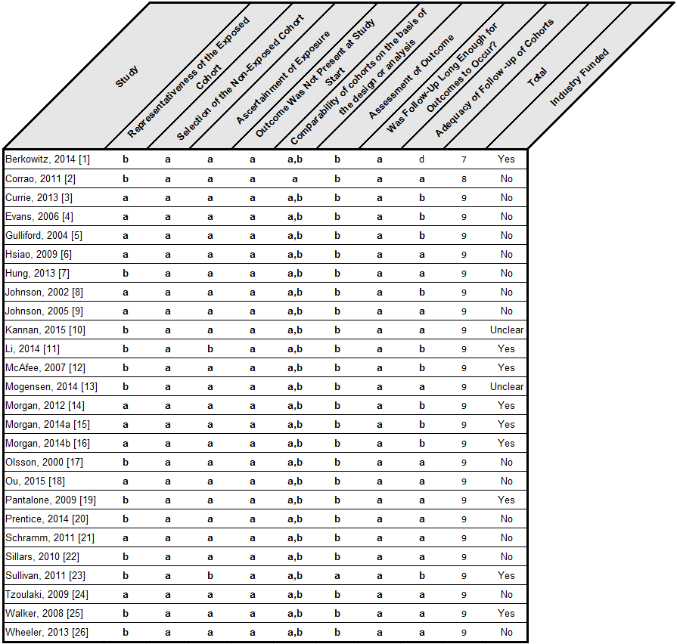

S5. Items from Jadad Scale for randomized trials and an additional item on industry funding
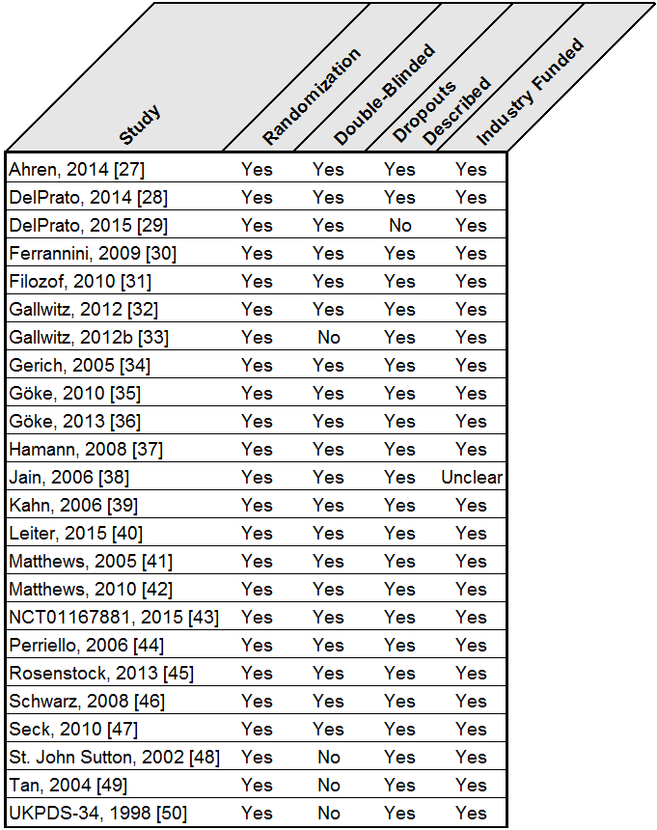

S6. Meta-analytic results for outcomes. Note: D&L = DerSimonian and Laird random effects model; NA=Not applicable; *= Comparison with less than 10 studies

METF+SU vs. METF
Outcome | Study | Study Effect Size (95% CI) | Bayesian Pooled Estimate (95% CI) | D&L Method (95% CI) | Inverse-Variance Method (95% CI) | I-squared | Egger's Test P-value
All-cause mortality | Single RCT
 | Ahrén, 2014 | 0.99  (0.10–9.38)
 | Obs Cohort
 | Johnson, 2002 | 0.81  (0.66–0.99)
 | Gulliford, 2004 | 0.95  (0.64–1.40)
 | Evans, 2006 | 0.60  (0.35–1.03)
 | Evans, 2006 | 2.47  (1.88–3.25)
 | Evans, 2006 | 2.16  (1.68–2.78)
 | Sillars, 2010 | 1.18  (0.81–1.72)
 | Currie, 2013 | 1.10  (1.02–1.18)
 | Pooled Estimate for Obs Cohort |  |  | 1.21  (0.89–1.65) | 1.15  (1.08–1.22) | 91.81% | 0.693*
 | Overall Pooled Estimate |  | 1.12  (0.17–7.59) | 1.21  (0.89–1.64) | 1.15  (1.08–1.22) | 90.44% | 0.72*
Cardio-vascular compo-site | Obs Cohort
 | Johnson, 2005 | 1.17  (0.92–1.48)
 | Sillars, 2010 | 0.83  (0.60–1.15)
 | Currie, 2013 | 1.10  (0.98–1.22)
 | Li, 2014 | 1.99  (1.07–3.70)
 | Pooled Estimate for Obs Cohort |  |  | 1.11  (0.91–1.34) | 1.10  (1.00–1.20) | 54.86% | 0.733*
Cardio-vascular death | Obs Cohort
 | Johnson, 2005 | 0.78  (0.52–1.15)
 | Evans, 2006 | 0.62  (0.25–1.53)
 | Evans, 2006 | 2.29  (1.45–3.61)
 | Evans, 2006 | 2.43  (1.61–3.66)
 | Sillars, 2010 | 1.49  (0.85–2.63)
 | Pooled Estimate for Obs Cohort |  |  | 1.38  (0.80–2.37) | 1.47  (1.18–1.82) | 82.73% | 0.692*

METF+SU vs. METF+DPP-4
Outcome | Study | Study Effect Size (95% CI) | Bayesian Pooled Estimate (95% CI) | D&L Method (95% CI) | Inverse-Variance Method (95% CI) | I-squared | Egger's Test P-value
All-cause mortality | RCT
 | Ferrannini, 2009 | 1.50  (0.25–8.98)
 | Filozof, 2010 | 1.03  (0.06–16.49)
 | Matthews, 2010 | 0.86  (0.29–2.55)
 | Seck, 2010 | 8.05  (1.01–64.20)
 | Gallwitz, 2012 | 1.00  (0.25–3.99)
 | Göke, 2013 | 0.50  (0.09–2.70)
 | Ahrén, 2014 | 2.95  (0.31–28.22)
 | DelPrato, 2014 | 1.68  (0.51–5.49)
 | Obs Cohort
 | Mogensen, 2014 | 1.54  (1.25–1.85)
 | Morgan, 2014a | 1.50  (1.09–2.05)
 | Kannan, 2015 | 0.97  (0.76–1.23)
 | Ou, 2015 | 1.59  (1.39–1.82)
 | Pooled Estimate for RCT |  |  | 1.28  (0.74–2.23) | 1.28  (0.74–2.23) | 0.00% | 0.347*
 | Pooled Estimate for Obs Cohort |  |  | 1.39  (1.12–1.72) | 1.45  (1.32–1.59) | 76.70% | 0.468*
 | Overall Pooled Estimate |  | 1.42  (0.67–2.81) | 1.38  (1.15–1.65) | 1.44(  1.32–1.59) | 41.12% | 0.698
Cardio-vascular compo-site | RCT
 | Filozof, 2010 | 1.77  (0.70–4.47)
 | Gallwitz, 2012 | 2.17  (1.10–4.35)
 | DelPrato, 2014 | 1.58  (0.72–3.47)
 | Obs Cohort
 | Mogensen, 2014 | 1.43  (1.18–1.75)
 | Morgan, 2014a | 1.55  (1.08–2.23)
 | Ou, 2015 | 1.47  (1.20–1.82)
 | Pooled Estimate for RCT |  |  | 1.86  (1.18–2.93) | 1.86  (1.18–2.93) | 0.00% | 0.589*
 | Pooled Estimate for Obs Cohort |  |  | 1.46  (1.27–1.68) | 1.46  (1.27–1.68) | 0.00% | 0.301*
 | Overall Pooled Estimate |  | 1.56  (0.77–3.52) | 1.49  (1.31–1.70) | 1.49  (1.31–1.70) | 0.00% | 0.055*
Cardio-vascular death | RCT
 | Ferrannini, 2009 | 0.50  (0.05–5.52)
 | Göke, 2010 | 1.99  (0.18–21.87)
 | Seck, 2010 | 5.03  (0.24–104.63)
 | Gallwitz, 2012 | 1.00  (0.14–7.14)
 | DelPrato, 2014 | 2.02  (0.51–8.04)
 | Single Obs Cohort
 | Mogensen, 2014 | 1.75  (1.25–2.50)
 | Pooled Estimate for RCT |  |  | 1.55  (0.63–3.81) | 1.55  (0.63–3.81) | 0.00% | 0.971*
 | Overall Pooled Estimate |  | 1.70  (0.56–4.81) | 1.73  (1.24–2.40) | 1.73  (1.24–2.40) | 0.00% | 0.731*

METF+SU vs. METF+GLP-1
Outcome | Study | Study Effect Size (95% CI) | Bayesian Pooled Estimate (95% CI) | D&L Method (95% CI) | Inverse-Variance Method (95% CI) | I-squared | Egger's Test P-value
All-cause mortality | RCT
 | Gallwitz, 2012b | 1.01  (0.29–3.45)
 | Ahrén, 2014 | 0.98  (0.20–4.84)
 | Obs Cohort
 | Mogensen, 2014 | 1.30  (0.85–1.96)
 | Kannan, 2015 | 1.76  (0.93–3.33)
 | Pooled Estimate for RCT |  |  | 1.00  (0.38–2.64) | 1.00  (0.38–2.64) | 0.00% | NA
 | Pooled Estimate for Obs Cohort |  |  | 1.42  (1.00–2.01) | 1.42  (1.00–2.01) | 0.00% | NA
 | Overall Pooled Estimate |  | 1.30  (0.37–3.80) | 1.36  (0.98–1.89) | 1.36  (0.98–1.89) | 0.00% | 0.639*

METF+SU vs. METF+MEGL
Outcome | Study | Study Effect Size (95% CI) | Bayesian Pooled Estimate (95% CI) | D&L Method (95% CI) | Inverse-Variance Method (95% CI) | I-squared | Egger's Test P-value
All-cause mortality | RCT
 | Gerich, 2005 | 1.05  (0.07–16.64)
 | Schwarz, 2008 | 2.63  (0.11–62.66)
 | Pooled Estimate for RCT |  |  | 1.56  (0.19–12.54) | 1.56  (0.19–12.54) | 0.00% | NA

METF+SU vs. METF+SGLT-2
Outcome | Study | Study Effect Size (95% CI) | Bayes-ian Pooled Esti-mate (95% CI) | D&L Method (95% CI) | Inverse-Variance Method (95% CI) | I-squared | Egger's Test P-value
All-cause mortality | RCT
 | DelPrato, 2015 | 2.49  (0.49–12.75)
 | Leiter, 2015 | 0.67  (0.14–3.30)
 | Leiter, 2015 | 6.02  (0.25–147.47)
 | NCT01167881, 2015 | 0.99  (0.25–3.93)
 | Pooled Estimate for RCT |  |  | 1.29  (0.55–3.01) | 1.29  (0.55–3.01) | 0.00% | 0.307*

METF+SU vs. METF+TZD
Outcome | Study | Study Effect Size (95% CI) | Bayesian Pooled Estimate (95% CI) | D&L Method (95% CI) | Inverse-Variance Method (95% CI) | I-squared | Egger's Test P-value
All-cause mortality | RCT
 | Matthews, 2005 | 5.06  (0.24–105.05)
 | Hamann, 2008 | 0.98  (0.14–6.89)
 | Obs Cohort
 | Morgan, 2012 | 1.41  (1.03–1.94)
 | Morgan, 2012 | 1.10  (0.90–1.35)
 | Prentice, 2014 | 1.50  (1.09–2.09)
 | Kannan, 2015 | 1.16  (1.00–1.35)
 | Pooled Estimate for RCT |  |  | 1.58  (0.31–8.18) | 1.58  (0.31–8.18) | 0.00% | NA
 | Pooled Estimate for Obs Cohort |  |  | 1.21  (1.07–1.37) | 1.20  (1.08–1.34) | 17.24% | 0.164*
 | Overall Pooled Estimate |  | 1.22  (0.30–6.50) | 1.20  (1.08–1.34) | 1.20  (1.08–1.34) | 0.00% | 0.257*
Cardio-vascular compo-site | Obs Cohort
 | McAfee, 2007 | 1.27  (0.75–2.13)
 | Walker, 2008 | 1.12  (0.96–1.32)
 | Walker, 2008 | 1.08  (0.95–1.22)
 | Morgan, 2012 | 1.38  (0.93–2.06)
 | Morgan, 2012 | 1.19  (0.91–1.55)
 | Pooled Estimate for Obs Cohort |  |  | 1.12  (1.03–1.23) | 1.12  (1.03–1.23) | 0.00% | 0.026*

METF+SU vs. SU
Outcome | Study | Study Effect Size (95% CI) | Bayesian Pooled Estimate (95% CI) | D&L Method (95% CI) | Inverse-Variance Method (95% CI) | I-squared | Egger's Test P-value
All-cause mortality | Single RCT
 | UKPDS, 1998 | 1.60  (1.02–2.52)
 | Obs Cohort
 | Olsson, 2000 | 1.63  (1.27–2.09)
 | Johnson, 2002 | 0.63  (0.57–0.71)
 | Gulliford, 2004 | 1.06  (0.85–1.31)
 | Evans, 2006 | 0.42  (0.23–0.75)
 | Evans, 2006 | 1.73  (1.22–2.45)
 | Evans, 2006 | 1.51  (1.09–2.10)
 | Sillars, 2010 | 1.02  (0.76–1.37)
 | Morgan, 2012 | 0.69  (0.57–0.83)
 | Currie, 2013 | 0.63  (0.57–0.69)
 | Pooled Estimate for Obs Cohort |  |  | 0.94  (0.73–1.22) | 0.75  (0.71–0.80) | 93.15% | 0.05*
 | Overall Pooled Estimate |  | 1.06  (0.02–50.38) | 0.98  (0.76–1.27) | 0.77  (0.72–0.81) | 92.92% | 0.024
Cardio-vascular compo-site | Obs Cohort
 | Johnson, 2005 | 0.96  (0.82–1.12)
 | Sillars, 2010 | 0.87  (0.66–1.15)
 | Morgan, 2012 | 0.63  (0.48–0.84)
 | Currie, 2013 | 0.79  (0.68–0.92)
 | Li, 2014 | 1.79  (0.68–4.74)
 | Pooled Estimate for Obs Cohort |  |  | 0.84  (0.71–0.99) | 0.84  (0.77–0.93) | 58.91% | 0.805*
Cardio-vascular death | Obs Cohort
 | Johnson, 2005 | 0.59  (0.45–0.78)
 | Evans, 2006 | 1.43  (0.83–2.47)
 | Evans, 2006 | 0.36  (0.14–0.97)
 | Evans, 2006 | 1.35  (0.75–2.41)
 | Sillars, 2010 | 0.98  (0.66–1.45)
 | Pooled Estimate for Obs Cohort |  |  | 0.88  (0.57–1.35) | 0.80  (0.66–0.97) | 74.13% | 0.591*

METF+SU vs. SU+TZD
Outcome | Study | Study Effect Size (95% CI) | Bayesian Pooled Estimate (95% CI) | D&L Method (95% CI) | Inverse-Variance Method (95% CI) | I-squared | Egger's Test P-value
Cardio-vascular composite | Obs Cohort
 | Walker, 2008 | 0.85  (0.72–1.01)
 | Walker, 2008 | 0.99  (0.83–1.18)
 | Pooled Estimate for Obs Cohort |  |  | 0.92  (0.79–1.07) | 0.92  (0.81–1.04) | 30.98% | NA

SU vs. DDP-4
Outcome | Study | Study Effect Size (95% CI) | Bayesian Pooled Estimate (95% CI) | D&L Method (95% CI) | Inverse-Variance Method (95% CI) | I-squared | Egger's Test P-value
Cardio-vascular compo-site | Single RCT
 | Rosenstock, 2013 | 2.03  (0.19–22.20)
 | Single Obs Cohort
 | Berkowitz, 2014 | 1.17  (0.97–1.42)
 | Overall Pooled Estimate |  | 1.25  (0.15–10.53) | 1.18  (0.97–1.42) | 1.18  (0.97–1.42) | 0.00% | NA

SU vs. METF
Outcome | Study | Study Effect Size (95% CI) | Bayesian Pooled Estimate (95% CI) | D&L Method (95% CI) | Inverse-Variance Method (95% CI) | I-squared | Egger's Test P-value
All-cause mortality | Single RCT
 | Kahn, 2006 | 1.01  (0.62–1.65)
 | Obs Cohort
 | Johnson, 2002 | 1.28  (1.09–1.54)
 | Evans, 2006 | 1.43  (1.15–1.77)
 | Pantalone, 2009 | 1.85  (1.56–2.17)
 | Tzoulaki, 2009 | 1.24  (1.14–1.35)
 | Corrao, 2011 | 1.37  (1.26–1.49)
 | Schramm, 2011 | 1.05  (0.94–1.16)
 | Schramm, 2011 | 1.32  (1.24–1.40)
 | Schramm, 2011 | 1.27  (1.17–1.38)
 | Schramm, 2011 | 1.19  (1.11–1.28)
 | Sullivan, 2011 | 1.09  (0.83–1.42)
 | Currie, 2013 | 1.75  (1.64–1.86)
 | Wheeler, 2013 | 1.38  (1.27–1.50)
 | Wheeler, 2013 | 1.55  (1.43–1.67)
 | Morgan, 2014b | 1.50  (1.37–1.65)
 | Pooled Estimate for Obs Cohort |  |  | 1.37  (1.26–1.48) | 1.38  (1.35–1.41) | 90.73% | 0.672
 | Overall Pooled Estimate |  | 1.30  (0.46–3.05) | 1.36  (1.25–1.47) | 1.38  (1.35–1.41) | 90.12% | 0.568
Cardio-vascular compo-site | Single RCT
 | Kahn, 2006 | 0.71  (0.43–1.16)
 | Obs Cohort
 | Johnson, 2005 | 1.22  (1.02–1.47)
 | McAfee, 2007 | 1.30  (1.04–1.61)
 | Pantalone, 2009 | 1.06  (0.95–1.18)
 | Schramm, 2011 | 1.06  (0.95–1.18)
 | Schramm, 2011 | 1.21  (1.14–1.29)
 | Schramm, 2011 | 1.17  (1.07–1.28)
 | Schramm, 2011 | 1.12  (1.04–1.21)
 | Sullivan, 2011 | 0.97  (0.79–1.18)
 | Currie, 2013 | 1.39  (1.25–1.55)
 | Hung, 2013 | 1.68  (1.15–2.45)
 | Hung, 2013 | 3.23  (2.50–4.17)
 | Berkowitz, 2014 | 1.16  (1.04–1.29)
 | Li, 2014 | 1.11  (0.52–2.35)
 | Morgan, 2014b | 1.07  (0.88–1.30)
 | Pooled Estimate for Obs Cohort |  |  | 1.24  (1.13–1.36) | 1.18  (1.15–1.22) | 85.18% | 0.294
 | Overall Pooled Estimate |  | 1.02  (0.13–6.12) | 1.22  (1.11–1.34) | 1.18  (1.15–1.22) | 84.76% | 0.517
Cardio-vascular death | Single RCT
 | Kahn, 2006 | 1.52  (0.25–9.06)
 | Obs Cohort
 | Johnson, 2005 | 1.32  (1.00–1.72)
 | Evans, 2006 | 1.70  (1.18–2.45)
 | Schramm, 2011 | 1.05  (0.91–1.20)
 | Schramm, 2011 | 1.28  (1.18–1.38)
 | Schramm, 2011 | 1.25  (1.12–1.40)
 | Schramm, 2011 | 1.14  (1.03–1.25)
 | Sullivan, 2011 | 1.17  (0.72–1.91)
 | Pooled Estimate for Obs Cohort |  |  | 1.21  (1.12–1.31) | 1.21  (1.16–1.27) | 50.63% | 0.718*
 | Overall Pooled Estimate |  | 1.25  (0.29–5.67) | 1.21  (1.12–1.31) | 1.21  (1.16–1.27) | 42.68% | 0.674*

SU vs. METF+TZD
Outcome | Study | Study Effect Size (95% CI) | Bayesian Pooled Estimate (95% CI) | D&L Method (95% CI) | Inverse-Variance Method (95% CI) | I-squared | Egger's Test P-value
All-cause mortality | Obs Cohort
 | Morgan, 2012 | 2.06  (1.43–2.98)
 | Morgan, 2012 | 1.61  (1.21–2.12)
 | Pooled Estimate for Obs Cohort |  |  | 1.77  (1.39–2.24) | 1.76  (1.41–2.20) | 11.90% | NA
Cardio-vascular compo-site | Obs Cohort
 | Morgan, 2012 | 1.87  (1.27–2.76)
 | Morgan, 2012 | 2.18  (1.34–3.56)
 | Pooled Estimate for Obs Cohort |  |  | 1.99  (1.47–2.69) | 1.99  (1.47–2.69) | 0.00% | NA

SU vs. TZD
Outcome | Study | Study Effect Size (95% CI) | Bayesian Pooled Estimate (95% CI) | D&L Method (95% CI) | Inverse-Variance Method (95% CI) | I-squared | Egger's Test P-value
All-cause mortality | RCT
 | Tan, 2004 | 3.59  (0.15–87.00)
 | Jain, 2006 | 5.00  (0.24–103.62)
 | Kahn, 2006 | 0.92  (0.57–1.49)
 | Obs Cohort
 | Pantalone, 2009 | 1.69  (1.23–2.33)
 | Pantalone, 2009 | 1.37  (0.98–1.96)
 | Tzoulaki, 2009 | 1.16  (0.82–1.63)
 | Wheeler, 2013 | 1.13  (0.90–1.42)
 | Wheeler, 2013 | 1.27  (1.01–1.59)
 | Pooled Estimate for RCT |  |  | 0.99  (0.62–1.58) | 0.99  (0.62–1.58) | 0.00% | 0.09*
 | Pooled Estimate for Obs Cohort |  |  | 1.28  (1.12–1.47) | 1.28  (1.13–1.45) | 13.73% | 0.445*
 | Overall Pooled Estimate |  | 1.20  (0.46–2.60) | 1.26  (1.11–1.43) | 1.26  (1.12–1.42) | 6.97% | 0.426*
Cardio-vascular compo-site | RCT
 | St. John Sutton, 2002 | 0.58  (0.20–1.69)
 | Jain, 2006 | 2.00  (1.01–3.99)
 | Kahn, 2006 | 0.67  (0.41–1.08)
 | Perriello, 2006 | 0.53  (0.14–2.09)
 | Obs Cohort
 | McAfee, 2007 | 1.22  (0.98–1.61)
 | Walker, 2008 | 1.10  (0.94–1.29)
 | Walker, 2008 | 1.12  (0.94–1.34)
 | Hsiao, 2009 | 0.97  (0.61–1.54)
 | Hsiao, 2009 | 0.65  (0.54–0.78)
 | Pantalone, 2009 | 0.96  (0.79–1.16)
 | Pantalone, 2009 | 1.11  (0.88–1.41)
 | Berkowitz, 2014 | 1.10  (0.89–1.37)
 | Pooled Estimate for RCT |  |  | 0.87  (0.45–1.67) | 0.87  (0.61–1.24) | 61.39% | 0.939*
 | Pooled Estimate for Obs Cohort |  |  | 1.01  (0.87–1.18) | 1.00  (0.93–1.07) | 75.11% | 0.73*
 | Overall Pooled Estimate |  | 0.98  (0.53–1.70) | 0.99  (0.85–1.16) | 0.99  (0.92–1.07) | 69.83% | 0.871
Cardio-vascular death | RCT
 | Tan, 2004 | 3.59  (0.15–87.00)
 | Jain, 2006 | 3.00  (0.12–73.29)
 | Kahn, 2006 | 1.52  (0.25–9.06)
 | Pooled Estimate for RCT |  |  | 2.04  (0.50–8.29) | 2.04  (0.50–8.29) | 0.00% | 0.095*

