Electronic Supplementary Material
Semaglutide s.c. Once-Weekly
in Type 2 Diabetes: a Population Pharmacokinetic Analysis
KCC Petri¹, SH Ingwersen¹, A Flint¹, J Zacho¹, and RV Overgaard¹
¹Novo Nordisk A/S, Vandtårnsvej 108, 2860 Søborg, Denmark

Results

Population pharmacokinetic model
Table S1 Baseline characteristics across trials of subjects included in the population PK analysis
Category | Group | SUSTAIN 1 | SUSTAIN 2 | SUSTAIN 3 | SUSTAIN 6 | SUSTAIN–Japan | Total
All | N | 237 (14.7%) | 417 (25.9%) | 366 (22.7%) | 118 (7.3%) | 474 (29.4%) | 1612 (100%)
Sex | Male | 128 (54%) | 204 (48.9%) | 193 (52.7%) | 66 (55.9%) | 336 (70.9%) | 927 (57.5%)
Sex | Female | 109 (46%) | 213 (51.1%) | 173 (47.3%) | 52 (44.1%) | 138 (29.1%) | 685 (42.5%)
Age group | 18-64 years | 195 (82.3%) | 343 (82.3%) | 285 (77.9%) | 54 (45.8%) | 326 (68.8%) | 1203 (74.6%)
Age group | 65-74 years | 34 (14.3%) | 68 (16.3%) | 72 (19.7%) | 49 (41.5%) | 130 (27.4%) | 353 (21.9%)
Age group | ≥75 years | 8 (3.4%) | 6 (1.4%) | 9 (2.5%) | 15 (12.7%) | 18 (3.8%) | 56 (3.5%)
Race | White | 155 (65.4%) | 284 (68.1%) | 315 (86.1%) | 84 (71.2%) | 0 (0%) | 838 (52.0%)
Race | Asian | 50 (21.1%) | 104 (24.9%) | 7 (1.9%) | 23 (19.5%) | 474 (100%) | 658 (40.8%)
Race | Black or African American | 19 (8.0%) | 26 (6.2%) | 19 (5.2%) | 9 (7.6%) | 0 (0%) | 73 (4.5%)
Race | American Indian or Alaska Nativeª | 0 (0%) | 0 (0%) | 2 (0.5%) | 0 (0%) | 0 (0%) | 2 (0.1%)
Race | Unknownª | 13 (5.5%) | 3 (0.7%) | 23 (6.3%) | 2 (1.7%) | 0 (0%) | 41 (2.5%)
Ethnicity | Not Hispanic or Latino | 169 (71.3%) | 347 (83.2%) | 290 (79.2%) | 91 (77.1%) | 474 (100%) | 1371 (85.0%)
Ethnicity | Hispanic or Latino | 68 (28.7%) | 70 (16.8%) | 76 (20.8%) | 27 (22.9%) | - | 241 (15.0%)
Renal function^{b} | Normal | 143 (60.3%) | 284 (68.1%) | 226 (61.7%) | 23 (19.5%) | 321 (67.7%) | 997 (61.8%)
Renal function^{b} | Mild | 83 (35.0%) | 133 (31.9%) | 140 (38.3%) | 34 (28.8%) | 143 (30.2%) | 533 (33.1%)
Renal function^{b} | Moderate | 11 (4.6%) | 0 (0%) | 0 (0%) | 28 (23.7%) | 10 (2.1%) | 49 (3%)
Renal function^{b} | Severe | 0 (0%) | 0 (0%) | 0 (0%) | 33 (28.0%) | 0 (0.0%) | 33 (2.0%)
Maintenance dose | Semaglutide 0.5 mg | 119 (50.2%) | 221 (53%) | 0 (0%) | 57 (48.3%) | 237 (50%) | 634 (39.3%)
Maintenance dose | Semaglutide 1.0 mg | 118 (49.8%) | 196 (47%) | 366 (100%) | 61 (51.7%) | 237 (50%) | 978 (60.7%)
Age | Mean (SD) | 53.2 (11.6) | 55.8 (9.5) | 56.3 (10.3) | 65.4 (7.7) | 58.4 (10.4) | 57 (10.6)
Age | Range | [26-80] | [30-82] | [20-78] | [51-86] | [26-83] | [20-86]
Body weight | Mean (SD) | 93.8 (24.9) | 89.4 (20.4) | 96.2 (22.2) | 88.3 (19.7) | 71.3 (15.5) | 86.2 (22.5)
Body weight | Range | [39.8-185.3] | [49-151.6] | [49.9-198.3] | [51.5-166] | [39.7-142] | [39.7-198.3]
BMI | Mean (SD) | 33.4 (8.3) | 32.3 (6.1) | 34.1 (7.3) | 32.1 (5.9) | 26.3 (4.7) | 31.1 (7.1)
BMI | Range | [16.4-71.8] | [19.6-53.3] | [21.0-72.8] | [21.1-52.5] | [16.3-53.5] | [16.3-72.8]
Duration of diabetes | Mean (SD) | 4.2 (5.5) | 6.9 (5.4) | 8.9 (5.9) | 15.5 (8.7) | 8.7 (6.3) | 8.1 (6.6)
Duration of diabetes | Range | [0-34.5] | [0.3-39.2] | [0.4-37.1] | [0.4-48.9] | [0.1-41.7] | [0-48.9]
HbA_{1c} | Mean (SD) | 8.1 (0.9) | 8 (0.9) | 8.3 (0.9) | 8.7 (1.4) | 8.1 (0.9) | 8.2 (1)
HbA_{1c} | Range | [6.4-10.2] | [5.9-10.7] | [6.7-11.1] | [6.8-12.7] | [6.7-13.1] | [5.9-13.1]
Notes: Categories are ordered with categorical variables first followed by continuous variables.
ªThe two groups ‘American Indian or Alaska Native’ and ‘unknown’ were merged with the group ‘white’ for the covariate analysis. Subjects without information on race were from France (n=20), Mexico (n=13), Canada (n=2), USA (n=2), Australia (n=1), Norway (n=1), South Africa (n=1) and United Kingdom (n=1). ^{b}Renal function based on eGRF defined as normal function: ≥90 mL/min, mild impairment: 60–89 mL/min, moderate impairment: 30–59 mL/min, severe: <30 mL/min.
Abbreviations: BMI, body mass index; HbA1c, glycated hemoglobin A1c; PK, pharmacokinetic; SD, standard deviation; SUSTAIN, Semaglutide Unabated Sustainability in Treatment of Type 2 Diabetes.

Table S2 Parameter estimates from the base PK model
Parameter | Estimate | CI_{95%}  lower limit | CI_{95%}  upper limit | RSE (%) | IIV  (% CV) | Shrinkage (%)
k_{a} (h⁻¹) | 0.0286 | Fixed | Fixed | Fixed | NA | NA
CL/F (L/h) | 0.0480 | 0.0471 | 0.0488 | 0.899 | 26.6 | 7.9
V/F (L) | 12.5 | 11.5 | 13.4 | 3.76 | 30.4 | 70.2
Proportional residual error (%CV) | 23.5 | NA | NA | NA | NA | 10.4
Abbreviations: CI, confidence interval; CL/F, apparent clearance; CV, coefficient of variation; IIV, Inter-individual variation; k_{a}, absorption rate constant; NA, not applicable; PK, pharmacokinetic; RSE, Relative standard error obtained from NONMEM; V/F, apparent volume of distribution.
Table S3 Parameter estimates from the full population PK model with covariate effects included
Parameter | Estimate | 95% CI lower limit | 95% CI upper limit | RSE (%) | IIV (%CV) | Shrinkage (%)
k_{a} (h⁻¹) | 0.0286 | Fixed | Fixed | Fixed | NA | NA
CL/F (L/h) | 0.0478 | 0.0468 | 0.0488 | 1.06 | 12.9 | 25
V/F (L) | 12.2 | 12.1 | 12.4 | 0.487 | 37.3 | 58.1
Body weight | 0.774 | 0.724 | 0.823 | 3.27 | NA | NA
Sex - male | 1.04 | 1.02 | 1.06 | 0.963 | NA | NA
Age 65–74 years | 0.988 | 0.966 | 1.01 | 1.11 | NA | NA
Age >74 years | 0.961 | 0.916 | 1.01 | 2.41 | NA | NA
Maintenance dose  0.5 mg | 1.00 | 0.984 | 1.02 | 0.855 | NA | NA
Race - black | 0.974 | 0.912 | 1.04 | 3.28 | NA | NA
Race - Asian | 0.989 | 0.965 | 1.01 | 1.25 | NA | NA
Ethnicity – Hispanic or Latino | 1.06 | 1.03 | 1.1 | 1.62 | NA | NA
Injection site - thigh | 1.04 | 0.993 | 1.08 | 2.1 | NA | NA
Injection site - upper arm | 1.08 | 1.03 | 1.12 | 2.13 | NA | NA
Renal - Mild impairment | 0.948 | 0.930 | 0.965 | 0.963 | NA | NA
Renal - Moderate impairment | 0.955 | 0.900 | 1.01 | 2.95 | NA | NA
Renal - Severe impairment | 0.920 | 0.846 | 0.995 | 4.15 | NA | NA
Proportional residual error (%CV) | 23.8 | NA | NA | NA | NA | 8.0
Abbreviations: CI, confidence interval; CL/F, apparent clearance; CV, coefficient of variation; IIV, Inter-individual variation; k_{a}, absorption rate constant; NA, not applicable; PK, pharmacokinetic; RSE: Relative standard error obtained from NONMEM.

Fig. S1 Semaglutide exposure versus time. Data points are individual values and lines represent geometric mean concentrations over time

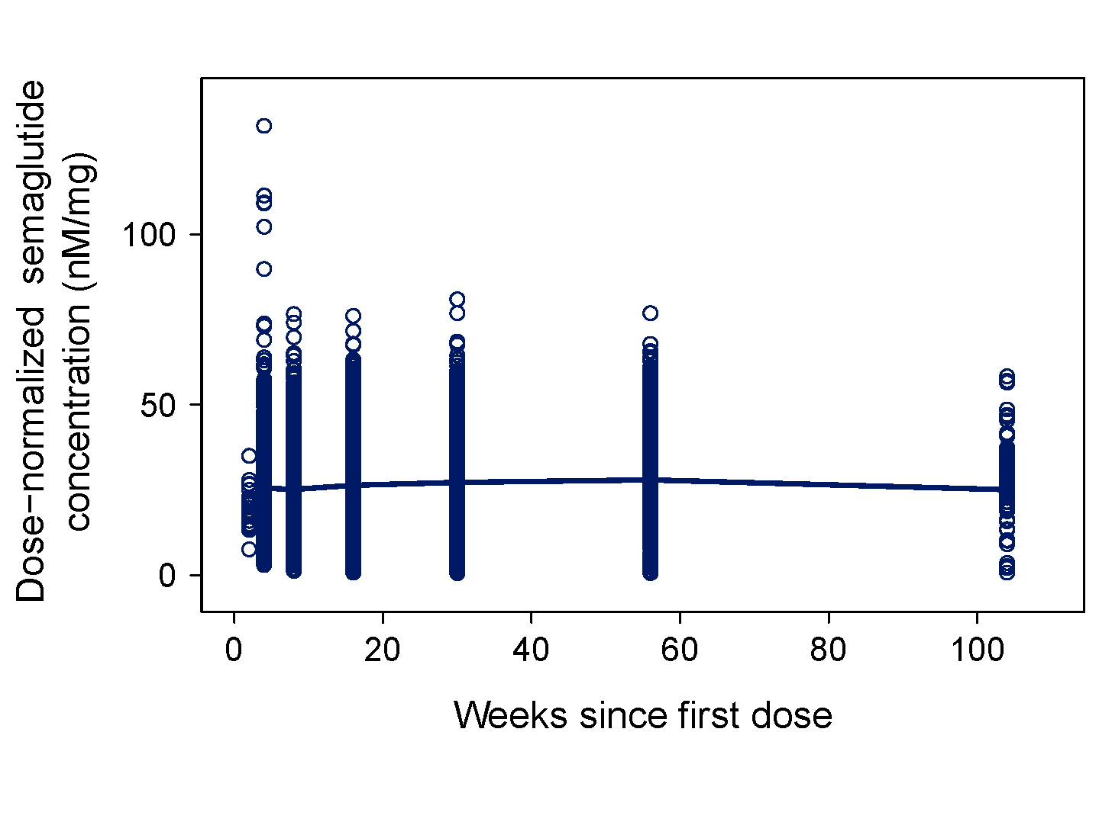

Population pharmacokinetic model evaluation
Table S4 Sensitivity analysis for the full PK model towards changes in the fixed value of k_{a} and towards exclusion of outliers
Parameter | Final model  (full model) | k_{a} -25%ª | k_{a} +25%ª | Excluding high residuals^{b}
k_{a} (h⁻¹) | 0.0286 | 0.0215 | 0.0358 | 0.0286
CL/F (L/h) | 0.0478 | 0.0479 | 0.0478 | 0.0478
V/F (L) | 12.2 | 10.3 | 13.6 | 12.2
Body weight | 0.774 | 0.778 | 0.772 | 0.775
Sex - male | 1.04 | 1.04 | 1.04 | 1.04
Age 65–74 y | 0.988 | 0.987 | 0.989 | 0.987
Age >74 y | 0.961 | 0.962 | 0.962 | 0.961
Maintenance dose 0.5 mg | 1.00 | 1.00 | 1.00 | 1.00
Race – black or African American | 0.974 | 0.973 | 0.97 | 0.981
Race - Asian | 0.989 | 0.991 | 0.989 | 0.990
Ethnicity – Hispanic or Latino | 1.06 | 1.06 | 1.06 | 1.07
Injection site - thigh | 1.04 | 1.04 | 1.04 | 1.04
Injection site - upper arm | 1.08 | 1.08 | 1.08 | 1.08
Renal - Mild impairment | 0.948 | 0.948 | 0.948 | 0.947
Renal - Moderate impairment | 0.955 | 0.956 | 0.956 | 0.955
Renal - Severe impairment | 0.920 | 0.923 | 0.921 | 0.92
Proportional error (%CV) | 23.8 | 23.9 | 23.9 | 23.8
ªValues of k_{a} were fixed at a 25% lower and higher value, respectively than used in the reference run. ^{b}Values giving rise to conditional weighted residuals above 4 or below -4 were excluded.
Abbreviations: CL/F, apparent clearance; CV, coefficient of variation; k_{a}, absorption rate constant; PK, pharmacokinetic.

Fig. S2 Diagnostic plots for the full PK model. Data are observed concentrations versus population predictions (top left) and versus individual predictions (bottom left), conditional weighted residuals versus population predictions (mid right) and versus time (mid left), QQ-plot of conditional weighted residuals (top right) and distribution plot of conditional weighted residuals (bottom right). The light blue lines represent quantiles of concentration or time.
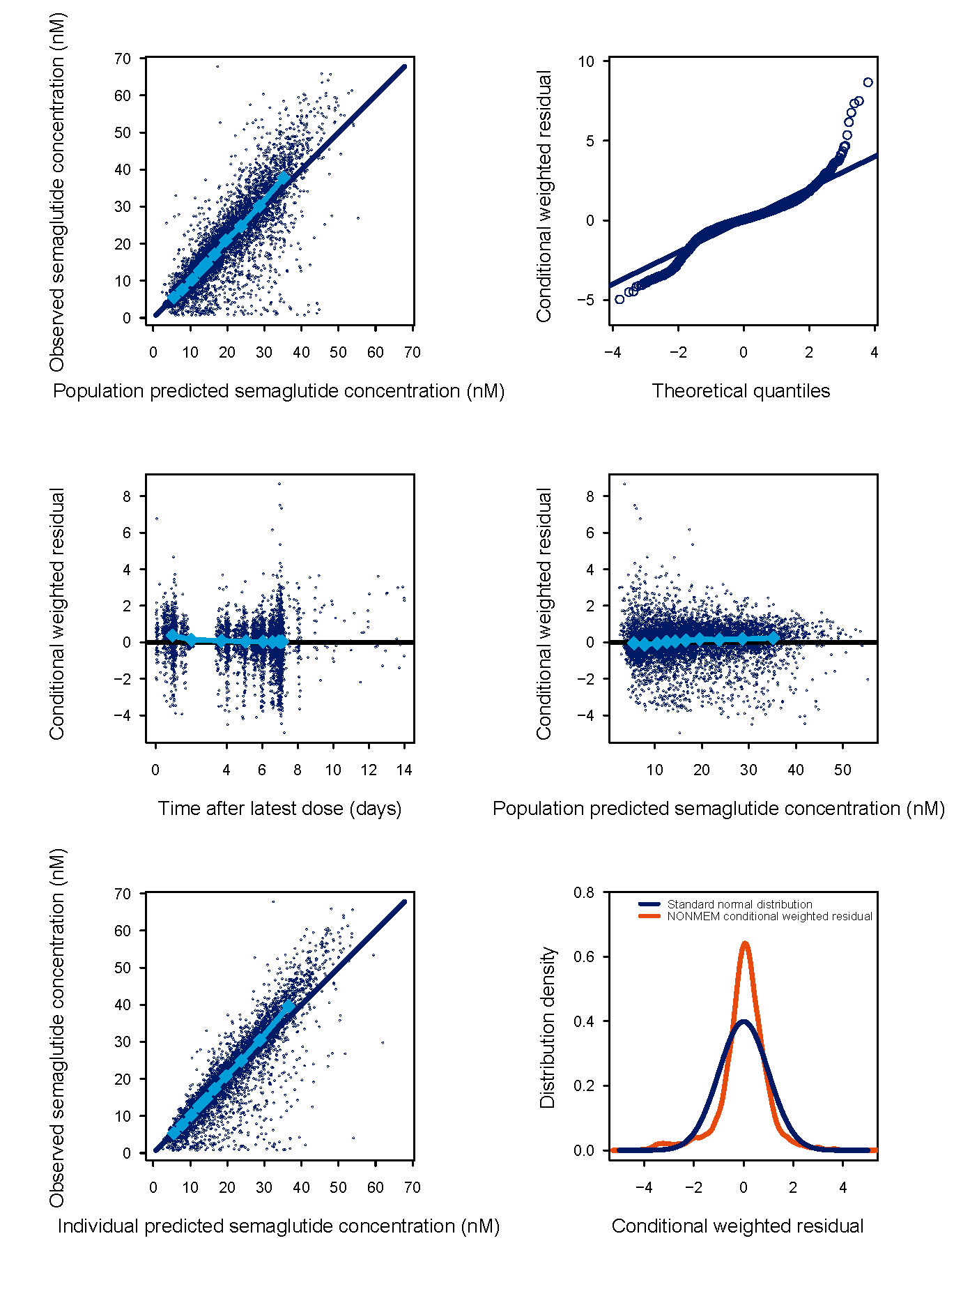
Fig. S3 Distribution of individual clearance (CL/F) and volume (V/F) estimates from the full PK model

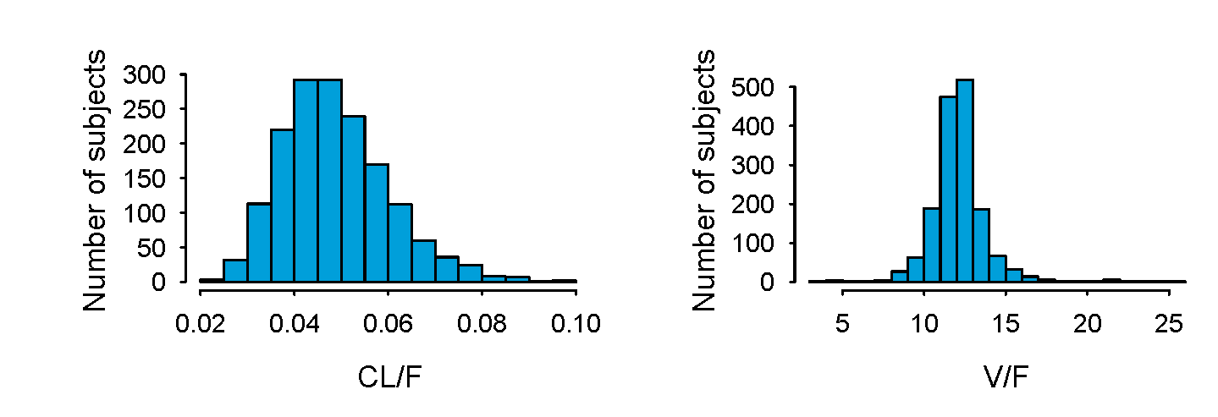

Fig. S4 Visual predictive check from all studies stratified by dose level: semaglutide 0.5 mg (left) and 1.0 mg (right). Lines represent the 2.5th, 50th and 97.5th observed percentiles and the shaded area represents the 95th confidence interval of 2.5th, 50th and 97.5th percentile of the simulated semaglutide plasma concentration versus actual time (days) after the latest dose.

