Supplement
Supplementary Table 1. Inclusion and exclusion criteria
Inclusion criteria | - Male or female  - Age ≥18 years  - With type 1 diabetes mellitus  - Being treated BID with any basal insulin in combination with prandial rapid-acting insulin analogue for at least 1 year  - Have an HbA_{1c} measurement of 8.0–10.0% at study entry (Visit 0)  - Patients who have signed an Informed Consent Form
Exclusion criteria | - Type 2 diabetes mellitus  - Known hypoglycaemia unawareness  - Repeated episodes of severe hypoglycaemia or DKA within the last 12 months  - End-stage renal failure or being on haemodialysis  - Any clinically significant abnormality identified on physical examination, laboratory tests, or vital signs at the time of screening or baseline, or any major systemic disease resulting in short life expectancy that in the opinion of the Investigator would restrict or limit the patient’s successful participation for the duration of the study  - Patients treated with GLP-1 RA  - Participation in another clinical trial  - Use of systemic glucocorticoids (excluding topical application or inhaled forms) for 2 weeks or more within 8 weeks prior to the time of screening  - Pregnant or lactating women  - Women of childbearing potential with no effective contraceptive method  - Known hypersensitivity/intolerance to insulin glargine or any of its excipients  - Patient who withdrew consent during the screening or run-in phase (patient who was not willing to continue or failed to return)  - Patients who could not demonstrate the proper use of injection pens, diary or glucose meter before receiving the first injection of insulin glargine 300 IU/ml
BID, twice daily; DKA, diabetic ketoacidosis; GLP-1 RA, glucagon-like peptide 1 receptor antagonist.

Supplementary Table 2. Number of hypoglycaemic events per patient-year during the run-in period and last 4 weeks of treatment
Number of hypoglycaemic events per patient-year | Time period | N | Mean (SD) | p-value
Total | Run-in | 70 | 103.10 (70.41) | 0.520
Total | Last 4 weeks | 70 | 110.39 (85.52) | 0.520
Nocturnal | Run-in | 70 | 16.40 (20.38) | 0.419
Nocturnal | Last 4 weeks | 70 | 13.66 (23.79) | 0.419
Severe | Run-in | 69 | 1.04 (3.42) | 0.326
Severe | Last 4 weeks | 69 | 1.95 (7.52) | 0.326
Symptomatic | Run-in | 65 | 80.35 (59.67) | 0.383
Symptomatic | Last 4 weeks | 65 | 89.53 (73.90) | 0.383
Confirmed (≤70 mg/dL) | Run-in | 70 | 93.17 (67.23) | 0.647
Confirmed (≤70 mg/dL) | Last 4 weeks | 70 | 97.83 (75.45) | 0.647
Confirmed (<54 mg/dL) | Run-in | 70 | 33.40 (31.04) | 0.496
Confirmed (<54 mg/dL) | Last 4 weeks | 70 | 37.14 (39.85) | 0.496
ITT population.
ITT, intent-to-treat; SD, standard deviation

Supplementary Table 3. DTSQ perceived hyperglycaemia and hypoglycaemia scores
Perceived hyperglycaemia score | N |  | Mean | SD | p-value versus baseline
Perceived hyperglycaemia score | Valid | Missing | Mean | SD | p-value versus baseline
Screening | 94 | 0 | 3.69 | 1.445
Baseline | 94 | 0 | 3.98 | 1.391
Week 12 | 91 | 3 | 3.21 | 1.216 | <0.0001
Week 24 | 92 | 2 | 3.25 | 1.315 | <0.0001
Perceived hypoglycaemia score | N |  | Mean | SD | p value versus baseline
Perceived hypoglycaemia score | Valid | Missing | Mean | SD | p value versus baseline
Screening | 94 | 0 | 2.61 | 1.438
Baseline | 94 | 0 | 2.79 | 1.473
Week 12 | 91 | 3 | 3.09 | 1.450 | 0.14
Week 24 | 92 | 2 | 2.86 | 1.442 | 0.14
ITT population.
DTSQs, Diabetes Treatment Satisfaction Questionnaire status version; N, number;
SD, standard deviation

Supplementary Table 4. Comparison of patients’ satisfaction score concerning the number of injections at baseline and Month 6
 |  |  | Month 6 score |  |  |  |  |  | Total
 |  |  | 1 | 2 | 3 | 4 | 5 | 6 | Total
Baseline score | 0 | Count | 0 | 0 | 1 | 0 | 1 | 1 | 3
Baseline score | 0 | % of total | 0.0% | 0.0% | 1.1% | 0.0% | 1.1% | 1.1% | 3.3%
Baseline score | 1 | Count | 1 | 1 | 1 | 1 | 1 | 2 | 7
Baseline score | 1 | % of total | 1.1% | 1.1% | 1.1% | 1.1% | 1.1% | 2.2% | 7.6%
Baseline score | 2 | Count | 0 | 0 | 1 | 3 | 6 | 3 | 13
Baseline score | 2 | % of total | 0.0% | 0.0% | 1.1% | 3.3% | 6.5% | 3.3% | 14.1%
Baseline score | 3 | Count | 1 | 0 | 4 | 7 | 9 | 8 | 29
Baseline score | 3 | % of total | 1.1% | 0.0% | 4.3% | 7.6% | 9.8% | 8.7% | 31.5%
Baseline score | 4 | Count | 0 | 0 | 3 | 3 | 9 | 5 | 20
Baseline score | 4 | % of total | 0.0% | 0.0% | 3.3% | 3.3% | 9.8% | 5.4% | 21.7%
Baseline score | 5 | Count | 0 | 0 | 1 | 2 | 6 | 4 | 13
Baseline score | 5 | % of total | 0.0% | 0.0% | 1.1% | 2.2% | 6.5% | 4.3% | 14.1%
Baseline score | 6 | Count | 0 | 0 | 0 | 2 | 2 | 3 | 7
Baseline score | 6 | % of total | 0.0% | 0.0% | 0.0% | 2.2% | 2.2% | 3.3% | 7.6%
Total |  | Count | 2 | 1 | 11 | 18 | 34 | 26 | 92
 |  | % of total | 2.2% | 1.1% | 12.0% | 19.6% | 37.0% | 28.3% | 100.0%

Supplementary Figure 1. OPTIMIZE study design
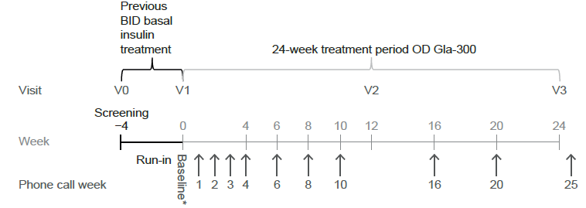

*Transfer to Gla-300 U/mL
BID, twice daily; Gla-300, insulin glargine 300 U/mL; OD, once daily; V, visit.

Supplementary Figure 2. Study Flow
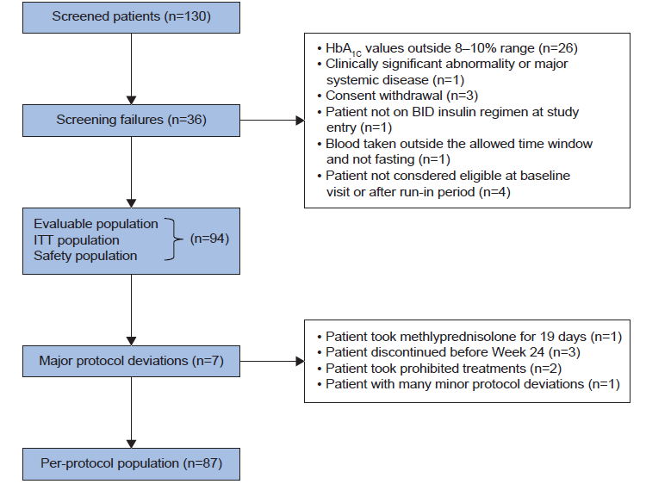
BID, twice daily; HbA, glycated haemoglobin, ITT, intent-to-treat.
Supplementary Figure 3. Changes in basal insulin dose A) and body weight B) from baseline to Week 24
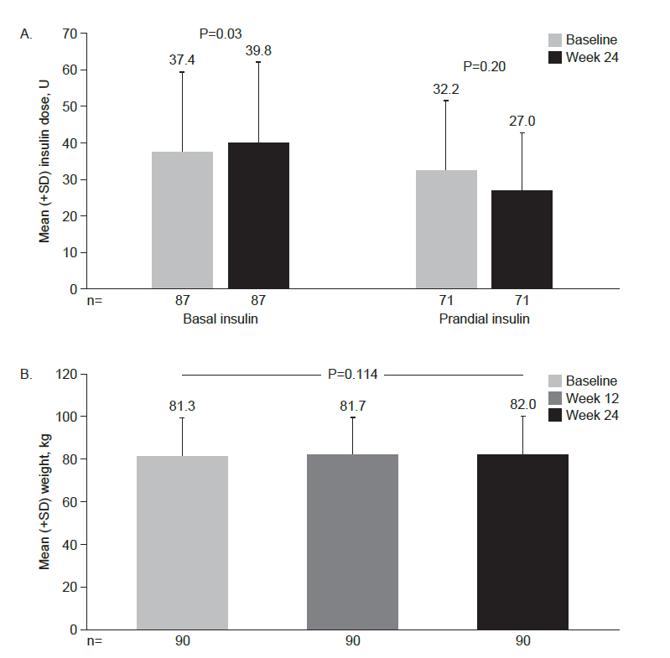
SD, standard deviation

