Supplementary Appendix
Population Pharmacokinetics of Semaglutide for Type 2 Diabetes
Rune V. Overgaard • Philip H. Delff • Kristin C.C. Petri • Thomas W. Anderson • Anne Flint • Steen H. Ingwersen
R. V. Overgaard P. H. Delff • Kristin C.C. Petri • Steen H. Ingwersen
Quantitative Clinical Pharmacology, Novo Nordisk A/S, Søborg, Denmark
T. W. Anderson
Development PK/PD, Novo Nordisk A/S, Måløv
A. Flint
Clinical Pharmacology, Novo Nordisk A/S, Søborg, Denmark

Methods for trial 7
Absolute bioavailability
The absolute bioavailability of the subcutaneous versus intravenous administration of semaglutide was investigated in healthy subjects. In a randomized, double-blind, cross-over setting, a single dose of 0.25 mg semaglutide was given intravenously on one occasion and a single dose of 0.5 mg was given subcutaneously on separate occasions. The absolute bioavailability was estimated as the ratio of dose-adjusted AUC_{0-∞}.
Drug product strength
In a randomized, double-blind, cross-over setting, a single dose of 0.5 mg semaglutide of 2 out of 3 different strengths (1 mg ml⁻¹, 3 mg ml⁻¹, 10 mg ml⁻¹) was given on separate occasions. The equivalence between drug product strengths was investigated pairwise and declared if the confidence interval for the ratio of AUC_{0-∞} and C_{max} was contained within the pre-specified limit [0.80, 1.25] (both included).

Tables

Table S1. Equivalence between product strengths in healthy subjects

Trial | Semaglutide | Dose (injection volume) | AUC_{0−∞} ratio [90% CI] | C_{max} ratio  [90% CI]
7 | Strengths
 | 1 mg ml⁻¹ | 0.50 mg (500 μL)
 | 3 mg ml⁻¹ | 0.51 mgª (170 μL)
 | 10 mg ml⁻¹ | 0.50 mg (50 μL)
 | Treatment ratio
 | 1 mg ml⁻¹ / 3 mg ml⁻¹ |  | 1.02 [0.99–1.05] | 0.91 [0.84–1.00]
 | 1 mg ml⁻¹ / 10 mg ml⁻¹ |  | 0.97 [0.94–1.01] | 0.71 [0.65–0.78]
 | 3 mg ml⁻¹ / 10 mg ml⁻¹ |  | 0.96 [0.92–0.99] | 0.78 [0.72–0.85]
AUC: area under the concentration-time curve; CI, confidence interval; C_{max}: maximum concentration.
ªFor semaglutide strength of 3 mg ml⁻¹, 0.51 mg was administered due to increments in the device. For the statistical evaluation, the endpoint was dose-adjusted from 0.51 mg to 0.5 mg.
AUC was a primary endpoint and C_{max} was a supportive secondary endpoint.

Table S2. Parameter estimates obtained from the one-compartment model

Parameter | Estimate | [95% CI] | RSE  (% CV) | IIV  (% CV) | Shrinkage (%)
Absorption rate constant (k_{a}), h⁻¹ | 0.0296 | [0.027–0.0322] | 4.5 | 73 | 6.7
Apparent clearance (CL/F), L/h | 0.0415 | [0.0404–0.0426] | 1.4 | 15.5 | 1.2
Volume of distribution (V/F), L | 9.77 | [9.57–9.97] | 1.0 | 11.5 | 14.9
Body weight effect on CL/F | 1.09 | [0.965–1.21] | 5.7 | NA | NA
Body weight effect on V/F | 0.933 | [0.843–1.02] | 4.9 | NA | NA
T2D effect on CL/F | 1.14 | [1.09–1.2] | 2.5 | NA | NA
Residual error | 0.108 | NA | NA | NA | 4.2
CI, confidence interval; CL/F, apparent clearance; CV, coefficient of variation; IIV, inter-individual variability; NA, not applicable; RSE, relative standard error; T2D, type 2 diabetes; V/F, volume of distribution.
Data from 7 trials with multiple doses of semaglutide were included in the model.

Figures

Figure S1. Individual estimates of clearance (A), central volume of distribution (B) or the absorption rate constant (C) versus baseline body weight for subjects with type 2 diabetes or normoglycaemia.
Open symbols are individual values versus baseline body weight. Closed symbols are mean values with 95% CI versus quantiles of baseline body weight. Estimate values were obtained from the final two-compartment PK model.
CI, confidence interval; PK, pharmacokinetics

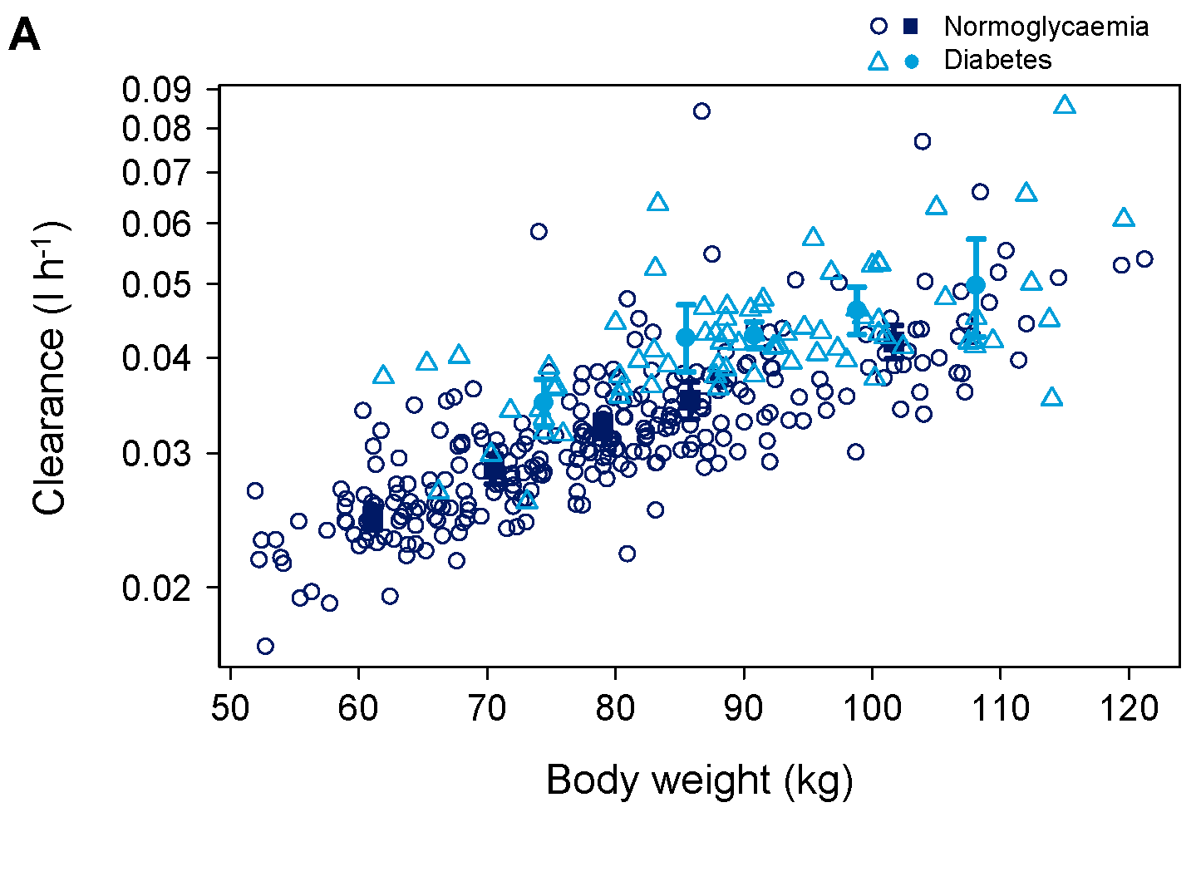
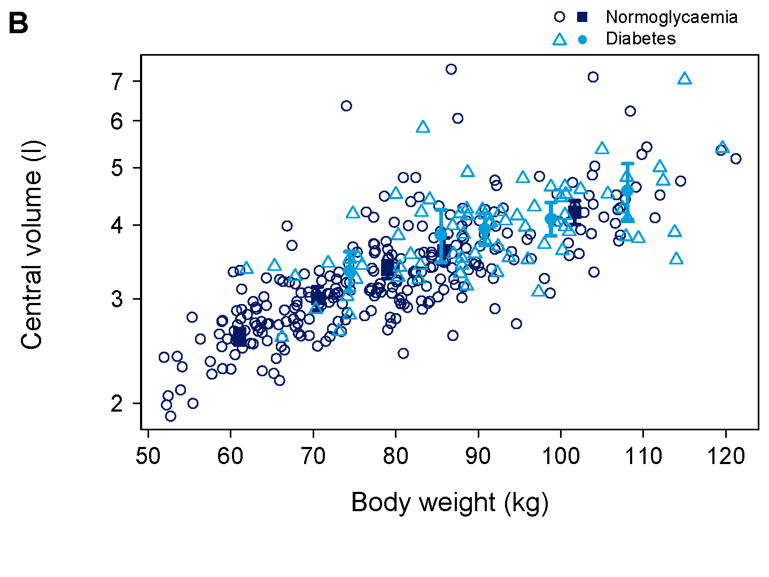
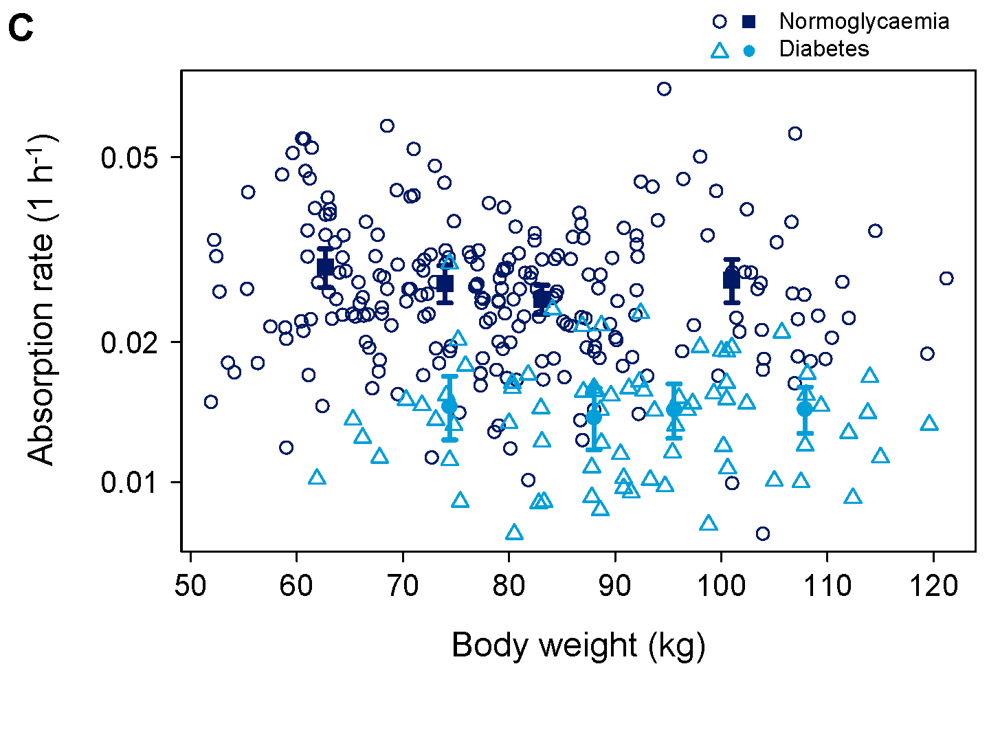
Figure S2. Semaglutide concentration versus time after first dose in trials and treatment arms with (A) single-dose data and (B) steady-state profiles.
i.v., intravenously; s.c., subcutaneously
A
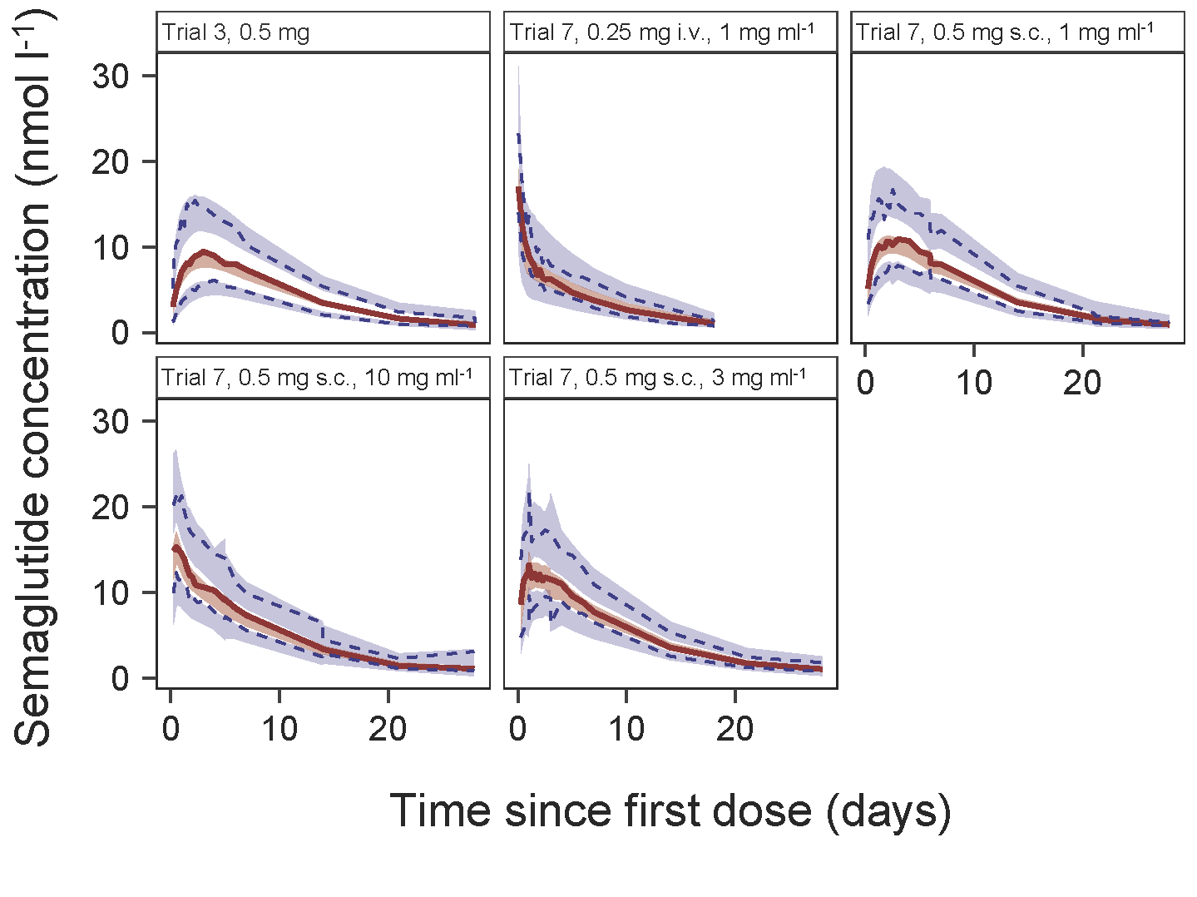
B
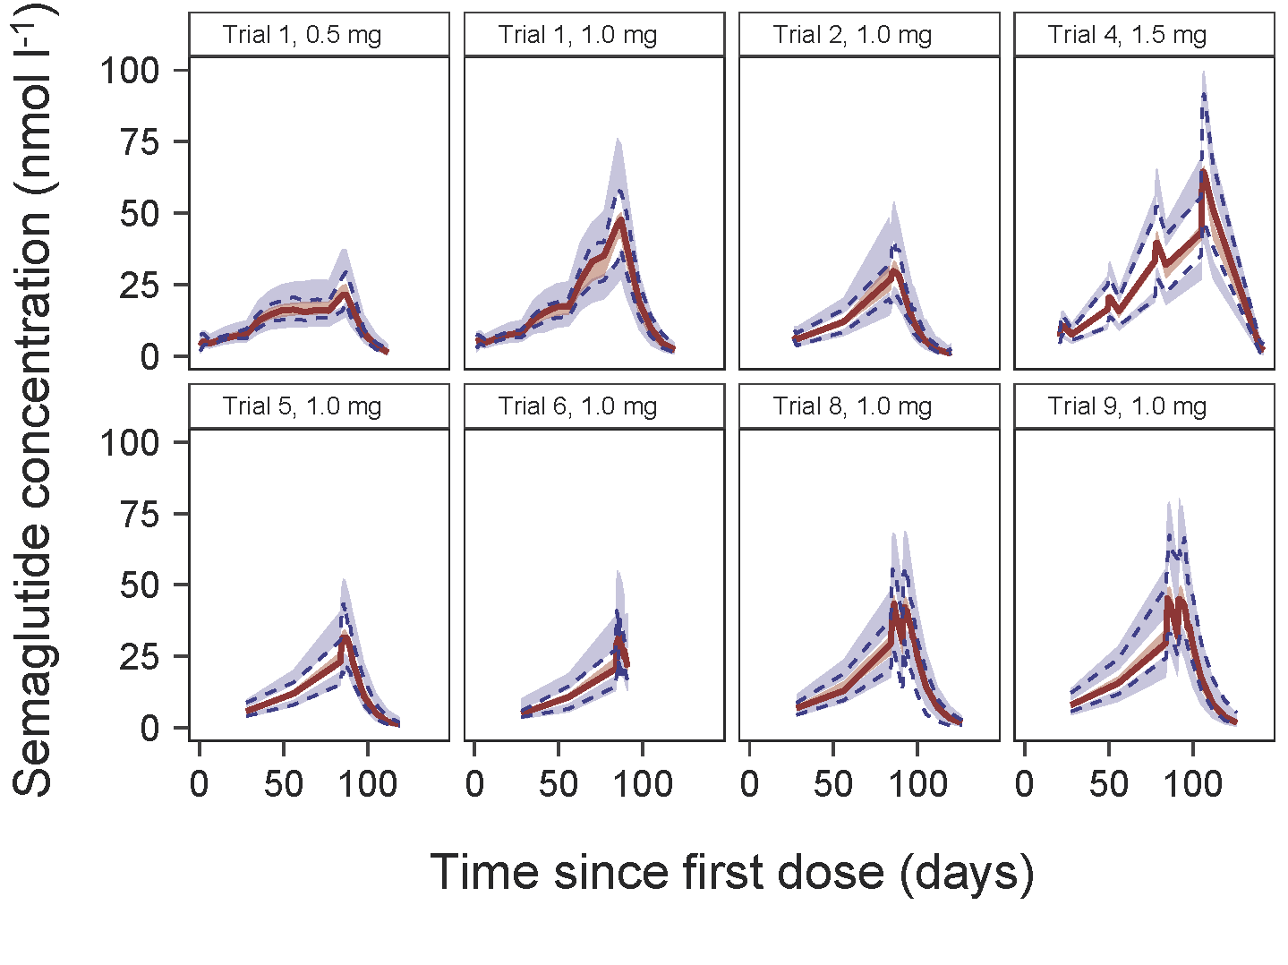
Figure S3. Individual exposure estimates (A) and mean simulated PK profiles (B) obtained from the one-compartment model versus the final two-compartment model.
Data in A are individual C_{avg} estimates at steady-state concentrations from a population of seven clinical pharmacology trials with multiple dosing of semaglutide. Data in B are geometric means of individual simulated PK profiles for the population shown in panel A, based on the individual parameter estimates of either the one- or two-compartment model.
C_{avg}, average steady state concentration; PK, pharmacokinetic
A
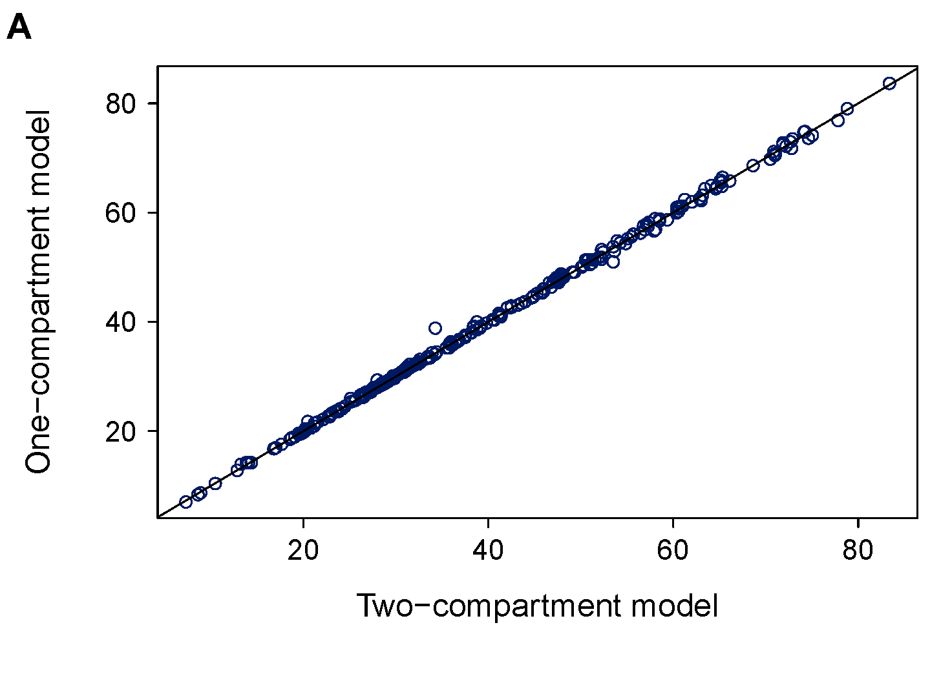
B

