Supplementary appendix

Supplementary Figure 1. Percentage of patients achieving target apo B/A1 < 0.7 after 8 weeks of treatment.
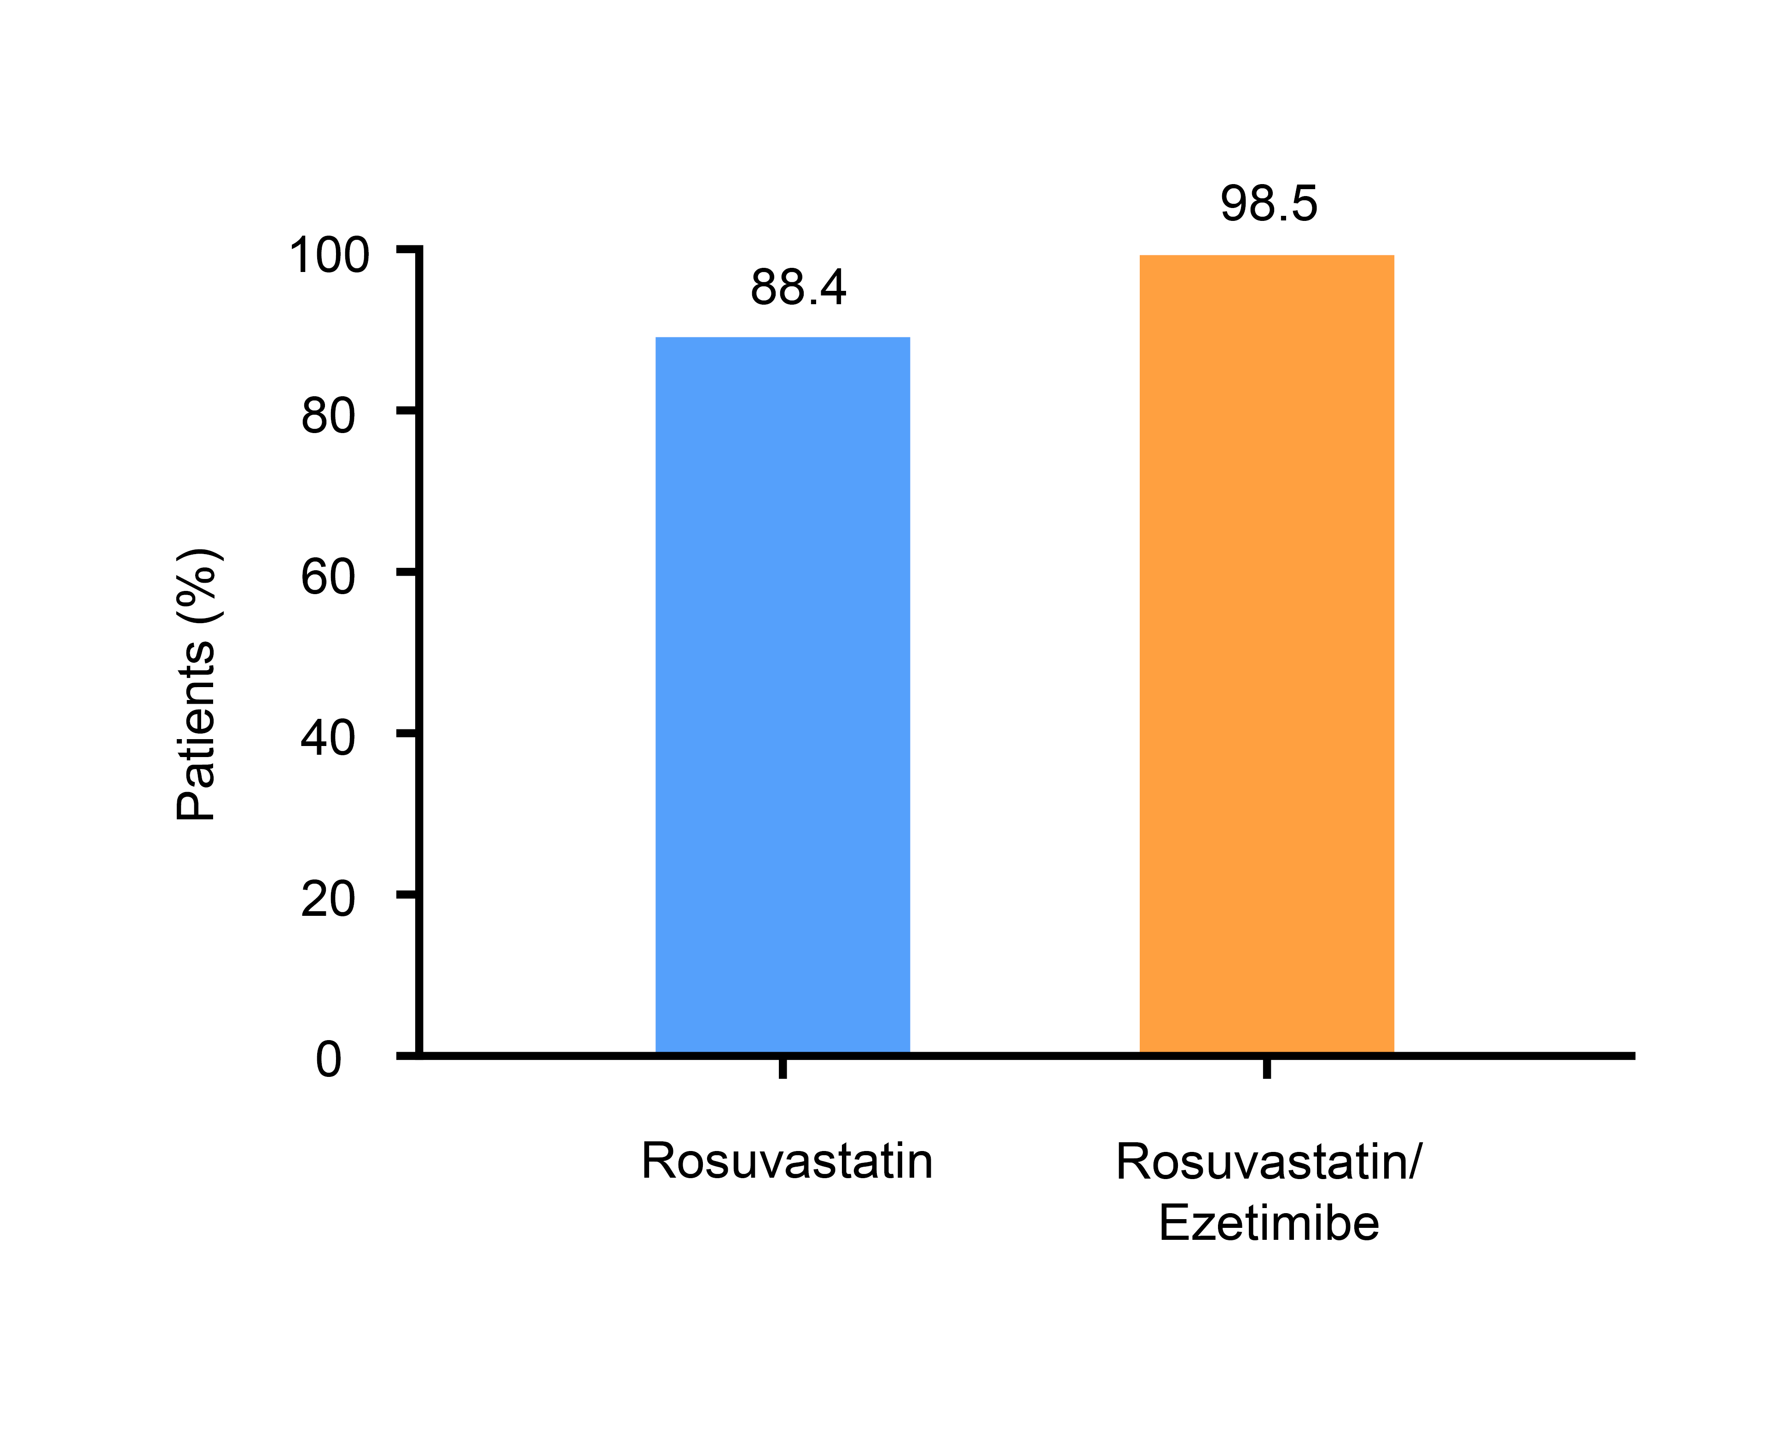

Supplementary Figure 2. Percentage of patients achieving target LDL cholesterol < 70 mg/dL after 8 weeks of treatment
