Supplementary Appendix
Title: Once-weekly Semaglutide Reduces HbA_{1c} and Body Weight in Patients with Type 2 Diabetes Regardless of Background OAD: A Subgroup Analysis from SUSTAIN 2–4 and 10
Authors: Matthew Capehorn, Yasmin Ghani, Charlotte Hindsberger, Pierre Johansen, Esteban Jódar

Trial Registration
SUSTAIN 2: https://clinicaltrials.gov/ct2/show/NCT01930188
SUSTAIN 3: https://clinicaltrials.gov/ct2/show/NCT01885208
SUSTAIN 4: https://clinicaltrials.gov/ct2/show/NCT02128932
SUSTAIN 10: https://clinicaltrials.gov/ct2/show/NCT03191396

Supplementary Figure S1. Mean (SE) change from baseline in BMI by background oral antidiabetic drug subgroup

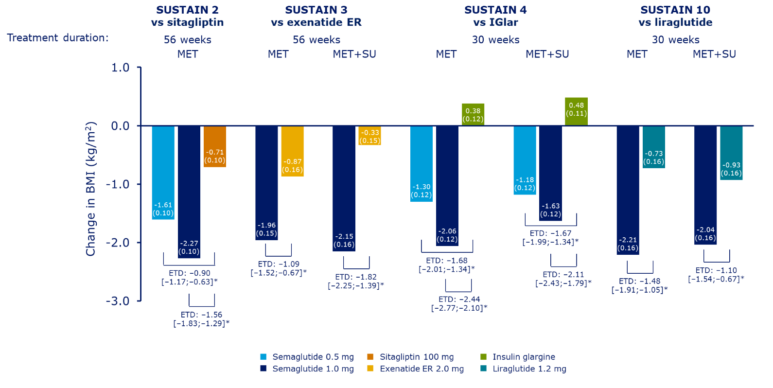
Mean (SE) change from baseline and ETD [95% confidence interval] for semaglutide vs comparators shown.
*p<0.0001.
BMI, body mass index; ETD, estimated treatment difference; exenatide ER, exenatide extended release;
IGlar, insulin glargine; MET, metformin; SE, standard error; SU, sulphonylurea.

Supplementary Figure S2. Change from baseline and difference vs comparator in systolic blood pressure by background oral antidiabetic drug subgroup
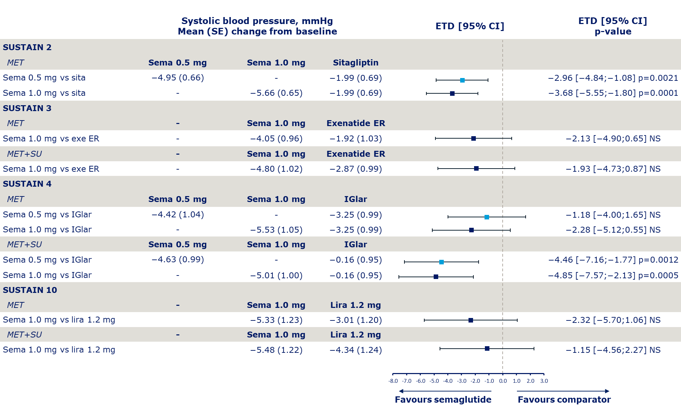Error bars represent 95% CI. p>0.05 reported as NS.
CI, confidence interval; ETD, estimated treatment difference; exe ER, exenatide extended release; IGlar, insulin glargine; lira, liraglutide; MET, metformin;
NS, non-significant; SE, standard error; Sema, semaglutide; sita, sitagliptin; SU, sulphonylurea.
Supplementary Figure S3. Change in total cholesterol (A), HDL cholesterol (B) and LDL cholesterol (C), and triglycerides (D) from baseline to EOT and difference vs comparator by background oral antidiabetic drug subgroup
A
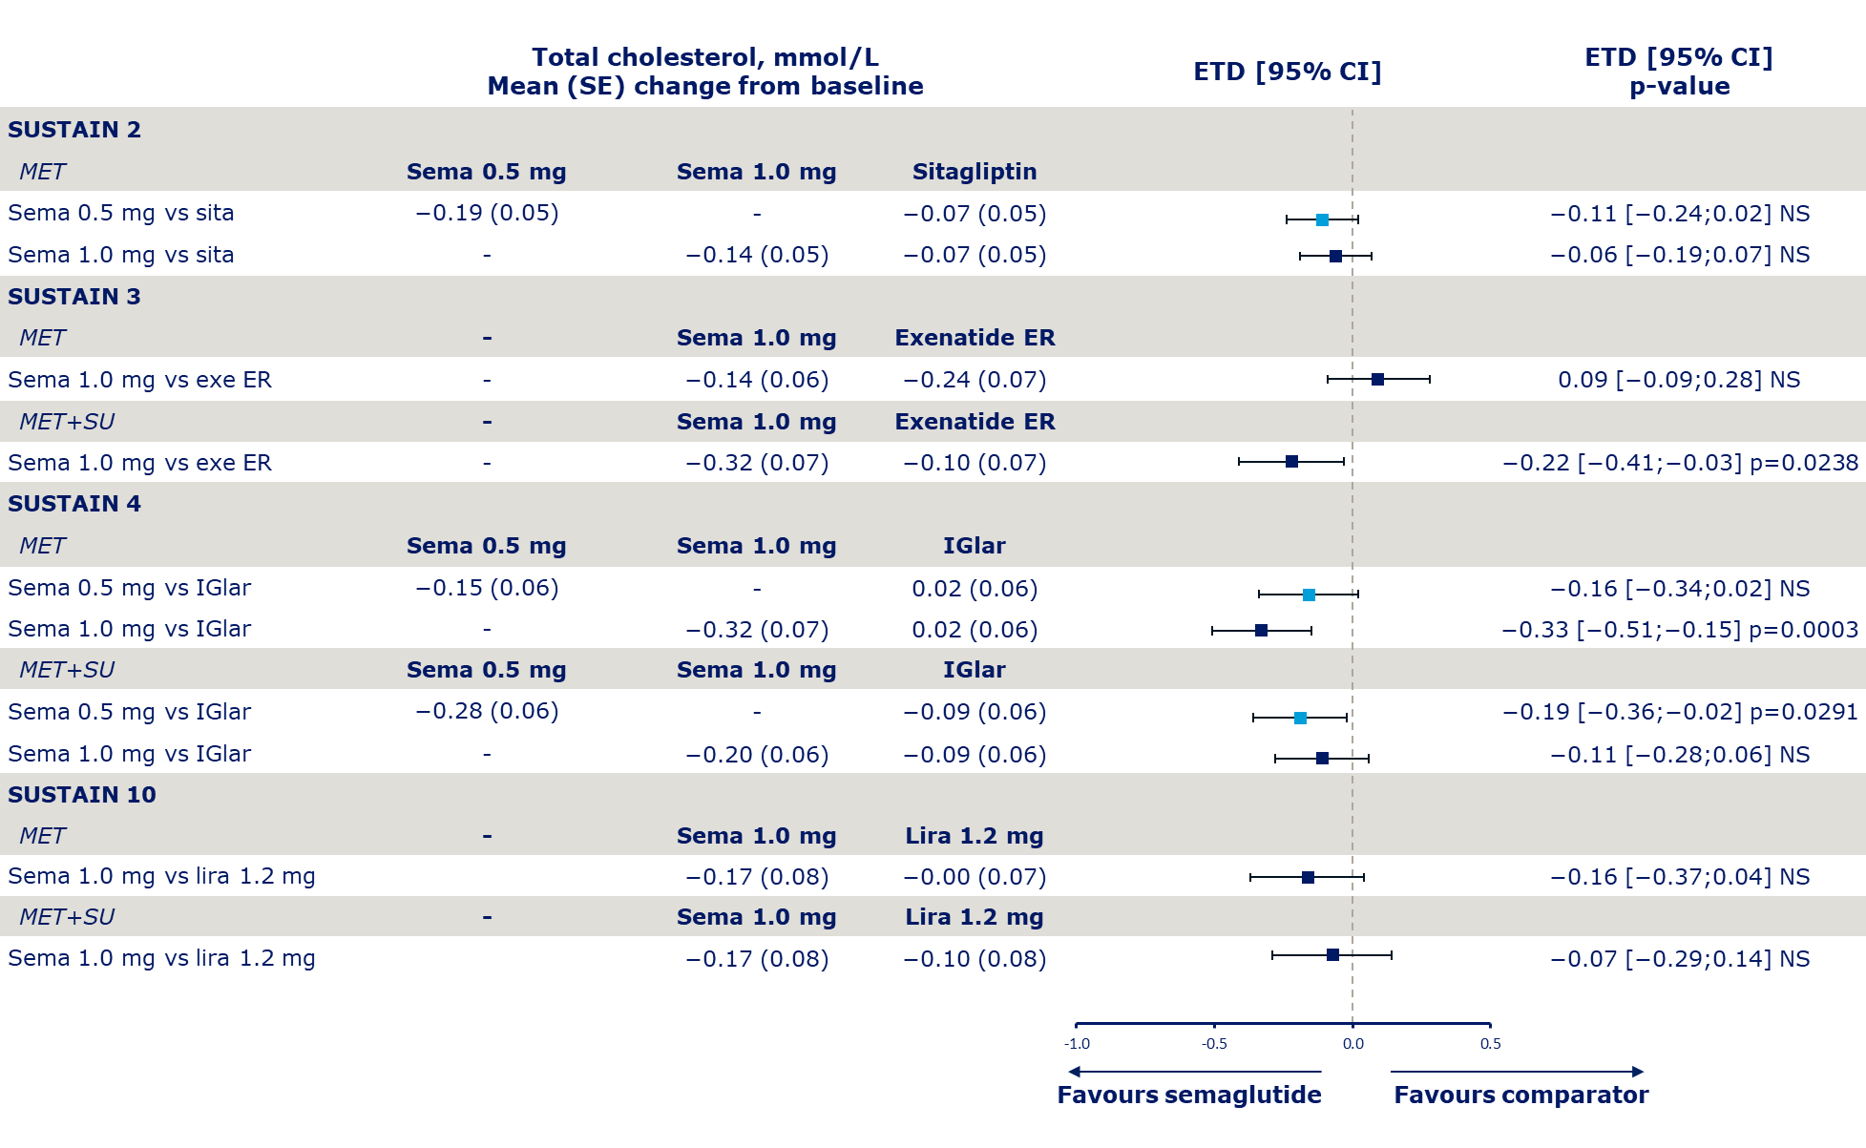

B
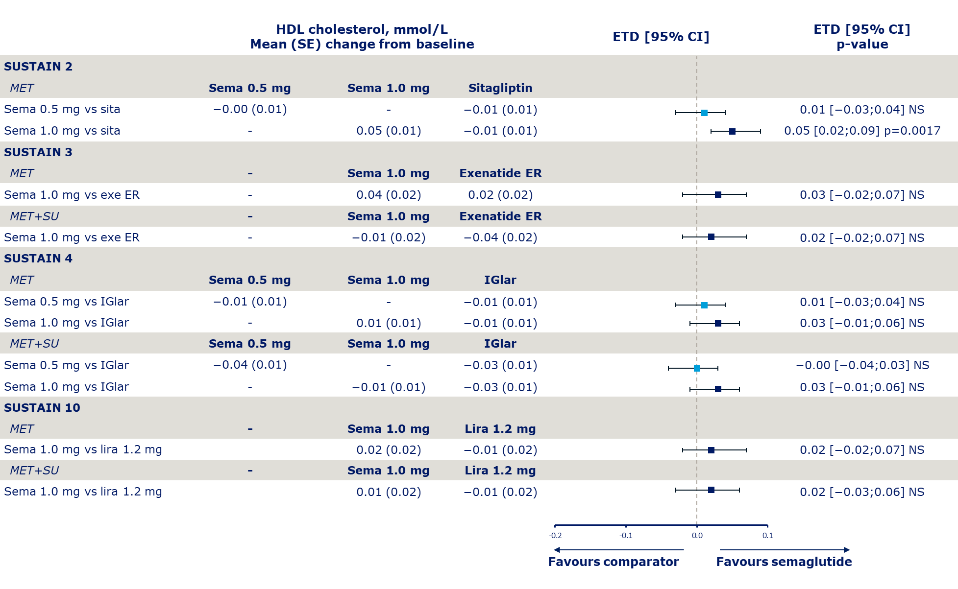

C
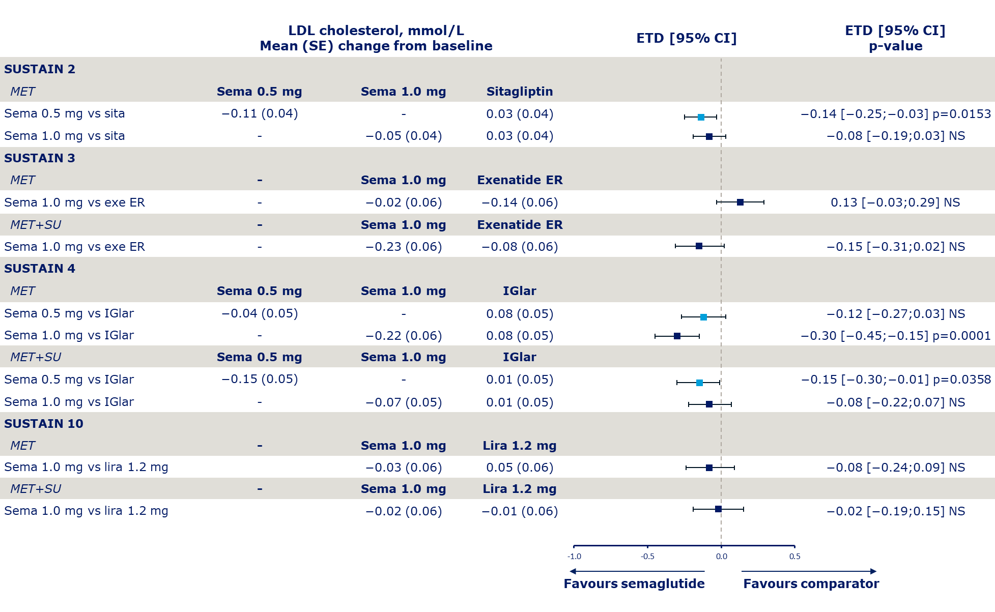

D
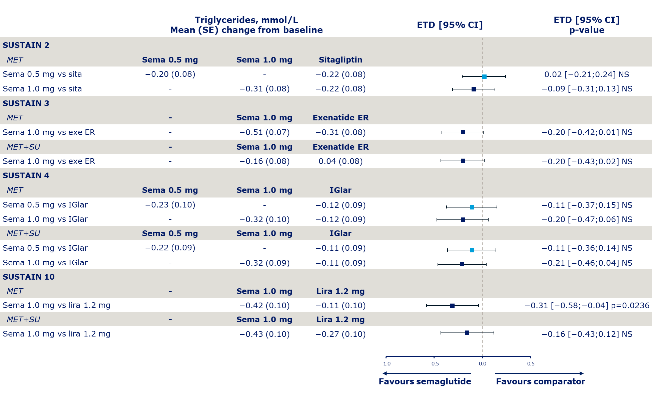
Error bars represent 95% CI. p>0.05 reported as NS.
CI, confidence interval; ETD, estimated treatment difference; exe ER, exenatide extended release; HDL, high-density lipoprotein; IGlar, insulin glargine;
LDL, low-density lipoprotein; lira, liraglutide; MET, metformin; NS, non-significant; SE, standard error; sema, semaglutide; sita, sitagliptin; SU, sulphonylurea.
Supplementary Figure S4. Change in eGFR from baseline to EOT and difference vs comparator by background OAD subgroup
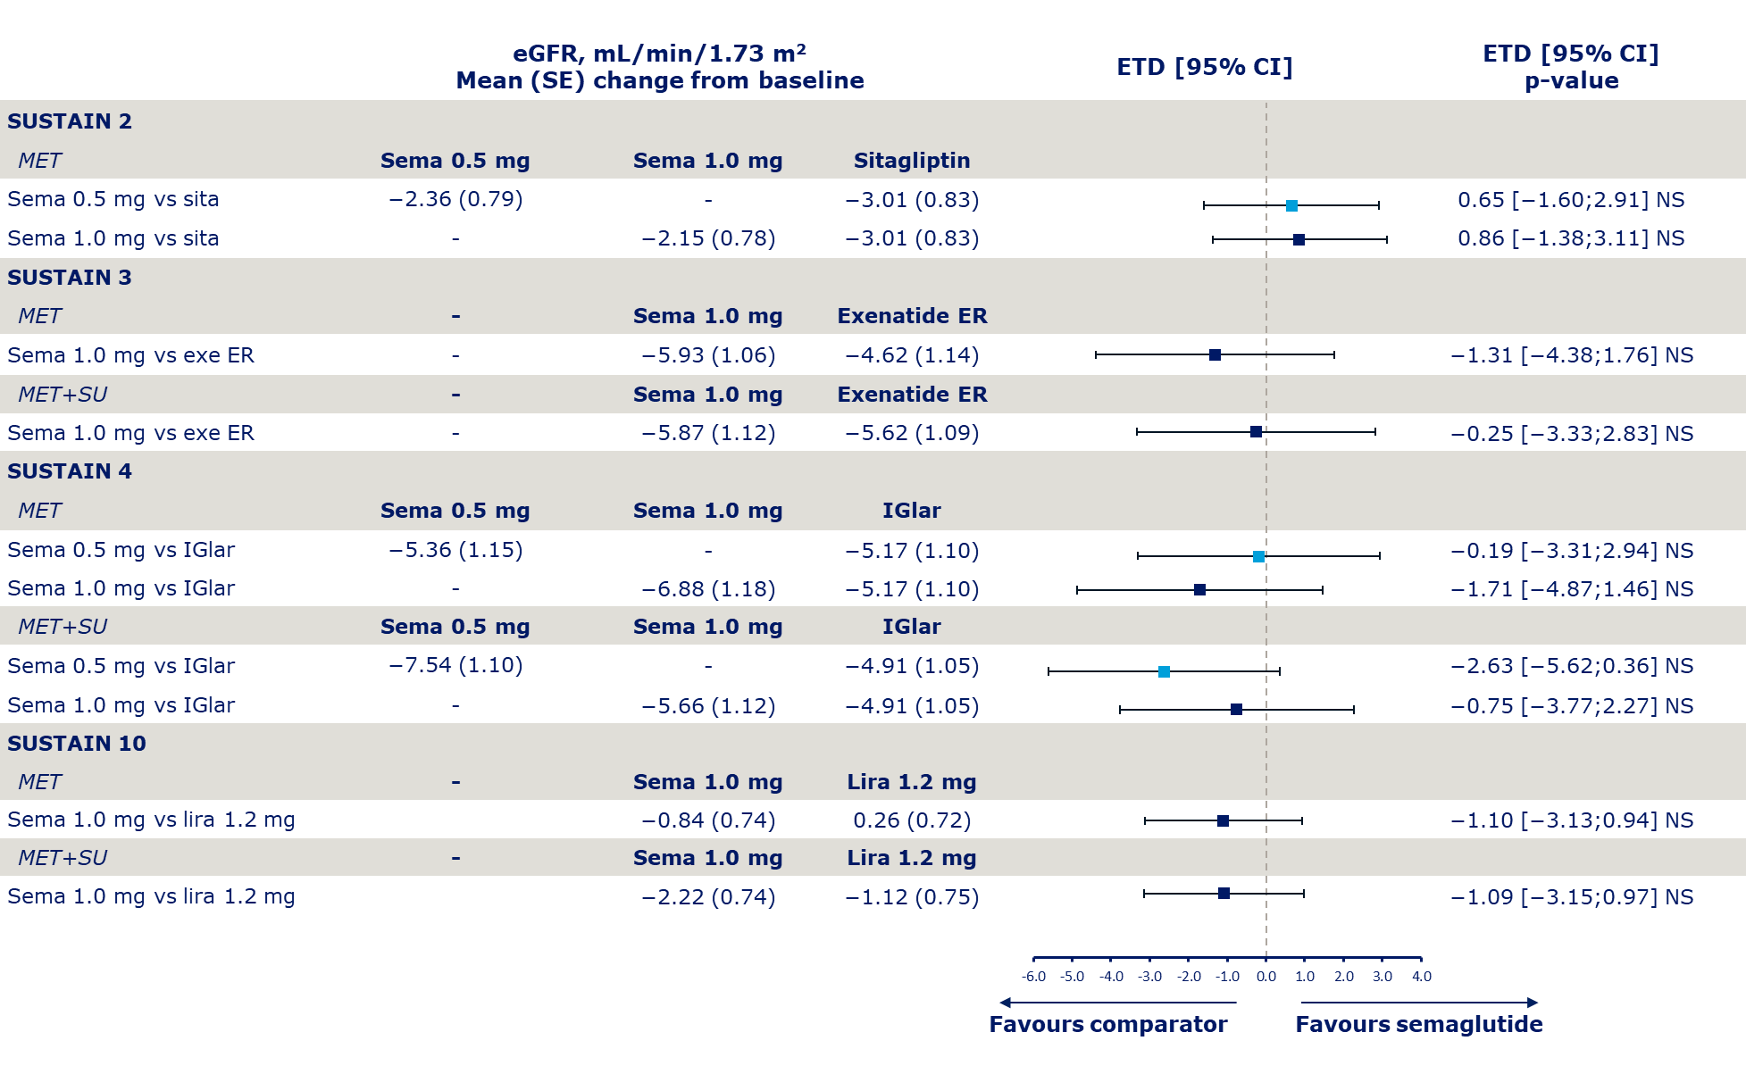
Error bars represent 95% CI. p>0.05 reported as NS.
CI, confidence interval; eGFR, estimated glomerular filtration rate; ETD, estimated treatment difference; exe ER, exenatide extended release; IGlar, insulin glargine; lira, liraglutide; MET, metformin; NS, non-significant; SE, standard error; Sema, semaglutide; sita, sitagliptin; SU, sulphonylurea.

