Supplementary Appendix

Supplementary Methods
Quality assessment of included studies
Network meta-analysis (NMA) model description

Supplementary Tables
Supplementary Table 1. PRISMA checklist
Supplementary Table 2. Search strings used for Embase, MEDLINE and Cochrane databases using OVID® SP platform
Supplementary Table 3. Efficacy outcomes reported for treatment groups of interest in included studies
Supplementary Table 4. Surface Under the Cumulative Ranking Curve (SUCRA) and ranking analysis
Supplementary Table 5. Statistics from the NMA and inconsistency models
Supplementary Table 6. League table presenting pairwise treatment comparisons for mean difference (95% CrI) in change in diastolic blood pressure (mmHg) from baseline
Supplementary Table 7. League table presenting pairwise treatment comparisons in odds ratio (95% CrI) for number of patients meeting HbA1c target (<7%)

Supplementary Figures
Supplementary Figure 1. Quality assessment of included studies
Supplementary Figure 2. Network diagrams of studies evaluating efficacy of antihyperglycemic agents in a) reducing diastolic blood pressure; b) number of patients meeting HbA1c target (<7%)
Supplementary Figure 3. Forest plots for efficacy outcomes in active treatment versus placebo groups a) mean change in diastolic blood pressure from baseline (mmHg; FE), mean difference; b) number of patients meeting HbA1c target (<7%) (RE), odds ratio.
Supplementary Figure 4. Sensitivity analysis excluding PIONEER 2
Supplementary Figure 5. Sensitivity analysis excluding Asian studies
Supplementary Methods

Quality assessment of included studies
Quality assessment was used to provide an assessment of the risk of bias for each study and was not used to exclude eligible studies. Critical appraisal was performed using the Revised Cochrane Risk of Bias Tool for Randomized Trials (RoB2), with the aim to assess assignment to intervention (the ‘intention-to-treat’ effect).

The Excel tool available from the RoB2 website (https://www.riskofbias.info/welcome/rob-2-0-tool/current-version-of-rob-2) was used to implement the assessment. For each study, reviewers rated all signalling questions in 5 domains (randomization process, deviations from the intended interventions, missing outcome data, measurement of outcome, selection of reported results), and the tool algorithm determined the risk of bias for each domain based on the responses to the signalling questions. Level of risk of bias for each domain was rated as low risk of bias, some concerns, or high risk or bias. Overall risk of bias for a study was determined collectively from the ratings across the 5 individual domains. A study would be rated as overall high risk of bias if any domain was considered with high risk of bias, some concerns if any domain presented some concerns of bias, or low risk of bias if all domains were rated as low risk of bias. A summary figure for overall risk of bias was created, with the quality assessment for each domain provided.

Randomization process domain - Reviewers considered the generation of allocation sequence (i.e. method of randomization) to be adequate if study authors state that they used a method resulting in unpredictable sequences (such as computer-generated random numbers; reference to a random number table; coin tossing; shuffling cards or envelopes; throwing dice; or drawing lots), unclear if a trial was stated to be randomized but no further information was provided, and inadequate where allocation could be related to prognosis and therefore introduced selection bias (for example, the date of birth or date of admission to hospital). Reviewers considered allocation concealment to be adequate if the assignment to arms of the study could not be predicted by the investigators or participants, minimization is generally implemented with a random element (at least when the scores are equal), unclear if concealment was not addressed, or inadequate if a method such as alternation was used, where the allocation of participants could be predicted. Reviewers considered there was a problem with the randomization process if there were significant baseline differences between intervention groups.

Blinding process domain – Reviewers considered blinding to be adequate when studies are double-blind and patients/participants, investigator, carers or people delivering the interventions were not aware of the assigned intervention. It must be clear how patients/personnel and outcome assessors were blinded; this may include use of an identical placebo/sham. Unclear blinding would be noted if the methods of blinding were not described adequately, and inadequate blinding would be noted when blinding was not used or where the authors stated that unblinding had occurred. High risk of bias would be attributed in case of open label studies and studies reporting deviations from the blinding process. Risk of bias would be considered higher if there is imbalance of important non-protocol interventions between intervention groups and if the intervention was not implemented as per protocol.

Missing outcome data – Reviewers considered the outcome reporting to be adequate if appropriate study population was used for an analysis of the intention to treat effect. Number of participants with missing outcome data should be sufficiently small so that their outcomes should not make any significant difference to the overall estimated effect of intervention. For continuous outcomes, availability of data from 95% of the participants would be considered sufficient. For dichotomous outcomes, the proportion required is directly linked to the risk of the event. If the observed number of events is much greater than the number of participants with missing outcome data, the bias would be considered small. If no information is provided on the missing outcome data, certain evidence should be reported that results were not biased by missing outcome data.
Low risk of attrition bias would be assumed when trials have no missing outcome data or few drop-outs/ withdrawals, or when detailed (justified) reasons for missing data are provided and an ITT analysis was conducted. Higher risk of bias would be assumed when there are uneven differences in drop-outs/withdrawals between the intervention group and the control group, or if the rate of attrition is higher than 10%. Unclear risk of bias would be assumed when the rate of participants withdrawing or lost from the study and/or attrition is not reported or inadequate details are reported to assess risk of bias.

Measurement of outcome – Reviewers considered the measurement to be adequate if outcome assessors were not aware of the intervention received by study participants. Reviewer also checked if measurement or ascertainment of the outcome have differed between intervention groups. High risk of bias would be attributed if the method of measuring the outcome is inappropriate, for example: (a) it is unlikely to be sensitive to plausible intervention effects (e.g. important ranges of outcome values fall outside levels that are detectable using the measurement method); or (b) the measurement instrument has been demonstrated to have poor validity. Reviewers also checked if assessment of the outcome would have been influenced by knowledge of intervention received. High risk of bias would be assumed if assessment of the outcome was influenced by knowledge of intervention received.

Selection of reported results – Reviewers considered if there is clear evidence (usually through examination of a trial protocol or statistical analysis plan) that a domain was measured in multiple eligible ways, but data for only one or a subset of measures is fully reported (without justification), and the fully reported result is likely to have been selected on the basis of the results. It would be marked as no information if the analysis intentions are not available, or the analysis intentions are not reported in sufficient detail to enable an assessment, and there is more than one way in which the outcome domain could have been measured. It would be marked as high risk of bias if there is clear evidence (usually through examination of a trial protocol or statistical analysis plan) that a measurement was analysed in multiple eligible ways, but data for only one or a subset of analyses is fully reported (without justification), and the fully reported result is likely to have been selected on the basis of the results. To assess reporting bias, where it is not clear as to whether all outcomes are reported, study protocols were sought and consulted.

Overall risk of bias judgement
Low risk of bias - The study is judged to be at low risk of bias for all domains for this result.
Some concerns - The study is judged to raise some concerns in at least one domain for this result, but not to be at high risk of bias for any domain.
High risk of bias - The study is judged to be at high risk of bias in at least one domain for this result.

Network meta-analysis (NMA) model description
Network meta-analysis is a meta-analysis in which multiple treatments (i.e. ≥3) are being compared using both direct comparisons of interventions within randomized controlled trials and indirect comparisons across trials based on a common comparator. It combines data from randomized comparisons, A vs B, A vs C, A vs D, B vs D, and so on, to deliver an internally consistent set of estimates while respecting the randomization in the evidence. Suppose we have a number of multi-arm trials involving the treatments of interest. In a random effects model, each study i provides an estimate of the study-specific treatment effects $δ_{i}$. Under exchangeability assumptions and assuming that the relative effects all have the same between-trial variance we have
$δ_{i}=\left(\begin{matrix}δ_{i,12} \\ ⋮ \\ δ_{i,1a_{i}}\end{matrix}\right)\sim N_{a_{i}-1}\left(\left(\begin{matrix}d_{t_{i1}, { t}_{i2 }} \\ ⋮ \\ d_{t_{i1}, { t}_{ia_{i} }}\end{matrix}\right),\left(\begin{matrix}σ^{2} & {σ^{2}}/2 & \begin{matrix}⋯ & {σ^{2}}/2\end{matrix} \\ ⋮ & ⋮ & \begin{matrix}⋱ & ⋮\end{matrix} \\ {σ^{2}}/2 & {σ^{2}}/2 & \begin{matrix}⋯ & σ^{2}\end{matrix}\end{matrix}\right)\right) \left(1\right)$
where $δ_{i}$ is the vector of random effects, which follows a multivariate normal distribution.$a_{i}$represents the number of arms in trial ${i (a}_{i}= 2,3, ⋯$) and $d_{t_{i1}, { t}_{ik }}=\left(d_{1, { t}_{ik }}₋{ d}_{1, { t}_{i1 }}\right)$. Then the conditional univariate distributions for the random effect of arm k>2, given all arms from 2 to k-1, is
$δ_{i,1k}|\left(\begin{matrix}δ_{i,12} \\ ⋮ \\ δ_{i,1(k-1)}\end{matrix}\right)\sim N\left(\left(d_{1, { t}_{ik }}-d_{1, { t}_{i1 }}\right)+\frac{1}{k-1}\sum_{j=1}^{k-1}{\left[δ_{i,1j}-\left(d_{1, { t}_{ij }}-d_{1, { t}_{i1 }}\right)\right]‚\frac{k}{2\left(k-1\right)}}σ^{2}\right) \left(2\right)$
It follows that the fixed effect model is a special case of this, obtained by setting the variance $σ^{2}$to zero. Either the multivariate distribution in equation (1) or the conditional distributions in equation (2) must be used to estimate the random effects for each multi-arm study so that the between arm correlations between parameters are taken into account. Our code is based on a conditional distribution formulation of the multivariate normal distribution, which takes a Bayesian approach to estimation with Markov chain Monte Carlo (MCMC) simulation.
Supplementary Table 1. PRISMA checklist
Section/topic | # | Checklist item | Reported on page #
TITLE
Title | 1 | Identify the report as a systematic review, meta-analysis, or both. | 1
ABSTRACT
Structured summary | 2 | Provide a structured summary including, as applicable: background; objectives; data sources; study eligibility criteria, participants, and interventions; study appraisal and synthesis methods; results; limitations; conclusions and implications of key findings; systematic review registration number. | 2
INTRODUCTION
Rationale | 3 | Describe the rationale for the review in the context of what is already known. | 4
Objectives | 4 | Provide an explicit statement of questions being addressed with reference to participants, interventions, comparisons, outcomes, and study design (PICOS). | 4-5
METHODS
Protocol and registration | 5 | Indicate if a review protocol exists, if and where it can be accessed (e.g., Web address), and, if available, provide registration information including registration number. | 5
Eligibility criteria | 6 | Specify study characteristics (e.g., PICOS, length of follow-up) and report characteristics (e.g., years considered, language, publication status) used as criteria for eligibility, giving rationale. | 5, 19
Information sources | 7 | Describe all information sources (e.g., databases with dates of coverage, contact with study authors to identify additional studies) in the search and date last searched. | 5
Search | 8 | Present full electronic search strategy for at least one database, including any limits used, such that it could be repeated. | Appendix: 7
Study selection | 9 | State the process for selecting studies (i.e., screening, eligibility, included in systematic review, and, if applicable, included in the meta-analysis). | 5
Data collection process | 10 | Describe method of data extraction from reports (e.g., piloted forms, independently, in duplicate) and any processes for obtaining and confirming data from investigators. | 6
Data items | 11 | List and define all variables for which data were sought (e.g., PICOS, funding sources) and any assumptions and simplifications made. | 6, 19
Risk of bias in individual studies | 12 | Describe methods used for assessing risk of bias of individual studies (including specification of whether this was done at the study or outcome level), and how this information is to be used in any data synthesis. | 6  Appendix: 2-4
Summary measures | 13 | State the principal summary measures (e.g., risk ratio, difference in means). | 6-7
Synthesis of results | 14 | Describe the methods of handling data and combining results of studies, if done, including measures of consistency (e.g., I²) for each meta-analysis. | 6-7  Appendix: 4
Risk of bias across studies | 15 | Specify any assessment of risk of bias that may affect the cumulative evidence (e.g., publication bias, selective reporting within studies). | 6  Appendix: 2-4
Additional analyses | 16 | Describe methods of additional analyses (e.g., sensitivity or subgroup analyses, meta-regression), if done, indicating which were pre-specified. | 7
RESULTS
Study selection | 17 | Give numbers of studies screened, assessed for eligibility, and included in the review, with reasons for exclusions at each stage, ideally with a flow diagram. | 7, Figure 1
Study characteristics | 18 | For each study, present characteristics for which data were extracted (e.g., study size, PICOS, follow-up period) and provide the citations. | 7, 20-22
Risk of bias within studies | 19 | Present data on risk of bias of each study and, if available, any outcome level assessment (see item 12). | 7-8,  Appendix: 15
Results of individual studies | 20 | For all outcomes considered (benefits or harms), present, for each study: (a) simple summary data for each intervention group (b) effect estimates and confidence intervals, ideally with a forest plot. | 7-8,  Appendix: 8-9
Synthesis of results | 21 | Present results of each meta-analysis done, including confidence intervals and measures of consistency. | 8-10, 23-28, Figure 2-3, Appendix:  10-14, 16
Risk of bias across studies | 22 | Present results of any assessment of risk of bias across studies (see Item 15). | 7-8,  Appendix: 15
Additional analysis | 23 | Give results of additional analyses, if done (e.g., sensitivity or subgroup analyses, meta-regression [see Item 16]). | 10,  Appendix:  17-18
DISCUSSION
Summary of evidence | 24 | Summarize the main findings including the strength of evidence for each main outcome; consider their relevance to key groups (e.g., healthcare providers, users, and policy makers). | 10-13
Limitations | 25 | Discuss limitations at study and outcome level (e.g., risk of bias), and at review-level (e.g., incomplete retrieval of identified research, reporting bias). | 12-13
Conclusions | 26 | Provide a general interpretation of the results in the context of other evidence, and implications for future research. | 13
FUNDING
Funding | 27 | Describe sources of funding for the systematic review and other support (e.g., supply of data); role of funders for the systematic review. | 14
From: Moher D, Liberati A, Tetzlaff J, Altman DG, The PRISMA Group (2009). Preferred Reporting Items for Systematic Reviews and Meta-Analyses: The PRISMA Statement. PLoS Med 6(7): e1000097. doi:10.1371/journal.pmed1000097 For more information, visit: www.prisma-statement.org

Supplementary Table 2. Search strings used for Embase, MEDLINE and Cochrane databases using OVID® SP platform
# | Search term | Notes
1 | ((('type ii' or 'type 2') adj3 diabet*) or t2dm).ab,ti. or exp non insulin dependent diabetes mellitus/ or exp Diabetes Mellitus, Type 2/ or ((diabet* and metformin) adj5 ('not controlled' or uncontroll* or inadequate* or fail*)).ab,ti. | Population string – title/abstract/MeSH/Emtree field search
2 | ((metformin and Ertugliflozin) or ((ertu5 or ert-5 or ertu-15 or ertu15) and metformin) or 'ertugliflozin plus metformin' or ('ertugliflozin plus sitagliptin' and metformin)).ab,ti,sh. or (metformin and sitagliptin).ab,sh,ti. | Intervention string - title/abstract/MeSH/Emtree field search
3 | ((canagliflozin or dapagliflozin or empagliflozin or ertugliflozin).sh,ti,ab. or (gliflozin or gliflozins).ab,ti. or ((sglt2 or 'sglt 2' or sglt-2) adj3 (inhibit* or block*)).ab,ti. or exp sodium glucose cotransporter 2 inhibitor/ or exp Sodium-Glucose Transporter 2 Inhibitors/) and metformin.ab,sh,ti. | Comparator string - title/abstract/MeSH/Emtree field search
4 | ((sitagliptin or saxagliptin or linagliptin or alogliptin or vildagliptin).sh,ti,ab. or ((dpp4 or 'dpp 4' or dpp-4) adj3 (inhibit* or block*)).ab,ti. or (gliptin or gliptins).ab,ti. or exp dipeptidyl peptidase IV inhibitor/ or exp Dipeptidyl-Peptidase IV Inhibitors/) and metformin.ab,sh,ti. | Comparator string - title/abstract/MeSH/Emtree field search
5 | semaglutide.sh,ti,ab. | Comparator string - title/abstract/MeSH/Emtree field search
6 | 2 or 3 or 4 or 5 | Intervention / Comparator strings combined
7 | 1 and 6 | Intervention, comparator, and population strings combined
8 | (HbA1c or weight or overweight or 'blood pressure' or hyoptens* or hypertens*).ab,ti,sh. or exp blood pressure/ or exp abnormal blood pressure/ or exp blood pressure control/ or exp hypertension/ or exp hypotension/ | Outcome string – title/abstract/MeSH/Emtree field search
9 | 7 and 8 | Intervention, comparator, and population strings combined + outcome string
10 | 9 and (exp randomized controlled trial/ or randomi*.mp.) | Search narrowed to RCTs
11 | remove duplicates from 10 | deduplicated
12 | 11 not ('case report' or 'case reports' or editorial or news or 'case control' or prospective* or retrospective* or 'real world' or 'claims data').mp. | Undesired study designs excluded
13 | limit 12 to english language | English language journals only

Supplementary Table 3. Efficacy outcomes reported for T2DM patients in included studies
 |  |  | Continuous outcome  mean change from baseline  (24 +/- 2 wk) |  |  |  | Binary outcome  (24 +/- 2 wk)
Study Name | Treatment Name | Sample Size | HbA1c  (%) | Weight (kg) | SBP (mmHg) | DBP (mmHg) | HbA1c <7.0% (%)
Rosenstock 2019 | Dapa5/Saxa5 | 290 | -1.03 | -2.00 | -2.4 | -2.2 | 42.8%
Rosenstock 2019 | Dapa5 | 289 | -0.63 | NR | -1.8 | -1.4 | 21.8%
Rosenstock 2019 | Saxa5 | 291 | -0.69 | -0.40 | -0.8 | -0.4 | 28.5%
Rosenstock 2015 | Dapa10/Saxa5 | 179 | -1.47 | -2.10 | -1.9 | -1.0 | 41.8%
Rosenstock 2015 | Dapa10 | 179 | -1.20 | -2.40 | -3.5 | -1.4 | 23.1%
Rosenstock 2015 | Saxa5 | 176 | -0.88 | 0.00 | 0.3 | -0.4 | 16.6%
Handelsman 2018 | Dapa10/Saxa5 | 232 | -1.41 | -1.86 | NR | NR | 36.6%*
Handelsman 2018 | Sita100 | 229 | -1.07 | -0.51 | NR | NR | 24.2%*
Müller-Wieland 2018 | Dapa10/Saxa5 | 312 | -1.04 | NR | NR | NR | NR
Müller-Wieland 2018 | Dapa10 | 311 | -0.75 | NR | NR | NR | NR
DeFronzo 2015 | Empa10/Lina5 | 135 | -1.08 | -2.60 | NR | NR | 57.8%
DeFronzo 2015 | Empa25/Lina5 | 134 | -1.19 | -2.99 | NR | NR | 61.8%
DeFronzo 2015 | Empa10 | 137 | -0.66 | -2.53 | NR | NR | 28.0%
DeFronzo 2015 | Empa25 | 140 | -0.62 | -3.18 | NR | NR | 32.6%
DeFronzo 2015 | Lina5 | 128 | -0.70 | -0.69 | NR | NR | 36.1%
VERTIS FACTORIAL | Ertu5/Sita100 | 243 | -1.49 | -2.52 | -3.4 | -0.7** | 52.3%
VERTIS FACTORIAL | Ertu15/Sita100 | 244 | -1.52 | -2.94 | -3.7 | -1.3** | 49.2%
VERTIS FACTORIAL | Ertu5 | 250 | -1.02 | -2.69 | -3.9 | -1.1** | 26.4%
VERTIS FACTORIAL | Ertu15 | 248 | -1.08 | -3.74 | -3.7 | -1.0** | 31.9%
VERTIS FACTORIAL | Sita100 | 247 | -1.05 | -0.67 | -0.7 | -0.3** | 32.8%
PIONEER 2 | Sema14 | 411 | -1.30 | -3.80 | -5.0 | -2.0 | 66.8%
PIONEER 2 | Empa25 | 410 | -0.90 | -3.70 | -5.0 | -3.0 | 40.0%
Lavalle-González 2013 | Cana100 | 365 | -0.79 | -3.30 | -3.8 | -2.2 | 45.5%
Lavalle-González 2013 | Cana300 | 360 | -0.94 | -3.60 | -5.1 | -2.1 | 57.8%
Lavalle-González 2013 | Sita100 | 354 | -0.82 | -1.10 | -1.8 | -1.1 | 54.5%
Lavalle-González 2013 | PBO | 181 | -0.17 | -1.10 | 1.5 | 0.3 | 29.8%
Bolinder 2012 | Dapa10 | 89 | -0.39 | -2.96 | -2.7 | -0.7 | NR
Bolinder 2012 | PBO | 91 | -0.10 | -0.88 | 0.1 | 0.3 | NR
Bailey 2010 | Dapa5 | 133 | -0.70 | -3.00 | -4.3 | -2.5 | 35.3%
Bailey 2010 | Dapa10 | 132 | -0.84 | -2.90 | -5.1 | -1.8 | 43.9%
Bailey 2010 | PBO | 134 | -0.30 | -0.90 | -0.2 | -0.1 | 24.6%
Yang 2016 | Dapa5 | 146 | -0.82 | -1.84 | -4.1 | -0.9 | 17.3%
Yang 2016 | Dapa10 | 149 | -0.85 | -2.56 | -2.5 | -0.1 | 32.9%
Yang 2016 | PBO | 139 | -0.23 | -0.74 | 1.8 | 0.8 | 32.9%
Häring 2014 | Empa10 | 217 | -0.70 | -2.08 | -4.5 | -2.0 | 34.6%
Häring 2014 | Empa25 | 213 | -0.77 | -2.46 | -5.2 | -1.6 | 34.7%
Häring 2014 | PBO | 207 | -0.13 | -0.45 | -0.4 | 0.0 | 11.1%
VERTIS ASIA | Ertu5 | 170 | -1.00 | -3.00 | -5.1 | -2.4 | 38.2%
VERTIS ASIA | Ertu15 | 169 | -0.90 | -3.20 | -3.9 | -2.4 | 40.8%
VERTIS ASIA | PBO | 167 | -0.20 | -1.20 | 0.2 | -1.0 | 16.2%
VERTIS MET | Ertu5 | 207 | -0.73 | -3.01 | -4.4 | -1.6 | 35.3%
VERTIS MET | Ertu15 | 205 | -0.91 | -2.93 | -5.2 | -2.2 | 40.0%
VERTIS MET | PBO | 209 | -0.03 | -1.33 | -0.7 | 0.2 | 15.8%
VERTIS SU | Ertu5 | 448 | -0.54* | -2.98* | -2.6* | -1.4* | 34.4%
VERTIS SU | Ertu15 | 440 | -0.63* | -3.20* | -3.3* | -0.7* | 38.0%
Nauck 2009 | Alo25 | 210 | -0.60 | -0.67 | NR | NR | 44.4%
Nauck 2009 | PBO | 104 | -0.10 | -0.39 | NR | NR | 18.3%
Taskinen 2011 | Lina5 | 513 | -0.49 | -0.40 | NR | NR | 26.2%
Taskinen 2011 | PBO | 175 | 0.15 | -0.50 | NR | NR | 9.2%
Wang 2016 | Lina5 | 203 | -0.66 | -0.12 | NR | NR | 40.4%
Wang 2016 | PBO | 97 | -0.14 | -0.67 | NR | NR | 14.4%
DeFronzo 2009 | Saxa2.5 | 186 | -0.59 | -1.43 | -4.3 | -1.3 | 37.1%
DeFronzo 2009 | Saxa5 | 186 | -0.69 | -0.87 | -3.6 | -1.3 | 43.5%
DeFronzo 2009 | PBO | 175 | 0.13 | -0.92 | -4.5 | -2.4 | 16.6%
Yang 2011 | Saxa5 | 275 | -0.78 | -1.05 | -5.2 | -2.3 | 46.5%
Yang 2011 | PBO | 279 | -0.37 | -0.97 | -3.1 | -1.7 | 30.5%
Charbonnel 2006 | Sita100 | 453 | -0.67 | NR | NR | NR | 47.0%
Charbonnel 2006 | PBO | 224 | -0.02 | NR | NR | NR | 18.3%
DURATION-NEO-2 | Sita100 | 122 | -0.78 | -1.07* | NR | NR | NR
DURATION-NEO-2 | PBO | 61 | -0.39 | 0.12* | NR | NR | NR
Raz 2008 | Sita100 | 95 | -1.14* | NR | NR | NR | NR
Raz 2008 | PBO | 92 | 0.02* | NR | NR | NR | NR
Yang 2012 | Sita100 | 191 | -1.02 | 0.00 | NR | NR | 31.4%
Yang 2012 | PBO | 194 | -0.14 | -0.50 | NR | NR | 8.2%
Pan 2012 | Vilda50bid | 145 | -1.05 | -0.70 | NR | NR | 50.3%
Pan 2012 | PBO | 144 | -0.54 | -1.00 | NR | NR | 33.3%

*Values estimated from figures; ** Values obtained from Merck clinical study report
Treatment is presented as intervention name and dosage once per day if not otherwise specified

Alo alogliptin, bid twice a day, Cana canagliflozin, Dapa dapagliflozin, DBP diastolic blood pressure, Empa empagliflozin, Ertu ertugliflozin, FPG fasting plasma glucose, HbA1c glycated hemoglobin, Lina linagliptin, Lira liraglutide, NR not reported, Pbo placebo, Saxa saxagliptin, SBP systolic blood pressure, Sema semaglutide, Sita sitagliptin, Vilda vildagliptin, wk weeks
Supplementary Table 4. Surface Under the Cumulative Ranking Curve (SUCRA) and ranking analysis
 | Efficacy Outcome - NMA model
 | HbA1c*  - RE |  | Weight*  - RE |  | SBP*  - FE |  | DBP*  - FE |  | HbA1c <7%**  - RE
Treatment | SUCRA  (median rank)  rank 22 is the best | SUCRA  (median rank)  rank 22 is the best |  | SUCRA  (median rank)  rank 17 is the best |  | SUCRA  (median rank)  rank 17 is the best |  | SUCRA  (median rank)  rank 1 is the best
Ertu15/Sita100 | 0.05 (21) | 0.21 (18) |  | 0.20 (14) |  | 0.22 (14) |  | 0.82 (5)
Ertu5/Sita100 | 0.07 (21) | 0.37 (14) |  | 0.24 (14) |  | 0.45 (10) |  | 0.86 (4)
Empa25/Lina5 | 0.11 (20) | 0.35 (15) |  | NA |  | NA |  | 0.95 (2)
Empa10/Lina5 | 0.19 (18) | 0.5 (11) |  | NA |  | NA |  | 0.92 (3)
Dapa10/Saxa5 | 0.20 (18) | 0.48 (11) |  | 0.66 (6) |  | 0.69 (5) |  | 0.77 (6)
Sema14 | 0.21 (18) | 0.28 (17) |  | 0.42 (10) |  | 0.73 (5) |  | 0.92 (2)
Dapa5/Saxa5 | 0.31 (16) | 0.52 (10) |  | 0.62 (6) |  | 0.27 (13) |  | 0.48 (12)
Cana300 | 0.36 (15) | 0.14 (20) |  | 0.13 (15) |  | 0.20 (14) |  | 0.55 (10)
Ertu15 | 0.38 (14) | 0.05 (22) |  | 0.14 (15) |  | 0.40 (11) |  | 0.51 (11)
Sita100 | 0.47 (12) | 0.83 (5) |  | 0.68 (6) |  | 0.56 (8) |  | 0.54 (11)
Ertu5 | 0.48 (12) | 0.22 (18) |  | 0.21 (14) |  | 0.22 (14) |  | 0.38 (14)
Cana100 | 0.57 (10) | 0.24 (17) |  | 0.34 (12) |  | 0.17 (15) |  | 0.26 (17)
Lina5 | 0.65 (8) | 0.94 (2) |  | NA |  | NA |  | 0.61 (9)
Empa25 | 0.68 (8) | 0.31 (16) |  | 0.41 (10) |  | 0.46 (9) |  | 0.56 (10)
Dapa10 | 0.68 (8) | 0.33 (15) |  | 0.52 (8) |  | 0.62 (6) |  | 0.20 (18)
Saxa2.5 | 0.70 (7) | 0.75 (7) |  | 0.89 (2) |  | 0.93 (1) |  | 0.21 (18)
Empa10 | 0.71 (7) | 0.51 (11) |  | 0.54 (8) |  | 0.33 (12) |  | 0.50 (11)
Alo25 | 0.77 (4) | 0.79 (6) |  | NA |  | NA |  | 0.50 (11)
Vilda50bid | 0.77 (5) | 0.92 (2) |  | NA |  | NA |  | 0.22 (18)
Saxa5 | 0.80 (5) | 0.89 (3) |  | 0.89 (3) |  | 0.85 (3) |  | 0.19 (18)
Dapa5 | 0.83 (4) | 0.51 (11) |  | 0.64 (6) |  | 0.48 (9) |  | 0.04 (21)
PBO | 1.00 (1) | 0.85 (4) |  | 0.98 (1) |  | 0.90 (2) |  | 0.01 (22)

* For mean changes from baseline in HbA1c, Weight, SBP, and DBP, since the outcome has a negative direction, where reduction indicates more favorable results, the highest rank (rank=22 for HbA1c and weight, or rank=17 for SBP and DBP) represents the best treatment, while rank=1 represents the worst treatment in this analysis. SUCRA values range from 0 to 1. For these outcomes, the lower the SUCRA value, the higher the likelihood that a therapy is in the top rank or is one of the top ranks; the closer to 1 the SUCRA value, the more likely that a therapy is in the bottom rank, or is one of the bottom ranks.
** Since the outcome for HbA1c within target (<7%) has a positive direction, where higher proportion of patients meeting HbA1c target indicates more favorable results, rank=1 represents the best treatment, while rank=22 represents the worst treatment in this analysis. Similarly, the higher the SUCRA value, the higher the likelihood that a therapy is in the top rank or is one of the top ranks; the closer to 0 the SUCRA value, the more likely that a therapy is in the bottom rank, or is one of the bottom ranks.

Alo alogliptin, bid twice a day, Cana canagliflozin, Dapa dapagliflozin, DBP diastolic blood pressure, Empa empagliflozin, Ertu ertugliflozin, FE fixed effects model, HbA1c Glycated hemoglobin, Lina linagliptin, Lira liraglutide, NA not applicable, NMA network meta-analysis, Pbo placebo, RE random effects model, Saxa saxagliptin, SBP diastolic blood pressure, Sema semaglutide, Sita sitagliptin, Vilda vildagliptin
Supplementary Table 5. Statistics from the NMA and inconsistency models
Outcomes | Model selected in base case NMA | Mean resdev |  |  | pD |  |  | DIC
Outcomes | Model selected in base case NMA | NMA | Inconsistency model | diff | NMA | Inconsistency model | diff | NMA | Inconsistency model | diff*
HbA1c | RE | 71.0 | 68.8 | (2.2) | 57.8 | 71.2 | (-13.3) | -109.4 | -98.3 | (-11.1)
Weight | RE | 54.1 | 54.0 | (0.1) | 47.7 | 53.7 | (-6.0) | 39.7 | 45.5 | (-5.9)
SBP | FE | 35.8 | 32.6 | (3.1) | 28.0 | 28.2 | (-0.2) | 118.2 | 115.2 | (3.0)
DBP | FE | 31.4 | 31.4 | (0.0) | 28.0 | 29.2 | (-1.2) | 81.7 | 82.9 | (-1.2)
HbA1c <7% | RE | 63.2 | 59.5 | (3.7) | 49.6 | 59.0 | (-9.4) | 435.5 | 441.2 | (-5.7)
*Numbers in bold indicate statistically meaningful difference in DIC (difference of >=3 in DIC values between NMA and inconsistency models)

DBP diastolic blood pressure, diff difference, DIC Deviance Information Criterion, FE fixed effects model, HbA1c glycated hemoglobin, NMA network meta-analysis, pD effective number of parameters, RE random effects model, resdev residual deviance, SBP diastolic blood pressure

Supplementary Table 6. League table presenting pairwise treatment comparisons for mean difference (95% CrI) in change in diastolic blood pressure (mmHg) from baseline
Cana100 | Cana300 | Dapa10 | Dapa10/Saxa5 | Dapa5 | Dapa5/Saxa5 | Empa10 | Empa25 | Ertu15 | Ertu15/Sita100 | Ertu5 | Ertu5/Sita100 | PBO | Saxa2.5 | Saxa5 | Sema14 | Sita100
Cana100 | -0.11  (-1.21, 1.00) | -1.44  (-3.06, 0.20) | -1.76  (-3.88, 0.36) | -1.01  (-2.66, 0.67) | -0.35  (-2.19, 1.54) | -0.53  (-2.38, 1.32) | -0.93  (-2.76, 0.93) | -0.64  (-2.19, 0.92) | -0.16  (-1.78, 1.50) | -0.19  (-1.74, 1.38) | -0.81  (-2.45, 0.83) | -2.53  (-3.76,-1.29) | -3.05  (-5.24,-0.87) | -2.31  (-3.91,-0.67) | -1.93  (-4.18, 0.34) | -1.12  (-2.23, 0.00)
 | Cana300 | -1.33  (-2.98, 0.32) | -1.64  (-3.78, 0.48) | -0.90  (-2.56, 0.79) | -0.24  (-2.10, 1.65) | -0.42  (-2.27, 1.44) | -0.83  (-2.69, 1.05) | -0.53  (-2.10, 1.03) | -0.05  (-1.70, 1.60) | -0.08  (-1.65, 1.49) | -0.70  (-2.36, 0.95) | -2.42  (-3.66,-1.15) | -2.94  (-5.13,-0.77) | -2.20  (-3.83,-0.56) | -1.82  (-4.08, 0.46) | -1.01  (-2.12, 0.11)
 |  | Dapa10 | -0.32  (-1.93, 1.30) | 0.43  (-0.74, 1.60) | 1.10  (-0.35, 2.54) | 0.91  (-0.83, 2.67) | 0.51  (-1.25, 2.26) | 0.80  (-1.18, 2.78) | 1.28  (-0.77, 3.32) | 1.25  (-0.75, 3.23) | 0.63  (-1.43, 2.67) | -1.09  (-2.17,-0.02) | -1.61  (-3.59, 0.35) | -0.87  (-1.99, 0.25) | -0.49  (-2.68, 1.70) | 0.32  (-1.34, 1.96)
 |  |  | Dapa10/ Saxa5 | 0.75  (-0.96, 2.47) | 1.41  (-0.44, 3.27) | 1.24  (-0.99, 3.46) | 0.83  (-1.40, 3.06) | 1.12  (-1.28, 3.54) | 1.60  (-0.86, 4.05) | 1.57  (-0.85, 3.99) | 0.95  (-1.50, 3.41) | -0.76  (-2.49, 0.96) | -1.30  (-3.62, 1.03) | -0.54  (-2.10, 0.99) | -0.16  (-2.75, 2.41) | 0.64  (-1.49, 2.77)
 |  |  |  | Dapa5 | 0.66  (-0.45, 1.78) | 0.48  (-1.31, 2.27) | 0.07  (-1.71, 1.87) | 0.36  (-1.65, 2.38) | 0.85  (-1.21, 2.90) | 0.82  (-1.21, 2.83) | 0.19  (-1.88, 2.27) | -1.52  (-2.65,-0.39) | -2.04  (-4.00,-0.10) | -1.30  (-2.26,-0.34) | -0.92  (-3.15, 1.28) | -0.11  (-1.80, 1.56)
 |  |  |  |  | Dapa5/ Saxa5 | -0.19  (-2.17, 1.80) | -0.58  (-2.57, 1.37) | -0.31  (-2.48, 1.88) | 0.18  (-2.03, 2.41) | 0.15  (-2.02, 2.32) | -0.48  (-2.70, 1.76) | -2.18  (-3.59,-0.79) | -2.70  (-4.79,-0.62) | -1.96  (-3.08,-0.85) | -1.58  (-3.95, 0.77) | -0.77  (-2.67, 1.09)
 |  |  |  |  |  | Empa10 | -0.40  (-1.77, 0.99) | -0.11  (-2.28, 2.06) | 0.37  (-1.84, 2.59) | 0.34  (-1.82, 2.50) | -0.28  (-2.52, 1.95) | -2.00  (-3.38,-0.62) | -2.52  (-4.78,-0.27) | -1.78  (-3.55,-0.03) | -1.40  (-3.31, 0.48) | -0.58  (-2.46, 1.28)
 |  |  |  |  |  |  | Empa25 | 0.29  (-1.89, 2.46) | 0.77  (-1.47, 2.99) | 0.75  (-1.46, 2.90) | 0.12  (-2.13, 2.34) | -1.60  (-2.98,-0.21) | -2.12  (-4.39, 0.12) | -1.38  (-3.13, 0.38) | -1.00  (-2.30, 0.31) | -0.18  (-2.07, 1.67)
 |  |  |  |  |  |  |  | Ertu15 | 0.48  (-0.62, 1.60) | 0.45  (-0.27, 1.18) | -0.17  (-1.27, 0.94) | -1.89  (-3.56,-0.21) | -2.41  (-4.84, 0.05) | -1.67  (-3.65, 0.33) | -1.29  (-3.82, 1.25) | -0.48  (-1.58, 0.63)
 |  |  |  |  |  |  |  |  | Ertu15/ Sita100 | -0.03  (-1.13, 1.07) | -0.65  (-1.86, 0.55) | -2.37  (-4.11,-0.62) | -2.89  (-5.39,-0.39) | -2.15  (-4.20,-0.10) | -1.78  (-4.34, 0.81) | -0.96  (-2.17, 0.25)
 |  |  |  |  |  |  |  |  |  | Ertu5 | -0.62  (-1.73, 0.48) | -2.34  (-4.02,-0.66) | -2.85  (-5.31,-0.41) | -2.12  (-4.11,-0.11) | -1.75  (-4.27, 0.83) | -0.93  (-2.04, 0.18)
 |  |  |  |  |  |  |  |  |  |  | Ertu5/ Sita100 | -1.72  (-3.47, 0.04) | -2.24  (-4.73, 0.26) | -1.49  (-3.56, 0.56) | -1.12  (-3.68, 1.48) | -0.31  (-1.52, 0.92)
 |  |  |  |  |  |  |  |  |  |  |  | PBO | -0.52  (-2.31, 1.26) | 0.22  (-0.85, 1.28) | 0.60  (-1.30, 2.49) | 1.41  (0.14, 2.65)
 |  |  |  |  |  |  |  |  |  |  |  |  | Saxa2.5 | 0.74  (-1.07, 2.56) | 1.12  (-1.49, 3.72) | 1.93  (-0.26, 4.11)
 |  |  |  |  |  |  |  |  |  |  |  |  |  | Saxa5 | 0.38  (-1.82, 2.54) | 1.19  (-0.47, 2.82)
 |  |  |  |  |  |  |  |  |  |  |  |  |  |  | Sema14 | 0.82  (-1.47, 3.07)
 |  |  |  |  |  |  |  |  |  |  |  |  |  |  |  | Sita100
The results presented in the table correspond to pairwise comparison of the treatment in the row vs the treatment in the column. Posterior median of mean difference is presented with 95% credible interval. For difference in mean change from baseline, lower values (<0) indicate more favorable results. For example, the mean difference for Cana100 vs. placebo is -2.53, indicating Cana100 had a 2.53 mmHg greater reduction in diastolic blood pressure than placebo. Credible intervals not including 0 indicate statistically significant difference, which are highlighted in orange in the table.
Cana canagliflozin, Dapa dapagliflozin, Empa empagliflozin, Ertu ertugliflozin, Lina linagliptin, Lira liraglutide, N/A not applicable, Pbo placebo, Saxa saxagliptin, Sema semaglutide, Sita sitagliptin
Supplementary Table 7. League table presenting pairwise treatment comparisons in odds ratio (95% CrI) for number of patients meeting HbA1c target (<7%)
Alo25 | Cana100 | Cana300 | Dapa10 | Dapa10/  Saxa5 | Dapa5 | Dapa5/  Saxa5 | Empa10 | Empa10/  Lina5 | Empa25 | Empa25/  Lina5 | Ertu15 | Ertu15/  Sita100 | Ertu5 | Ertu5/  Sita100 | Lina5 | PBO | Saxa2.5 | Saxa5 | Sema14 | Sita100 | Vilda50bid
Alo25 | 1.54  (0.64, 3.70) | 0.94  (0.39, 2.24) | 1.76  (0.76, 4.00) | 0.57  (0.24, 1.35) | 3.15  (1.38, 7.22) | 1.05  (0.41, 2.64) | 1.00  (0.41, 2.52) | 0.32  (0.11, 0.86) | 0.91  (0.37, 2.29) | 0.27  (0.10, 0.74) | 1.01  (0.44, 2.27) | 0.48  (0.19, 1.16) | 1.22  (0.53, 2.72) | 0.42  (0.17, 1.03) | 0.84  (0.35, 2.02) | 3.58  (1.72, 7.46) | 1.75  (0.69, 4.43) | 1.76  (0.79, 3.94) | 0.30  (0.10, 0.86) | 0.97  (0.44, 2.10) | 1.76  (0.66, 4.59)
 | Cana100 | 0.61  (0.35, 1.04) | 1.14  (0.60, 2.09) | 0.37  (0.19, 0.70) | 2.04  (1.08, 3.90) | 0.68  (0.32, 1.45) | 0.65  (0.31, 1.35) | 0.20  (0.09, 0.48) | 0.59  (0.28, 1.23) | 0.17  (0.07, 0.40) | 0.66  (0.36, 1.18) | 0.31  (0.15, 0.61) | 0.79  (0.43, 1.42) | 0.27  (0.13, 0.54) | 0.55  (0.27, 1.07) | 2.32  (1.38, 3.83) | 1.14  (0.52, 2.40) | 1.14  (0.62, 2.06) | 0.20  (0.08, 0.49) | 0.63  (0.37, 1.02) | 1.14  (0.49, 2.59)
 |  | Cana300 | 1.87  (0.99, 3.50) | 0.61  (0.31, 1.15) | 3.36  (1.78, 6.44) | 1.11  (0.52, 2.43) | 1.07  (0.51, 2.23) | 0.34  (0.14, 0.79) | 0.97  (0.46, 2.04) | 0.28  (0.12, 0.67) | 1.08  (0.59, 1.94) | 0.51  (0.25, 1.01) | 1.30  (0.71, 2.34) | 0.45  (0.22, 0.90) | 0.90  (0.45, 1.76) | 3.82  (2.28, 6.36) | 1.88  (0.86, 3.97) | 1.88  (1.02, 3.40) | 0.32  (0.13, 0.80) | 1.03  (0.62, 1.68) | 1.86  (0.82, 4.25)
 |  |  | Dapa10 | 0.32  (0.20, 0.53) | 1.79  (1.19, 2.78) | 0.59  (0.32, 1.12) | 0.57  (0.30, 1.12) | 0.18  (0.08, 0.40) | 0.52  (0.27, 1.01) | 0.15  (0.07, 0.34) | 0.58  (0.34, 0.98) | 0.27  (0.14, 0.52) | 0.69  (0.41, 1.17) | 0.24  (0.12, 0.46) | 0.48  (0.26, 0.87) | 2.04  (1.39, 3.02) | 1.00  (0.52, 1.92) | 1.00  (0.66, 1.53) | 0.17  (0.07, 0.41) | 0.55  (0.35, 0.87) | 1.00  (0.47, 2.15)
 |  |  |  | Dapa10/ Saxa5 | 5.55  (3.25, 9.77) | 1.83  (0.94, 3.72) | 1.75  (0.87, 3.63) | 0.55  (0.24, 1.27) | 1.61  (0.79, 3.29) | 0.47  (0.20, 1.08) | 1.78  (1.01, 3.12) | 0.84  (0.42, 1.64) | 2.15  (1.22, 3.76) | 0.74  (0.37, 1.45) | 1.48  (0.78, 2.86) | 6.30  (3.97,10.08) | 3.10  (1.53, 6.18) | 3.10  (1.92, 5.05) | 0.53  (0.22, 1.29) | 1.70  (1.07, 2.69) | 3.08  (1.40, 6.94)
 |  |  |  |  | Dapa5 | 0.33  (0.19, 0.56) | 0.32  (0.16, 0.62) | 0.10  (0.04, 0.22) | 0.29  (0.15, 0.56) | 0.08  (0.04, 0.19) | 0.32  (0.18, 0.55) | 0.15  (0.08, 0.29) | 0.39  (0.22, 0.65) | 0.13  (0.07, 0.26) | 0.27  (0.14, 0.48) | 1.14  (0.75, 1.68) | 0.56  (0.28, 1.05) | 0.56  (0.36, 0.83) | 0.10  (0.04, 0.22) | 0.31  (0.19, 0.49) | 0.56  (0.26, 1.18)
 |  |  |  |  |  | Dapa5/ Saxa5 | 0.96  (0.43, 2.11) | 0.30  (0.12, 0.74) | 0.88  (0.40, 1.91) | 0.26  (0.10, 0.62) | 0.97  (0.48, 1.89) | 0.46  (0.20, 0.99) | 1.17  (0.58, 2.27) | 0.40  (0.18, 0.87) | 0.81  (0.38, 1.67) | 3.43  (1.90, 6.07) | 1.69  (0.77, 3.52) | 1.69  (0.98, 2.84) | 0.29  (0.11, 0.74) | 0.93  (0.48, 1.72) | 1.68  (0.70, 3.98)
 |  |  |  |  |  |  | Empa10 | 0.31  (0.17, 0.58) | 0.91  (0.58, 1.43) | 0.27  (0.14, 0.49) | 1.01  (0.52, 1.94) | 0.47  (0.22, 1.00) | 1.21  (0.63, 2.32) | 0.42  (0.19, 0.90) | 0.84  (0.49, 1.43) | 3.58  (2.09, 6.09) | 1.76  (0.79, 3.82) | 1.75  (0.94, 3.30) | 0.30  (0.15, 0.61) | 0.97  (0.52, 1.77) | 1.75  (0.76, 4.04)
 |  |  |  |  |  |  |  | Empa10/ Lina5 | 2.90  (1.57, 5.34) | 0.85  (0.43, 1.65) | 3.19  (1.46, 7.06) | 1.50  (0.62, 3.66) | 3.85  (1.74, 8.49) | 1.33  (0.55, 3.22) | 2.66  (1.42, 5.08) | 11.32  (5.71,22.67) | 5.58 (2.24,13.46) | 5.57 (2.59,11.94) | 0.96  (0.42, 2.16) | 3.06  (1.44, 6.46) | 5.54  (2.18,14.28)
 |  |  |  |  |  |  |  |  | Empa25 | 0.29  (0.16, 0.54) | 1.10  (0.58, 2.11) | 0.52  (0.24, 1.11) | 1.33  (0.69, 2.54) | 0.46  (0.21, 0.99) | 0.92  (0.54, 1.56) | 3.91  (2.30, 6.66) | 1.92  (0.87, 4.17) | 1.92  (1.02, 3.59) | 0.33  (0.19, 0.57) | 1.06  (0.57, 1.94) | 1.92  (0.83, 4.43)
 |  |  |  |  |  |  |  |  |  | Empa25/ Lina5 | 3.79  (1.71, 8.31) | 1.77  (0.73, 4.30) | 4.56 (2.08,10.02) | 1.57  (0.65, 3.83) | 3.16  (1.66, 6.05) | 13.43  (6.74,27.02) | 6.60 (2.62,16.20) | 6.60 (3.06,14.26) | 1.13  (0.50, 2.57) | 3.63  (1.70, 7.72) | 6.57  (2.57,17.06)
 |  |  |  |  |  |  |  |  |  |  | Ertu15 | 0.47  (0.28, 0.78) | 1.20  (0.90, 1.61) | 0.42  (0.25, 0.69) | 0.83  (0.46, 1.51) | 3.54  (2.45, 5.17) | 1.74  (0.88, 3.41) | 1.74  (1.06, 2.86) | 0.30  (0.13, 0.70) | 0.96  (0.64, 1.41) | 1.73  (0.83, 3.67)
 |  |  |  |  |  |  |  |  |  |  |  | Ertu15/ Sita100 | 2.56  (1.54, 4.26) | 0.89  (0.50, 1.56) | 1.78  (0.87, 3.64) | 7.54  (4.38,13.04) | 3.71  (1.66, 8.16) | 3.70  (1.97, 6.98) | 0.64  (0.25, 1.63) | 2.04  (1.19, 3.44) | 3.69  (1.60, 8.61)
 |  |  |  |  |  |  |  |  |  |  |  |  | Ertu5 | 0.35  (0.21, 0.57) | 0.69  (0.38, 1.25) | 2.94  (2.04, 4.28) | 1.45  (0.73, 2.84) | 1.44  (0.89, 2.38) | 0.25  (0.11, 0.58) | 0.80  (0.53, 1.18) | 1.44  (0.69, 3.06)
 |  |  |  |  |  |  |  |  |  |  |  |  |  | Ertu5/ Sita100 | 2.01  (0.97, 4.09) | 8.51  (4.94,14.89) | 4.19  (1.88, 9.24) | 4.18  (2.23, 7.95) | 0.72  (0.28, 1.86) | 2.30  (1.35, 3.92) | 4.16  (1.80, 9.88)
 |  |  |  |  |  |  |  |  |  |  |  |  |  |  | Lina5 | 4.24  (2.71, 6.74) | 2.08  (0.99, 4.33) | 2.08  (1.19, 3.71) | 0.36  (0.17, 0.76) | 1.15  (0.66, 1.98) | 2.08  (0.94, 4.58)
 |  |  |  |  |  |  |  |  |  |  |  |  |  |  |  | PBO | 0.49  (0.27, 0.87) | 0.49  (0.35, 0.69) | 0.08  (0.04, 0.18) | 0.27  (0.20, 0.36) | 0.49  (0.26, 0.93)
 |  |  |  |  |  |  |  |  |  |  |  |  |  |  |  |  | Saxa2.5 | 1.00  (0.58, 1.77) | 0.17  (0.07, 0.45) | 0.55  (0.29, 1.04) | 1.00  (0.42, 2.43)
 |  |  |  |  |  |  |  |  |  |  |  |  |  |  |  |  |  | Saxa5 | 0.17  (0.08, 0.39) | 0.55  (0.36, 0.84) | 1.00  (0.48, 2.08)
 |  |  |  |  |  |  |  |  |  |  |  |  |  |  |  |  |  |  | Sema14 | 3.20  (1.41, 7.19) | 5.81 (2.15,15.64)
 |  |  |  |  |  |  |  |  |  |  |  |  |  |  |  |  |  |  |  | Sita100 | 1.81  (0.89, 3.74)
 |  |  |  |  |  |  |  |  |  |  |  |  |  |  |  |  |  |  |  |  | Vilda50bid
The results presented in the table correspond to pairwise comparison of the treatment in the row vs the treatment in the column. Posterior median of odds ratio is presented with 95% credible interval. For odds ratio of number of patients meeting HbA1c target (<7%), higher values (>1) indicate more favorable results. For example, the odds ratio for Alo25 vs. placebo is 3.58, indicating Alo25 had higher odds of meeting HbA1c target than placebo. Credible intervals not including 1 indicate statistically significant difference, which are highlighted in orange in the table.
Alo alogliptin, bid twice a day, Cana canagliflozin, Dapa dapagliflozin, Empa empagliflozin, Ertu ertugliflozin, HbA1c Glycated hemoglobin, Lina linagliptin, Lira liraglutide, N/A not applicable, Pbo placebo, Saxa saxagliptin, Sema semaglutide, Sita sitagliptin, Vilda vildagliptin

Supplementary Figure 1. Quality assessment of included studies

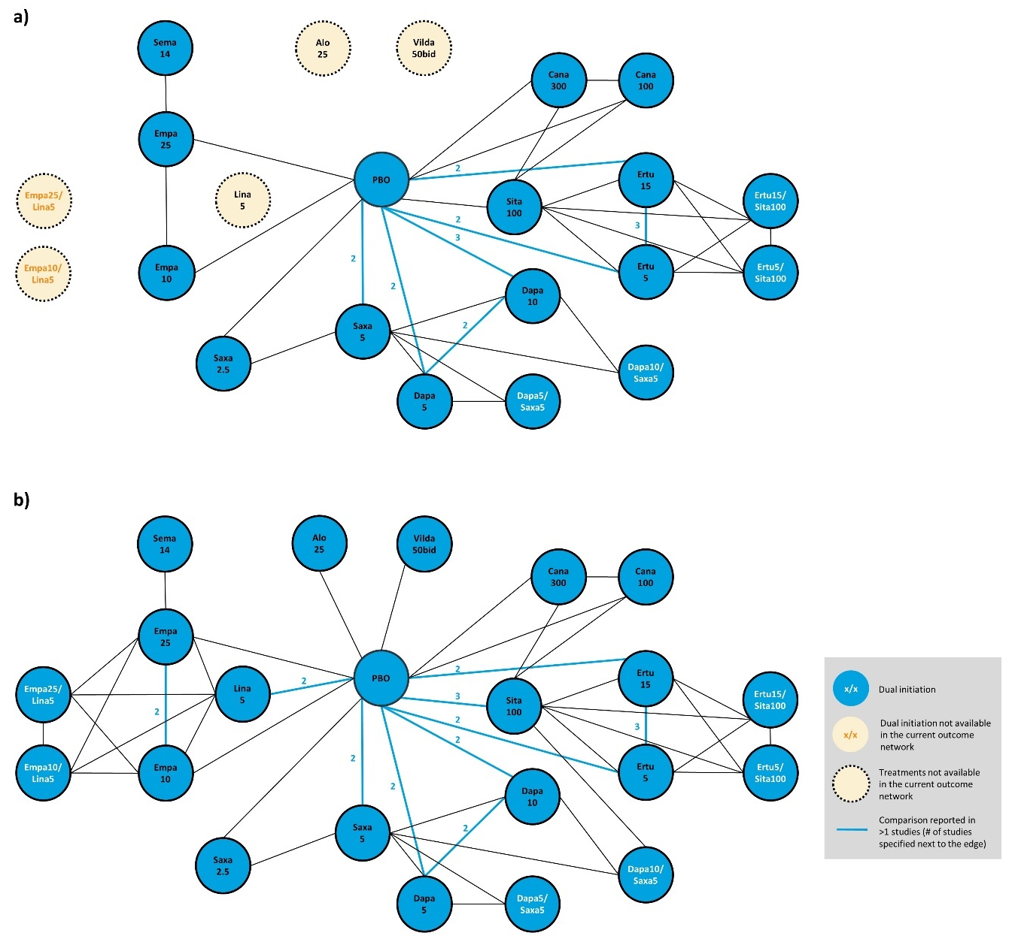
Supplementary Figure 2. Network diagrams of studies evaluating efficacy of antihyperglycemic agents in a) reducing diastolic blood pressure; b) number of patients meeting HbA1c target (<7%)
Treatments dosages are presented as mg per day if not otherwise specified.
All patients received metformin as background therapy.
Only oral dosages approved in US/EU were included in the network meta-analysis. Vilda is only approved in the EU, at 50 mg twice a day (bid). Vilda is not approved in the US.

Alo alogliptin, bid twice a day, Cana canagliflozin, Dapa dapagliflozin, Empa empagliflozin, Ertu ertugliflozin, EU, Europe, Exen exenatide, Glim glimepiride, Lina linagliptin, Lira liraglutide, PBO placebo, Saxa saxagliptin, Sema semaglutide, Sita sitagliptin, US United States, Vilda vildagliptin

a)
b)

Supplementary Figure 3. Forest plots for efficacy outcomes in active treatment versus placebo groups a) mean change in diastolic blood pressure from baseline (mmHg; FE), mean difference; b) number of patients meeting HbA1c target (<7%), (RE), odds ratio.
For difference in mean change from baseline, lower values (<0) indicate more favorable results. Credible intervals not including 0 indicate statistically significant difference, which are highlighted in blue in the figure. For odds ratio of number of patients meeting HbA1c target (<7%), higher values (>1) indicate more favorable results. Credible intervals not including 1 indicate statistically significant difference, which are highlighted in orange in the table.
Alo alogliptin, bid twice a day, Cana canagliflozin, CrI Credible interval, Dapa dapagliflozin, Dt mean difference between treatments, Empa empagliflozin, Ertu ertugliflozin, FE fixed effects model, HbA1c Glycated hemoglobin, Lina linagliptin, Lira liraglutide, OR odds ratio, Pbo placebo, RE random effects model, Saxa saxagliptin, Sema semaglutide, Sita sitagliptin, Vilda vildagliptin

a) | 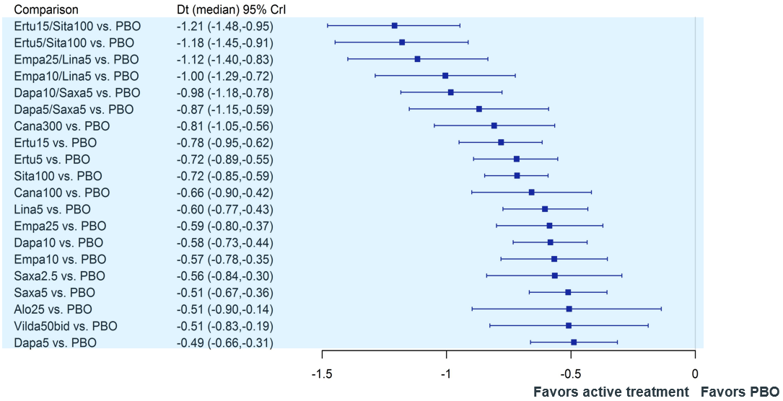 | b) | 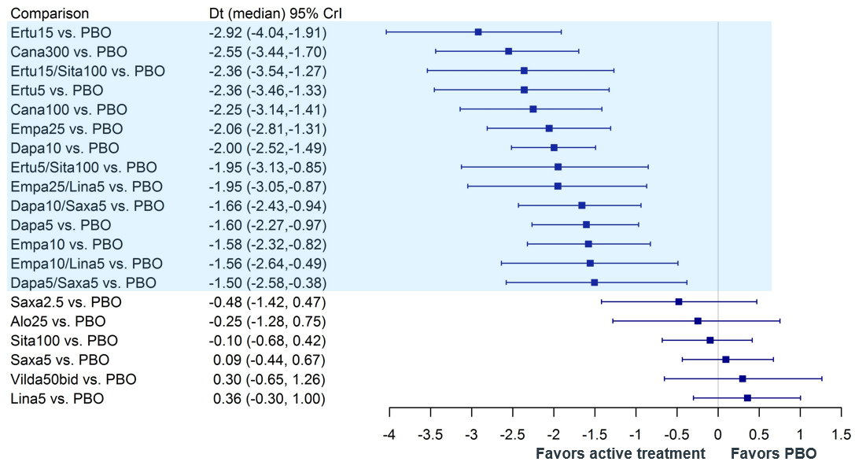
c) | 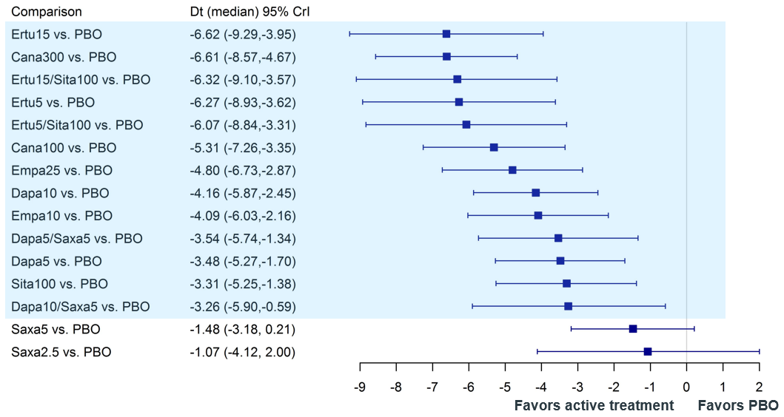 | d) | 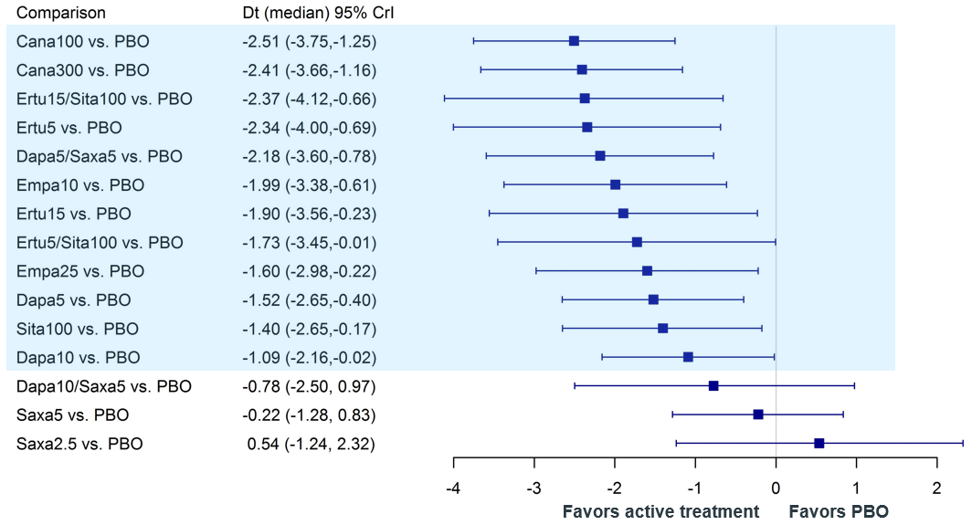
e) | 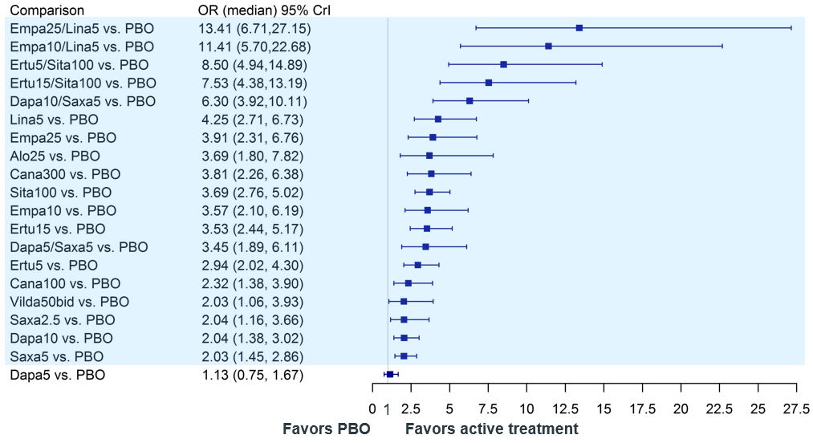

Supplementary Figure 4. Sensitivity analysis excluding PIONEER 2. Forest plots for T2DM patients for efficacy outcomes in active treatment versus placebo groups: a) mean change in HbA1c from baseline (%; RE); b) mean change in weight from baseline (kg; RE); c) mean change in systolic blood pressure from baseline (mmHg; FE); d) mean change in diastolic blood pressure from baseline (mmHg; FE); e) patients meeting HbA1c target (<7%), (RE)
For difference in mean change from baseline, lower values (<0) indicate more favorable results. Credible intervals not including 0 indicate statistically significant difference, which are highlighted in blue in the figure. For odds ratio of number of patients meeting HbA1c target (<7%), higher values (>1) indicate more favorable results. Credible intervals not including 1 indicate statistically significant difference, which are highlighted in orange in the table.
Alo alogliptin, bid twice a day, Cana canagliflozin, CrI Credible interval, Dapa dapagliflozin, Dt, mean difference between treatments, Empa empagliflozin, Ertu ertugliflozin, FE fixed effects model, HbA1c Glycated hemoglobin, Lina linagliptin, Lira liraglutide, OR odds ratio, Pbo placebo, RE random effects model, Saxa saxagliptin, Sema semaglutide, Sita sitagliptin, Vilda vildagliptin

a) | 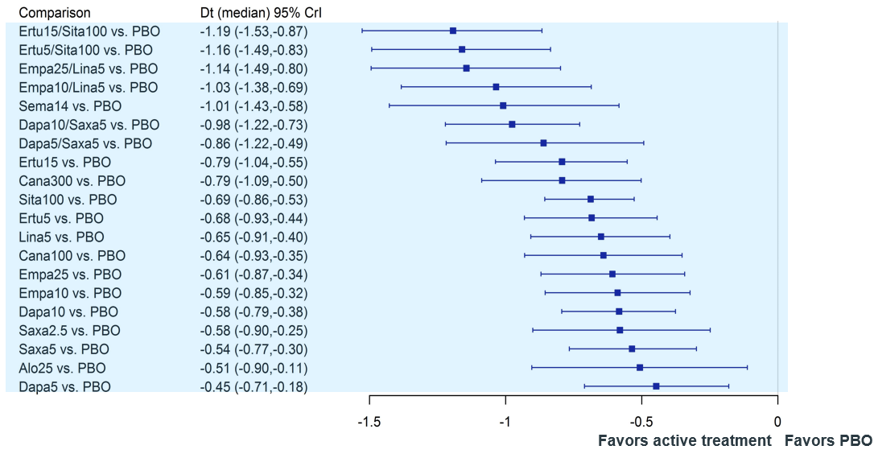 | b) | 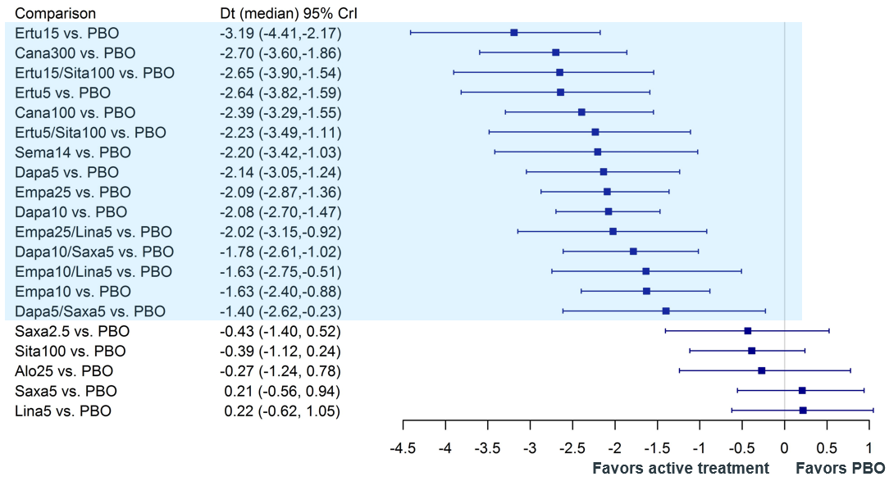
c) | 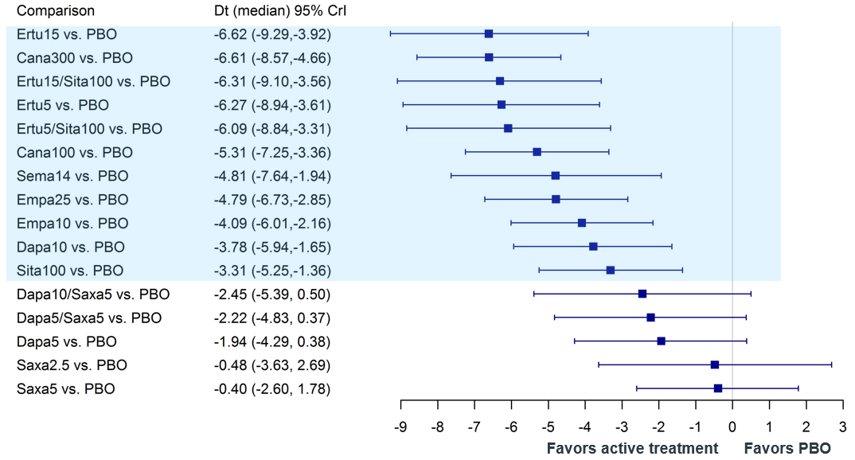 | d) | 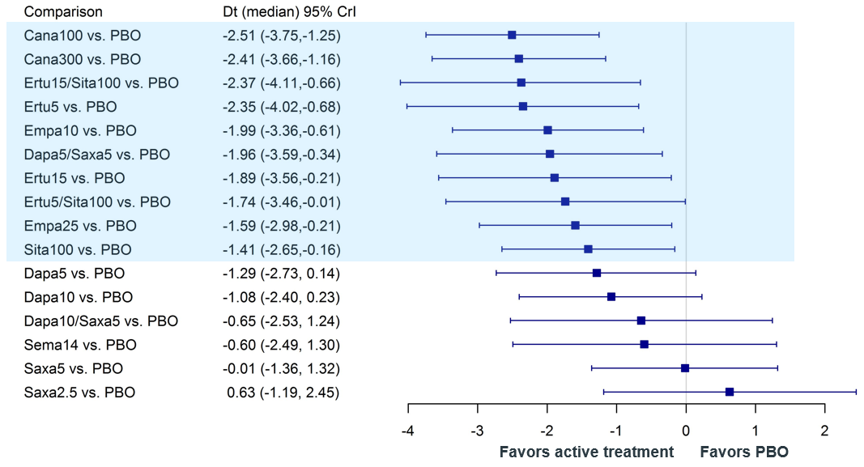
e) | 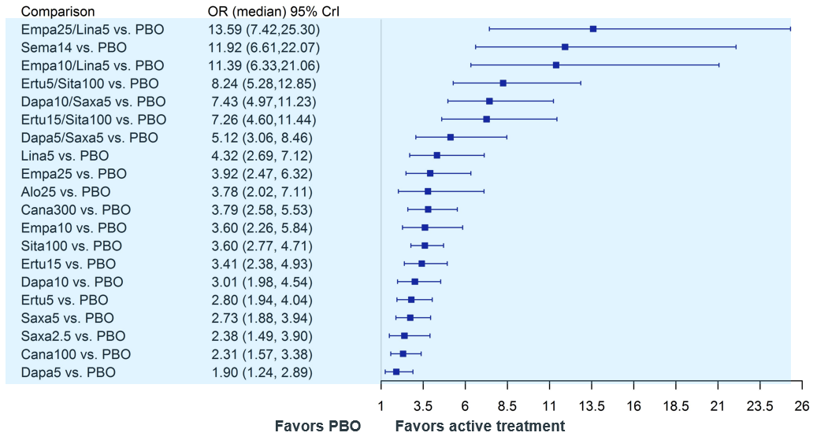

Supplementary Figure 5. Sensitivity analysis excluding Asian studies. Forest plots for T2DM patients for efficacy outcomes in active treatment versus placebo groups: a) mean change in HbA1c from baseline (%; RE); b) mean change in weight from baseline (kg; RE); c) mean change in systolic blood pressure from baseline (mmHg; FE); d) mean change in diastolic blood pressure from baseline (mmHg; FE); e) patients meeting HbA1c target (<7%), (RE)
For difference in mean change from baseline, lower values (<0) indicate more favorable results. Credible intervals not including 0 indicate statistically significant difference, which are highlighted in blue in the figure. For odds ratio of number of patients meeting HbA1c target (<7%), higher values (>1) indicate more favorable results. Credible intervals not including 1 indicate statistically significant difference, which are highlighted in orange in the table.
Alo alogliptin, bid twice a day, Cana canagliflozin, CrI Credible interval, Dapa dapagliflozin, Dt, mean difference between treatments, Empa empagliflozin, Ertu ertugliflozin, FE fixed effects model, HbA1c Glycated hemoglobin, Lina linagliptin, Lira liraglutide, OR odds ratio, Pbo placebo, RE random effects model, Saxa saxagliptin, Sema semaglutide, Sita sitagliptin, Vilda vildagliptin

