SUPPLEMENTARY MATERIAL

A Retrospective Analysis of Therapeutic Inertia in Type 2 Diabetes Management Across a Diverse Population of Health Care Organizations in the USA

Cori R. Rattelman, MS,¹ Elizabeth L. Ciemins, PhD,¹ Nikita Stempniewicz, MSc,¹ Michelle Mocarski, MPH,^{2*} Rahul Ganguly, PhD,² John K. Cuddeback, MD¹

1. AMGA (American Medical Group Association), Alexandria, VA 22314, USA
2. Novo Nordisk Inc., Plainsboro, NJ 08536, USA
*Note to journal: the affiliation of Michelle Mocarski at the time of this study and the development of this manuscript was Novo Nordisk Inc., Plainsboro, NJ 08536, USA. Her current affiliation is Bristol Myers Squibb, Lawrence Township, NJ 08648, USA. Email: Michelle.mocarski@gmail.com.

Corresponding Author: Cori R. Rattelman, Senior Research Analyst, American Medical Group Association, One Prince Street, Alexandria, VA 22314, USA
Tel: 703 838 0033 ext. 357; Email: crattelman@amga.org

Supplemental Table S1. Patient disposition.
Inclusion and exclusion criteria | Running total of patients meeting all inclusion/exclusion criteria
Inclusion criteria  - Index HbA_{1c} 24–30 months from end of data  - Type 2 diabetes ≥6 months before index date  - ≥1 ambulatory visit in the last 12 months of data*  - Age 18–75 years | 354,441
Exclusion criteria  - General  - Death or hospice prior to end of data (15,716)  - Type 1 or chemical-induced diabetes diagnosis (40,964)  - Pregnancy, POD, or gestational diabetes (6,075)  - Hemolytic anemia or chronic blood loss anemia during the 15 months prior to index HbA_{1c} or the 24-month follow-up study period (10,024)  - No baseline activity (inpatient, outpatient, ED, laboratory, or prescriptions) (824)  - Specific to clinical inertia  - Index HbA_{1c} <8.0% (<64 mmol/mol) (214,034)  - Most recent HbA_{1c} prior to index <8.0% (19,111)  - With baseline bolus insulin (19,78) | 338,725  297,761  291,686  281,662  280,838
66,804
47,693
27,925
*Ambulatory visit with a primary care, endocrinology, cardiology, or nephrology provider.
ED, emergency department; HbA_{1c}, glycated hemoglobin; POD, polycystic ovary disease.

Supplemental Figure S1. Degree of therapeutic inertia among bolus insulin-naïve patients with an index HbA_{1c} ≥8.0% in the first 6 months following index date, among PCPs at nine healthcare systems.
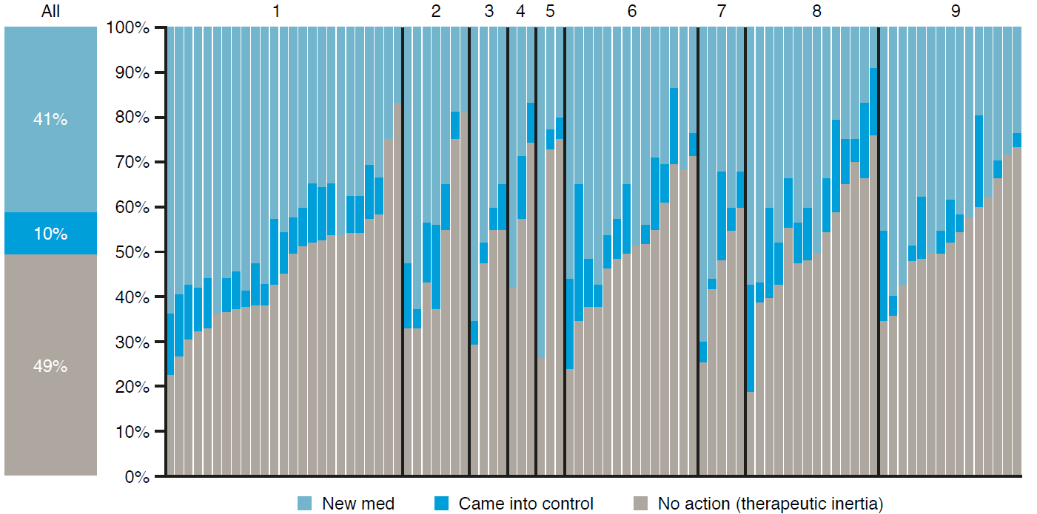
Each bar represents an individual PCP assigned to one of nine healthcare systems, which are identified by number (1−9). Only PCPs with ≥20 patients assigned to the therapeutic inertia cohort were included.
New med: patients were prescribed a new class of glucose-lowering medication between 0 and 6 months from the index date. Came into control: patients without a new prescription achieved an HbA_{1c} <8.0% (<64 mmol/mol) between 0 and 6 months from the index date. No action (therapeutic inertia): patients were not prescribed a new class of medication and did not achieve an HbA_{1c} <8.0% (<64 mmol/mol).
HbA_{1c}, glycated hemoglobin; PCP, primary care provider.

Supplemental Figure S2. Therapeutic inertia among bolus insulin-naïve patients with a baseline HbA_{1c} ≥8.0% over 24 months according to antidiabetes treatment regimen at baseline and race.
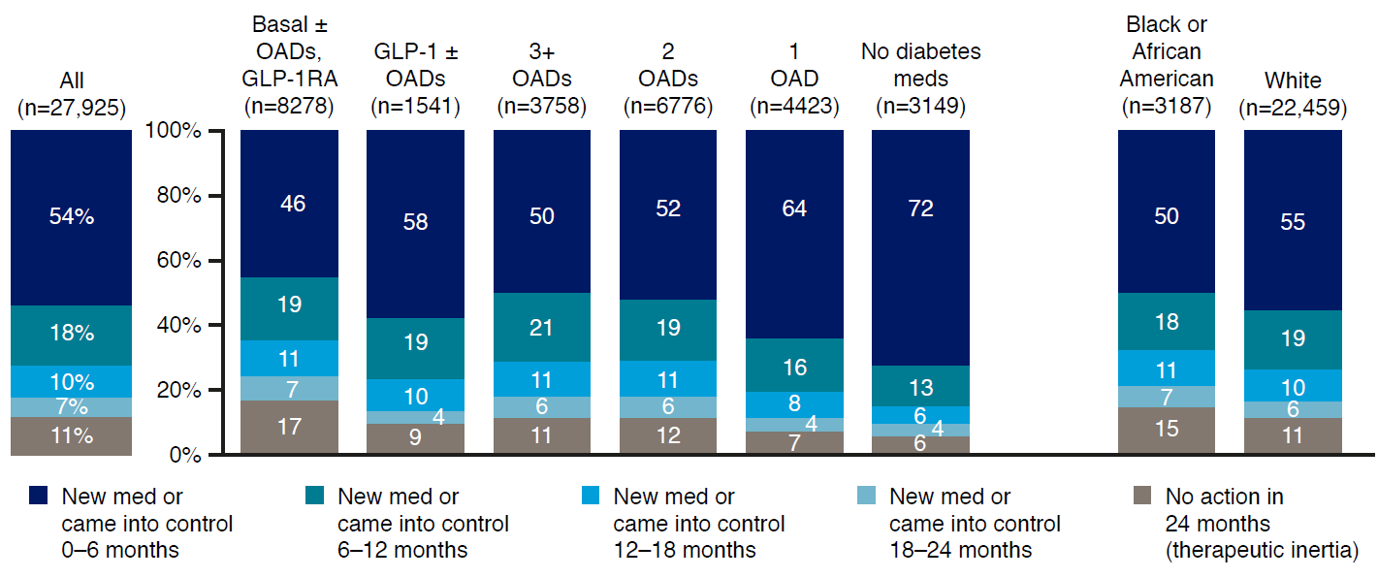
New med: patients were prescribed a new class of glucose-lowering medication between 0 and 24 months from the index date. Came into control: patients achieved an HbA_{1c} <8.0% (<64 mmol/mol) between 0 and 24 months from the index date. No action (therapeutic inertia): patients did not achieve an HbA_{1c} <8.0% (<64 mmol/mol) and were not prescribed a new medication.
Major OADs included metformin, sulfonylureas, thiazolidinediones, dipeptidyl peptidase-4 inhibitors, and SGLT-2i, sodium-glucose cotransporter-2 inhibitors. The sum of percentages in some of the groups do not total 100% due to rounding.
Basal, basal insulin; HbA_{1c}, glycated hemoglobin; OAD, oral antidiabetic drug; GLP-1 RA, glucagon-like peptide-1 receptor agonist.

Supplemental Figure S3. Median time to glycemic control in each of the participating AMGA healthcare organization and the proportion of patients achieving HbA_{1c} <8.0% (between 0 and 24 months from the index date).
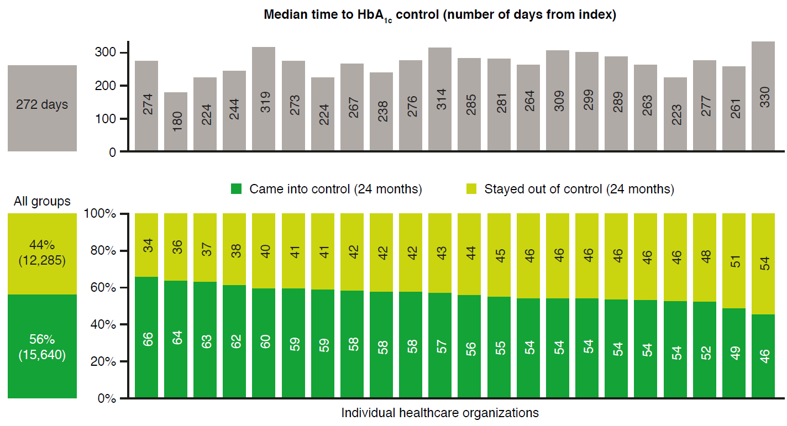
Came into control (24 months): patients achieved an HbA_{1c} <8.0% (<64 mmol/mol) between 0 and 24 months from the index date. Stayed out of control (24 months): patients had an HbA_{1c} ≥8.0% (≥64 mmol/mol) between 0 and 24 months from the index date.
AMGA, American Medical Group Association; HbA_{1c}, glycated hemoglobin;

