Supplemental Figures and Tables
Supplemental Figure 1: Study design schematic
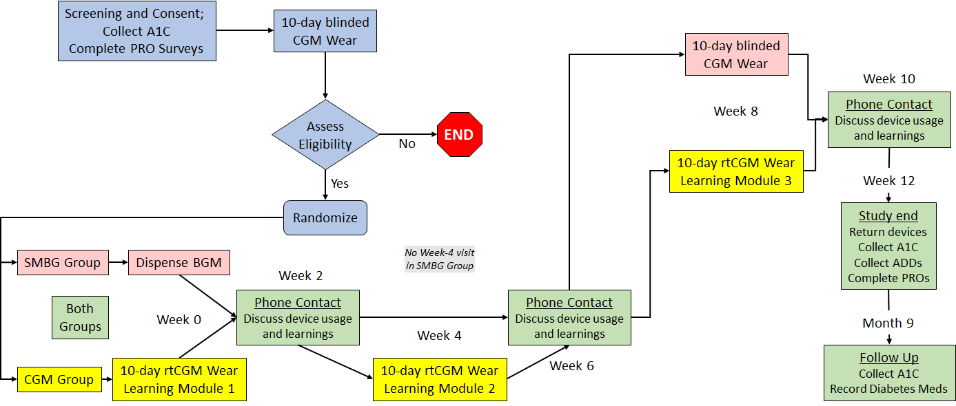

Supplemental Figure 2: Example learning module for the rtCGM group—breakfast
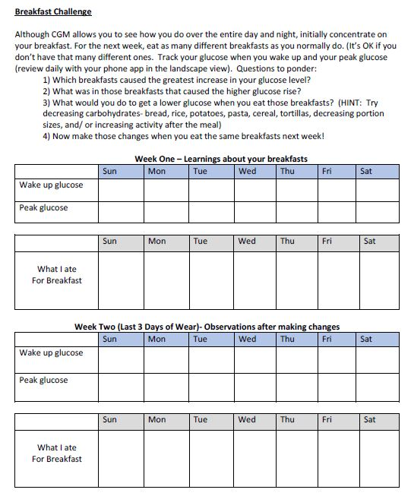

Supplemental Table 1: Summary of Diabetes Medications by Subject

Medications | CGM  (N=45) | SMBG  (N=23) | Overall  (N=68)
Sulfonylureas | 34 (75.6%) | 13 (56.5%) | 47 (69.1%)
DPP-4 Inhibitors | 13 (28.9%) | 10 (43.5%) | 23 (33.8%)
SGLT-2 Inhibitors | 26 (57.8%) | 9 (39.1%) | 35 (51.5%)
Alpha-glucosidase Inhibitors | 0 (0.0%) | 0 (0.0%) | 0 (0.0%)
Thiazolidinediones | 5 (11.1%) | 3 (13.0%) | 8 (11.8%)
Biguanides | 37 (82.2%) | 19 (82.6%) | 56 (82.4%)
Meglitinides | 0 (0.0%) | 1 (4.3%) | 1 (1.5%)
Other | 16 (35.6%) | 8 (34.8%) | 24 (35.3%)

Supplemental Table 2: Continuous Glucose Monitoring (CGM) coding, including for intermittent CGM use and data interpretation
CPT Code | Description | Billing frequency covered
CPT 95249 | Personal CGM - Startup/Training  Ambulatory continuous glucose monitoring of interstitial tissue fluid via a subcutaneous sensor for a minimum of 72 hours; patient-provided equipment, sensor placement, hook-up, calibration of monitor, patient training, and printout of recording. | Bill only once during the time period that the patient owns the device.
CPT 95250 | Professional CGM  Ambulatory continuous glucose monitoring of interstitial tissue fluid via a subcutaneous sensor for a minimum of 72 hours; physician or other qualified health care professional (office) provided equipment, sensor placement, hook-up, calibration of monitor, patient training, removal of sensor, and printout of recording. | Do not bill more than once a month.
CPT 95251 | CGM Interpretation  Ambulatory continuous glucose monitoring of interstitial tissue fluid via a subcutaneous sensor for a minimum of 72 hours; analysis, interpretation and report. | Do not bill more than once a month.

