Differential cost-sharing undermines treatment adherence to combination therapy: evidence from diabetes treatment
Supplementary material
Medical Expenditure Panel Survey (MEPS) database
MEPS is a nationally representative household survey that provides estimates of healthcare utilization and expenditures, health status, health insurance coverage, and sociodemographic and socioeconomic characteristics of the US population.¹ Each year a new panel of households is sampled and interviewed in ﬁve survey rounds over 2.5 years to obtain annual data reﬂecting a two-year reference period.² During each interview round, MEPS inquires the names of drugs acquired since the last interview, number of times the drugs were obtained, and the permission to contact pharmacies. Typically, respondents use their medicine containers and receipts to answer these questions, implying accurate reporting of their medications for chronic conditions.³ Additional details about medications including out-of-pocket (OOP) payments and quantities (e.g. number of pills) were obtained from pharmacies.⁴
In this analysis, selected individuals from panels 14–18 of the MEPS database, spanning 2009–2013 for year one and 2010–2014 for year two (see Table S1 for details on sample selection) had type 2 diabetes (T2D) which was defined based on three self-report questions: “Yes” to the ‘Do you have diabetes?’ question, and “Yes” to either “age of diagnosis 30 years or older” or “no insulin injections” for their diabetes.
Measures of OOP costs
The OOP costs were first converted to 2014 values using the MEPS OOP expenditures guideline of the Consumer Price Index.⁵ Following Miller et al,⁶ the last purchase in the second year was used to calculate OOP spending per day supplied because using the last purchase minimizes the chance that the OOP spending was for paying an expense such as a deductible. After OOP cost per day was obtained for each medication, the two medications with the highest and the lowest OOP costs per day were selected for each patient. Two related measures employed in the two different analyses described below, difference in OOP costs (∆OOP) and difference in medication possession ratio (∆MPR), were calculated. The ∆OOP was calculated as OOP cost for the most costly medication subtracted by the OOP cost for the least costly medication. Table S2 lists the two medications with highest and lowest OOP costs among the large ∆OOP cost subgroup. The relative OOP cost was calculated as OOP cost for the least costly medication divided by that for the most costly medication. Due to the skewed distribution of ∆OOP and the ∆OOP cost of $0 between 10 percentile and 20 percentile, we defined ten categories (from least to most) as one group patients with ∆OOP of $0, and the remaining patients broken into nine equal groups. For convenience, we use the term “decile” even though the $0 group contained more than 10% of the sample. The ten deciles were further categorized as least OOP cost difference group (Least ∆OOP), moderate OOP cost difference group (Moderate ∆OOP), and large OOP cost difference group (Large ∆OOP) with the cost difference cut-off determined post hoc based on adherence patterns.
Exploratory analysis to examine factors associated with the adherence status of the patients
The primary objective of the study was “within-patient” examination of adherence to their most and least costly diabetes medications. Table 2 in the main text provides a classification of these patients into four groups based on their adherence to these two drugs: adherent to both, adherent to neither, adherent to the most costly medication, or adherent to the least costly medication. We performed an exploratory analysis to investigate factors associated with this patient classification in a cross-sectional way. This was an exploratory analysis and validation in other data sources solidified the findings.
Initially, the four classes of patients were included in a classification tree to examine factors that are noted in Table 1. The first split in the tree was whether the difference in cost was more than ≥$0.127 a day (Figure S1). If the difference was more than this, adherence to both medications was 27.9% and adherence to neither was 28.4%, whereas if the difference was less than the cutoff, adherence to both medications was 41.7% and adherence to neither was 15.4%.
Both nodes were then split by the class of the most costly medication. The tree algorithm grouped together insulin and fixed dose combination (FDC) versus the others for both splits. The main difference in the insulin/FDC group was higher rates of adherence to the most costly medication only (19.8% in the higher ∆OOP cost node; 27.1% in the lower ∆OOP cost node) compared to the other drug classes (8.1% in the higher ∆OOP cost node; 13.5% in the lower ∆OOP cost node).
CART indicated ∆OOP cost, but we also attempted to find the optimal ratio of costs to discriminate among these groups. To find the ratio, we utilized methodology from the morphometrics (the analysis of body size and shape) literature to find optimal ratios,⁷ because costs and body measurements have common qualities, particularly the need to logarithm-transform. Due to the log transform, the concept is to use canonical discriminant functions, and the most positive and least positive factor loadings will be the variables to choose for the optimal ratios. We performed such an analysis with five independent variables: total OOP of the most costly medication, total OOP of the least costly medication, per day OOP of the most costly medication, per day OOP of the least costly medication, and yearly family income. This approach was used to determine whether per day or total OOP cost was more discriminatory or the groups, and whether the ratio should include family income. The results indicated that per day OOP of the least costly medication had by far the most negative loading, and family income did not surpass the positive loading of per day OOP of the most costly medication, so the ratio of least to most costly medication was chosen as the ratio to take into the multinomial logistic regression described in Table 2, rather than ratios of total OOP and family income.
Figure S2 illustrates the relationships among the four variables in the multinomial model with adherence behavior class. The most costly medication being insulin or FDC was associated with lower low/high OOP ratio (i.e., large cost differences among medications), higher total OOP cost/day, and lower SF-12 PCS score (i.e. poorer health). Particularly for patients whose most costly medication were not insulin or FDC, the ratios of low/high OOP cost for all four behavior types were all higher than those who were on insulin/FDC, as illustrated in Figure S2a. The patients who only adhered to the least costly medication were, on average, paying three more times for their most costly medication, whereas those adherent to other non-insulin/FDC medication on average paid about two times or less for their most costly medication. Note the relationship of this group (those with insulin/FDC as the most costly medication) to the others below the dashed line in Figure S2d is distinguished by their low ratio of least costly to most costly medication.
References
1. Medical Expenditure Panel Survey. https://meps.ahrq.gov. Accessed January 1, 2021.
2. Design and methods of the medical expenditure panel survey household component. Rockville (MD): Agency for Health Care Policy and Research. (MEPS Methodology Report No. 1). 1997. https://meps.ahrq.gov/data_files/publications/mr1/mr1.pdf#:~:text=Design%20and%20Methods%20of%20the%20Medical%20Expenditure%20Panel,wide%20variety%20of%20users%20in%20a%20cost-effective%20manner. Accessed January 1, 2021.
3. Hill SC, Zuvekas SH, Zodet MW. Implications of the accuracy of MEPS prescription drug data for health services research. Inquiry. 2011;48(3):242-259.
4. Outpatient prescription drugs: Data collection and editing in the 2011 Medical Expenditure Panel Survey. Methodology Report No. 29. Agency for Healthcare Research and Quality, Rockville, MD; 2014. http://meps.ahrq.gov/mepsweb/data_files/publications/mr29/mr29.pdf. Accessed January 1, 2021.
5. Dunn A, Grosse SD, Zuvekas SH. Adjusting Health Expenditures for Inflation: A Review of Measures for Health Services Research in the United States. Health Serv Res. 2018;53(1):175-196.
6. Miller GE, Sarpong EM, Hill SC. Does increased adherence to medications change health care financial burdens for adults with diabetes? J Diabetes. 2015;7(6):872-880.
7. Baur H, Leuenberger C. Analysis of ratios in multivariate morphometry. Syst Biol. 2011;60(6):813-825.

Table S1. Attrition for sample selection from MEPS database.
Criteria | n | Weighted n
Total MEPS participants during 2009-2013 | 83,911 | 316.9 million
↓
Individuals participating for entire two years | 77,191 | 292.2 million
↓
Individuals identified as having T2D | 5,323 | 18,894,413
↓
Individuals who obtained >2 classes of diabetes therapy drugs in the first yearª | 1,928 | 6,898,003
↓
Individuals who used only the medicines from the same drug classes in the second year | 1,192 | 4,306,111
↓
Individuals who had both ‘Days’ Supply^{b}’ and ‘Out-of-pocket costs’ for at least 2 medications for the entire year | 1,189 | 4,294,336
ªDrug classes were identified using Multum Lexicon therapeutic codes for Sub-Sub-Class. Individuals were chosen only if they took each of the two medication for at least two rounds during that year. ^{b}Days Supply was either recorded in the data or imputed by NDC median.T2D=Type 2 diabetes

Table S2. Top five medications comprising the highest and lowest out-of-pocket cost drug classes among the large ∆OOP subgroup (during second year in MEPS database).
Highest OOP medication based on cost/days supply |  | Lowest OOP medication based on cost/days supply
Medication | Percent | Medication | Percent
Insulin glargine | 18.6 | Metformin | 49.6
Sitagliptin | 17.6 | Glipizide | 15.1
Pioglitazone | 15.0 | Glimepiride | 13.8
Insulin human isophane (NPH) | 12.6 | Glyburide | 9.6
Liraglutide | 6.6 | Insulin human isophane (NPH) | 3.1
Abbreviation: MEPS = Medical Expenditure Panel Survey; OOP = out-of-pocket.

Figure S1: Classification tree with dependent variable of adherence status to the most costly and least costly medication.
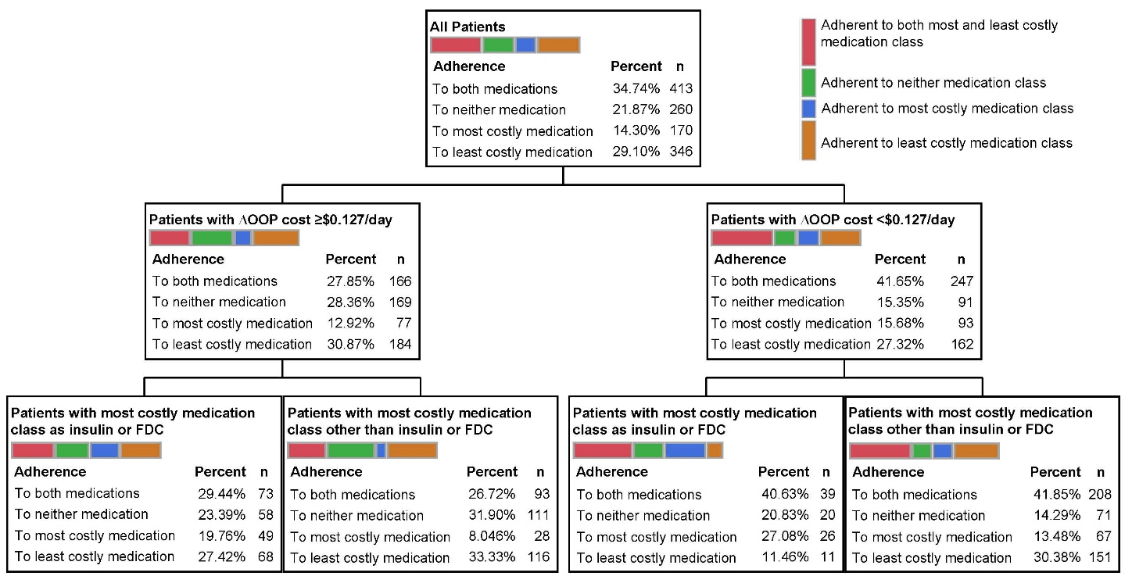
Abbreviations: FDC = fixed dose combination; n = number of MEPS participants in each category; OOP = out-of-pocket.

Figure S2. Means of three variables that relate to the four adherence groups.
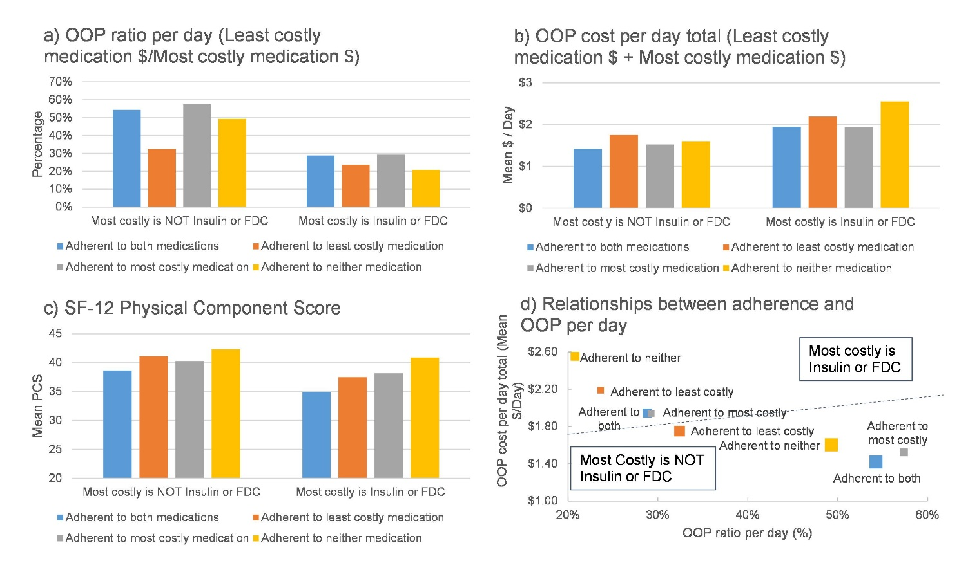
Note: For subfigure b and d, OOP cost/day total is geometric mean.
Abbreviation: FDC = fixed-dose combination; OOP = out-of-pocket

