Author, year, country | Study design | Method of randomization | Surgeons' eligibility | Surgical quality control | Blinding | Power analysis
Valverde, France, 1996 ²⁰ | nr | Blind enveloppe method  Stratified | >5y experience in esophageal surgery  >30 anastomoses/year per surgeon | nr | nr | Y
Law, Hong Kong, 1997 ²¹ | nr | Blind enveloppe method | nr | nr | nr | nr
Laterza, Italy, 1999 ²² | nr | Blind enveloppe method | nr | nr | nr | nr
Walther, Sweden, 2003 ²³ | nr | nr | single experienced surgeon | nr | nr | nr
Hsu, Taiwan, 2004 ²⁴ | nr | Blind enveloppe method | nr | nr | nr | nr
Okuyama, Japan, 2007 ²⁵ | nr | Blind enveloppe method | nr | nr | nr | nr
Luechakiettisak, Thailand, 2008 ²⁶ | nr | nr | nr | nr | nr | nr
Zhang, China, 2010 ²⁷ | nr | According to clinical chart number | nr | nr | nr | nr
Saluja, India, 2012 ²⁸ | nr | Computer-based non-stratified 1:1 randomization | nr | nr | nr | Y
Wang, China, 2013 ²⁹ | nr | nr | nr | nr | nr | Y
Liu, China, 2015 ³⁰ | nr | According to clinical chart number  Stratified | nr | nr | nr | Y
Nederlof, Netherlands, 2020 ³¹ | nr | Computer based hidden block size of 10  Stratified | 3 experienced surgeons | nr | Single-blinded | Y

Supplementary Table 1. Randomized Clinical Trials (RCTs) quality evaluation. Y yes, nr not reported.

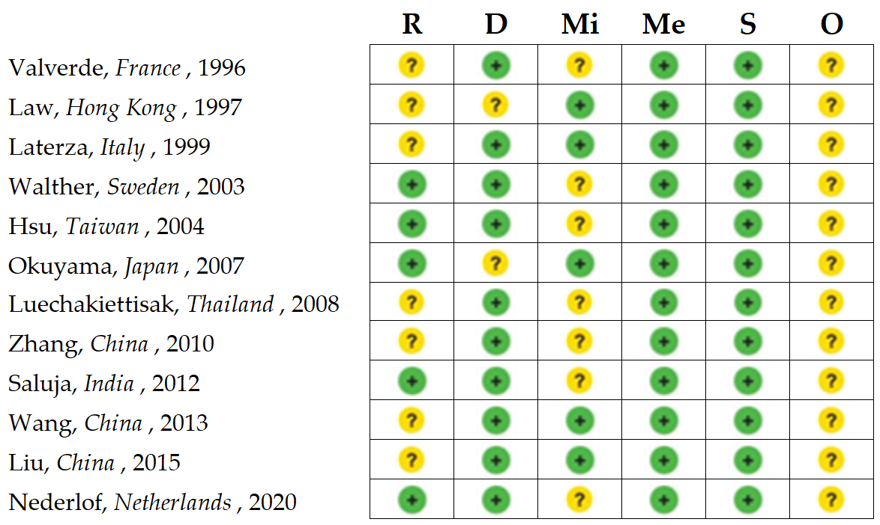
Supplementary Fig. 1. Risk of bias for randomized controlled trials (RCT) assessed with use of the Cochrane risk-of-bias tool 2. Green circle: low risk of bias; red circle: high risk of bias; yellow circle: unclear risk of bias. Bias arising from the randomization process (R); bias due to deviations from intended interventions (D); bias due to missing outcome data (Mi); bias in measurement of the outcome (Me); bias in selection of the reported result (S); overall risk of bias (O).
Author, country, year | Anastomosis specifications | Type of suture/
Stapler | Anastomosis location T-C | Anastomosis type (E-E, E-S, S-S) | Surgical procedure (Open-Hybrid-TMI)
Valverde, France, 1996 ²⁰ | HS - One layer | A-NA 71-3 | 50-24 | 14-60-0 | 74-0-0
 | ST - Circular | nr | 57-21 | 4-74-0 | 78-0-0
Law, Hong Kong, 1997 ²¹ | HS- One layer | A, MF | 61-0 | nr | 61-0-0
 | ST - Circular | 18 25mm/30 28mm/ 4 29mm/ 51 31mm/ 4 33mm | 61-0 | 0-61-0 | 61-0-0
Laterza, Italy, 1999 ²² | HS - Two layers | A, MF | 0-21 | nr | 21-0-0
 | ST - Circular | 12 21mm/8 25mm | 0-20 | 0-20-0 | 20-0-0
Walther, Sweden, 2003 ²³ | HS - nr | A, MF | 0-41 | 41-0-0 | 41-0-0
 | ST - Circular | 24 25mm/ 14 28mm/ 4 31mm | 42-0 | 0-42-0 | 42-0-0
Hsu, Taiwan, 2004 ²⁴ | HS - Two layers | A, MF; NA, PF | 0-32 | 0-32-0 | 32-0-0
 | ST - Circular | 31 21mm | 0-31 | 0-31-0 | 31-0-0
Okuyama, Japan, 2007 ²⁵ | HS - Two layers | A, MF; NA, PF | 0-18 | nr | 18-0-0
 | ST - Circular | 14 25mm | 14-0 | 0-14-0 | 14-0-0
Luechakiettisak, Thailand, 2008 ²⁶ | HS - One layer | A, PF | 59-0 | nr | 59-0-0
 | ST - Circular | 40 25mm/ 18 31mm | 58-0 | nr | 58-0-0
Zhang, China, 2010 ²⁷ | HS - Two layers | A, PF; NA, PF | 244-0 | 244-0-0 | 244-0-0
 | ST - Circular | 272 25mm | 272-0 | 0-272-0 | 272-0-0
Saluja, India, 2012 ²⁸ | HS - Two layers | NA, PF | 0-87 | 0-87-0 | 87-0-0
 | ST - Linear | nr | 0-87 | 0-0-87* | 87-0-0
Wang, China, 2013 ²⁹ | HS - One layer | nr | 44-8 | 52-0-0 | 52-0-0
 | ST - Circular | 47 25mm | 70-22 | 0-47-45 | 92-0-0
Liu, China, 2015 ³⁰ | HS - One layer | A, MF | 113-354 | 232-0-0 | 237-0-0
 | ST - Circular | 58 25mm/171 29mm/ 6 33mm |  | 0-235-0 | 241-0-0
Nederlof, Netherlands, 2020 ³¹ | HS - One layer | A, MF | 0-44 | 44-0-0 | 44-0-0
 | ST - Linear | nr | 0-49 | 0-0-49# | 49-0-0
Supplementary Table 2 Technical anastomosis data. HS Hand-sewn anastomosis. ST Stapled anastomosis. MF=mono-filament, PF=pluri-filament, NA=non-absorbable, A=absorbable, T=Toracic, C=Cervical, E-E= end to end, E-S= end to side, S-S= side to side, TMI=Totally minimally invasive *Orringer #Collard

