Supplementary Material
Predictors of disease progression in pancreatic neuroendocrine tumors after surgery
Journal: Updates in Surgery

Eva Maria Dobrindt^{1*}, Janina Maren Krömer^{1*}, Martina T. Mogl¹, Agata Dukaczewska¹, Charlotte Friederieke Müller-Debus¹, Peter Steinhagen², Uli Fehrenbach³, Thomas Malinka¹, Johann Pratschke¹, Frederike Butz^{1°}

¹Department of Surgery, Campus Charité Mitte | Campus Virchow Klinikum, Charité – Universitätsmedizin Berlin, Corporate Member of Freie Universität Berlin and Humboldt-Universität zu Berlin, Berlin, Germany

²Department of Hepatology and Gastroenterology, Campus Charité Mitte | Campus Virchow-Klinikum, Charité – Universitätsmedizin Berlin, Corporate Member of Freie Universität Berlin and Humboldt-Universität zu Berlin, Berlin, Germany
³Department of Radiology, Charité – Universitätsmedizin Berlin, Corporate Member of Freie Universität Berlin and Humboldt-Universität zu Berlin, Berlin, Germany

* These authors contributed equally

° Corresponding author:
Dr. med. Frederike Butz
Department of Surgery, Charité Campus Mitte
Charitéplatz 1, 10117 Berlin, Germany
frederike.butz@charite.de

Supplementary Table 1 Comparison of pNET patients depending on tumor location
 |  | Proximal  (n = 31) | Distal  (n = 58) | p-value
Sex¹ | Male | 15 (48.4) | 29 (50.0) | 0.885
Sex¹ | Female | 16 (45.9) | 29 (50.0) | 0.885
Age [years]² |  | 64 (35-76) | 61 (21-82) | 0.983
BMI [kg/m²]² (n = 80) |  | 27.0 (15.6 - 38.6) | 25.6 (15.6-40.5) | 0.524
ASA¹ | 1 | 2 (6.5) | 2 (3.4) | 0.766
ASA¹ | 2 | 16 (51.6) | 33 (56.9) | 0.766
ASA¹ | 3 | 13 (41.9) | 23 (39.7) | 0.766
UICC¹ | I | 9 (29.0) | 21 (36.2) | 0.003
UICC¹ | II | 7 (22.6) | 28 (48.3) | 0.003
UICC¹ | III | 15 (48.4) | 9 (15.5) | 0.003
Surgical procedure¹ | DP | 0 (0.0) | 57 (98.3) | <0.001
Surgical procedure¹ | PPPD | 31 (100.0) | 0 (0.0) | <0.001
Surgical procedure¹ | Pancreatectomy | 0 (0.0) | 1 (1.7) | <0.001
Multifocality¹ |  | 1 (3.2) | 2 (3.4) | 1.0
Grading (WHO)¹ | G1 | 16 (51.6) | 28 (48.3) | 0.810
Grading (WHO)¹ | G2 | 12 (38.7) | 26 (44.8) | 0.810
Grading (WHO)¹ | G3 | 3 (9.7) | 4 (6.9) | 0.810
Alternative grading¹ | G1 | 16 (51.6) | 28 (48.3) | 0.908
Alternative grading¹ | G2a | 9 (29.0) | 18 (31.0)
Alternative grading¹ | G2b | 3 (9.7) | 8 (13.8)
Alternative grading¹ | G3 | 3 (9.7) | 4 (6.9)
Ki-67 [%]² |  | 2 (1-68) | 3 (1-60) | 0.623
T stage¹ | T1 | 11 (35.5) | 21 (36.2) | 0.291
T stage¹ | T2 | 7 (22.6) | 21 (36.2) | 0.291
T stage¹ | T3 | 13 (41.9) | 16 (27.6) | 0.291
T stage¹ | T4 | 0 (0.0) | 0 (0.0) | 0.291
Tumor size [mm]² |  | 25 (4-140) | 25 (2-120) | 0.667
N stage¹ | N0 | 16 (51.6) | 48 (82.8) | 0.002
N stage¹ | N+ | 15 (48.4) | 10 (17.2) | 0.002
Lymph nodes resected² |  | 12 (4-33) | 8 (2-36) | 0.022
Lymph nodes positive² |  | 1 (0-15) | 0 (0-10) | 0.003
R status¹ (n = 88) | R0 | 23 (74.2) | 52 (89.7) | 0.075
R status¹ (n = 88) | R+ | 8 (25.8) | 5 (8.6) | 0.075
R status¹ (n = 88) | Rx | 0 0.0) | 1 (1.7) | 0.075
Additional treatment ¹ |  | 13 (41.9) | 9 (15.5) | 0.009
Progress¹ |  | 15 (48.4) | 10 (17.2) | 0.003
NET-related death¹ |  | 5 (16.1) | 5 (8.6) | 0.308
¹Data shown as frequencies (percentage); ²median (range); pNET, pancreatic neuroendocrine tumor; BMI, Body Mass Index; ASA, Association of Anesthesiologists; UICC, Union for International Cancer Control; MIS, minimally invasive surgery; SSA, Somatostatin analogue; PRRT, Peptide receptor radionuclide therapy; TAE, Transarterial embolization; SIRT, Selective internal radiation therapy.

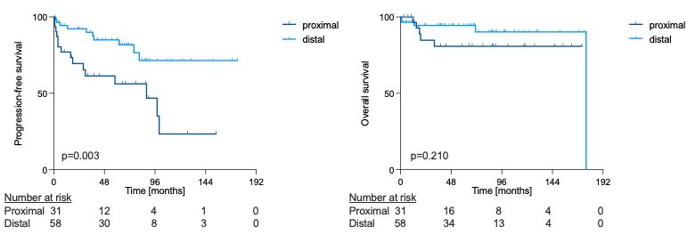
a. b.
Supplementary Figure 1 Comparison of a. Progression-free survival (PFS) and b. Overall survival (OS) in pNET patients depending on tumor location. Patients with proximal pNETs showed shorter PFS (p=0.003) while OS did not differ significantly according to tumor location (p=0.210). Survival rates were compared using log-rank tests. Censored data are marked with ticks.

Supplementary Table 2 Comparison of pNET patients depending on tumor location – matched study cohort
 |  | Proximal  (n = 25) | Distal  (n = 25) | p-value
Sex¹ | Male | 11 (44.0) | 12 (48.0) | 0.777
Sex¹ | Female | 14 (56.0) | 13 (52.0) | 0.777
Age [years]² |  | 65 (35 – 74) | 65 (31 – 78) | 0.877
BMI [kg/m²]² |  | 26.9 (15.6-33.4) | 27.7 (15.6-39.9) | 0.481
ASA¹ | 1 | 1 (4.0) | 0 (0.0) | 1.0
ASA¹ | 2 | 13 (52.0) | 14 (56.0) | 1.0
ASA¹ | 3 | 11 (44.0) | 11 (44.0) | 1.0
UICC¹ | I | 9 (36.0) | 8 (32.0) | 0.939
UICC¹ | II | 7 (28.0) | 8 (32.0) | 0.939
UICC¹ | III | 9 (36.0) | 9 (36.0) | 0.939
Multifocality¹ |  | 1 (4.0) | 0 (0.0) | 1.0
Grading (WHO)¹ | G1 | 15 (60.0) | 9 (36.0) | 0.252
Grading (WHO)¹ | G2 | 8 (32.0) | 13 (42.0) | 0.252
Grading (WHO)¹ | G3 | 2 (8.0) | 3 (12.0) | 0.252
Alternative grading¹ | G1 | 15 (60.0) | 9 (36.0) | 0.458
Alternative grading¹ | G2a | 5 (20.0) | 8 (32.0) | 0.458
Alternative grading¹ | G2b | 3 (12.0) | 5 (20.0) | 0.458
Alternative grading¹ | G3 | 2 (8.0) | 3 (12.0) | 0.458
Ki-67 [%]² |  | 2 (1-68) | 4 (1-60) | 0.184
T stage¹ | T1 | 9 (36.0) | 8 (32.0) | 1.0
T stage¹ | T2 | 6 (24.0) | 6 (24.0) | 1.0
T stage¹ | T3 | 10 (40.0) | 11 (44.0) | 1.0
T stage¹ | T4 | - | - | 1.0
Tumor size [mm]² |  | 23 (2-60) | 32.5 (5-140) | 0.054
N stage¹ | N0 | 16 (64.0) | 16 (64.0) | 1.0
N stage¹ | N+ | 9 (36.0) | 9 (36.0) | 1.0
Lymph nodes resected² |  | 11 (4-33) | 8 (2-20) | 0.221
Lymph nodes positive² |  | 0 (0-15) | 0 (0-10) | 0.747
R status¹ | R0 | 20 (80.0) | 23 (92.0) | 0.417
R status¹ | R+ | 5 (20.0) | 2 (8.0) | 0.417
Adjuvant Therapy¹ |  | 8 (32.0) | 7 (28.0% | 0.758
Progress¹ |  | 9 (36.0) | 7 (28.0) | 0.544
NET-related death¹ |  | 5 (20.0) | 2 (8.0) | 0.417
¹Data shown as frequencies (percentage); ²median (range); pNET, pancreatic neuroendocrine tumor; BMI, Body Mass Index; ASA, Association of Anesthesiologists; UICC, Union for International Cancer Control; MIS, minimally invasive surgery; SSA, Somatostatin analogue; PRRT, Peptide receptor radionuclide therapy; TAE, Transarterial embolization; SIRT, Selective internal radiation therapy.

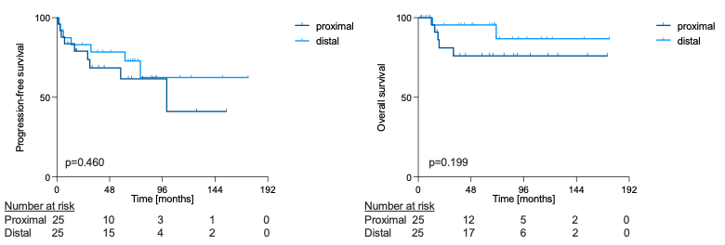
a. b.
Supplementary Figure 2 Comparison of a. progression-free survival (PFS) and b. overall survival (OS) in matched pNET patients depending on tumor location. PFS (p=0.460) and OS (p=0.199) did not differ significantly according to tumor location. Survival rates were compared using log-rank tests. Censored data are marked with ticks.

