Supplementary Figure 2
Comparison of the cytokine levels at 11-13 DIV and 20 DIV
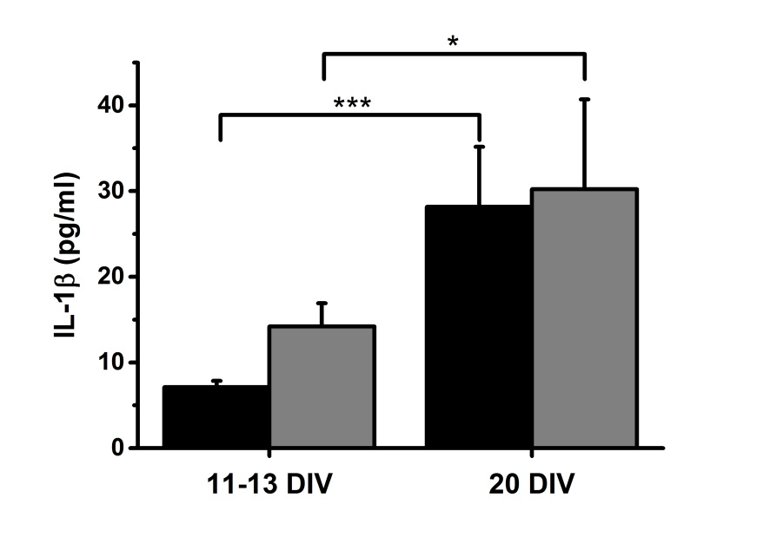
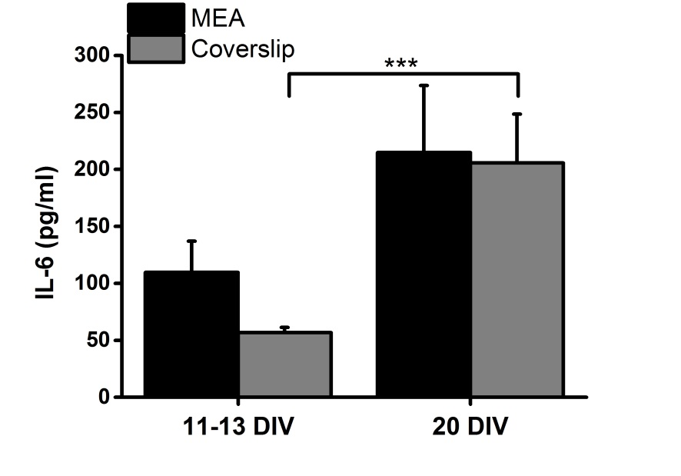
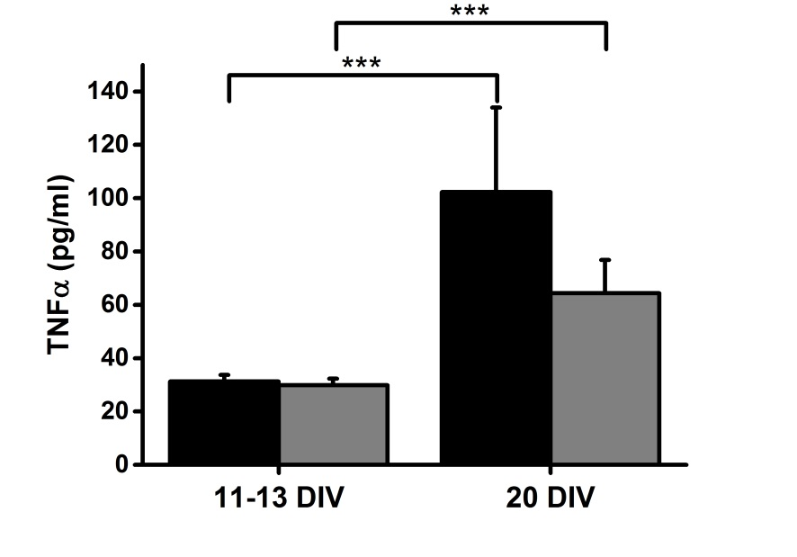
The inflammatory cytokines IL-1β, TNFα and IL-6 levels at 11-13 DIV were compared with those at 20 DIV in slices cultured on MEAs and coverslips. * p<0.05 and *** p<0.001 by two-sample t-test. Data are presented as mean ± SEM.

