Supplementary Figure 5
Anti-TNFα polyclonal antibody titration
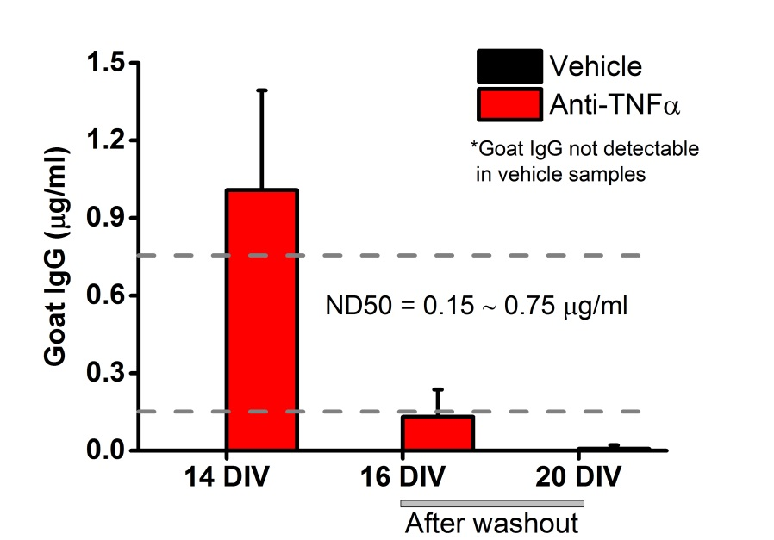
Polyclonal goat anti-TNFα antibody titration was measured by goat IgG ELISA kit from cultured supernatant collected at 14 (in the presence of the antibody) and at 16 and 20 DIV (after washout). Goat IgG was under the detection range in the vehicle group. n=9 slices for anti-TNFα group/DIV and 3 slices for vehicle group/DIV. Data are presented as mean ± SD.

