Supplementary Information
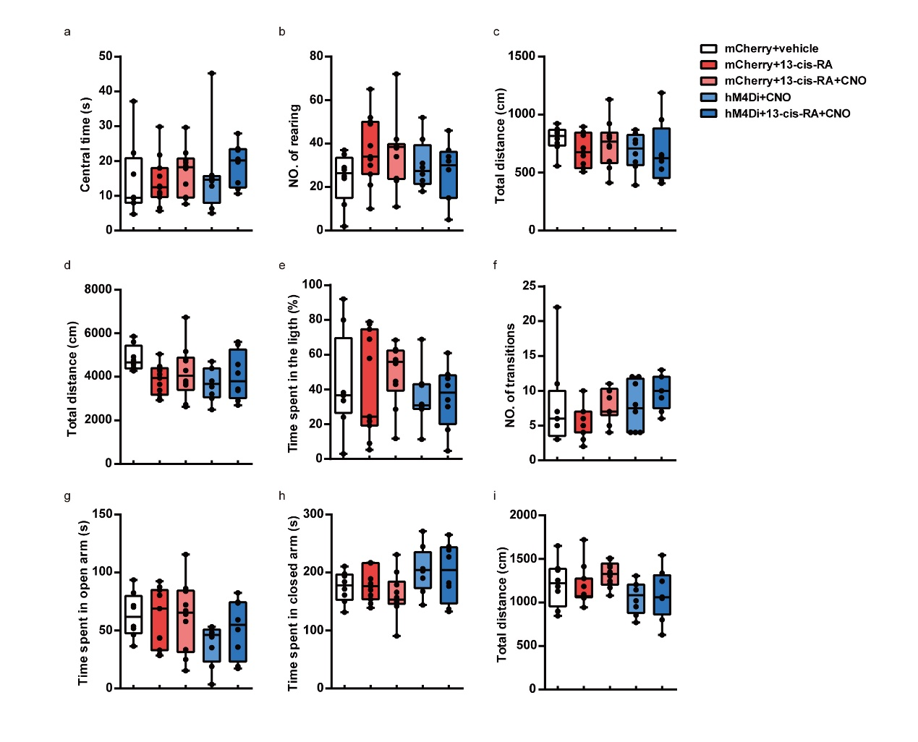
Supplemental Fig. 1 Decreasing the activity of DGCs through inhibitory DREADDs does not induce anxiety-like behavior or abnormal locomotor activity in mice.
a. The time spent in the central zone (central zone duration) during the first 5 min of the OFT. (mCherry+vehicle, n=8 mice, mCherry+13-cis-RA, n=11 mice, mCherry+13-cis-RA+CNO, n=10 mice, hM4Di+CNO, n=8 mice, hM4Di+13-cis-RA+CNO, n=8 mice; One-way ANOVA, F _{(4, 40)} = 0.4499, P = 0.7718).
b. The number of rearing (standing on the hind limbs) during the first 5 min of the OFT. (mCherry+vehicle, n=8 mice, mCherry+13-cis-RA, n=11 mice, mCherry+13-cis-RA+CNO, n=10 mice, hM4Di+CNO, n=8 mice, hM4Di+13-cis-RA+CNO, n=8 mice; One-way ANOVA, F _{(4, 40)} = 1.537, P = 0.2099).
c. The distance moved during the first 5 min of the OFT. (mCherry+vehicle, n=8 mice, mCherry+13-cis-RA, n=11 mice, mCherry+13-cis-RA+CNO, n=10 mice, hM4Di+CNO, n=8 mice, hM4Di+13-cis-RA+CNO, n=8 mice; One-way ANOVA, F _{(4, 40)} = 0.6249, P = 0.6474).
d. The distance moved during the 30-min duration of the OFT. (mCherry+vehicle, n=8 mice, mCherry+13-cis-RA, n=11 mice, mCherry+13-cis-RA+CNO, n=10 mice, hM4Di+CNO, n=8 mice, hM4Di+13-cis-RA+CNO, n=8 mice; One-way ANOVA, F _{(4, 40)} = 1.995, P = 0.1138).
e. The time spent in the light chamber during the LDT. (mCherry+vehicle, n=8 mice, mCherry+13-cis-RA, n=11 mice, mCherry+13-cis-RA+CNO, n=10 mice, hM4Di+CNO, n=8 mice, hM4Di+13-cis-RA+CNO, n=8 mice; One-way ANOVA, F _{(4, 40)} = 0.5325, P = 0.7125).
f. The number of entries in the light chamber during the LDT. (mCherry+vehicle, n=8 mice, mCherry+13-cis-RA, n=11 mice, mCherry+13-cis-RA+CNO, n=10 mice, hM4Di+CNO, n=8 mice, hM4Di+13-cis-RA+CNO, n=8 mice; One-way ANOVA, F _{(4, 40)} = 2.196, P = 0.0868).
g. The time spent in the open arms of the EPM. (mCherry+vehicle, n=8 mice, mCherry+13-cis-RA, n=11 mice, mCherry+13-cis-RA+CNO, n=10 mice, hM4Di+CNO, n=8 mice, hM4Di+13-cis-RA+CNO, n=8 mice; One-way ANOVA, F _{(4, 40)} = 1.555, P = 0.2051).
h. The time spent in the closed arms of the EPM. (mCherry+vehicle, n=8 mice, mCherry+13-cis-RA, n=11 mice, mCherry+13-cis-RA+CNO, n=10 mice, hM4Di+CNO, n=8 mice, hM4Di+13-cis-RA+CNO, n=8 mice; One-way ANOVA, F _{(4, 40)} = 2.091, P = 0.1001).
i. The distance traveled in the EPM. (mCherry+vehicle, n=8 mice, mCherry+13-cis-RA, n=11 mice, mCherry+13-cis-RA+CNO, n=10 mice, hM4Di+CNO, n=8 mice, hM4Di+13-cis-RA+CNO, n=8 mice; One-way ANOVA, F _{(4, 40)} = 1.957, P = 0.1197).
The data are presented as the mean ± s.e.m. ns P > 0.05.

