Supplementary Figures
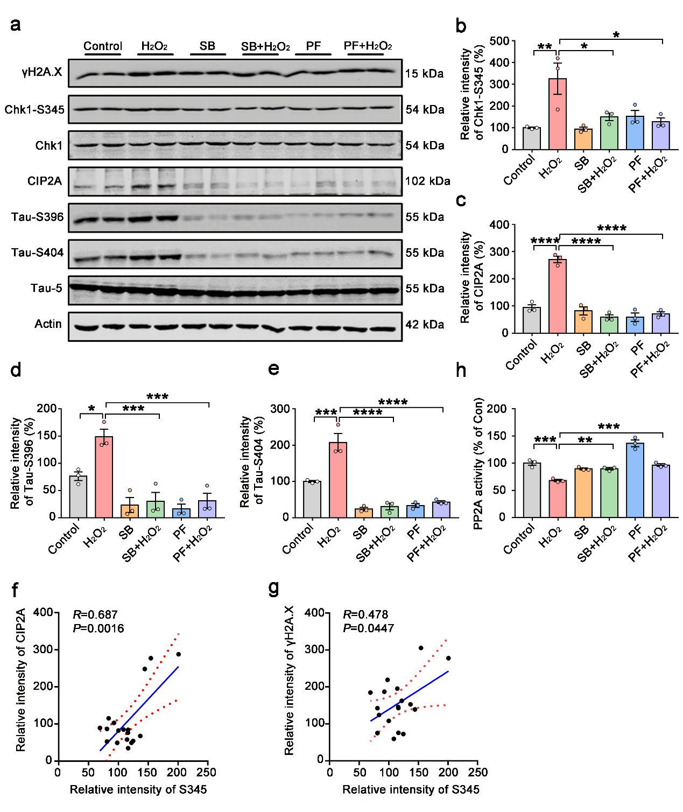
Fig. S1 Chk1 inhibition reverses CIP2A overexpression and tau hyperphosphorylation caused by H₂O₂ in primary neurons
(a-g) Primary neurons were treated with 200 µM H₂O₂ for 2 hours, with or without pre-incubation of ChK1 inhibitor SB218078 (1 μM) or PF477736 (1 μM) for 48 hours.
(a) Representative immunoblots of γH2A.X, Chk1-S345, Chk1, CIP2A, Tau-S396, Tau-S404, Tau-5 and β-actin.
(b-e) The quantitative analysis of the protein levels of Chk1-S345, CIP2A, Tau-S396 and Tau-S404 in (a).
(f) Correlation analysis of Chk1-S345 and CIP2A in (a)
(g) Correlation analysis of Chk1-S345 and γH2A.X in (a).
(h) PP2A activity assay. All data represent mean ± SEM, n=3, *P <0.05, **P < 0.01, ***P＜0.001, ****P＜0.0001, comparison between the indicated two groups.

Fig. S2 Chk1 inhibitor (GDC-0575) reduces tau phosphorylation and APP levels in cortex of APP/PS1 mice.
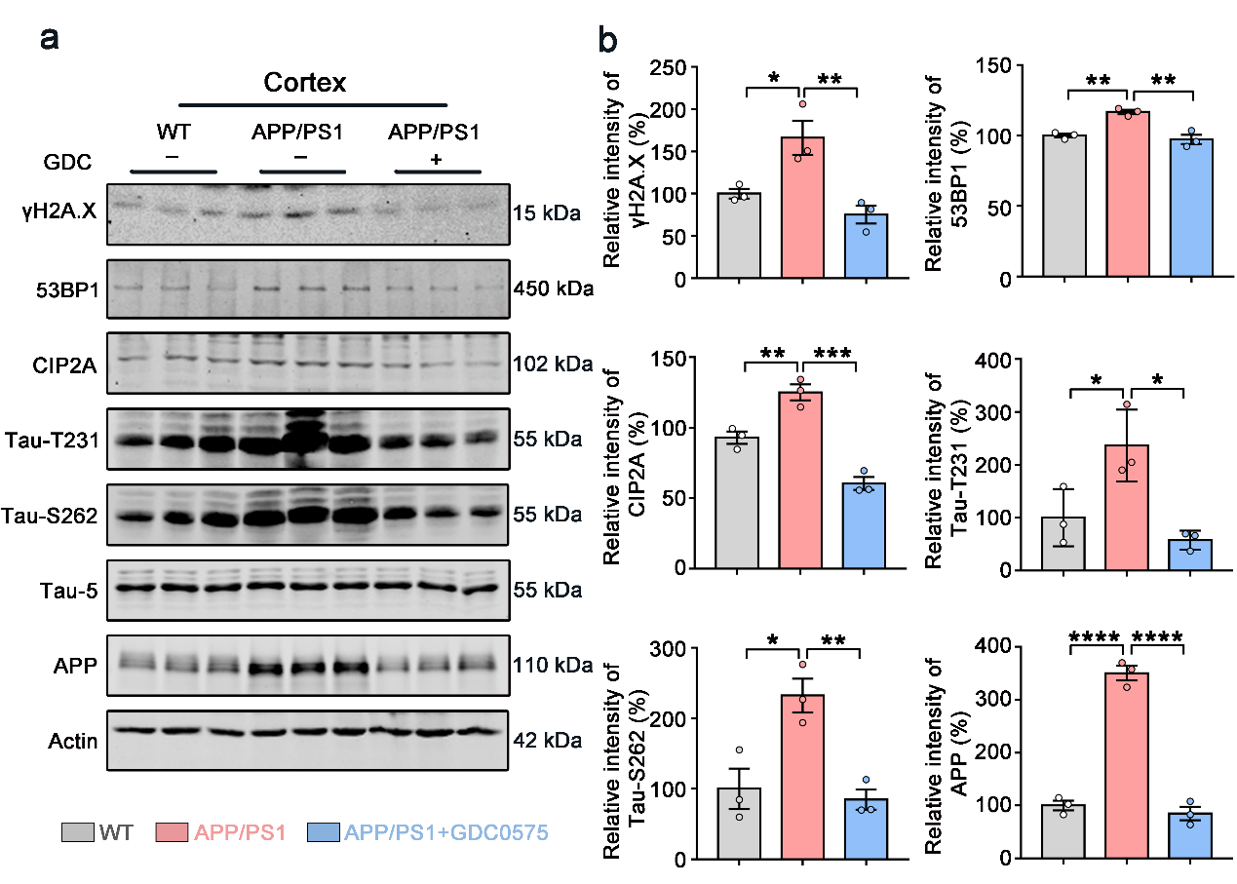
(a) Representative immunoblots of γH2A.X, 53BP1, CIP2A, Tau-T231, Tau-S262, Tau-5, APP and β-actin in cortex of the mice.
(b) The quantitative analysis of the protein level of γH2A.X, 53BP1, CIP2A, Tau-T231, Tau-S262 and APP in (a). All data represent mean ± SEM, n=3 per group, *P <0.05, **P < 0.01, ***P＜0.001, ****P＜0.0001, comparison between the indicated two groups.

