Host range of Colletotrichum pyricola: an aggressive pathogen of eucalypts

Aindreeya Alcova¹, Peter K. Ades¹, Jacqueline Edwards², Yu Pei Tan³, Niloofar Vaghefi¹ and Paul W.J. Taylor¹*

^{1.} School of Agriculture, Food and Ecosystem Science, The University of Melbourne, Parkville, Australia
^{2.} School of Applied Systems Biology, La Trobe University, Bundoora, Australia
^{3.} Queensland Plant Pathology Herbarium, Department of Primary Industries, Dutton Park, Australia

*Corresponding author: Paul W.J. Taylor; paulwjt@unimelb.edu.au

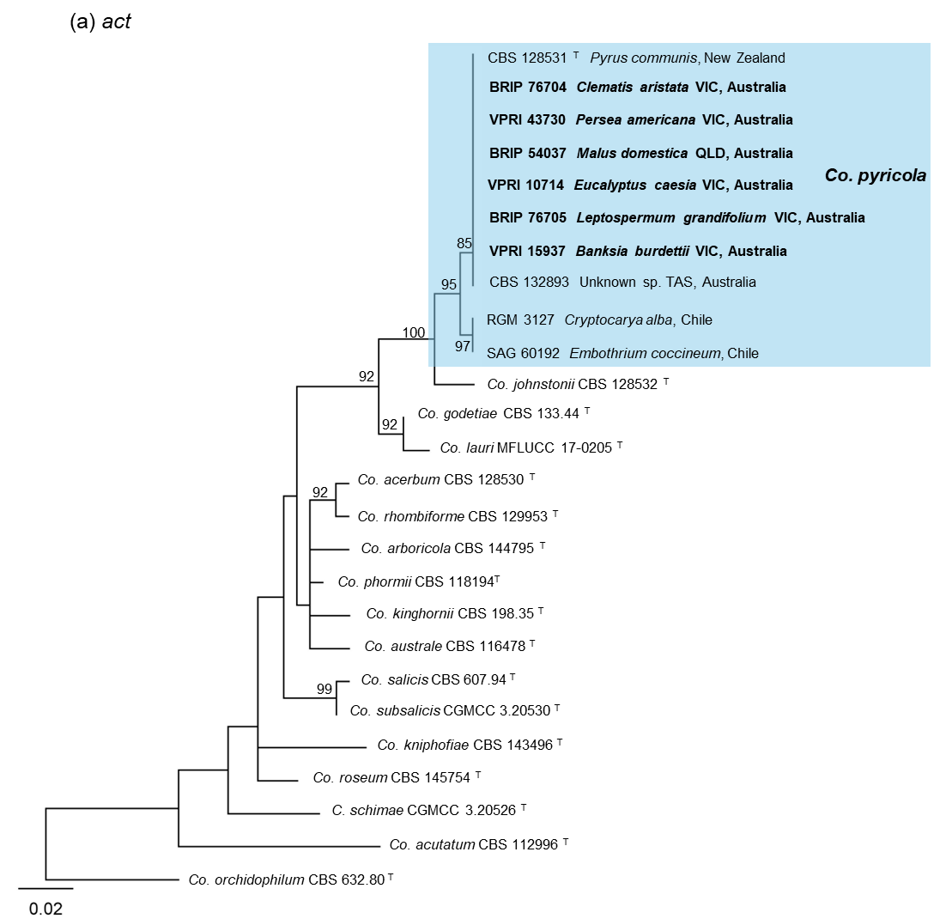
Supplementary Fig. 1: Maximum likelihood (ML) phylogenies of the Colletotrichum acutatum species complex based on single-gene sequences: (a) act; (b) chs-1; (c) gapdh; (d) his3; (e) ITS; and (f) tub2. ML bootstrap support values ≥70% are shown at the nodes. Trees are rooted to Colletotrichum orchidophilum (CBS 632.80). Scale bars represent 0.02 substitutions per site. Species names are followed by the isolate number, host, state, and country. Type specimens are indicated by ^{T}. Blue blocks highlight the monophyletic Co. pyricola clade, including the type specimen (CBS 128531).

