Nicotine Population Pharmacokinetics in Healthy Adult Smokers: A Retrospective Analysis

Mathilde Marchand¹, Patrick Brossard², Henri Merdjan¹, Nicola Lama², Rolf Weitkunat², and Frank Lüdicke²

¹Certara Strategic Consulting, Paris and Marseille, France
²PMI R&D, Philip Morris Products SA, Neuchâtel, Switzerland (part of Philip Morris International group of companies)

Corresponding author:
Rolf Weitkunat, Philip Morris Products SA, Quai Jean-Renaud 5, 2000 Neuchâtel, Switzerland Tel: +41 58 242 25 63; Email: rolf.weitkunat@pmi.com

Supplementary Material
Supplementary Table 1 Potential Covariates, Hierarchy, and Rationale for their Selection

Covariate category | Covariate | Variable type | Rationale for selection
Primary | Creatinine clearance | Continuous | Possible influence of renal function on nicotine clearance
 | Body weight | Continuous | Possible influence on nicotine clearance, volume of distribution and absorption parameters
 | CYP2A6 activity | Continuous | CYP2A6 is the major CYP enzyme involved in nicotine metabolism
 | Sex | Binary | Activity of nicotine-metabolizing enzymes might differ between males and females
 | Nature of product | Categorical | It is assumed that products a priori differ by their rate and extent of nicotine absorption
 | Nicotine ISO yield | Continuous | Check dose-dependency of nicotine PK
Secondary | Age | Continuous | Exploratory evaluation
 | ALT | Continuous | Exploratory evaluation
 | AST | Continuous | Exploratory evaluation
 | Total bilirubin | Continuous | Exploratory evaluation
 | Body height | Continuous | Exploratory evaluation
 | Body mass index | Continuous | Exploratory evaluation
 | Ethnicity | Categorical | Exploratory evaluation
 | Region | Categorical | Exploratory evaluation
 | Race | Categorical | Exploratory evaluation
 | Menthol | Binary | Exploratory evaluation
 | Daily CC use at baseline | Categorical | Exploratory evaluation
 | FTND score | Continuous | Exploratory evaluation
 | First item of the FTND questionnaire | Categorical | Exploratory evaluation
ALT: alanine aminotransferase; AST: aspartate aminotransferase; CC: conventional cigarette; CYP2A6: cytochrome P450 2A6 isoform; FTND: Fagerström test for nicotine dependence; ISO: International Organization for Standardization; PK: pharmacokinetics.

Supplementary Table 2 Key Steps to Base Model Building

Name | N Cp | Abs | Residual error | Product-specific Frel | Product-specific  Tdur/ka | IIV | Comment | -2(LL ) | AIC | -2(LL) ∆ | AIC ∆ | #Parm
Assessment of absorption model
BckModel01K0 | 2 | K0 | proportional | CC, NNS, GUM | GUM | Cl,V1,V2,Cl2,Tdur,C0 |  | 24385 | 24419 |  |  | 17
BckModel01KA | 2 | KA | proportional | CC, NNS, GUM | GUM | Cl,V1,V2,Cl2,Ka,C0 | Worse than K0 | 39665 | 39699 | 15279 | 15279 | 17
Assessment of residual error model
BckModel00K0 | 2 | K0 | combined | CC, NNS, GUM | GUM | Cl,V1,V2,Cl2,Tdur,C0 |  | 24574 | 24610 |  |  | 18
BckModel01K0 | 2 | K0 | proportional | CC, NNS, GUM | GUM | Cl,V1,V2,Cl2,Tdur,C0 | Better than combined | 24385 | 24419 | -188 | -190 | 17
BckModel04K0 | 2 | K0 | log additive | CC, NNS, GUM | GUM | Cl,V1,V2,Cl2,Tdur,C0 | Better than prop | 10676 | 10710 | -13898 | -13900 | 17
Assessment of product effect on Tdur
BckModel02K0 | 2 | K0 | log additive | CC, NNS, GUM | - | Cl,V1,V2,Cl2,Tdur,C0 | Remove Tdur effect | 11000 | 11032 |  |  | 16
BckModel03K0 | 2 | K0 | log additive | CC, NNS, GUM | CC | Cl,V1,V2,Cl2,Tdur,C0 | Test Tdur CC only | 11006 | 11040 | 6 | 8 | 17
BckModel04K0 | 2 | K0 | log additive | CC, NNS, GUM | GUM | Cl,V1,V2,Cl2,Tdur,C0 | Test Tdur GUM only | 10676 | 10710 | -324 | -322 | 17
BckModel05K0 | 2 | K0 | log additive | CC, NNS, GUM | NNS | Cl,V1,V2,Cl2,Tdur,C0 | Test Tdur NNS only | 11002 | 11036 | 2 | 4 | 17
Assessment of product effect on Frel
BckModel06K0 | 2 | K0 | log additive | NNS, GUM | GUM | Cl,V1,V2,Cl2,Tdur,C0 | Remove Frel CC | 10681 | 10713 | 5 | 3 | 16
Assessment of IIV assumptions
BckModel07K0 | 2 | K0 | log additive | CC, NNS, GUM | GUM | Cl,V1,Cl2,Tdur,C0 | Remove IIV V2 | 10882 | 10914 | 206 | 204 | 16
BckModel08K0 | 2 | K0 | log additive | CC, NNS, GUM | GUM | Cl,V1,V2,Tdur,C0 | Remove IIV Cl2 | 10777 | 10809 | 101 | 99 | 16
BckModel09K0 | 2 | K0 | log additive | CC, NNS, GUM | GUM | Cl,V1,V2,Cl2,Tdur | Remove IIV C0 | 11367 | 11399 | 691 | 689 | 16
BckModel10K0 | 2 | K0 | log additive | CC, NNS, GUM | GUM | Cl,V1,V2,Cl2,C0 | Remove IIV Tdur | 10941 | 10973 | 265 | 263 | 16
BckModel11K0 | 2 | K0 | log additive | CC, NNS, GUM | GUM | Cl,V1,V2,Cl2,Tdur,C0,Frel | Add IIV Frel but THS | 7219 | 7255 | -3457 | -3455 | 18
Assessment of 3 cp model
BckModel04K0 | 2 | K0 | log additive | CC, NNS, GUM | GUM | Cl,V1,V2,Cl2,Tdur,C0 |  | 10676 | 10710 |  |  | 17
BckModel013K0 | 3 | K0 | log additive | CC, NNS, GUM | GUM | Cl,V1,V2,Cl2,V3,Cl3,Tdur,C0 |  | 9942 | 9984 | -733 | -725 | 21
Model highlighted in grey is the selected base model -2(LL): minus 2*Log-likelihood; Abs: absorption; AIC: Akaike information criterion; C0: baseline nicotine concentration prior to first product use; CC: conventional cigarette; Cl: apparent clearance; Cl2: apparent inter-compartmental clearance; Frel: bioavailability relative to THS; IIV: inter-individual variability; K0: zero order; KA first-order; N of Cp: number of compartments; NNS: nicotine nasal spray; #Parm: number of parameters; Tdur: duration of zero-order absorption; THS: Tobacco Heating System; V1: apparent central volume of distribution; V2: apparent peripheral volume of distribution.

Supplementary Table 3 Parameter Estimates of the Base Model for Nicotine

 | Fixed effect |  | Random effects
Parameter (unit) | Estimate | RSE % | Variance | RSE% | IIV% | Shrinkage (%)
V1/F (L) | 71.7 | 3.4 | 0.645 | 1.2 | 80 | 2
Cl/F (L/min) | 0.430 | 2.1 | 0.507 | 1.1 | 71 | 3
V2/F (L) | 192 | 2.7 | 1.01 | 0.6 | 100 | 27
Cl2/F (L/min) | 0.201 | 4.7 | 1.82 | 0.8 | 135 | 14
Tdur (min) | 5.41 | 0.6 | 0.154 | 0.7 | 39 | 12
Frel –THS | 1
C0 (ng/mL) | 0.407 | 0.5 | 0.330 | 0.8 | 57 | 19
dTdurd- GUM | 2.20 | 1.5
dFreld – CC | 0.0283 | 0.1 | 0.631 | 1.0 | 79 | 4
dFreld – NNS | -1.77 | 0.3 | 0.631 | 1.0 | 79 | 4
dFreld – GUM | -1.25 | 0.3 | 0.631 | 1.0 | 79 | 4
Residual (log domain) | 0.290 | 1.6
Secondary parameters
Alpha (1/min) | 0.009162
Initial half-life (h) | 1.26
Beta (1/min) | 0.000695
Terminal half-life (h) | 16.6
Alpha: initial rate constant; Beta: terminal rate constant; C0: baseline nicotine concentration prior to first product use; CC: conventional cigarette; Cl/F: apparent clearance; Cl2/F: apparent inter-compartmental clearance; dTdurd- GUM: difference in gum Tdur compared to other products (log scale); dFreld: difference in Frel compared to THS (log scale); Frel: bioavailability relative to THS; IIV: inter-individual variability (measure of biological variability); NNS: nicotine nasal spray; RSE: relative standard error (measure of parameter uncertainty); Tdur: duration of zero-order absorption; THS: Tobacco Heating System; V1/F: apparent central volume of distribution; V2/F: apparent peripheral volume of distribution.

Supplementary Table 4 Geometric Mean (Geometric CV%) of Model-Derived Total and Background-Adjusted Nicotine Exposure Metrics Following Single Use and Stratified by Product (Learning dataset)

Metric (unit) | THS  (N=240) | CC  (N=170) | GUM  (N=36) | NNS  (N=36)
Raw exposure metrics
C_{max} (ng/mL) | 7.49 (85.8) | 9.72 (70.4) | 5.7 (44.4) | 2.72 (73)
AUC_{inf} (ng.min/mL) | 1655.81 (82.3) | 2010.74 (70.1) | 1618.29 (70.1) | 1020.86 (67.9)
AUC_{0-24h} (ng.min/mL) | 1240.3 (68.4) | 1575.48 (59.1) | 1278.6 (59.2) | 592.41 (38.9)
Background-adjusted exposure metrics
C_{max} (ng/mL) | 7.17 (90.8) | 9.42 (72.4) | 5.48 (45.1) | 2.41 (83.1)
AUC_{inf} (ng.min/mL) | 1135.54 (83.8) | 1531.95 (63.8) | 1224.27 (69.2) | 373.87 (73.2)
AUC_{0-24h} (ng.min/mL) | 1009.69 (77.1) | 1356.14 (59.6) | 1096.73 (64.3) | 317.31 (72.2)
Exposure metrics insensitive to background-adjustment
T_{max} (min) | 5.52 (34.5) | 5.56 (36.3) | 46.17 (24) | 5.44 (34.9)
t_{1/2,z} (h) | 15.18 (142.3) | 14.61 (135.7) | 11.97 (156.8) | 23.98 (130.2)
t_{1/2,1} (h) | 0.92 (113.3) | 0.94 (108.1) | 0.8 (181.4) | 1.04 (76.1)
CC: conventional cigarette; C_{max}: maximum concentration; AUC_{0-24h}: area under a concentration-time curve from time 0 to 24 h; AUC_{inf}: area under a concentration-time curve from time 0 to infinity; CV%: percent coefficient of variation; Gum: mentholated nicotine gum; N: number of PK profiles; NNS: regular nicotine nasal spray; THS: Tobacco Heating System; T_{max}: time to maximum concentration; t_{1/2,z}: terminal half-life; t_{1/2,1}: initial half-life.

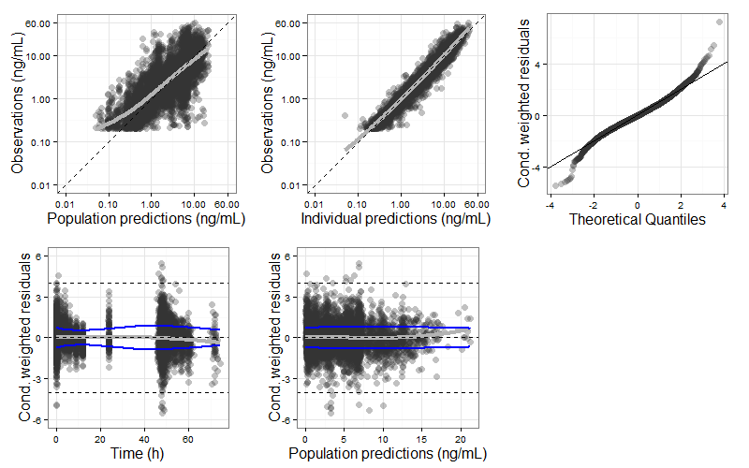
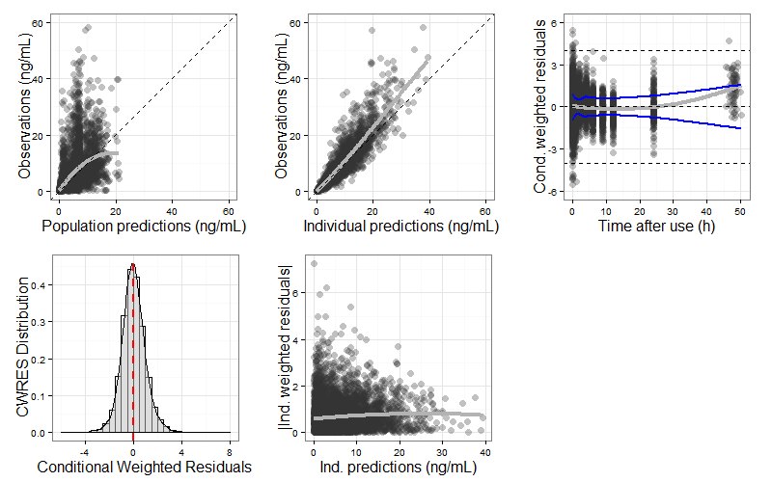
Supplementary Fig. 1 Goodness-of-fit Plots on the Base Model for Nicotine (Learning Dataset)
Blue curves: trend lines through positive and negative data points (obtained by LOESS: locally weighted scatterplot smoothing); Cond: Conditional; CWRES: conditional weighted residuals; Dashed line: either identity line or CWRES=0 line or CWRES=±4; Grey curve: trend line though all data points (LOESS); Ind.: Individual; Top panel is plotted on a semi-logarithmic scale.

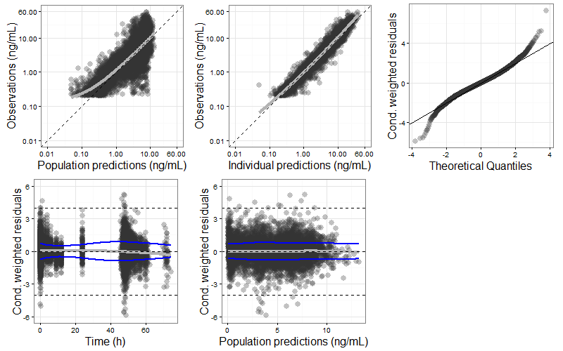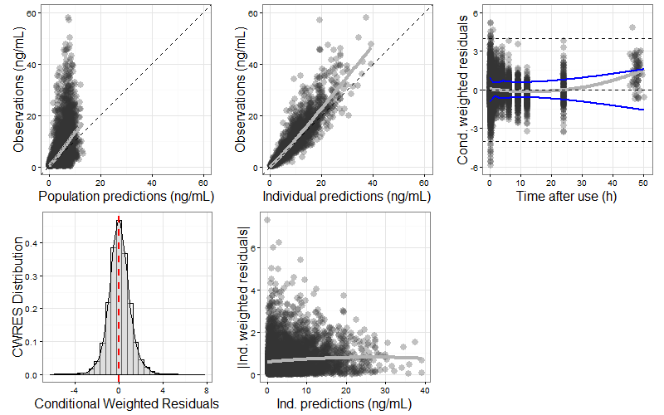
Supplementary Fig. 2 Goodness-of-fit Plots on the Final Model for Nicotine (Learning Dataset)
Blue curves: trend lines through positive and negative data points (obtained by LOESS: locally weighted scatterplot smoothing); Cond: Conditional; CWRES: conditional weighted residuals; Dashed line: either identity line or CWRES=0 line or CWRES=±4; Grey curve: trend line though all data points (LOESS); Ind.: Individual; Top panel is plotted on a semi-logarithmic scale.
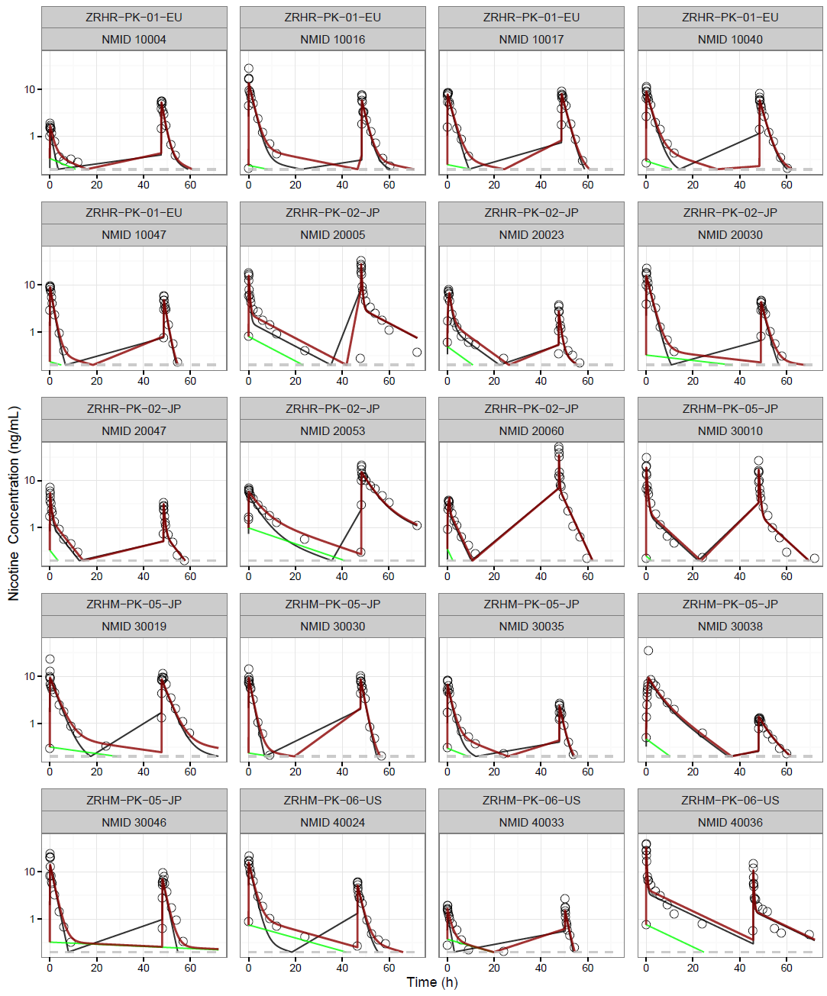
Supplementary Fig. 3 Randomly Selected Individual Fits
Grey circle: observation, grey line: individual prediction of product use, red line: individual prediction of total nicotine; green line: background prediction; dashed grey line: limit of quantification/2 (0.1 ng/mL); NMID: subject identifier number.

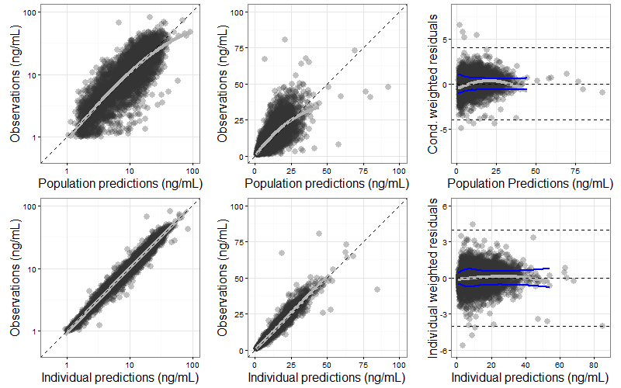
Supplementary Fig. 4 Goodness-of-fit Plots on the Final Model for Nicotine (Validation Dataset)
Blue curves: trend lines through positive and negative data points (obtained by LOESS: locally weighted scatterplot smoothing); Cond: conditional; CWRES: conditional weighted residuals; Dashed line: either identity line or CWRES=0 line or CWRES=±4; Grey curve: trend line though all data points (LOESS); Ind.: Individual; Top panel is plotted on a semi-log scale.

