Supplementary Figures

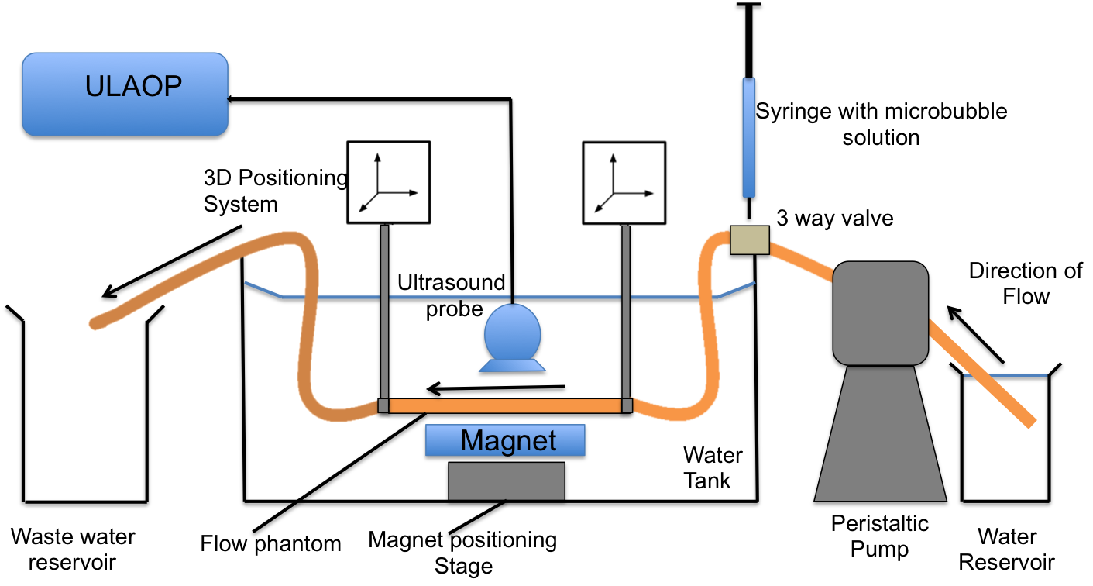
Supplementary Figure 1; schematic of the flow phantom with the magnetic Halbach array inserted below

