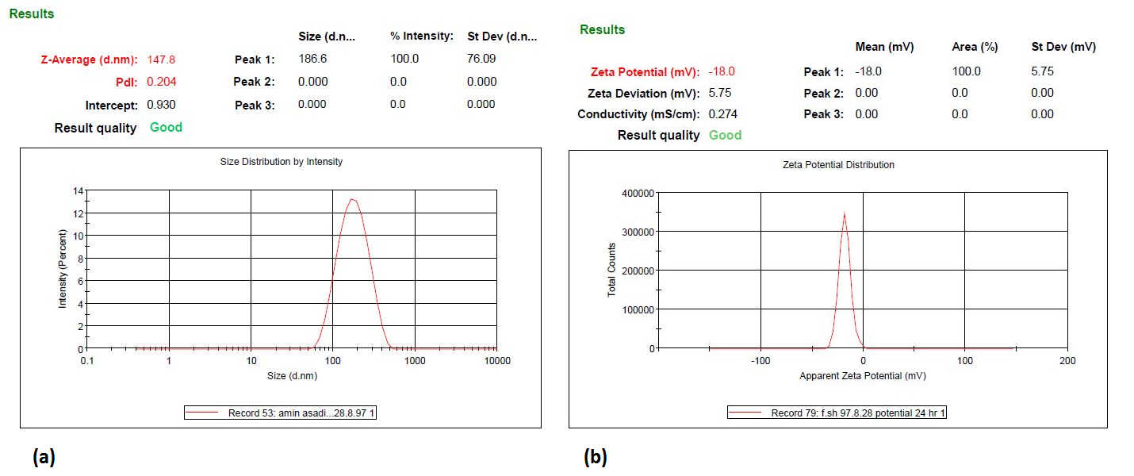
Supplementary Fig 1. Observed response values for the predicted optimal formulation.

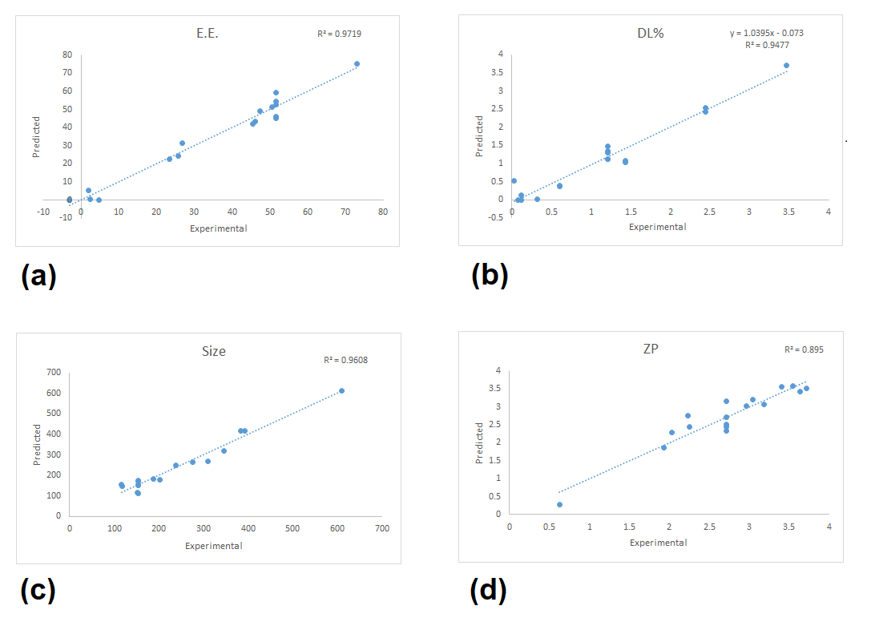

Supplementary Fig 2. Relationship between predicted and experimental values of all dependent variables. (a) encapsulation efficiency percent (E.E.%), (b) drug loading percent (DL%), (c) particle size, and (d) Zeta potential (ZP).

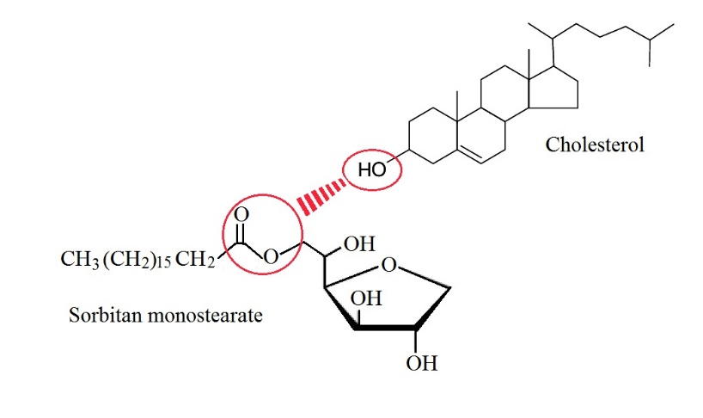
Supplementary Fig 3. The possible hydrogen bonding interaction between the cholesterol and Tween 60

Supplementary Fig 4. Histomorphologic scores of incisional wounds at 7 and 14 days after surgery.

