Dermal delivery of amitriptyline for topical analgesia

Chin-Ping Kung^{1*}, Bruno C. Sil², Yanling Zhang¹, Jonathan Hadgraft¹, Majella E. Lane¹, Bhumik Patel³, Renée McCulloch³

¹ UCL School of Pharmacy, 29-39 Brunswick Square, WC1N 1AX London, UK

² London Metropolitan University, 166‐220 Holloway Road, N7 8DB London, UK

³ Great Ormond Street Hospital for Children, Great Ormond Street, WC1N 3JH London, UK

* Corresponding author: c.kung@ucl.ac.uk (c.kung)

Supplementary Materials
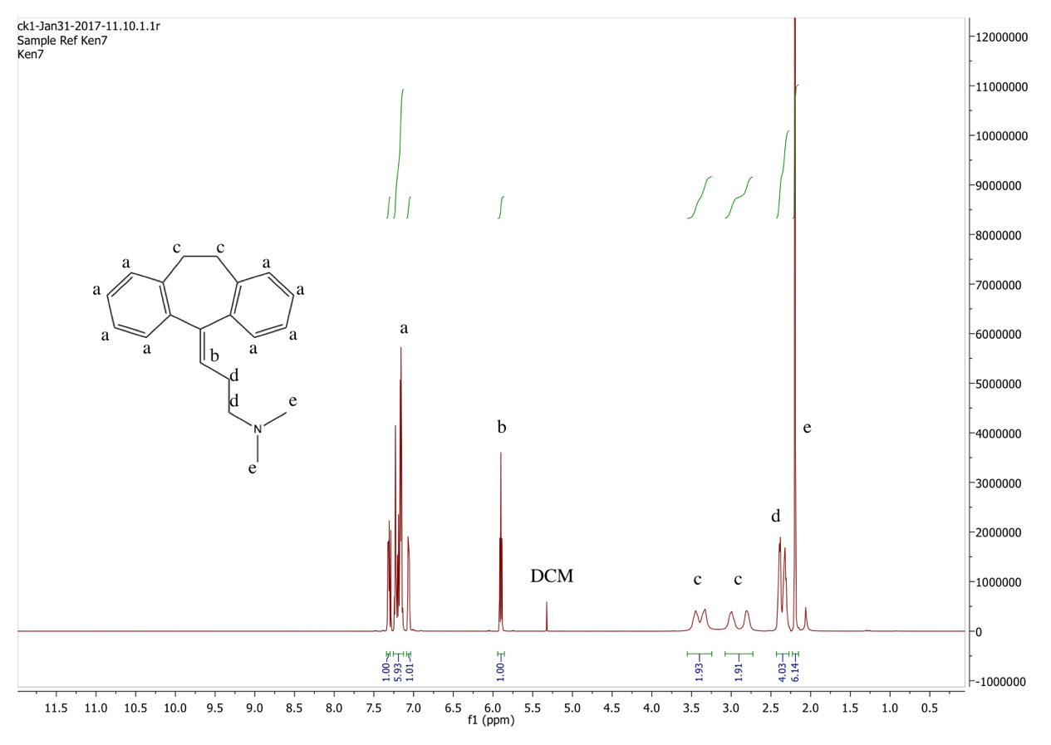
Fig. S1. ¹H NMR spectrum of amitriptyline free base in chloroform-d. ¹H NMR spectrum of amitriptyline free base in chloroform-d. ¹H NMR (500 MHz, Chloroform-d) δ 7.34 – 7.30 (m, 1H), 7.26 – 7.13 (m, 7H), 7.08 – 7.05 (m, 1H), 5.91 (t, 1H), 3.52 – 3.22 (m, 2H), 2.90 (d, 2H), 2.46 – 2.28 (m, 4H), 2.20 (s, 6H). There is no broad singlet around 13 ppm for the hydrochloride proton. This suggests the successful conversion of amitriptyline hydrochloride to amitriptyline free base. A small peak at 5.3 ppm was assigned to dichloromethane, the residual solvent.

Fig. S2. Electrical impedance measured across human skin over 24 h, (n=3, mean ± SD).

Table S1. HPLC method validation parameters.
Parameters | Concentrations (μg/mL) | Values
Accuracy (%) | 0.97 | 101.61 ± 0.24
Accuracy (%) | 24.18 | 100.35 ± 0.32
Accuracy (%) | 48.36 | 100.19 ± 0.19
Intra-day precision (%RSD) | 0.97 | 0.18
Intra-day precision (%RSD) | 24.18 | 0.32
Intra-day precision (%RSD) | 48.36 | 0.19
Inter-day precision (%RSD) | 0.97 | 1.43
Inter-day precision (%RSD) | 24.18 | 0.06
Inter-day precision (%RSD) | 48.36 | 0.23
Regression line equation |  | y = 26.96x – 3.74
Range |  | 0.5 – 100 µg/mL
r² |  | > 0.99
Limit of detection |  | 0.32 µg/mL
Limit of quantification |  | 0.96 µg/mL

Table S2. Summary of the solubility results for amitriptyline free base and amitriptyline hydrochloride in neat solvents at 32 ± 1 °C. The calculated van Krevelen and Hoftyzer solubility parameter of amitriptyline free base is 10.54 (cal/cm³)^{1/2}
Solvent | Solubility parameter (cal/cm³)^{1/2} | Solubility of amitriptyline free base (mg/mL) | Solubility of amitriptyline hydrochloride (mg/mL)
LIM | 8.02 | > 1149.27 | 0.11 ± 0.001
IPM | 8.21 | 984.49 ± 15.45 | 0.64 ± 0.09
PGML | 9.44 | >1600.05 | 92.18 ± 2.13
TC | 10.62 | > 1525.90 | 127.90 ± 15.80
OSAL | 10.87 | 968.50 ± 10.95 | 0.11± 0.003
PG | 14.06 | >1049.19 | 716.57 ± 4.13
LIM: limonene, IPM: isopropyl myristate, PGML: propylene glycol monolaurate, TC: Transcutol®P, OSAL: octyl salicylate, PG: propylene glycol.

