Controlled release of pharmaceutical agents using eutectic modified gelatin

Wanwan Quª Idrees B. Qader^{b} and Andrew P. Abbott,ª*

ªSchool of Chemistry, University of Leicester, Leicester LE1 7RH, UK
^{b}Pharmaceutical Chemistry Department, College of Pharmacy, Hawler Medical University, Erbil, Kurdistan Region, Iraq

Supplementary information
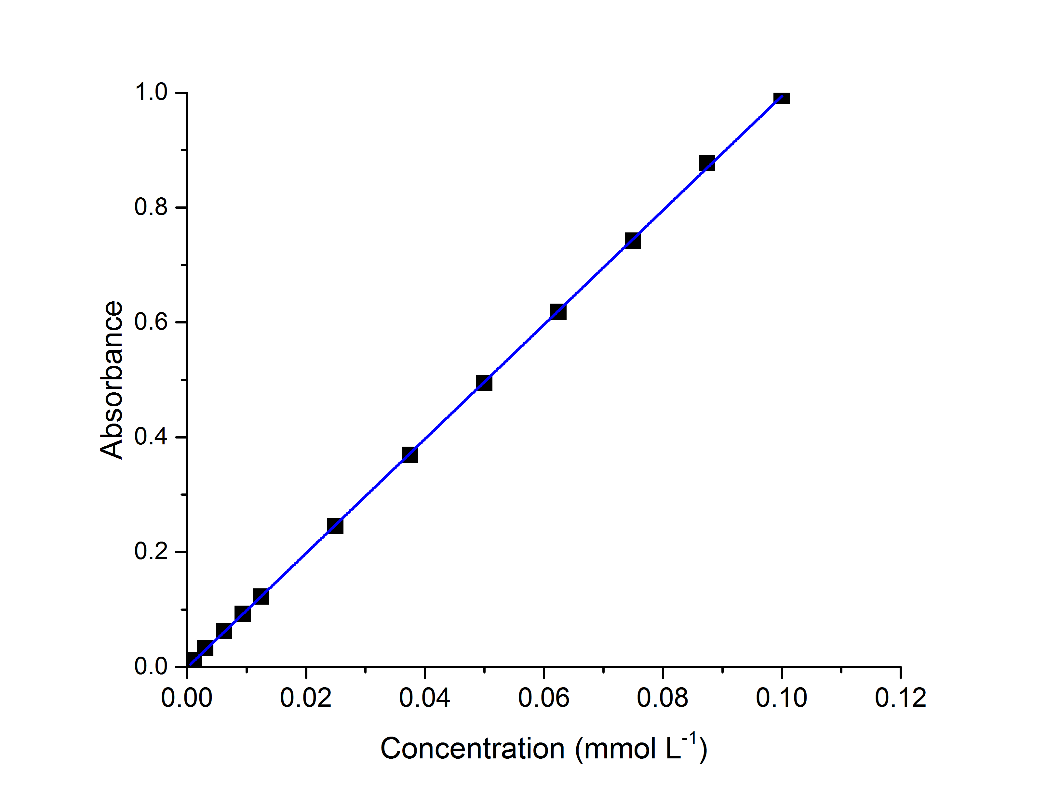(a) | 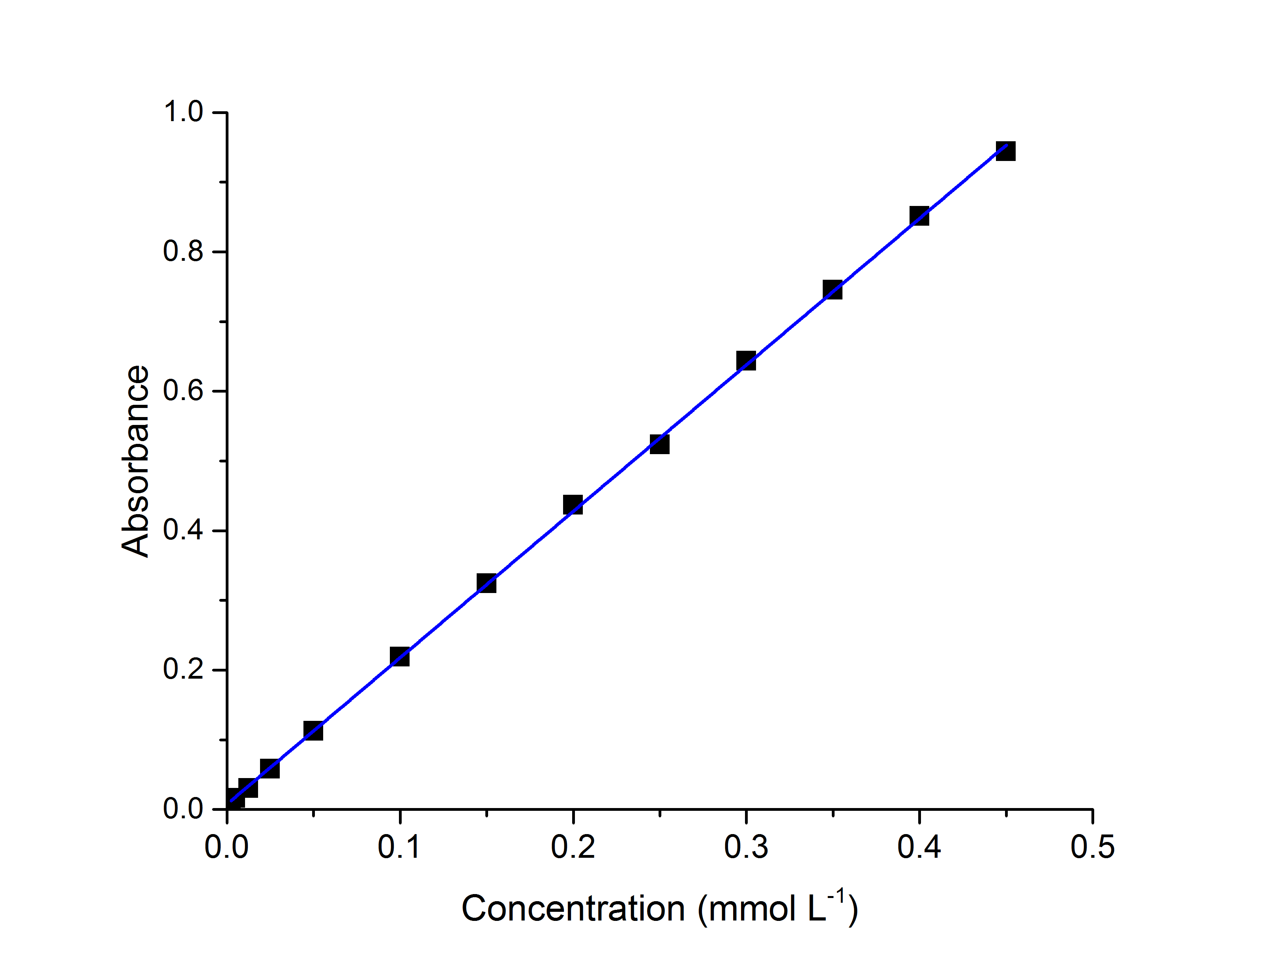(b)
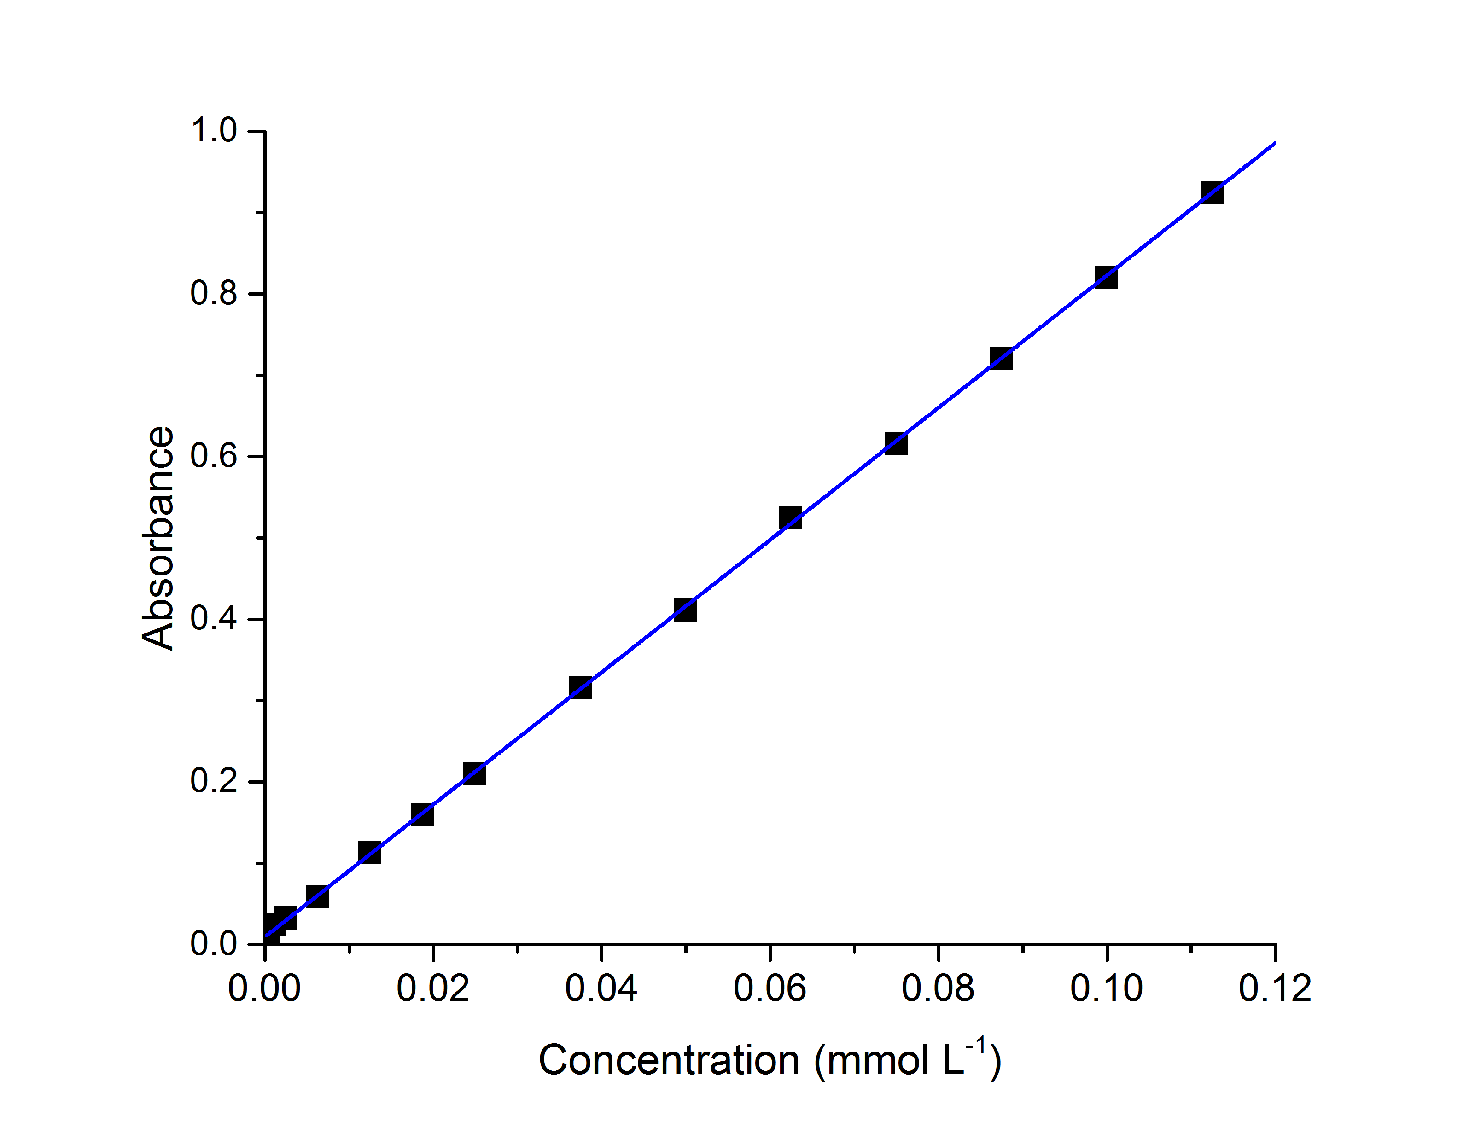
(c)

Figure 1S: UV-Vis spectroscopy calibration curves for standard concentrations of a) ascorbic acid b) catechol and c) imipramine HCl in 0.1M HCl. The error bars have been measured for three readings.

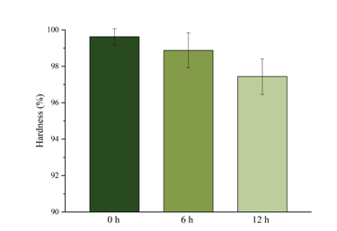
Figure 2S: Hardness comparison for gelatin samples plasticised by 20% wt ChCl:2 ascorbic acid after different lengths of setting time. The error bars have been measured for three readings.

(a)
(b)
(c)
Figure 3S: Dissolution rate of a) Pure ascorbic acid, ascorbic acid + ChCl, b) Pure catechol, catechol + ChCl and c) Pure imipramine HCl, imipramine HCl + glycerol in 0.1mol /l HCl at 37 ± 0.5°C.
(a)
(b)
(c)
Figure 4S: The intensity size distribution of (a) ascorbic acid + ChCl, (b)catechol + ChCl and (c) imipramine hydrochloride + glycerol versus particle diameter in nanometers. The different colors represent repeat measurements of the same sample.
(a): Ascorbic acid + ChCl + gelatin
(b): Catechol + ChCl + gelatin
(c): Imipramine HCl + glycerol + gelatin
Figure 5S: dissolution rate of PDES tablets made in two different methods in 0.1mol/l HCl at 37 ± 0.5°C.

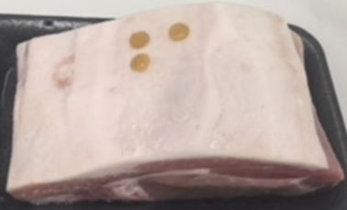
Figure 6S: Gelatin-based drug patches on pig loin for transdermal drug delivery test.

