SUPPLEMENTARY INFORMATION

Direct cyclodextrin based powder extrusion 3D printing for one-step production of the BCS Class II Niclosamide
Monica Pistone¹; Giuseppe Francesco Racaniello¹; Ilaria Arduino¹; Valentino Laquintana¹; Antonio Lopalco¹; Annalisa Cutrignelli¹; Rosanna Rizzi²; Massimo Franco¹; Angela A. Lopedota^{1, *}; Nunzio Denora^{1, *}
¹ Department of Pharmacy – Pharmaceutical Sciences, University of Bari “Aldo Moro”, Orabona St. 4, 70125 - Bari, Italy
² Institute of Crystallography-CNR, Amendola St. 122/o, 70126 – Bari, Italy

*Corresponding authors: Prof. Nunzio Denora e-mail: nunzio.denora@uniba.it ; Prof.ssa Angela A. Lopedota e-mail: angelaassunta.lopedota@uniba.it

Materials and Methods

1.1. TGA analysis
The TGA analysis were performed on Blend 4 using PerkinElmer Thermogravimetric Analyzer Pyris 1 TGA. Sample (9 mg) was placed in platinum pans and was then heated from 30 to 600 °C using 5 °C/min as a heating rate. The thermal decomposition (or degradation) profile was analysed using Pyris™ software version 11 The experiments were carried out under nitrogen gas flow of 20 mL/min.
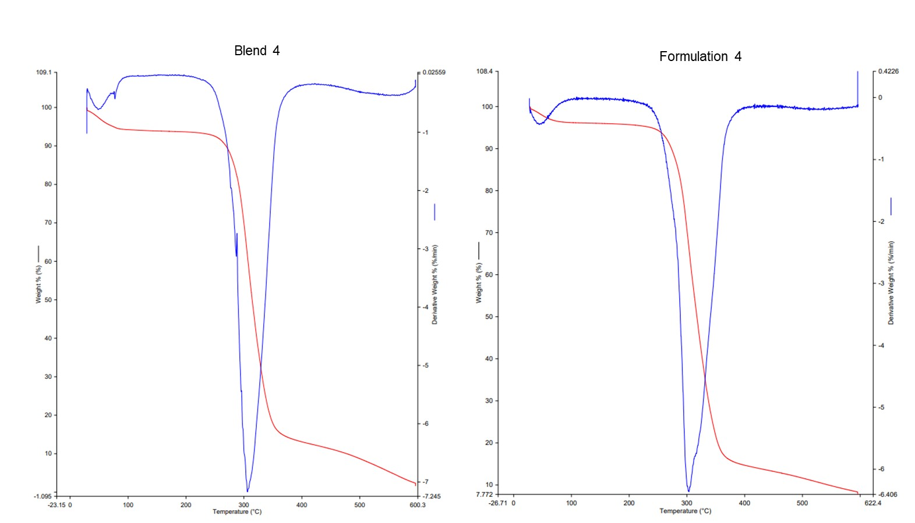
S1. Thermogravimetric Analysis (TGA) of Blend 4 and Formulation 4.

1.2. Qualitative Analysis of NCS by HPLC
To qualitatively assess the presence of not degraded NCS during the printing process, HPLC analyses were conducted. A sample of NCS maintained at 180 °C for 15 min and samples derived from the solubilisation of formulation 4 (see below) were also analysed. The investigations were performed with an Agilent 1260 Infinity Quaternary LC System equipped with an Agilent variable wavelength UV detector, a Rheodyne injector (Rheodyne, Model 7725i) equipped with a 20 µL loop and a OpenLAB CDS ChemStation software (Agilent, Santa Clara, CA). A ZORBAX Eclipse plus C18 column (4.6x250 mm 5-Micron) was used as the stationary phase and maintained at 30 °C for the duration of the analysis. The mobile phase consisted of methanol : phosphate buffer 1 mM (85:15 v/v) at pH 5.47 and was pumped at a flow rate of 0.7 mL/min. The wavelength selected for elution monitoring was 334 nm. A calibration line (R² = 0.9998) was obtained by analysing a range of concentrations between 0.05 and 0.005 mg/ml.

1.3. Mass spectroscopy
Mass spectrometry was performed using Agilent 6530 accurate mass Q-TOF. Mass spectra were achieved in negative (ESI⁻).
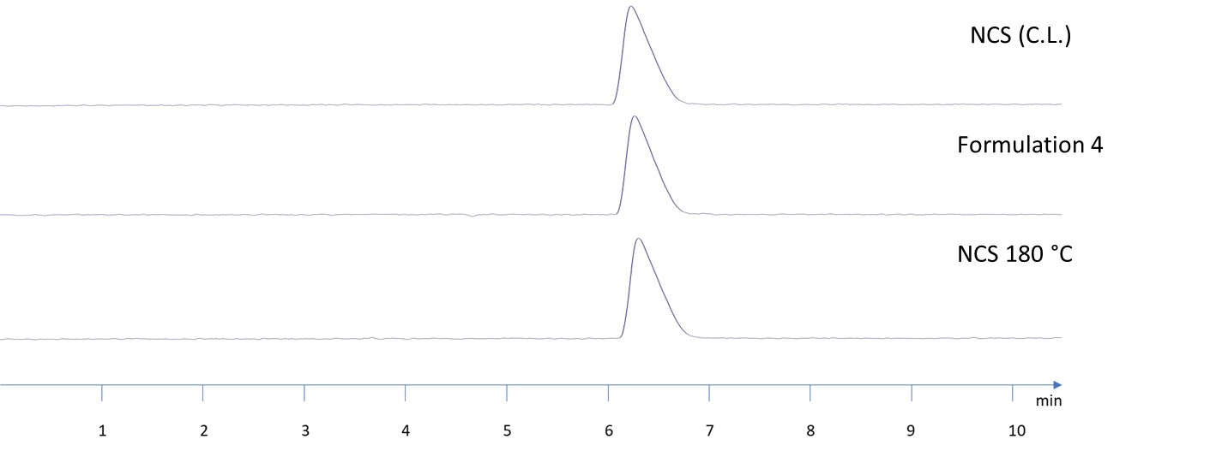
S2. Chromatograms for NCS (Calibration line), Formulation 4, and NCS placed at 180 °C for 15 minutes.

