Pre-clinical 2D and 3D toxicity response to a panel of nanomaterials; Comparative assessment of NBM-induced liver toxicity
Melissa Anne Tuttya,b, Gabriele Vellaa,b,, Adriele Prina-Melloa,b,c
a Nanomedicine and Molecular Imaging Group, Trinity Translational Medicine Institute (TTMI), School of Medicine, Trinity College Dublin, Dublin 8, Ireland
b Laboratory for Biological Characterisation of Advance Materials (LBCAM), TTMI, School of Medicine, Trinity College Dublin, Dublin 8, Ireland
c Trinity St James’s Cancer Institute, Trinity College Dublin, St James’s Hospital, Dublin 8, Ireland

SUPPLEMENTARY INFORMATION

Corresponding Authors:
*Dr. Melissa Anne Tutty
Email: tuttym@tcd.ie
ORCID: 0000-0002-6705-2492

*Dr. Adriele Prina-Mello
Email: prinamea@tcd.ie
ORCID: 0000-0002-4371-2214

Keywords: nanobiomaterials; 3D culture; spheroids; cytotoxicity; viability; HepG2; liver spheroid; 3Rs.

Supplementary Figure 1
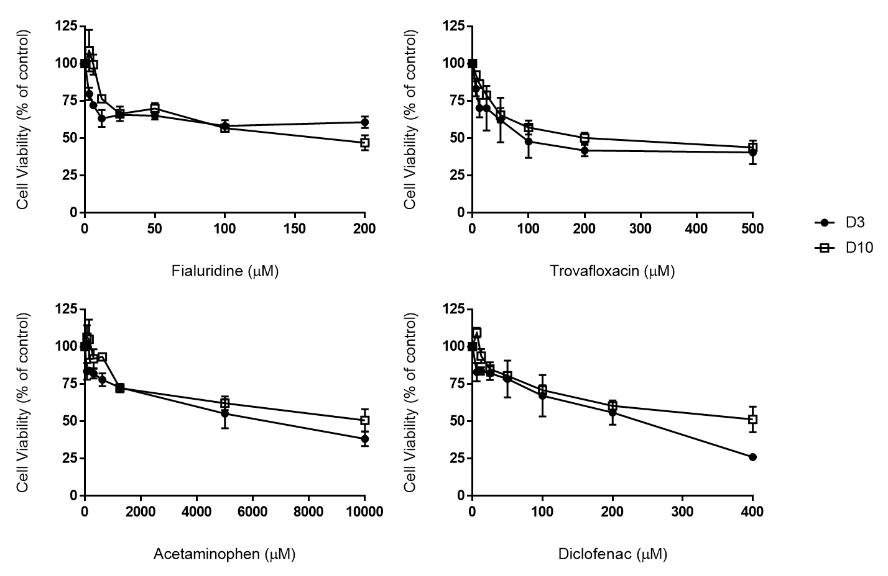
Supplementary Figure 1. Effect of culture time on spheroid response to hepatotoxins. Spheroids were cultured for both 3-day or 10-day and then incubated with the four chosen hepatotoxins (acetaminophen, diclofenac, fialuridine, and trovafloxacin) with repeated dosing at day 5 and day 12. Cell viability was determined using ATP quantification and results plotted as a percentage of untreated control. Data are represented as mean ± SEM (n=3 in duplicate). Changes were not statistically different (multiple t-tests with Bonferroni Dunn method).

