Supplementary to section 3.1: Infliximab microencapsulation
Table 2. Process yield (P.Y) and Encapsulation Efficiency (E.E) of developed formulations.
 | PEOT-PBT | PLGA RG502 | PLGA RG503 | Technique | P.Y. (%) | E.E (%)
F1 | 100 % | 0 % | 0 % | UA | 84.2 ± 2.1 | 69.74 ± 3.21
F2 | 65 % | 35 % | 0 % | UA | 94.5 ± 1.9 | 70.32 ± 3.18
F3 | 65 % | 0 % | 35 % | UA | 91.3 ± 1.7 | 80.21 ± 2.97
F4 | 100 % | 0 % | 0 % | Em/Ev | 68.7 ± 2.9 | 22.99 ± 1.90
F5 | 65 % | 35 % | 0 % | Em/Ev | 84.1 ± 3.2 | 17.26 ± 0.92
F6 | 65 % | 0 % | 35 % | Em/Ev | 79.2 ± 3.1 | 21.33 ± 1.02

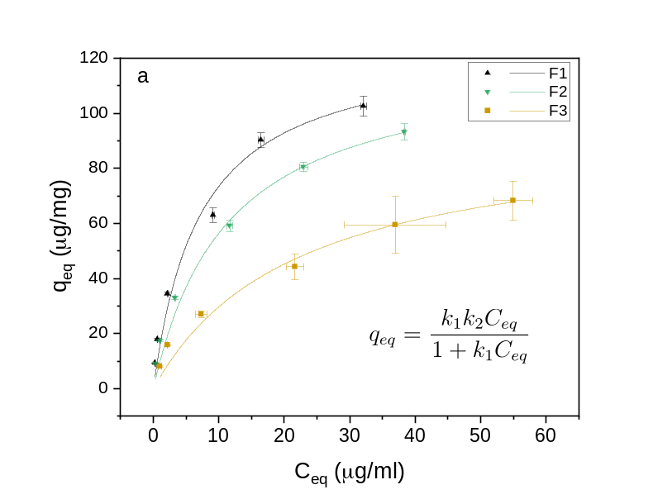
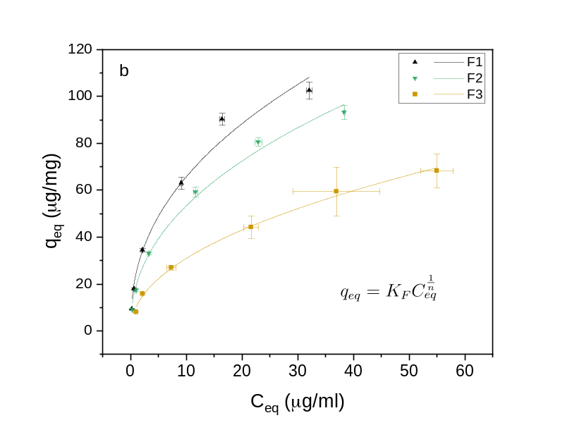
Supplementary to section 3.5: Surface Hydrophobicity
Fig. s1 Langmuir (a) and Freundlich (b) adsorption isotherms of Rose Bengal to the surface of microcapsules fabricated by UA in PBS 100 mM, pH 7.4 at 20ºC: F1 (PEOT-PBT), F2 (65:35 PEOT-PBT: PLGA RG502) and F3 (65:35 PEOT-PBT: PLGA RG503).

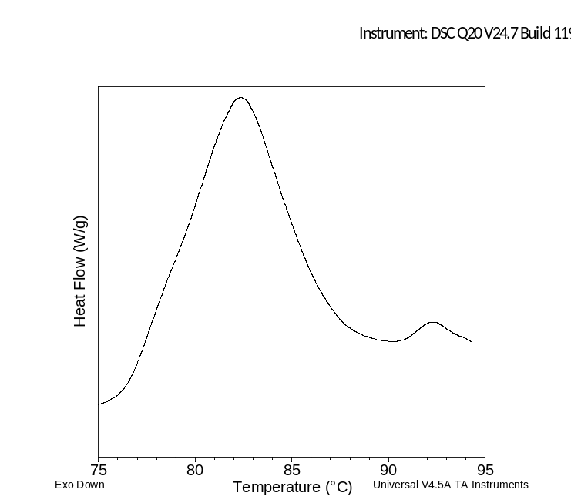
Supplementary to section 3.6: Differential Scanning Calorimetry
Fig. S2. DSC thermogram of INF (Remicade®) in solution (PBS 10 mM, pH 7,2). Characteristic endothermic transitions attributed to the denatured variable domain of the protein (F_{ab}) and the CH₃ domain of the heavy chains were detected.

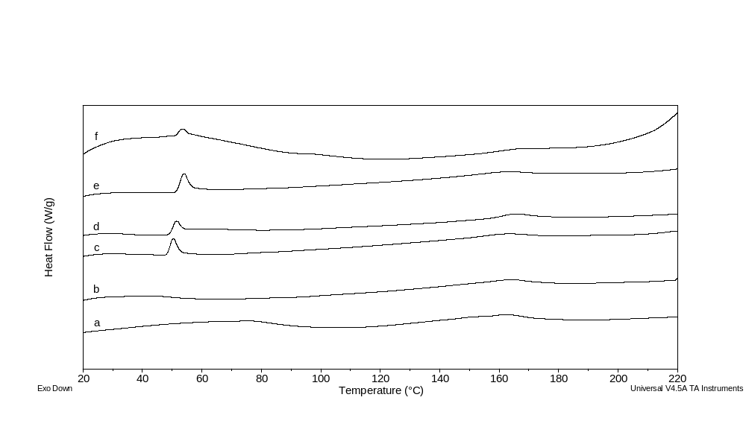
Fig. S3 DSC thermograms of microparticulate formulations fabricated by UA: Empty F1 (a), F1 (b), Empty F2 (c), F2 (d), Empty F3 (e), F3 (f).

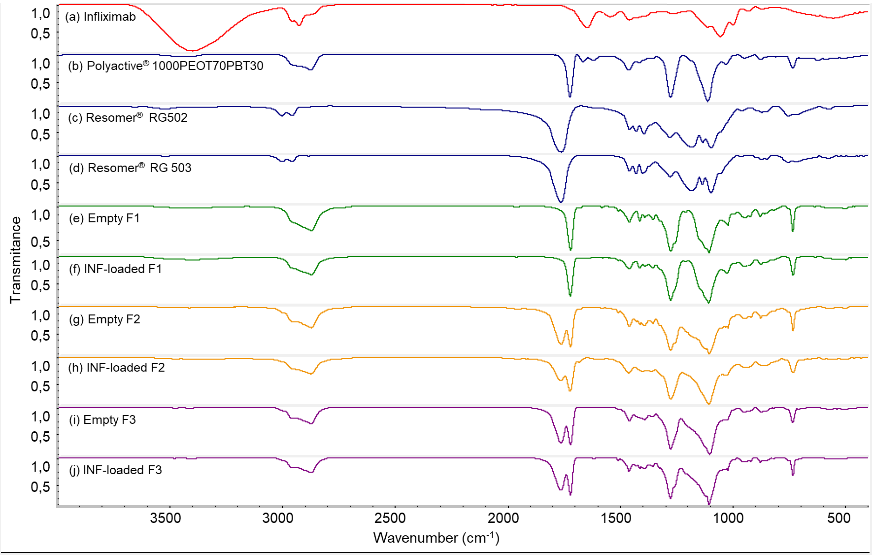
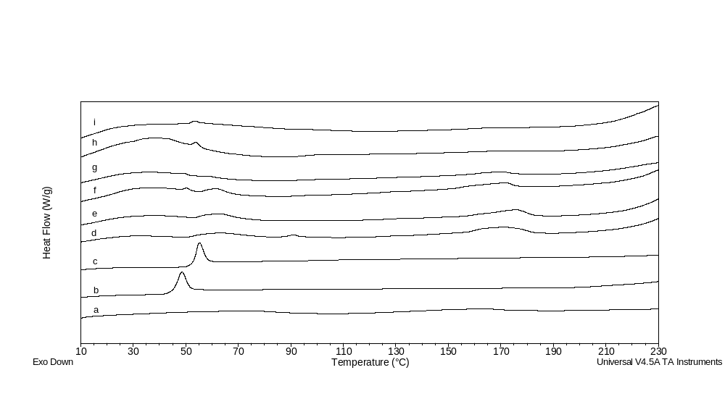
Supplementary to section 3.7: Fourier Transform Infrared Spectroscopy
Fig. S5 FTIR spectra of pure Infliximab (a), Polyactive® 1000PEOT70PBT30 (b), Resomer® RG502 (c), Resomer® RG503 (d), empty MCs (e, g, i) and INF-loaded MCs (f, h, j).
Fig. S4 DSC thermograms of Polyactive® 1000PEOT70PBT30 (a), Resomer® RG502 (b), Resomer® RG503 (c), Empty F4 (d), F4 (e), Empty F5 (f), F5 (g), Empty F6 (h), F6 (i).

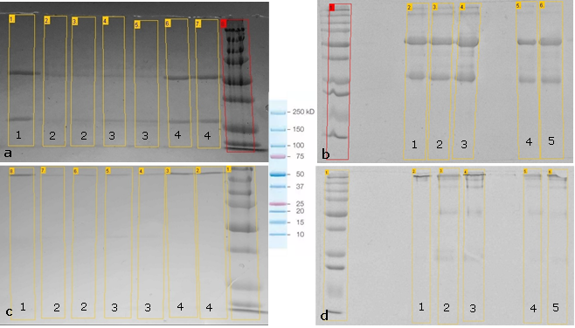
Supplementary to section 3.9: Structural stability of infliximab
Fig. S6 SDS page electrophoresis under reducing (a, b) and non-reducing (c, d) conditions of INF standard (1a, 5b; 1c, 5d), Ultrasonic atomized infliximab (4b; 4d) and INF extracted from microparticulate formulations F1(1b; 1d), F2 (b2; d2),, F3 (b3; d3), F4 (a2, c2), F5 (a3, c3) and F6 (a4, c4).

Supplementary to section 3.10: Biological activity of microencapsulated INF
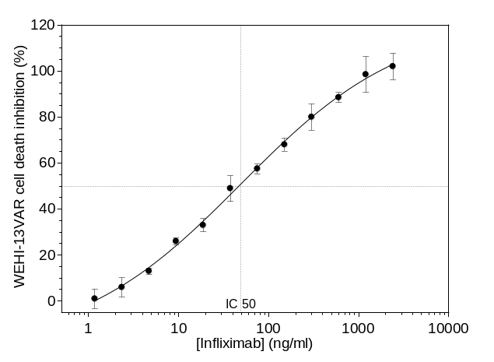
Fig.S7 Dose-response curve obtained for the neutralization of TNF-α produced by THP-1 macrophages after incubation with different concentrations of INF in solution.

