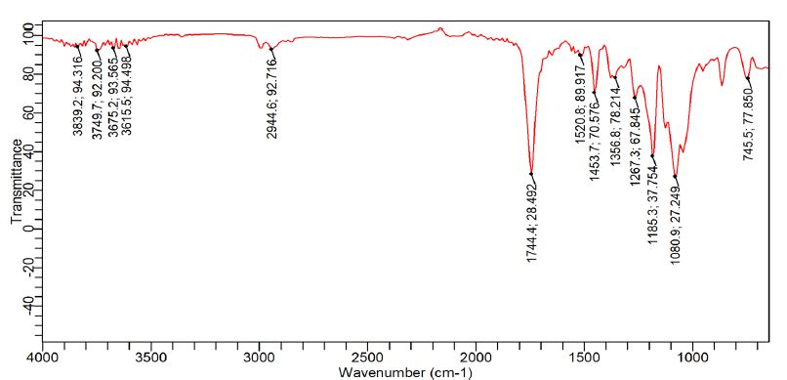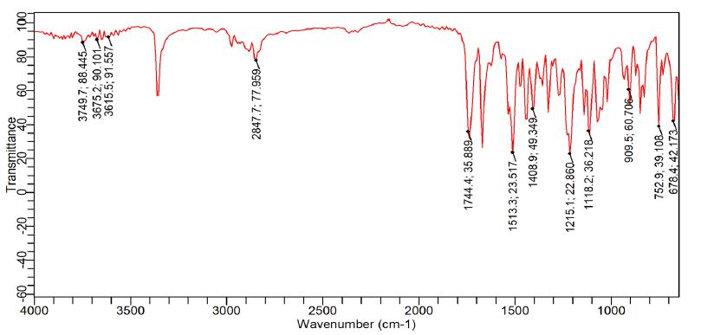
a
b
c
d
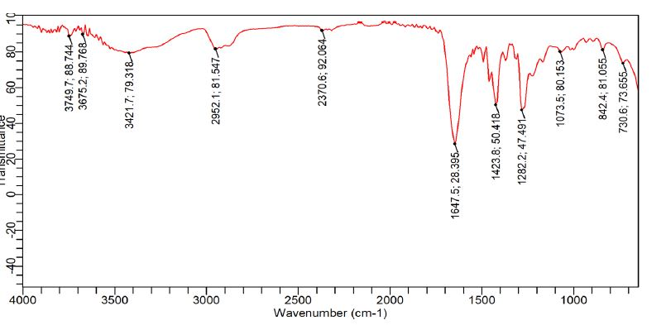
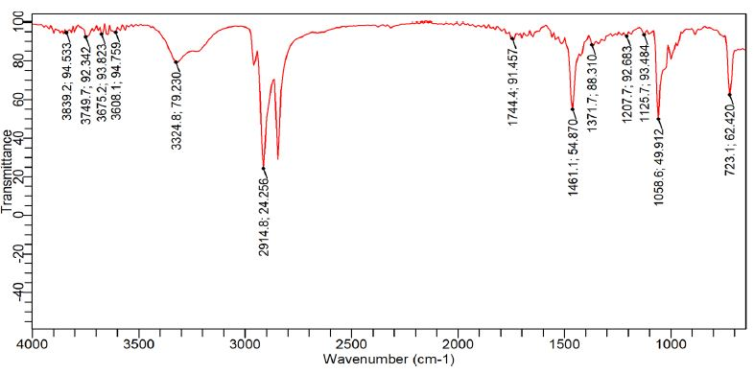
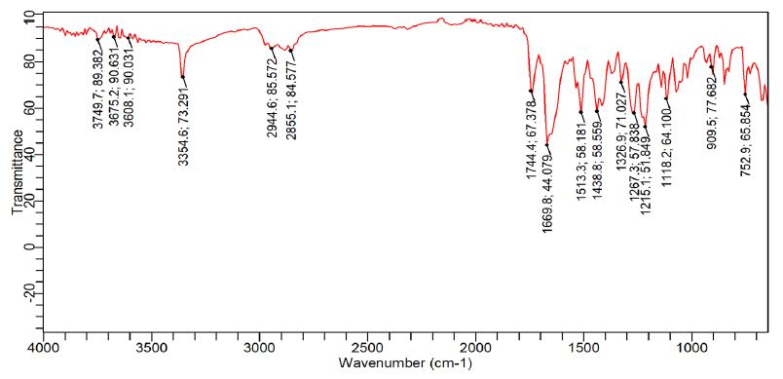
e
f
g
h
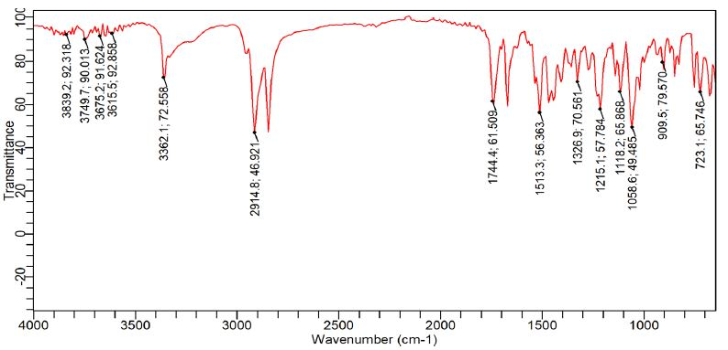
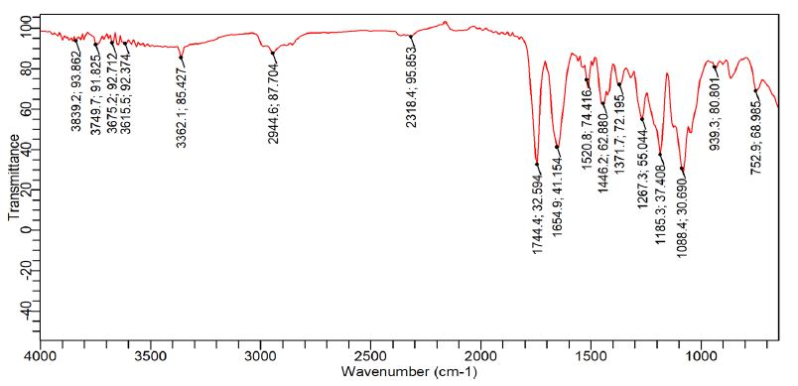
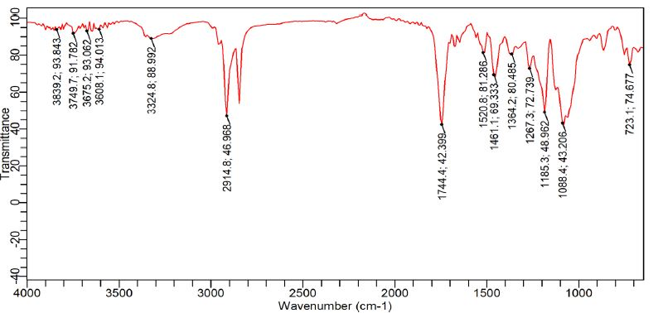

Supplimintary-1. FT-IR spectra of: a) Linezolid, b) Poly-Lactied, c) PVP K30, d) Cetyl alcohol, e) physical mixture of NP3 components, f) physical mixture of NP6 components, g) NP3 and h) NP6.

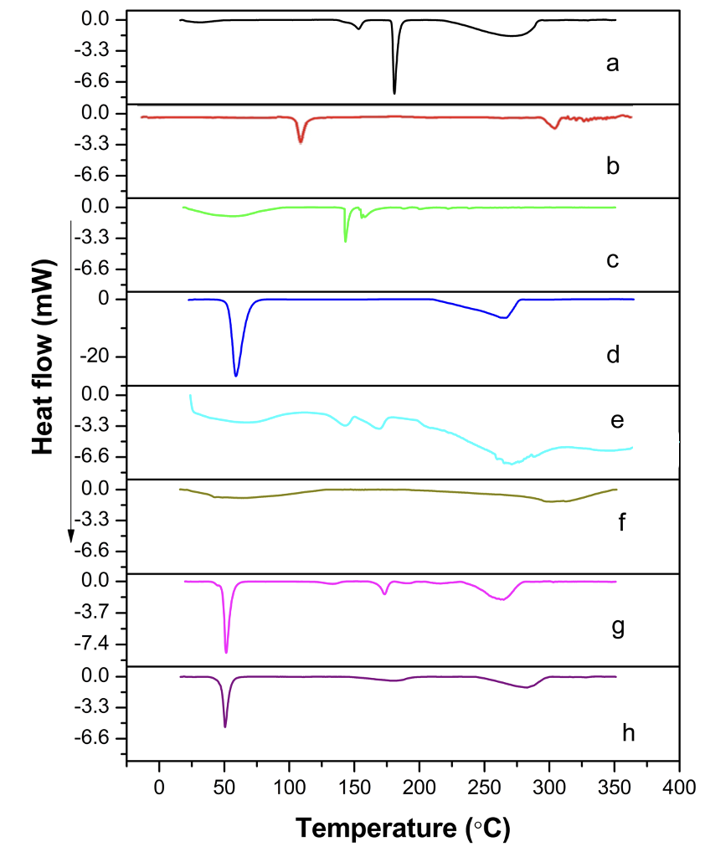
Supplimintary-2. DSC thermograms of a) Linezolid, b) Poly-Lactied, c) PVP K30, d) Cetyl alcohol, e) physical mixture of NP3 components, f) NP3, g) physical mixture of NP6 components and h) NP6.

