Supplementary material

- Size and Zeta Potential Analysis of PXs by Dynamic Light Scattering and Laser Doppler Anemometry

1.1 PS80-concentration optimization

A | 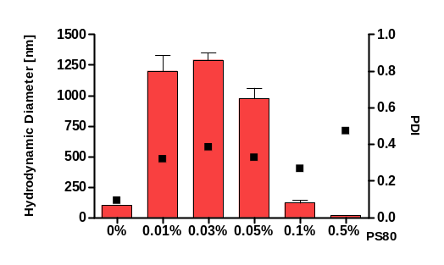 | B | 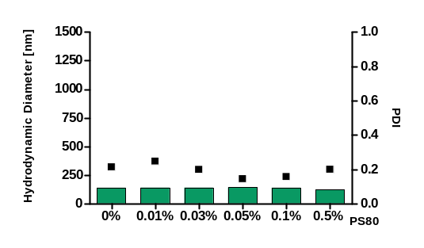
Figure S1. DLS measurements of PS80-b-PEI PXs (A) and PS80-NM_{0.2}/CP_{0.8} PXs (B) coated with varying PS80 concentrations (0.01% - 0.5% PS80) in comparison to uncoated particles (0% PS80). (Data points indicate mean ± SD, n = 3).

- Quantification of cellular uptake into glioblastoma cells by flow cytometry

2.1 LRP1-Receptor expression of glioblastoma cells
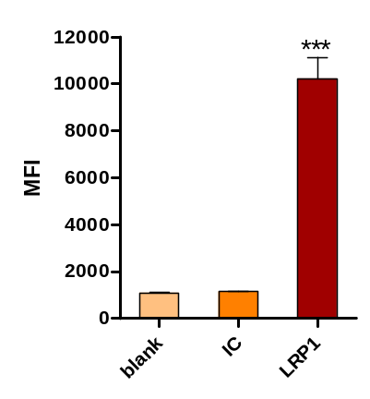
Figure S2. LRP1-receptor expression of U87 glioblastoma cells as determined by flow cytometry and presented as median fluorescence intensity (MFI): Cells were first stained with anti – LRP1 primary antibody or mouse IgG1 monoclonal antibody as isotype control (IC) to exclude unspecific binding and consequently reacted with AF488-labeled secondary goat anti-mouse IgG H&L antibody. Blank samples were left unstained. (Results are presented as median fluorescence intensity (MFI) and shown as mean ± SD, n = 3, one-way ANOVA with Bonferroni post-hoc test, *** p < 0.005).

2.2 Trypan quenching
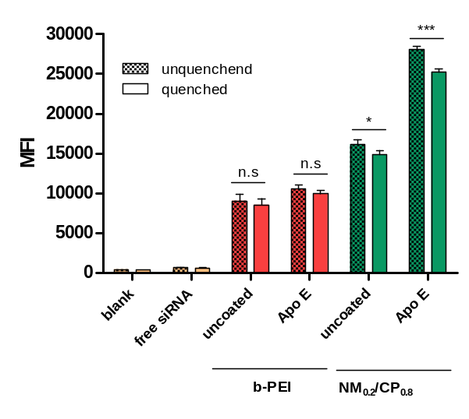
Figure S3. Cellular uptake of uncoated PXs and ApoE coated PXs after 24 h incubation as quantified by flow cytometry performed with and without trypan quenching and presented as median fluorescence intensitiy (MFI). Negative control: untreated cells (blank) and with free siRNA treated cells. (Results are shown as mean ± SD, n = 3, two-way ANOVA with Bonferroni post-hoc test, n.s (= not significant) p > 0.05, * p < 0.05, *** p < 0.005).

3. Influence of PS80 coating on celllar uptake efficacy

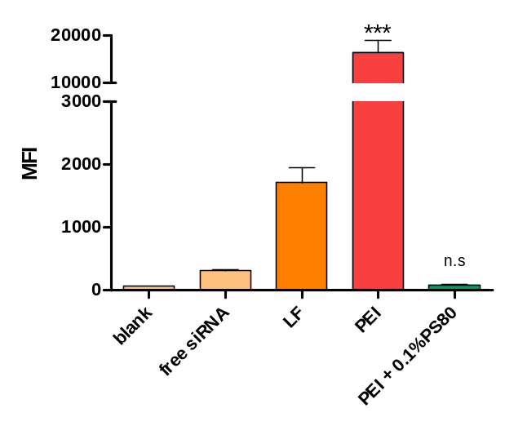
Figure S4. Cellular uptake of uncoated b-PEI and PS80-b-PEI PXs (b-PEI PXs: N/P ratio 7, final PS80 concentration = 0.1%) after 24 h incubation as quantified by flow cytometry and presented as median fluorescence intensitiy (MFI). Negative control: untreated cells (blank) and with free siRNA treated cells. Positive control: Lipofectamin 2000 lipoplexes (LF). (Results are shown as mean ± SD, n = 3, one-way ANOVA with Bonferroni post-hoc test, n.s (= not significant) p > 0.05, *** p < 0.005).

