Supplementary Data
Development of Antifungal Fibrous Ocular Insert Using Freeze-drying Technique
Hoda E. Tebaª, Islam A. Khalilª, Rana M. Gebreelª, Lamiaa I. Fahmy^{b} and Heba M. El Sorogyª
ª Department of Pharmaceutics, Faculty of Pharmacy and Drug Manufacturing, Misr University for Science and Technology, 12566, 6th of October, Giza, Egypt
^{b} Department of Microbiology and Immunology, Faculty of Pharmacy, October University for Modern Sciences and Arts, 12451, 6th of October, Giza, Egypt
Hoda E. Teba hoda.teba@must.edu.eg
Islam A. Khalil islam.khalil@must.edu.eg
Rana M. Gebreel rana.mohamed@must.edu.eg
Lamiaa I. Fahmy Lismail@msa.edu.eg
Heba M. El Sorogy heba.moner@must.edu.eg
Corresponding author: Heba M. El Sorogy
Egypt Email: heba.moner@must.edu.eg
Phone number: +201220892890, Egypt
Department of Pharmaceutics, Faculty of Pharmacy and Drug Manufacturing, Misr University for Science and Technology, 12566, 6th of October, Giza, Egypt

F1 | 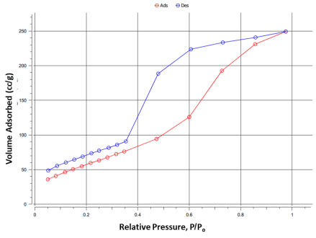 | 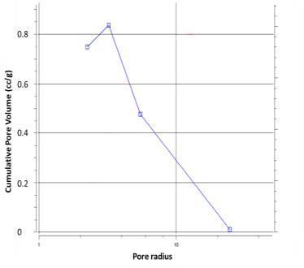 | 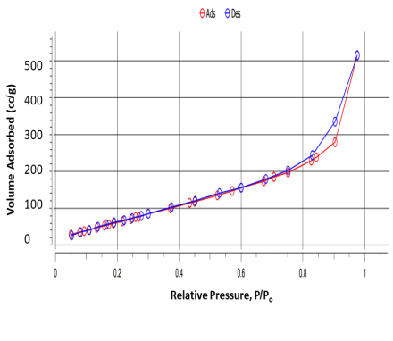
F2 | 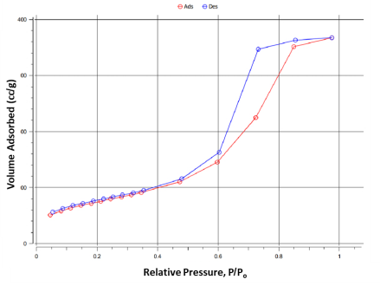 | 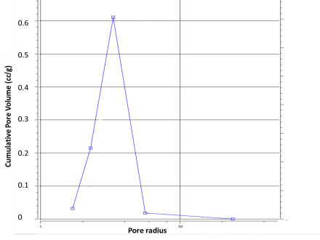 | 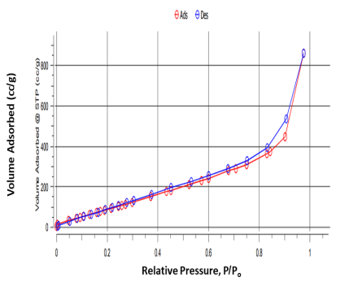
F3 | 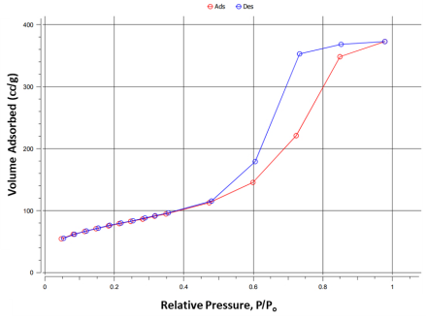 | 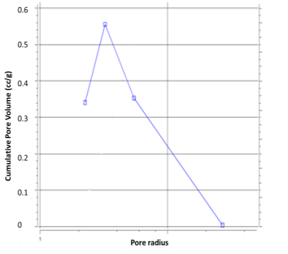 | 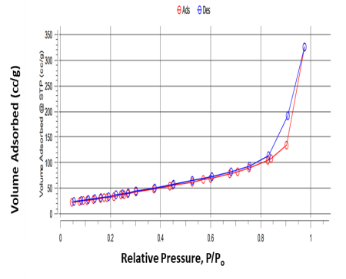
F4 | 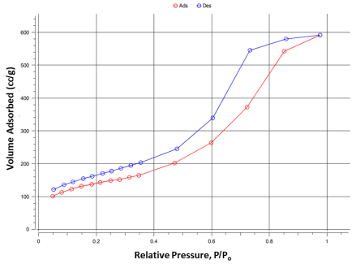 | 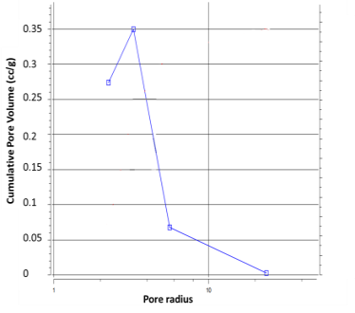 | 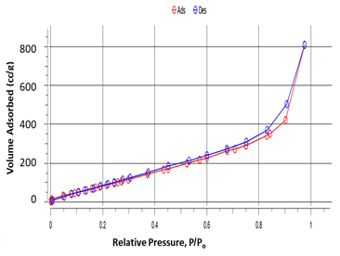
 | [a] | [b] | [c]

Fig. S1 N₂ adsorption/desorption isotherms [a], The BJH pore size distributions of plain Fs [b], and N₂ adsorption/desorption isotherms of FLZ-loaded Fs [c].

