PLGA-PEI nanoparticle covered with poly(I:C) for personalised cancer immunotherapy
Drug Delivery and Translational Research (DDTR)

Lorena Gonzalez-Melero^{1,2†}, Edorta Santos-Vizcaino^{1,2,3†}, Rubén Varela-Calvino⁴, Iria Gomez-Tourino^{5,6}, Aintzane Asumendi^{7,8}, Maria Dolores Boyano^{7,8}, Manoli Igartua^{1,2,3}*, Rosa Maria Hernandez^{1,2,3}*
¹NanoBioCel Research Group, Laboratory of Pharmaceutics, School of Pharmacy, University of the Basque Country (UPV/EHU), Vitoria-Gasteiz, Spain.
²Bioaraba, NanoBioCel Research Group, Vitoria-Gasteiz, Spain.
³Biomedical Research Networking Centre in Bioengineering, Biomaterials and Nanomedicine (CIBER-BBN). Institute of Health Carlos III, Madrid, Spain.
⁴Department of Biochemistry and Molecular Biology, School of Pharmacy, University of Santiago de Compostela, Santiago, Spain.
⁵Centre for Research in Molecular Medicine and Chronic Diseases (CiMUS), University of Santiago de Compostela, Santiago, Spain.
⁶Health Research Institute of Santiago de Compostela (IDIS), Santiago, Spain.
⁷Biocruces Bizkaia Health Research Institute, 48903 Barakaldo, Spain.
⁸Department of Cell Biology and Histology, Faculty of Medicine and Nursing, University of the Basque Country (UPV/EHU), 48940 Leioa, Spain.
*co-correspondings: rosa.hernandez@ehu.eus; manoli.igartua@ehu.eus
†These two authors contributed equally to this work.

Supplementary Table 1. Mean NP size (Z-average diameter), polydispersity index (PDI) and Z-potential values for NPs covered at pH 4.6 with 0-350 µg/ml poly(I:C) shows high NP sizes and suboptimal PdI values.
Formulation | Size (nm) | PdI | Zeta potential (mV)
NP PLGA PEI - pH 4,6 – 0 µg/ml poly(I:C) | 328,9 ± 1,4 | 0,309 ± 0,018 | 8,37 ± 0,17
NP PLGA PEI - pH 4,6 - 150 µg/ml poly(I:C) | 2347,0 ± 388,38 | 0,855 ± 0,108 | -8,59 ± 0,04
NP PLGA PEI - pH 4,6 - 250 µg/ml poly(I:C) | 772,3 ± 52,1 | 0,522 ± 0,066 | -19,70 ± 0,87
NP PLGA PEI - pH 4,6 - 350 µg/ml poly(I:C) | 608,6 ± 47,69 | 0,407 ± 0,003 | -26,71 ± 0,36

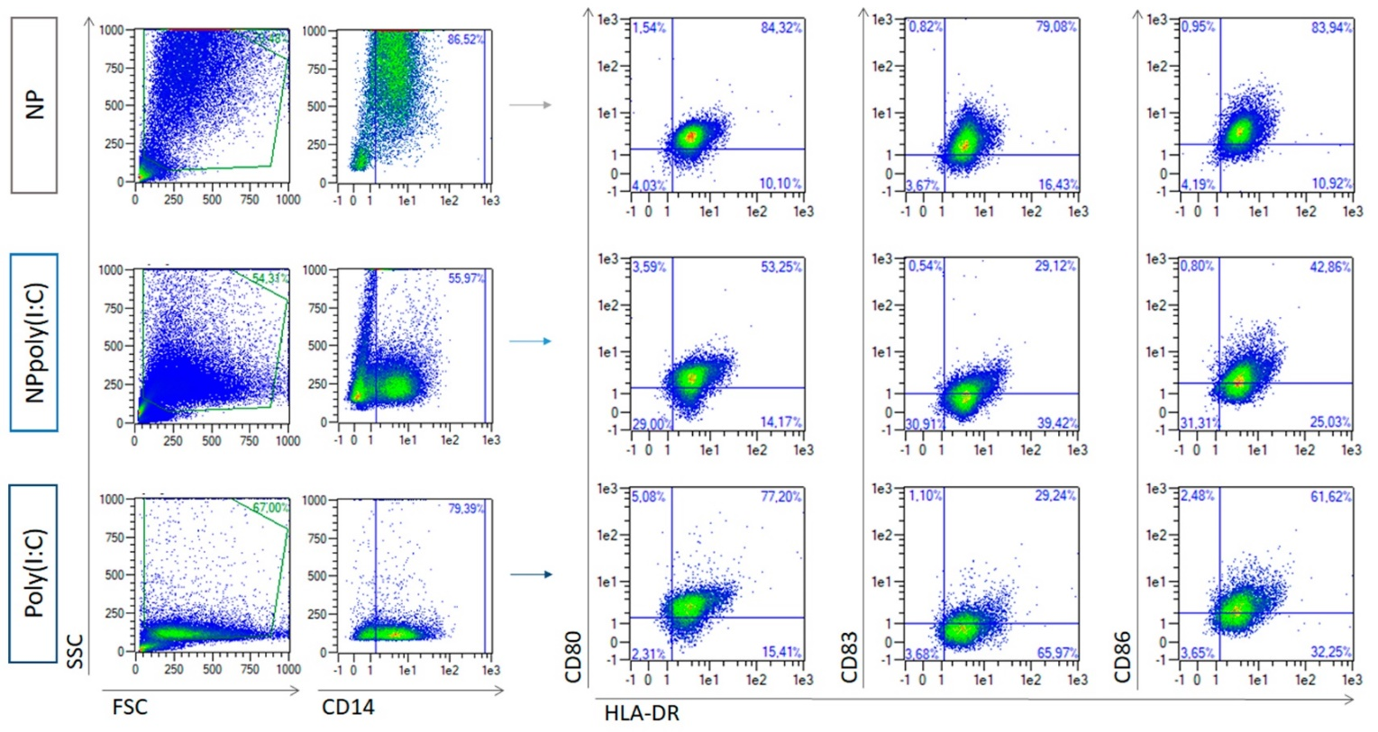
Supplementary figure 1. Representative flow cytometry plots from DCs after maturation with 5 µg/ml poly(I:C), NPpoly(I:C) and non-covered NPs.

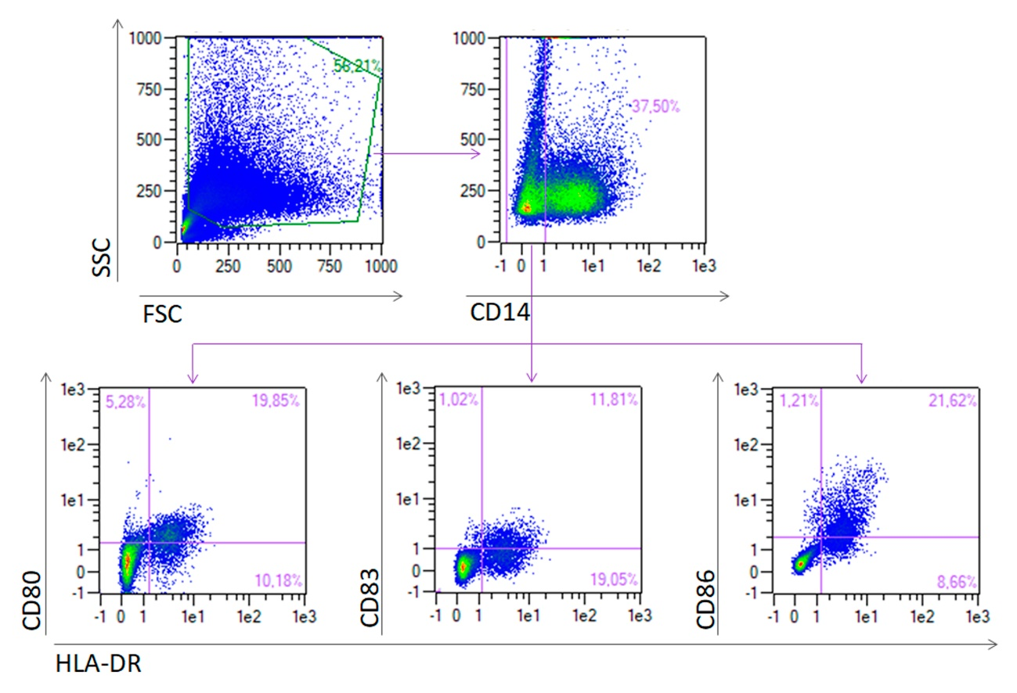
Supplementary figure 2. Representative flow cytometry plots from CD14⁻ cells after maturation with NPpoly(I:C) at 5 µg/ml poly(I:C).

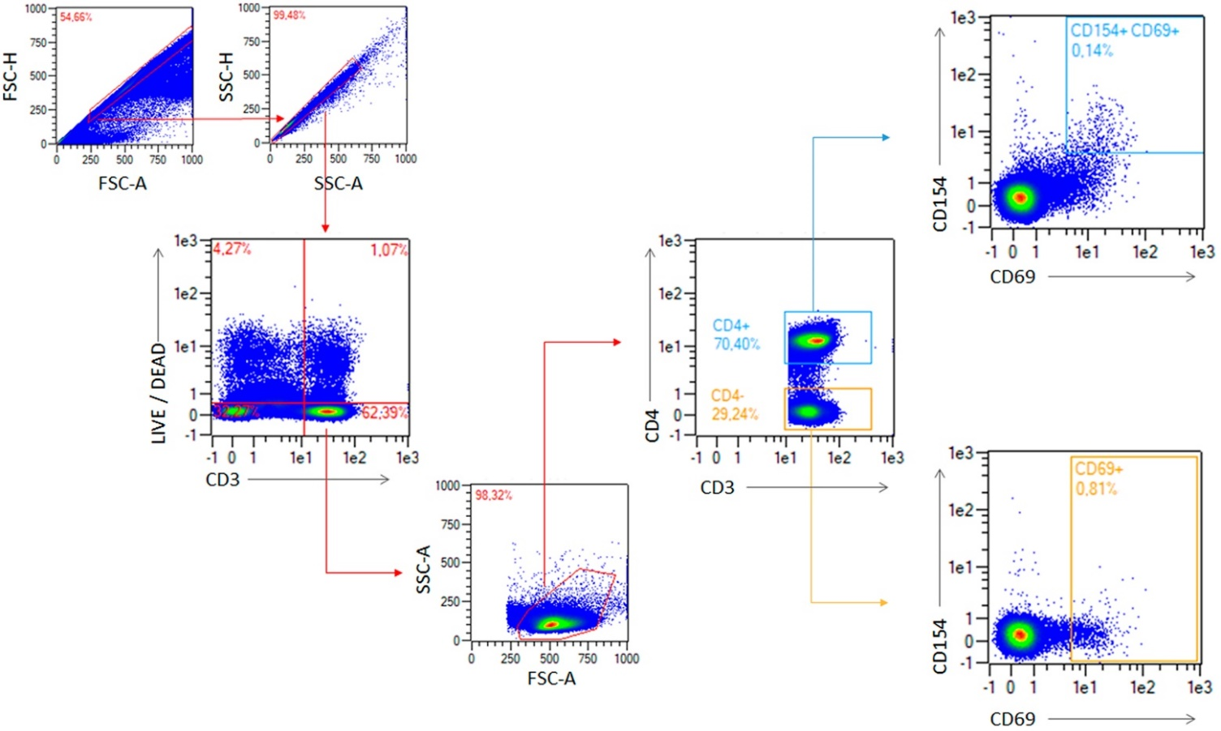
Supplementary figure 3. Flow cytometry gating of PBMCs for the specific response studies of T cells.

