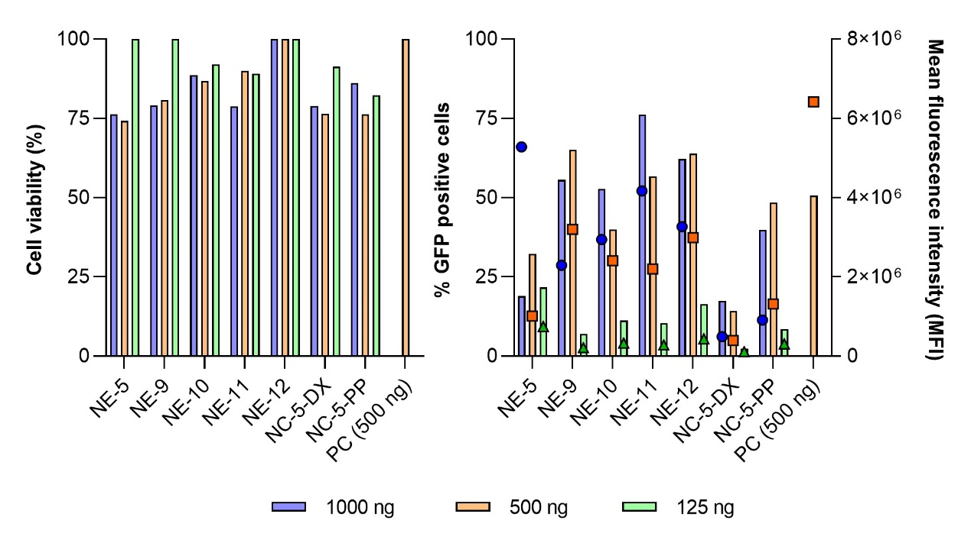

Supplementary Fig. 2. Cytotoxicity (left) and GFP transfection (right) of NE-3-mGFP, NE-9-mGFP, NE-10-mGFP, NE-11-mGFP, NE-12-mGFP, NC-5-DX-mGFP and NC-5-PP-mGFP, at different mGFP concentrations. Transfection efficiency is expressed in percentage of GFP positive cells (left axis) and mean fluorescence intensity (right axis) in HeLa cells, 24 hours post transfection.
Abbreviations: DX: dextran sulphate. mGFP: mRNA encoding for GFP. NE: nanoemulsion. NC: nanocapsule. PC: positive control, lipofectamine. PP: PGA-PEG or PEG (5 kDa)-b-PGA (10) (Na). (n = 1).

