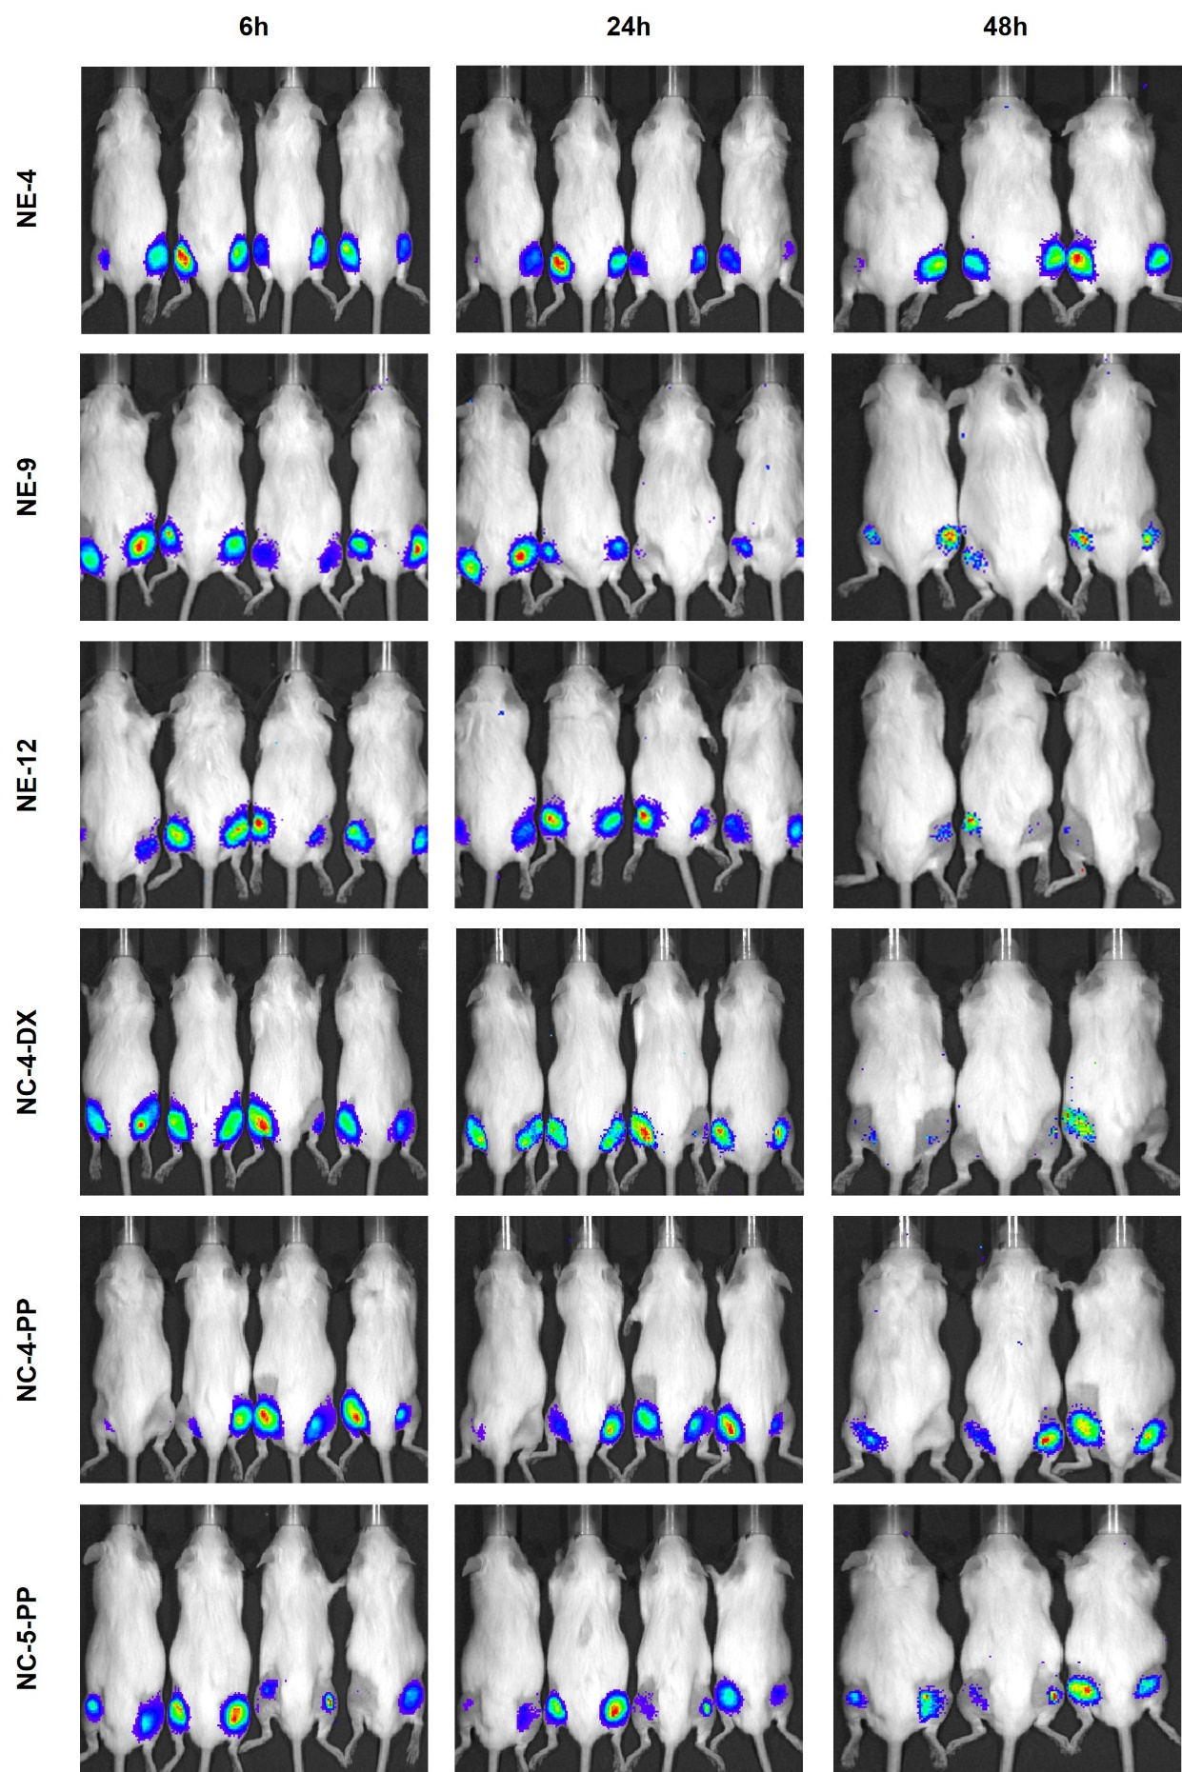

Supplementary Fig. 3. Luciferase fluorescence signal detected by IVIS using NE-4-mLuc, NE-9-mLuc, NE-12-mLuc, NC-4-DX-mLuc, NC-4-PP-mLuc, and NC-5-PP-mLuc at different time points (6,24, and 48 hours) after intramuscular administration.
Abbreviations: DX: dextran sulphate. mLuc: mRNA encoding for luciferase. NE: nanoemulsion. NC: nanocapsule. PP: PGA-PEG or PEG (5 kDa)-b-PGA (10) (Na).

