Supplemental Information
Supplemental Figures
Column 1: LNP
Column 2: LNP: FaSSIF (1:1)
Column 3: LNP+triton
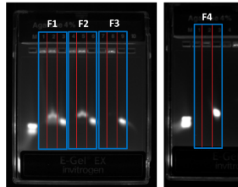
Supplemental Figure 0: Gel Electrophoresis data for F1 (0% DOTMA), F2 (10% DOTMA), F3 (20% DOTMA), F4 (50% DOTMA) through siRNA release at 1:1 dilution with FaSSIF to depict the stability of F3 and F4.

- RAW 264.7 cells Gating Strategy
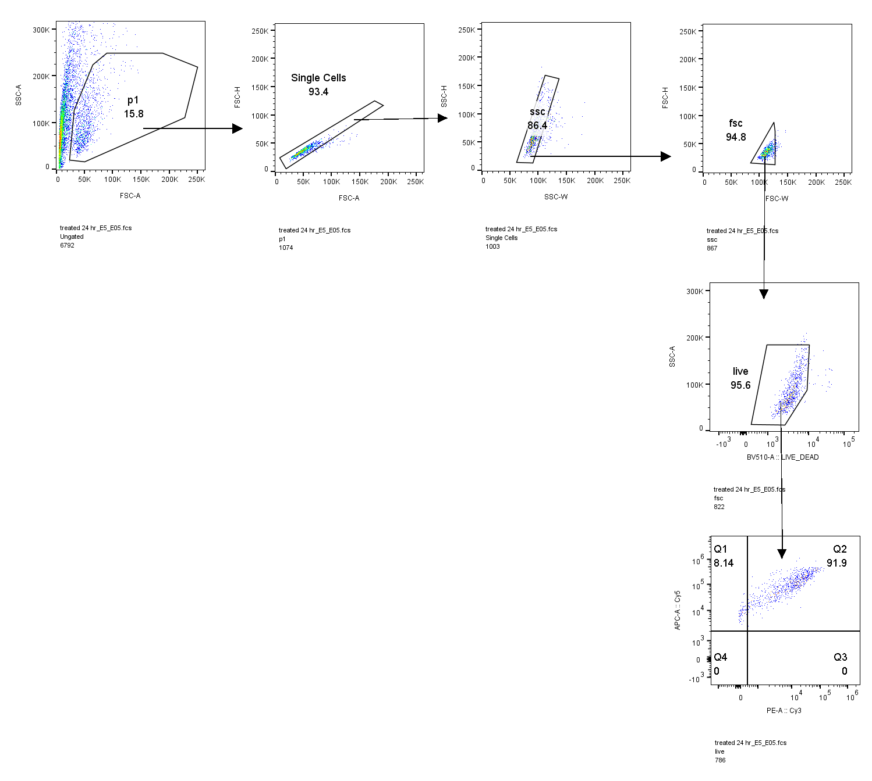
Caco-2 cells Gating Strategy
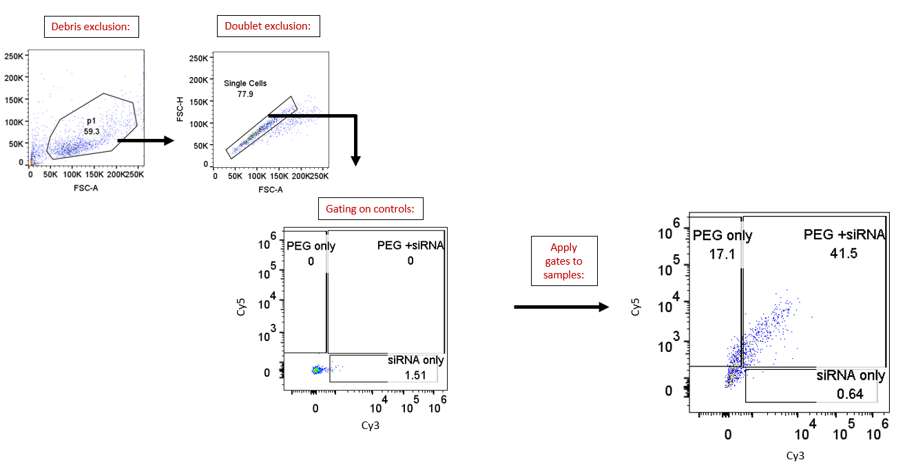

(b)
(c)
Supplemental Figure 2: Uptake kinetics of OrD LNP in RAW 264.7 cells and Caco-2 cells. (a) Flowcytometry gating strategy for RAW 264.7 and Caco-2 cells. Flowcytometry analysis showing appropriate signals in different concentrations and timepoints for (b) RAW 264.7 cells and (c) Caco-2 cells.

Supplemental Figure 3: Oral delivery of siHPRT OrD LNP doesn’t show gene silencing in the GIT after 24h. Female SKH1 mice, HPRT gene silencing data after 24h

