Supplementary material
Antimicrobial 3D Printed Implants for Periprosthetic Joint Infections
Iván Yuste ^{a#}, Francis C. Luciano ^{a#}, Carmina Rodríguez ^{b}, Bianca I. Ramirezª, Chrysi Raptiª, Brayan J. Anayaª, Aikaterini Lalatsa^{c}, Almudena Ribed-Sánchez^{d}, Pablo Sanz-Ruiz^{e,f}, Elena González-Burgos ^{g*}, Dolores R. Serrano ^{a,h*}

ª Pharmaceutics and Food Technology Department, Faculty of Pharmacy, Universidad Complutense de Madrid, Plaza Ramón y Cajal s/n, 28040 Madrid, Spain.
^{b} Department of Microbiology and Parasitology, Faculty of Pharmacy, Universidad Complutense de Madrid (UCM), Madrid, Spain.
^{c}School of Pharmacy and Biomedical Sciences, Robertson Wing, University of Strathclyde, 161, Cathedral Street, Glasgow, G4 0RE, Scotland, UK
^{d}Hospital Pharmacy Unit, Hospital General Universitario, Gregorio Marañón, Doctor Esquerdo 46, 28029, Madrid, Spain.
^{e}Orthopaedic and Trauma Department, Hospital General Universitario, Gregorio Marañón, Doctor Esquerdo 46, 28029, Madrid, Spain.
^{f}Department of Surgery, Faculty of Medicine, Universidad Complutense de Madrid (UCM), Madrid, Spain
^{g}Department of Pharmacology, Pharmacognosy and Botany, Faculty of Pharmacy, Universidad Complutense de Madrid (UCM), Madrid, Spain.
^{h}Instituto Universitario de Farmacia Industrial, Faculty of Pharmacy, Universidad Complutense de Madrid, 28040, Madrid, Spain.

# First authorship shared
*Corresponding authors
Elena Gonzalez Burgos
Email: elenagon@ucm.es
Tel: +34 91 394 22 76
Dolores R. Serrano
Email: drserran@ucm.es

Table S1. Design of experiments. Factors and responses evaluated.
Experiment | Ethanol (%) | AmB (mg/ml) | Implant Height (mm) | Drug loading AmB  (%)
1 | 75 | 5 | 1 | 0.203
2 | 75 | 2.5 | 1 | 0.165
3 | 75 | 2.5 | 2 | 0.098
4 | 85 | 2.5 | 2 | 0.029
5 | 75 | 5 | 2 | 0.213
6 | 85 | 5 | 1 | 0.105
7 | 85 | 5 | 2 | 0.036
8 | 85 | 2.5 | 1 | 0.112

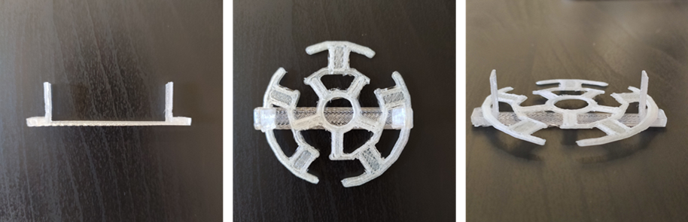
Figure S1. 3D printed support for holding the implant in the drug loading experiments.
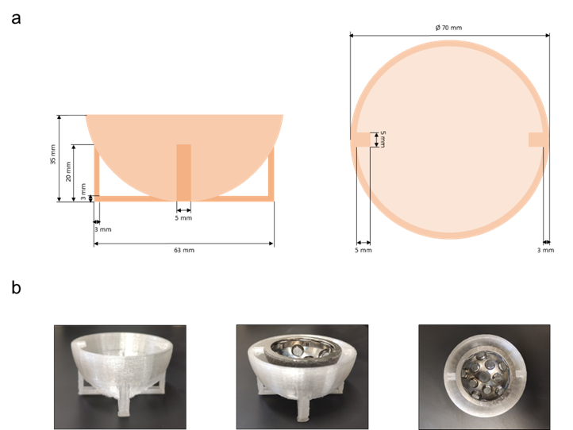

Figure S2. Receptacle specifically designed for the acetabular cup release experiments. Key: (a) Design and dimensions of the receptacle, front and top views, (b) Images of the 3D printed receptacle alone and with the acetabular cup.

