Supplementary material

In vivo efficacy study
The following diagram (Figure 1S) summarizes the efficacy study in the animal model.

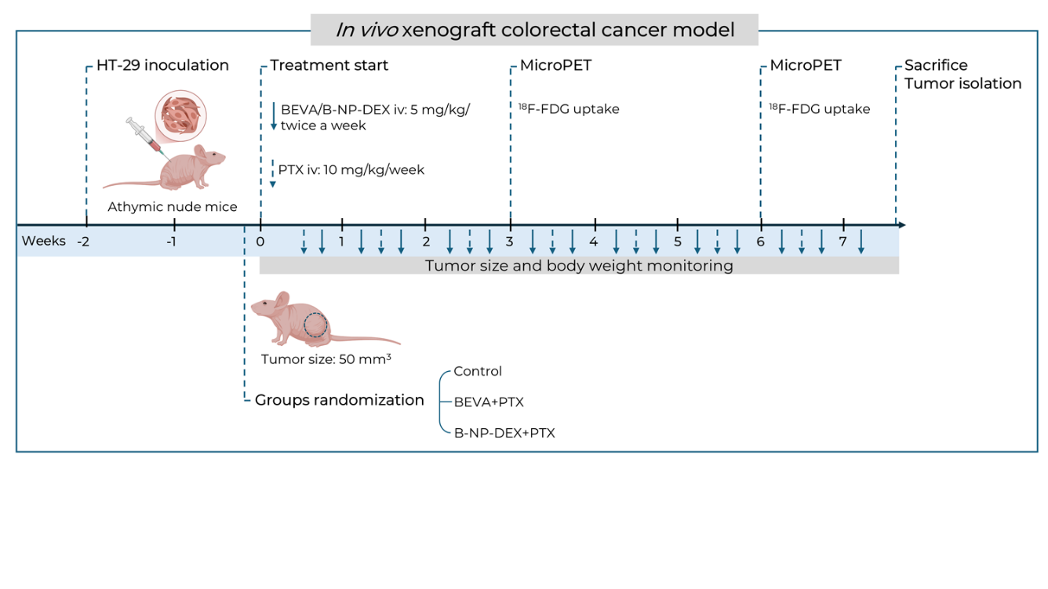
Figure 1S. Diagram summarizing the in vivo efficacy study.

