Table 1. Physicochemical properties of both prototypes, PGA-PEG NCs and PGAC14 NAs, with and without AlexaFluor⁴⁸⁸-BVZ
Prototype | Physicochemical properties |  |  | AE (%) | LC (%)
Prototype | Particle size (nm) | PDI | ζ potential (mV) | AE (%) | LC (%)
PGA-PEG NCs (BVZ) | 78 ± 3 | 0.06 | -1 ± 1 | 99 ± 14 | 4.0
PGA-PEG NCs (AlexaFluor⁴⁸⁸-BVZ) | 81 ± 13 | 0.10 | -1 ± 1 | 112 ± 1 | 5
PGAC14-based NAs (BVZ) | 44 ± 4 | 0.24 | -10 ± 2 | 64 ± 18 | 21
PGAC14-based NAs (AlexaFluor⁴⁸⁸-BVZ) | 43 ± 5 | 0.27 | -2 ± 1 | 69 ± 14 | 22

Figure S1. Dot blot analysis of BVZ-loaded nanosystems showing specificity for VEGF antigen. A) BVZ-loaded PGA14 NAs B) BVZ-loaded PGA-PEG NCs. Membranes were blotted with recombinant human VEGF (0.05 µg), followed by incubation with free BVZ, BVZ-loaded PGA14 NAs or BVZ-loaded PGA-PEG NCs (BVZ concentration of 0.01 mg/ml). Parallel control conditions included membranes without VEGF antigen to assess nonspecific binding (Controls 1 and 2), and direct blotting of free BVZ onto the membrane as a positive control (Control 3). Blank PGA14 NAs and PGA-PEG NCs were also incubated with VEGF to evaluate potential background signal from the carriers.
Figure S2. Radiochemical characterization of ⁸⁹Zr-BVZ, ⁸⁹Zr-BVZ-loaded PGA-PEG and ⁸⁹Zr -BVZ-loaded PGAC14 NAs. A) Radiochemical yield; B) Radiochemical purity; C) Radiochemical stability after 0, 4, 24 and 48 hours of incubation in PBS at 37ºC. BVZ-loaded PGA-PEG NCs without DFO were used as control (Control PGA-PEG NCs). Data are represented as mean ± SD, n≥2. Statistical analysis for comparison between free ⁸⁹Zr -BVZ and ⁸⁹Zr -BVZ-loaded PGA-PEG was done using a Mann-Whitney test (A) and unpaired t-test (B). Multiple unpaired t-test was used for comparison between groups (C).

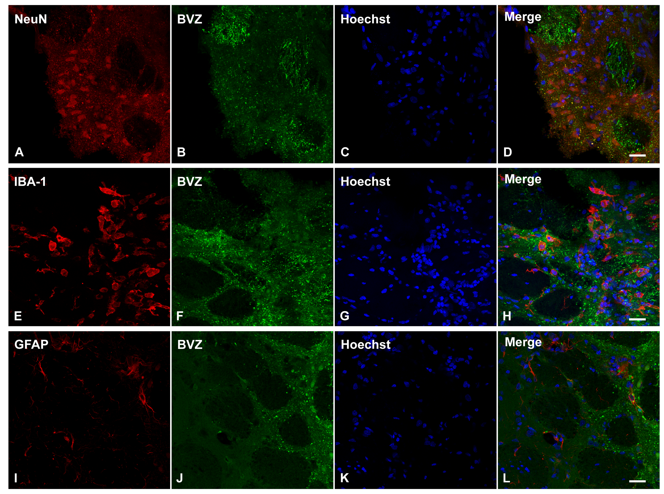
Figure S3. Representative confocal micrographs illustrating the lack of internalization of free BVZ in neuronal and glial populations within rat brain tissue. Double immunofluorescence labeling highlights cell-specific markers in red (NeuN for neurons [A]; IBA-1 for microglia [E]; and GFAP for astrocytes [I]), nuclear counterstaining with Hoechst in blue ([C, G, K]), and Alexa Fluor 568-labeled BVZ in green ([B, F, J]). Merged images ([D, H, L]) reveal no detectable colocalization of free BVZ with these cell populations. Scale bar, 20 µm.

