Adenosine and guanosine-based oligonucleotides-loaded PLGA nanoparticles attenuates progression of surgically induced osteoarthritis

Yoonhee Kim^{1,2}, Jin Han^{1,2,3}, Ji Young Park^{1,4} and Seungwoo Han^{1,2}

SUPPLEMENTARY TABLE
Supplementary Table1. Primer List used for qPCR Analysis in this study. The table includes the gene name, primer sequences for both forward and reverse primers, and the corresponding amplicon size.
Gene | Primer | Primer sequences
Mmp3 | forward | ACA TGG AGA CTT TGT CCC TTT TG
Mmp3 | reverse | TTG GCT GAG TGG TAG AGT CCC
Mmp13 | forward | TGT TTG CAG AGC ACT ACT TGA A
Mmp13 | reverse | CAG TCA CCT CTA AGC CAA AGA AA
Adamts5 | forward | CCA TCT TCC CGG TTG TGT ATC T
Adamts5 | reverse | ACT GTT TCA CTC TGG GCT CTT
Tnfα | forward | ACG GCA TGG ATC TCA AAG AC
Tnfα | reverse | GTG GGT GAG GAG CAC GTA GT
IL-6 | forward | CCG GAG AGG AGA CTT CAC AG
IL-6 | reverse | TCC ACG ATT TCC CAG AGA AC
Vegf | forward | GAG AGA GGC CGA AGT CCT TT
Vegf | reverse | TTG GAA CCG GCA TCT TTA TC
Gapdh | forward | AGC CCA AGA TGC CCT TCA GT
Gapdh | reverse | CCG TGT TCC TAC CCC CAA TG

Supplementary Table 2. Antibody list used for IHC and Western blot in this study.
Antibody | Host | Dilution | Application | source | catalogue number
MMP3 | Rabbit | 1:1000 | WB | Abcam,  Cambridge, UK | ab52915
MMP13 | Rabbit | 1:1000 | WB | Abcam,  Cambridge, UK | ab51072
ADAMTS5 | Rabbit | 1:250 | WB | Abcam,  Cambridge, UK | ab41037
IL-1β | Mouse | 1:1000 | WB | Abcam,  Cambridge, UK | ab234437
Tnf-α | Rabbit | 1:1000 | WB | Cell Signaling Technology,  Beverly, MA | 3707S
IL-6 | Rabbit | 1:1000 | WB | Cell Signaling Technology,  Beverly, MA | 12153S
IL-10 | Mouse | 1:1000 | WB | Abcam,  Cambridge, UK | ab33471
p-PKA | Rabbit | 1:1000 | WB | Thermo Fisher Scientific, Waltham, MA | PA5-64489
PKA | Rabbit | 1:1000 | WB | Thermo Fisher Scientific, Waltham, MA | PA5-17626
p-CREB | Rabbit | 1:1000 | WB | Cell Signaling Technology,  Beverly, MA | 9198S
CREB | Rabbit | 1:1000 | WB | Cell Signaling Technology,  Beverly, MA | 9197S
p-AMPK | Rabbit | 1:1000 | WB | Thermo Fisher Scientific, Waltham, MA | PA5-17831
AMPK | Mouse | 1:1000 | WB | Thermo Fisher Scientific, Waltham, MA | MA5-15815
p-p38 | Rabbit | 1:1000 | WB | Cell Signaling Technology,  Beverly, MA | 4631S
p38 | Rabbit | 1:1000 | WB | Cell Signaling Technology,  Beverly, MA | 9212S
p-ERK1/2 | Mouse | 1:1000 | WB | Thermo Fisher Scientific, Waltham, MA | 14-9109-82
ERK1/2 | Mouse | 1:1000 | WB | Thermo Fisher Scientific, Waltham, MA | 13-6200
p-IκB | Mouse | 1:1000 | WB | Cell Signaling Technology,  Beverly, MA | 9246S
IκB | Mouse | 1:1000 | WB | Cell Signaling Technology,  Beverly, MA | 4814S
p-p65 | Rabbit | 1:1000 | WB | Cell Signaling Technology,  Beverly, MA | 8242S
p65 | Rabbit | 1:1000 | WB | Cell Signaling Technology,  Beverly, MA | 3033S
p-FOXO3a | Rabbit | 1:1000 | WB | Cell Signaling Technology,  Beverly, MA | 9466S
FOXO3a | Rabbit | 1:1000 | WB | Cell Signaling Technology,  Beverly, MA | 2497S
8-oxo-dG | Mouse | 1:200 | IHC | Santa Cruz Biotechnology,  Santa Cruz, CA | sc-66036
Sirt1 | Rabbit | 1:1000 | WB | Cell Signaling Technology,  Beverly, MA | 9475S
Nrf2 | Rabbit | 1:1000 | WB | Cell Signaling Technology,  Beverly, MA | 12721S
HO-1 | Rabbit | 1:1000 | WB | Cell Signaling Technology,  Beverly, MA | 70081S
β-actin | Mouse | 1:1000 | WB | Santa Cruz Biotechnology,  Santa Cruz, CA | sc-47778
HPR-linked  anti-rabbit | Donkey | 1:2000 | WB | Cell Signaling Technology,  Beverly, MA | 7074s
HPR-linked  anti-mouse | Donkey | 1:2000 | WB | Cell Signaling Technology,  Beverly, MA | 7076s
FITC-conjugated  anti-mouse | Donkey | 1:200 | IHC | Jackson Immuno Research  Laboratories | 715-095-151
IHC: immunohistochemistry; WB: Western blot

Supplementary table 3. Top 30 sequences that most effectively reduced LPS-induced NO production at 10 nM among 482 oligonucleotides
Oligo_number | Sequence | NO change (%) compared to 1 µg/mL LPS treatment
359 | AGGGAGGGAGGGAGGGAT | -73.3272
281 | AGGGAGGGAGGGTG | -67.2976
260 | AGAGAGGAGAGGAG | -64.5636
259 | GAGAGAGAGAGAGA | -61.409
296 | GGAGGGAGGGAGGGA | -60.2524
283 | AGGGAGGGCGGGAG | -59.306
196 | AAGGAGGAGAGG | -57.0978
3 | AGGAGA | -56.1965
282 | AGGGAGGGTGGGAG | -53.7329
280 | GGGAGGGAGGCAGG | -53.4175
236 | AGAGAAGGAGGAA | -53.3123
241 | AAGAGAGGAGGAG | -53.2072
194 | GAGAGAGAGAGA | -52.6814
242 | AAGGGAGGGAGGG | -52.2608
235 | GGAGGAGAGGAGA | -51.3144
195 | AGAAGAGGAGGA | -50.2629
295 | GGAGGAGGAGGAGGA | -50.1577
233 | GAGAGAGAGAGGG | -49.3165
9 | AGAGAG | -49.1412
279 | GAGGCAGGAGGAGG | -49.1062
327 | AGAGGGAGGAGAGAGA | -48.6856
225 | GGAGAGGGTGA_G | -48.5804
326 | GAGAGAGAGAGAGAGG | -48.265
198 | AAGAGGAGAGGA | -47.9495
320 | AAGGGAGGGAGGGAGG | -47.7392
330 | GAGGGAGGGAGAGGGA | -47.3186
455 | GAGGAGGGAGGGAGGGAGGG | -47.2246
353 | AGGGAGGGAGCGGAGG | -47.0072
262 | AAGGGAAGGGAAGG | -47.0032
319 | GAGGAGGGAGGGAGGA | -46.5825

Supplementary table 4. Bottom 30 sequences that least reduced LPS-induced NO production at 10 nM among 482 oligonucleotides
Oligo_number | Sequence | NO change (%) compared to 1 µg/mL LPS treatment
378 | GAGGAGGAGGAGGAGGA | 22.9434
408 | AGAAGAGAAGAGAAGAGA | 22.8890
154 | GGAGCGGAGG | 22.1314
404 | AAGGAAGGAAGGAAGGAG | 18.1605
106 | GGGAAGGGA | 17.92388
415 | AGGGAGGGAGGGAGGGAT | 17.8344
156 | GGAGAGCGGG | 17.58794
164 | GGAGGAGGAGG | 15.39614
407 | AGAAAGAAAGAAAGAAGG | 14.02974
144 | AGAGTAGGAG | 13.8603
406 | AAAGAAAGAAAGAAAGAA | 13.4862
374 | AGAGGAGGAGGAGGAGA | 12.9971
168 | AGGGAGAGGGA | 12.9324
146 | ACGAGAGGAG | 12.1965
128 | GAGAGAGAGG | 11.8445
118 | AGGGAGTGG | 11.8445
85 | GAGGATGG | 11.4445
416 | CAGGGAGGGAGGGAGGGG | 11.2578
148 | GGAGACAGAG | 10.2447
121 | GAGGTAGAG | 10.0847
111 | TGAGGGAGA | 10.0847
405 | GAGGAAGGAAGGAAGGAG | 10.0077
464 | TGGAGGGAGGGAGGGAGGGA | 9.9534
110 | AGAGGGAGC | 9.8127
145 | GAAGATGAAG | 9.76471
95 | GGAGGAGGA | 9.02879
149 | AGAAGGTGGA | 9.01279
180 | AGAGAAGGAGC | 8.8328
376 | AGGAAGGAAGGAAGGAG | 8.5946
113 | GTAGGAGAG | 8.51686

Supplementary table 5. Encapsulation efficiency (EE%) for oligonucleotide loading into PLGA nanoparticles using 1000 µg total input in a 4 mL batch
No | Sample ID | Nucleic Acid Conc.( ng/µl) | A260 | A280 | 260/280 | 260/230 | EE(%)
1 | supertant (Free oligo) | 147.7 | 5.083 | 2.729 | 1.86 | 1.83 | 40.92
2 | supertant (Free oligo) | 158.7 | 5.461 | 2.896 | 1.89 | 1.97 | 36.52
3 | supertant (Free oligo) | 166.4 | 5.727 | 3.038 | 1.89 | 1.99 | 33.44

SUPPLEMENTARY FIGURE
Supplementary Figure 1. Protective effects of NanoOligo on cartilage degradation and osteophyte formation in the DMM-induced mouse OA model. (A) Representative results of Safranin-O staining (N = 7). (B) Quantification of total OARSI grade (0-24), medial tibial plateau OARSI grade (0-6), subchondral bone plate thickness (μm²), and osteophyte size (mm²). *p < 0.05, **p < 0.01 compared to PBS-treated control DMM mice, Mann-Whitney U test.
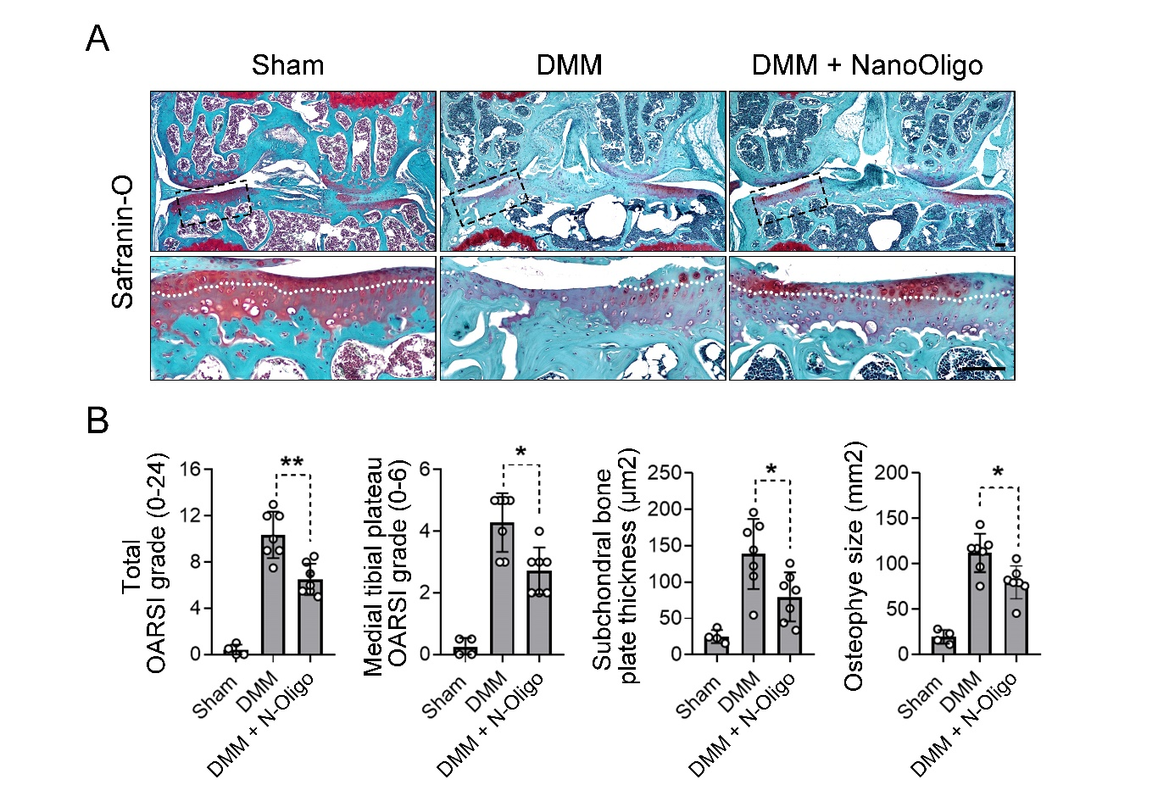

Supplementary Figure 2. Full blot image of Figure 3B.
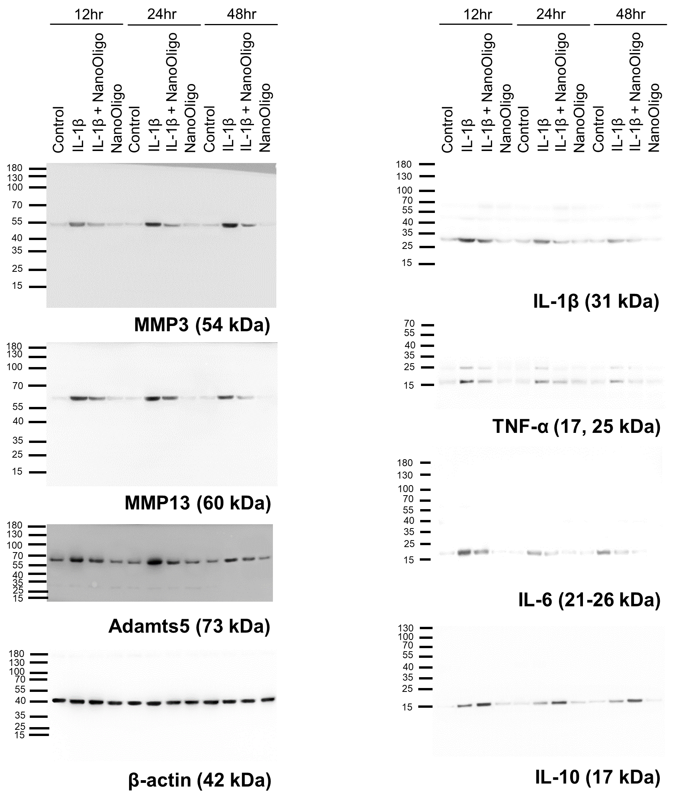

Supplementary Figure 3. Full blot image of Figure 3D
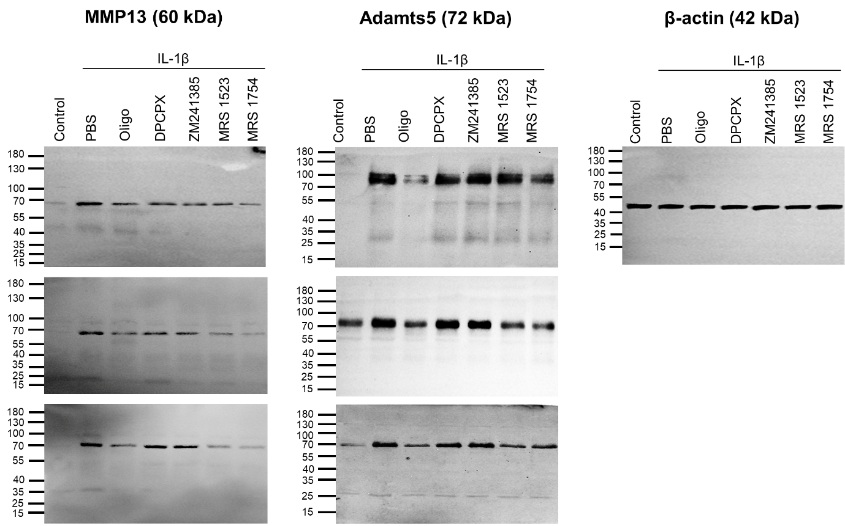

Supplementary Figure 4. Full blot image of Figure 4A
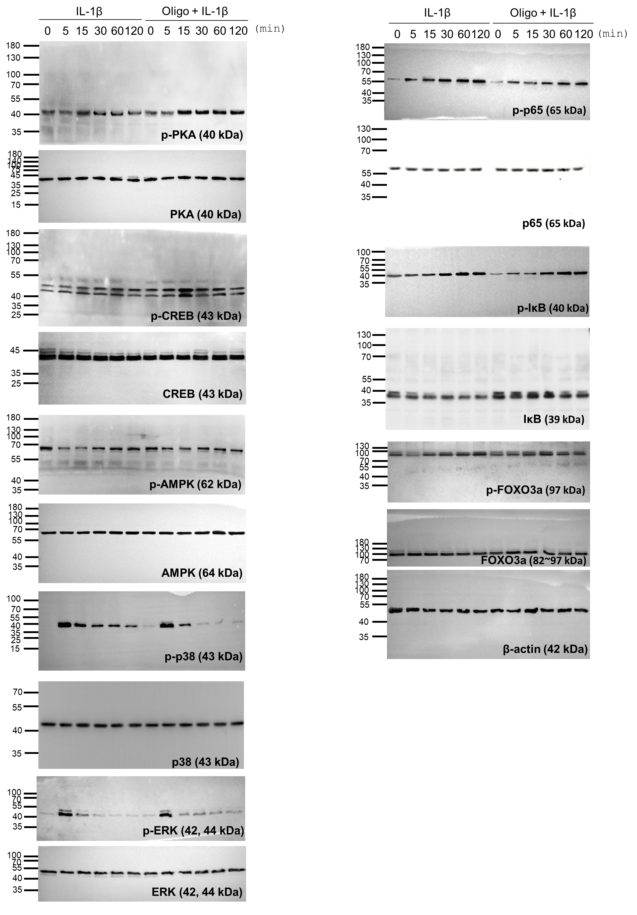
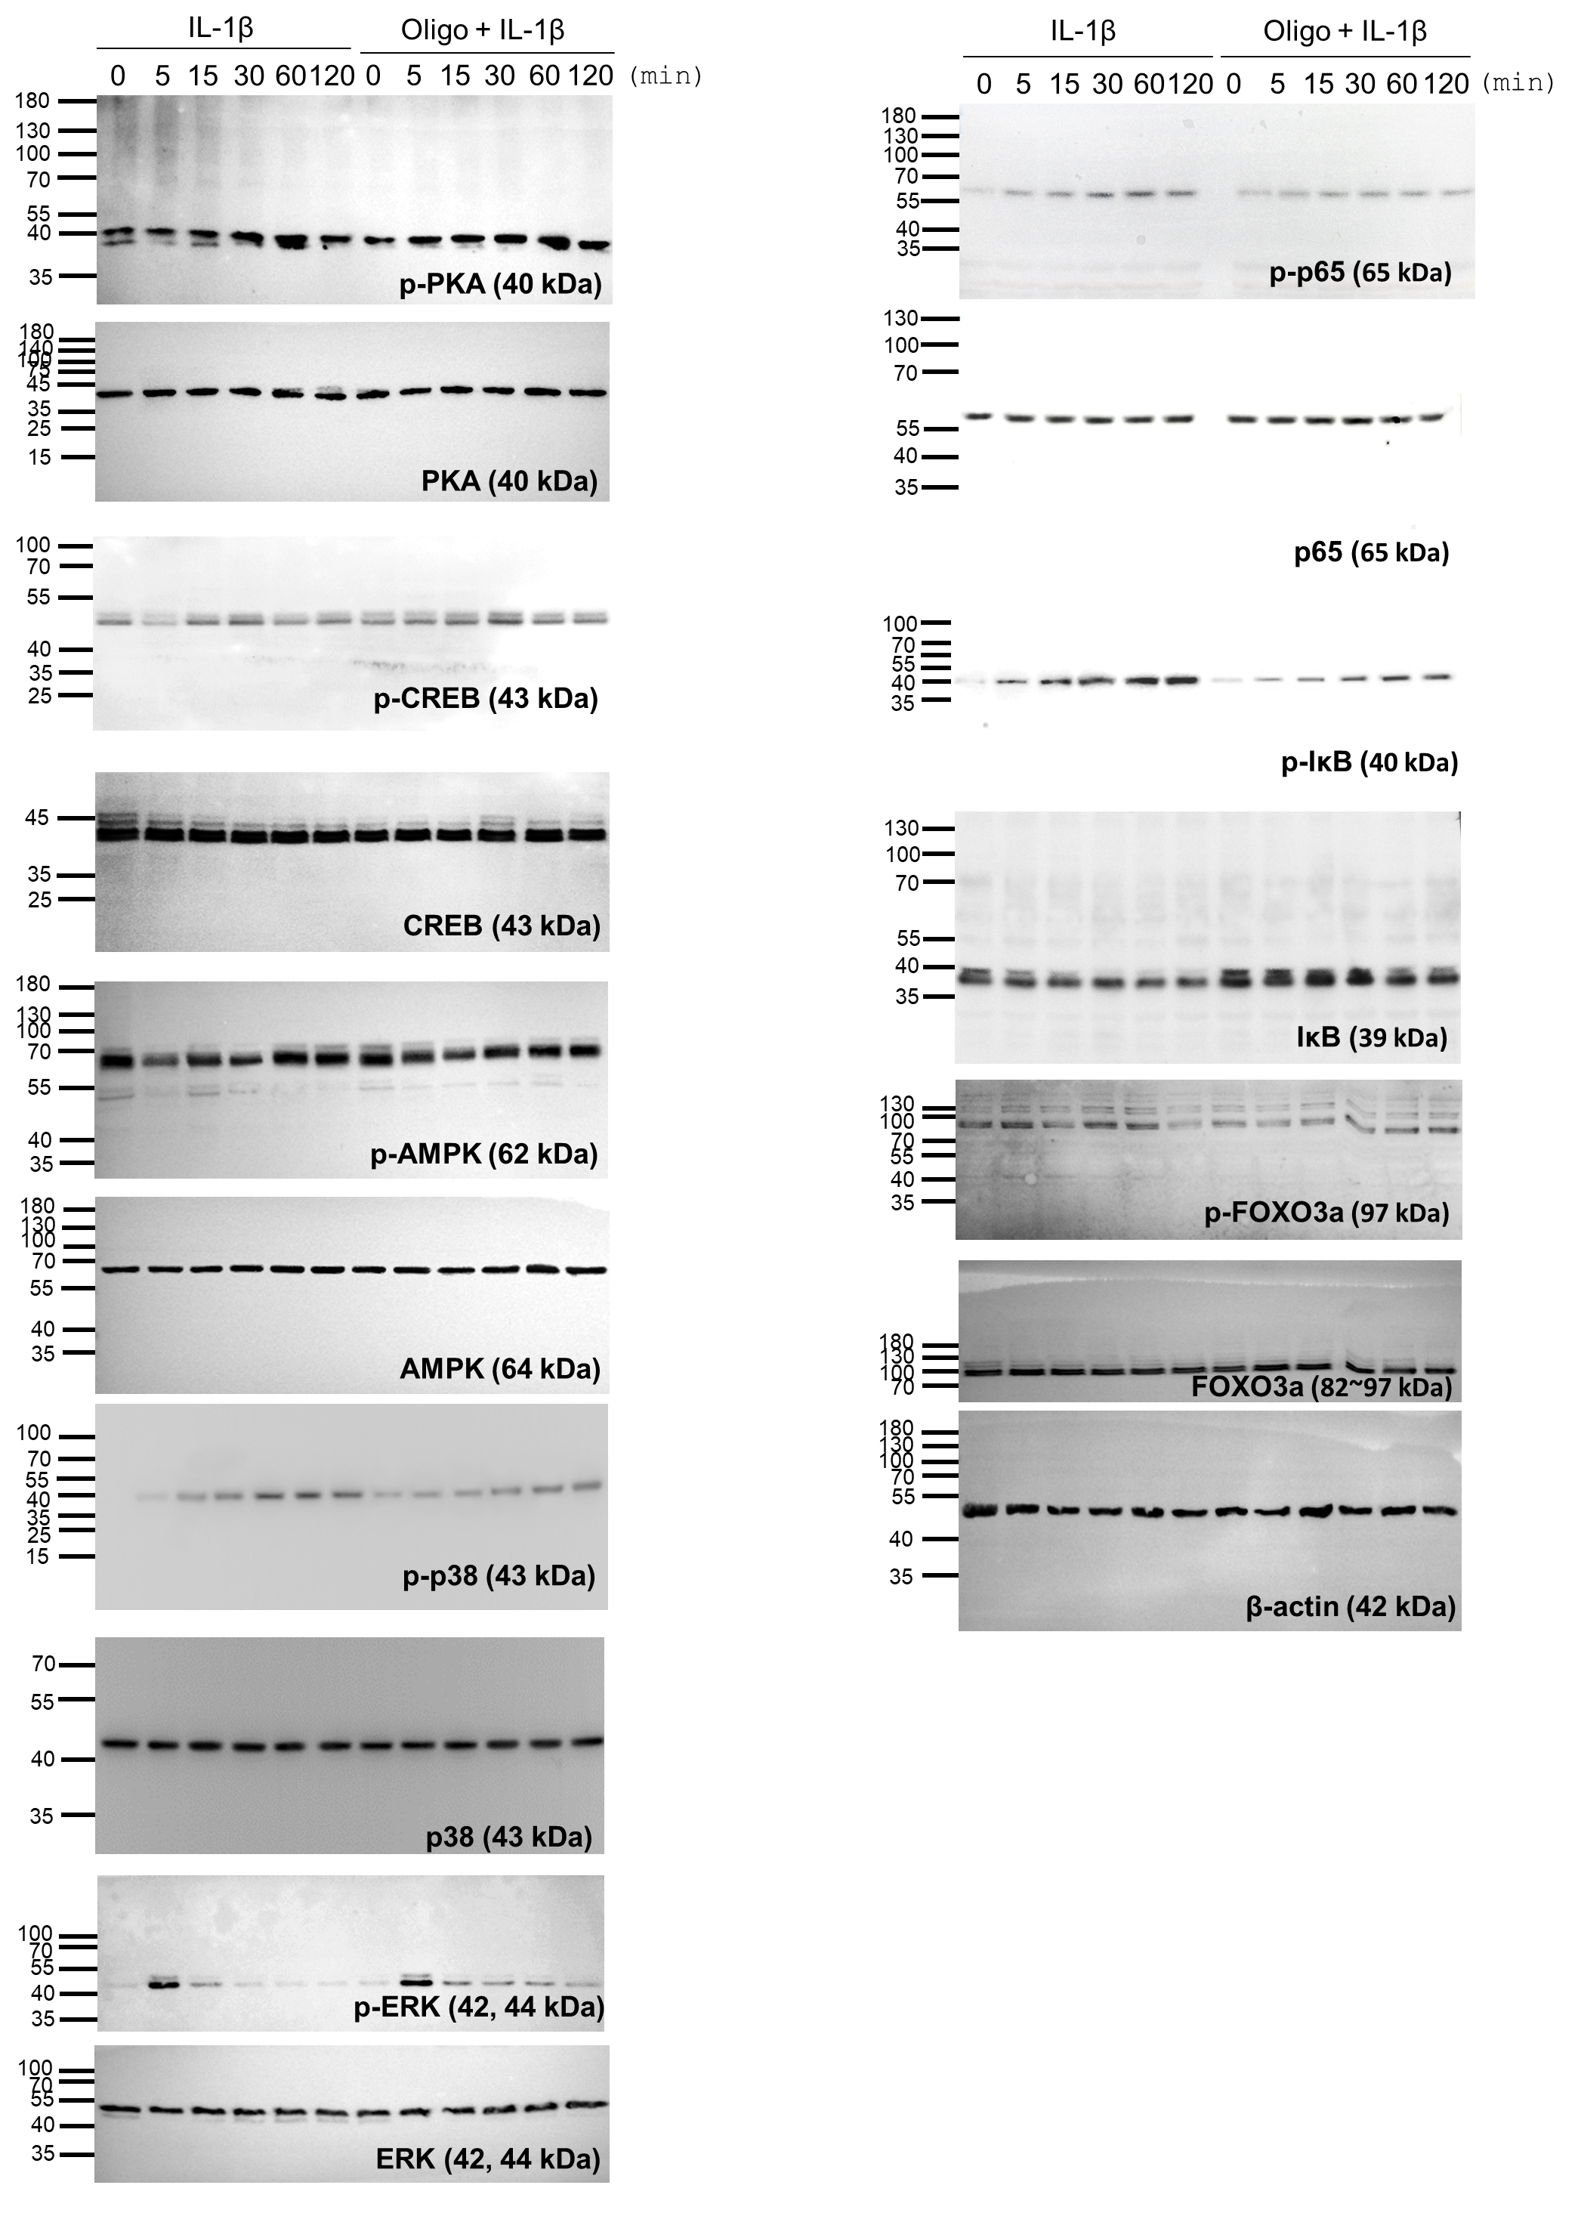

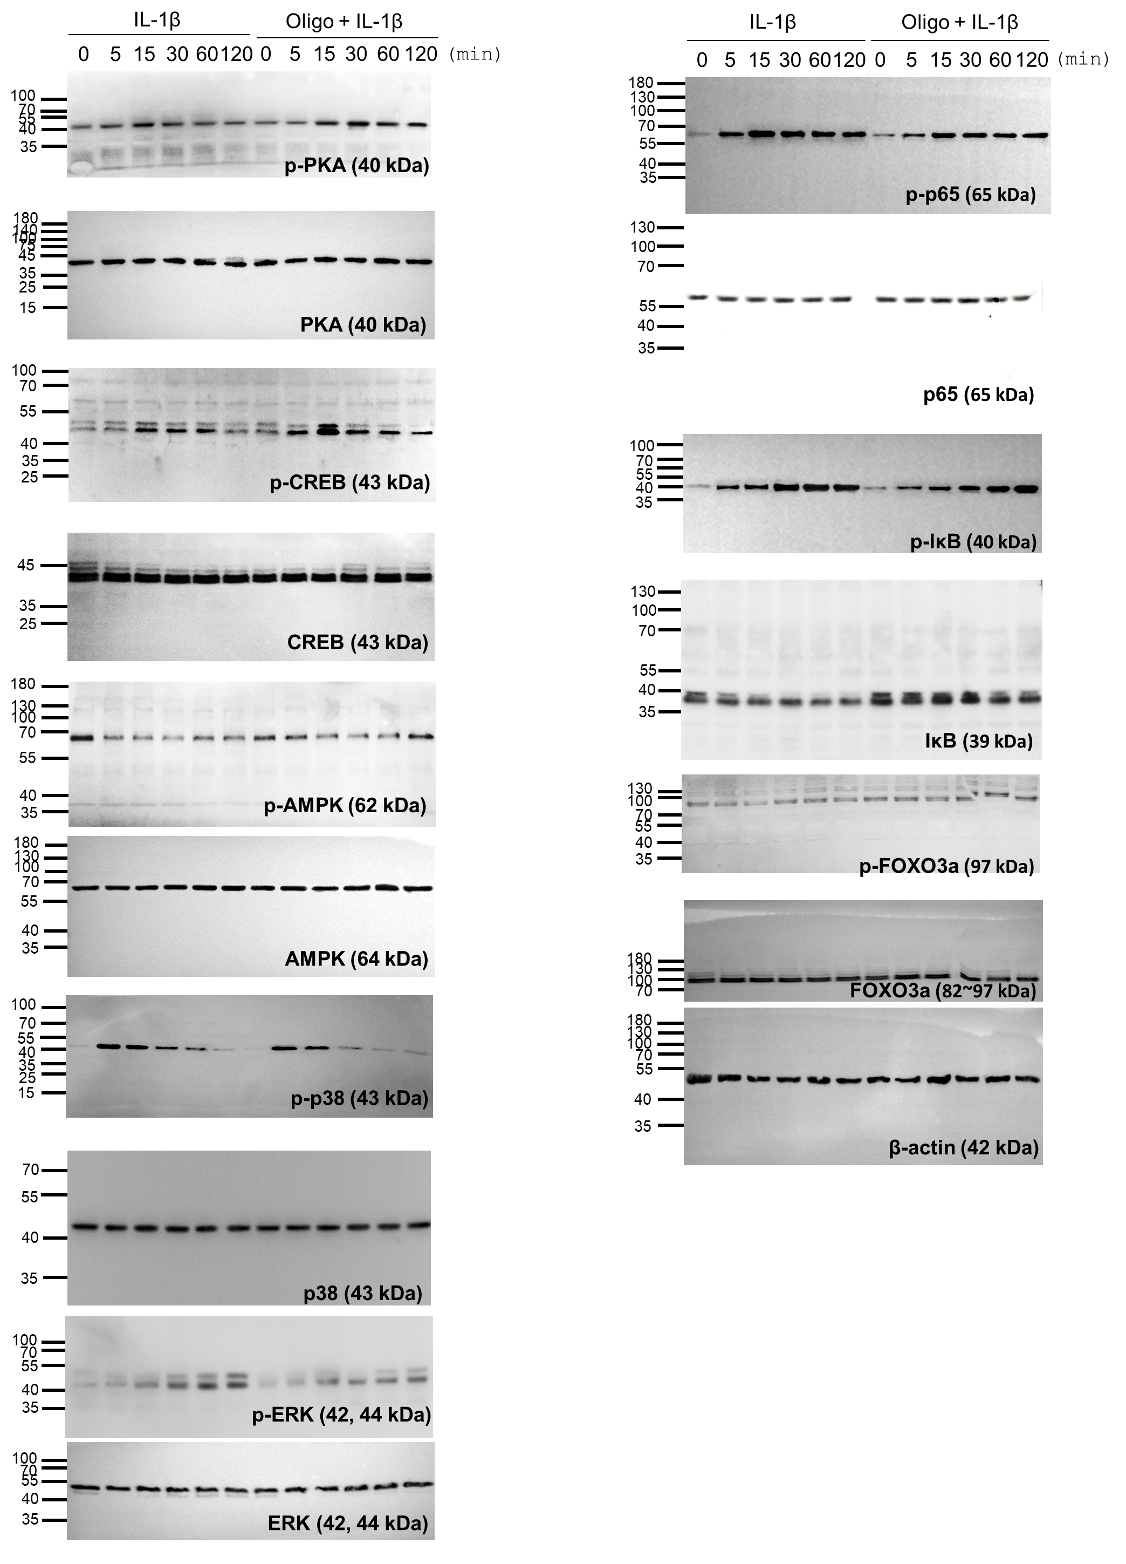

Supplementary Figure 5. Full blot image of Figure 5B
