Voriconazole nanosuspension-loaded ocular bilayer dissolving microneedle patch for the management of fungal keratitis

Supplementary figure
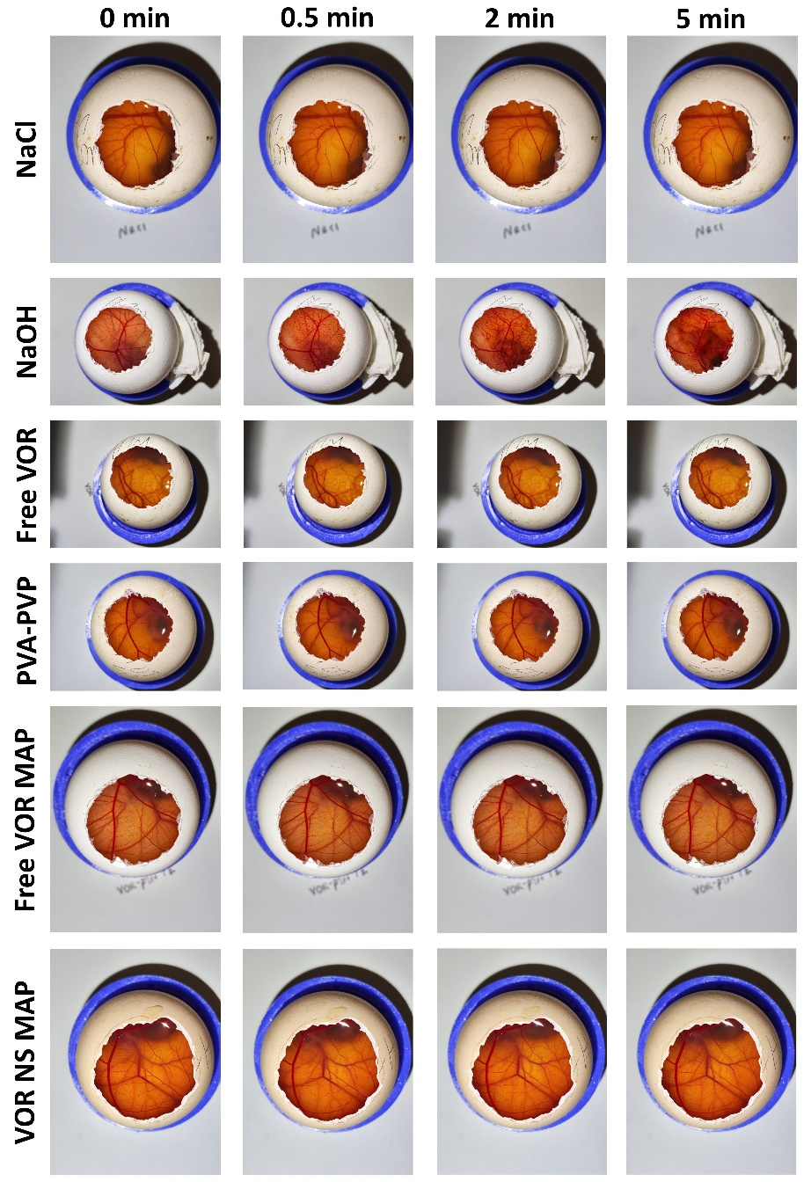
Figure S1. Representative raw digital images captured using mobile phone during the HET-CAM assay to evaluate the irritation potential of various components incorporated into the fabricated dMAPs. Except for the NaOH group (positive control), the images belonging to the NaCl (negative control), free VOR, PVA-PVP, free VOR MAP, and VOR NS MAP groups did not exhibit any haemorrhage, lysis, or coagulation and therefore look similar because we used a specialized box in which the mobile phone camera was positioned and kept steady to ensure proper capture of timelapse images. This setup minimized camera movement. However, differences can still be observed between the images in the raw files, likely caused by minor movements of the developing chick beneath the CAM surface.

