Supplementary Information

Dissolving Microneedles Incorporating Kopexil Multicomponent Crystals for Improved Transdermal Delivery
Yuehua Deng ^{a, b}, Si Nga Wong ^{a, b}, Wing Chi Nico Chan ª, Xinyue Zhang ª, Shing Fung Chow ^{a, b*}

ª Department of Pharmacology and Pharmacy, Li Ka Shing Faculty of Medicine, The University of Hong Kong, Pokfulam, Hong Kong SAR, China
^{b} Advanced Biomedical Instrumentation Centre, Hong Kong Science Park, Shatin, New Territories, Hong Kong SAR, China

* Corresponding author

Table S1. Hydrogen-bond geometry (Å) of KPX·H₂O, KPX-BA·H₂O, and KPX-SA·H₂O.
 | d(D–H)/Å | d(H···A)/Å | d(D···A)/Å | (D–H···A)/°
KPX·H₂O
N2–H2A···O2 | 0.880 | 2.132 | 2.939 | 152.07
N2–H2B···O2 | 0.880 | 2.068 | 2.921 | 162.95
O2–H2C···O1 | 0.870 | 1.878 | 2.745 | 174.25
O2–H2D···O1 | 0.870 | 2.024 | 2.823 | 152.06
N3–H3A···N4 | 0.880 | 2.159 | 2.997 | 158.90
KPX-BA·H₂O
N3–H3A···O3 | 0.880 | 1.953 | 2.816 | 166.30
O2–H2A···N2 | 0.840 | 1.772 | 2.596 | 166.32
O4–H4D···O3 | 0.869 | 2.143 | 2.962 | 156.64
N3–H3B···O1 | 0.880 | 2.010 | 2.760 | 142.38
O4–H4C···O1 | 0.871 | 1.828 | 2.697 | 176.20
N4–H4B···O4 | 0.880 | 1.980 | 2.858 | 174.99
KPX-SA·H₂O
N2–H2A···O2 | 0.881 | 2.058 | 2.916 | 164.50
N2–H2B···O1 | 0.880 | 2.180 | 2.895 | 138.08
N4–H4A···O3 | 0.880 | 1.688 | 2.560 | 171.01
O5–H5A···O1 | 0.870 | 1.979 | 2.795 | 155.80
N1–H1A···O5 | 0.881 | 2.201 | 2.997 | 150.12
N1–H1B···O5 | 0.880 | 1.990 | 2.853 | 166.49
O5–H5B···O4 | 0.870 | 2.139 | 2.951 | 154.85
O4–H4B···O2 | 0.840 | 1.835 | 2.575 | 146.00

Figure S1. The overlaid TGA thermogram of KPX·H₂O and its MCCs. Weight loss of dehydration for KPX·H₂O, KPX-BA·H₂O, and KPX-SA·H₂O are 12.8%, 7.5%, and 7.0%, respectively.

Figure S2. Heterosynthons in (a) KPX-BA·H₂O and (b) KPX-SA·H₂O.

Lattice water analysis
Water molecules present in crystalline organic compounds can be categorized as either lattice water or channel water [1]. In the three crystals examined in this study, all water molecules are identified as lattice water, participating in well-defined intermolecular interactions with the organic components. These hydrate structures feature water motifs characterized by a "DDAA" hydrogen-bonding configuration [2], where each water molecule acts as both two hydrogen bond donors (DD) and two hydrogen bond acceptors (AA). Figure S3 illustrates the distinct water interaction networks in each hydrate. In KPX·H₂O, every water molecule forms four hydrogen bonds exclusively with adjacent KPX molecules. In KPX-BA·H₂O, each water molecule interacts with three KPX molecules and one BA molecule. Similarly, in KPX-SA·H₂O, water bridges three KPX⁺ and one SA⁻. These interactions highlight the critical role of lattice water as a structural nexus, facilitating multidimensional molecular connectivity and enhancing the stability of the crystal packing through directional hydrogen bonds.
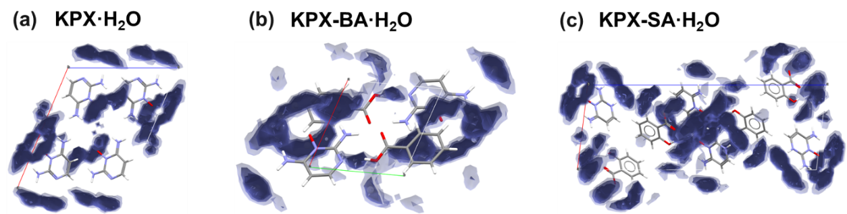
Figure S3. Water interaction maps for the water molecules in (a) KPX·H₂O, (b) KPX-BA·H₂O, and (c) KPX-SA·H₂O.

[1] Ahlqvist MUA, Taylor LS. Water Diffusion in Hydrated Crystalline and Amorphous Sugars Monitored Using H/D Exchange. J Pharm Sci 2002;91:690-98.
[2] Gillon AL, Feeder N, Davey RJ, Storey R. Hydration in Molecular CrystalsA Cambridge Structural Database Analysis. Cryst Growth Des 2003;3:663-73.

HS analysis
HS analysis was performed to characterize the nature of intermolecular interactions within the supramolecular lattices. The HS visualization employs a color-coded scheme where red regions indicate contacts with distances shorter than the sum of van der Waals radii (r_{vdW}), blue regions represent contacts exceeding r_{vdW}, and white areas denote distances equal to r_{vdW}. The surfaces are plotted as a function of the normalized contact distance (d_{norm}), defined through the parameters d_{e} (distance to the nearest external nucleus) and d_{i} (distance to the nearest internal nucleus).
The 3D HS along with 2D fingerprint plots for KPX·H₂O, KPX-BA·H₂O, and KPX-SA·H₂O are shown in Figures S4-S6, with quantitative contributions of intermolecular contacts detailed in Figure S7. Analysis of the contact histograms reveals that the structural stability of KPX·H₂O predominately arises from H···H (43.8%), N···H/H···N (19.0%), O···H/H···O (14.8%) and C···H/H···C (8.6%). The N···H/H···N contact is contributed by both H₂O-KPX, and KPX-KPX interactions, while the H···O/O···H contact mainly stems from H₂O-KPX interactions. It is noteworthy that H⋯H contacts constitute the largest contribution to the HS in three crystal structures. After the incorporation of coformer and H₂O, the contribution of both H···H and N···H/H···N decrease. In contrast, the contribution from the strong interactions O···H/H···O increase substantially from 14.8% in KPX·H₂O to 26.0% in KPX-BA·H₂O and 32.3% in KPX-SA·H₂O, becoming the secondary predominant type of interaction. This O···H/H···O contact enhancement is associated with the formation of acid-aminopyrimidine supramolecular heterosynthons between KPX and BA/SA. The KPX MCC formation alters the KPX crystal lattice arrangement, resulting in an increased availability of effective hydrogen bond sites with varying degrees of enhancement.
Figure S4. HS mapped according to d_{norm}, along with two-dimensional fingerprint plots of KPX·H₂O.

Figure S5. HS mapped according to d_{norm}, along with 2D fingerprint plots of KPX-BA·H₂O.
Figure S6. HS mapped according to d_{norm}, along with two-dimensional fingerprint plots of KPX-SA·H₂O.

Figure S7. Percentage contribution of molecular contact interactions to the HS in KPX·H₂O, KPX-BA·H₂O and KPX-SA·H₂O.
A comparison between the BFDH-predicted crystal morphologies and experimental SEM images for the three crystalline forms in Figure S8 illustrates that both KPX·H₂O and KPX-SA·H₂O crystals feature elongated prismatic morphologies, while KPX-BA·H₂O adopts a rhombohedral habit. The close correspondence between the calculated and observed crystal shapes validates the morphological predictions, showing strong agreement between theoretical modeling and experimental results.
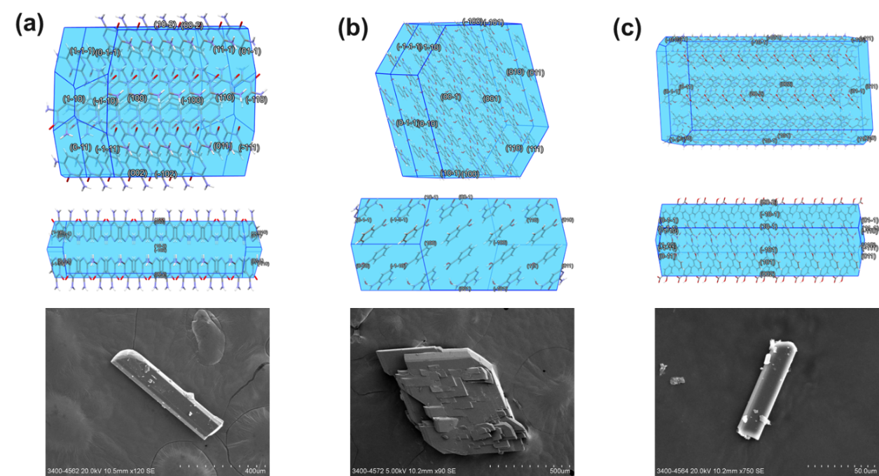
Figure S8. BFDH calculated crystal morphologies and SEM images of (a) KPX·H₂O, (b) KPX-BA·H₂O, and (c) KPX-SA·H₂O.

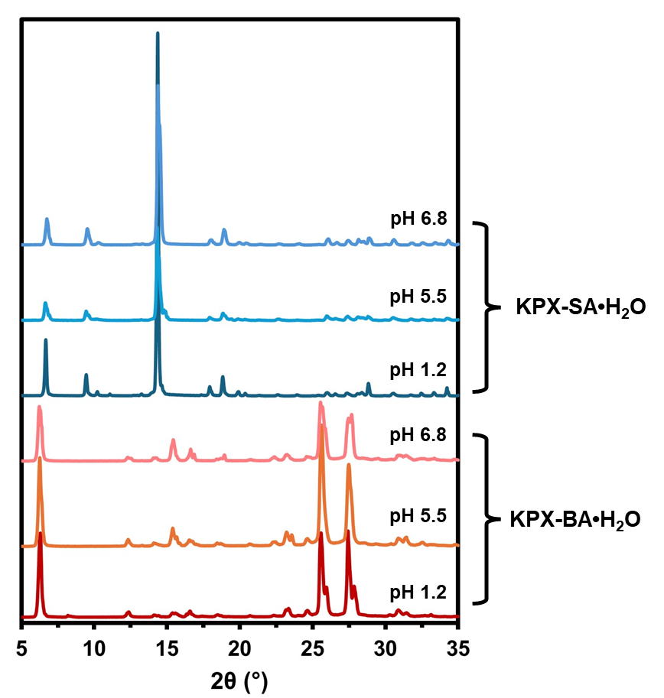
Figure S9. No major phase transformation of the KPX MCCs was detected when suspended in different physiological pH buffers at equilibrium.

Figure S10. PXRD patterns of (a) KPX·H₂O@MNs, (b) KPX-BA·H₂O@MNs and, (c) KPX-SA·H₂O@MNs after one month of storage under varying conditions.

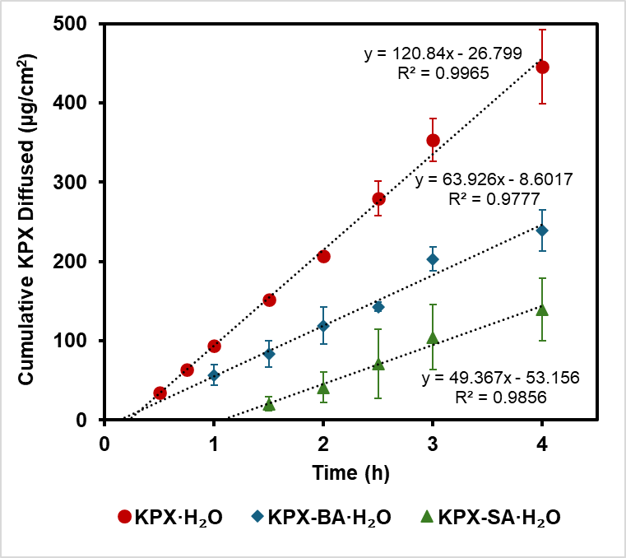
Figure S11. Quantification of the permeation parameters: the steady-state flux is the slope of the linear part of the graph of the cumulative amount penetrated as a function of time; the lag time is the time intercept of the linear portion of the graph.

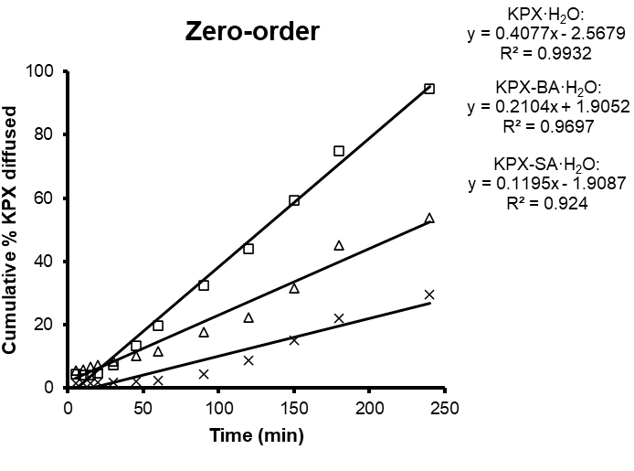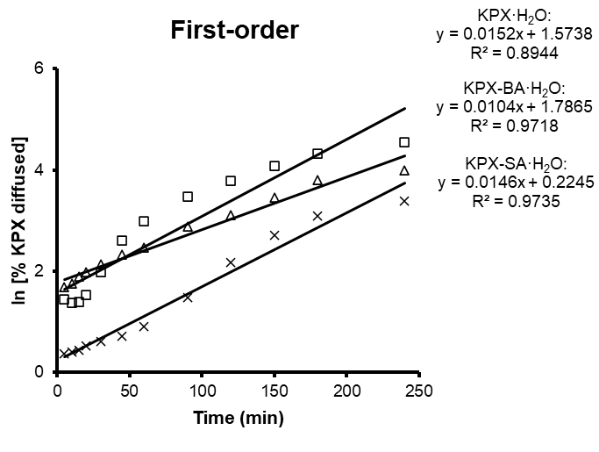
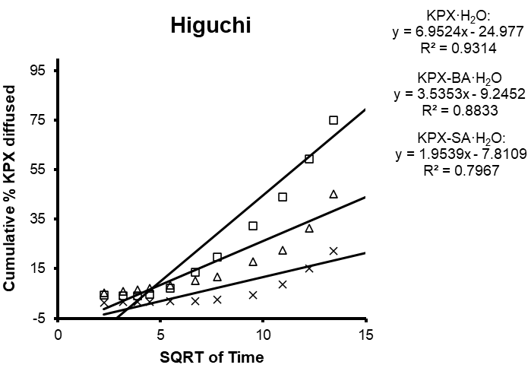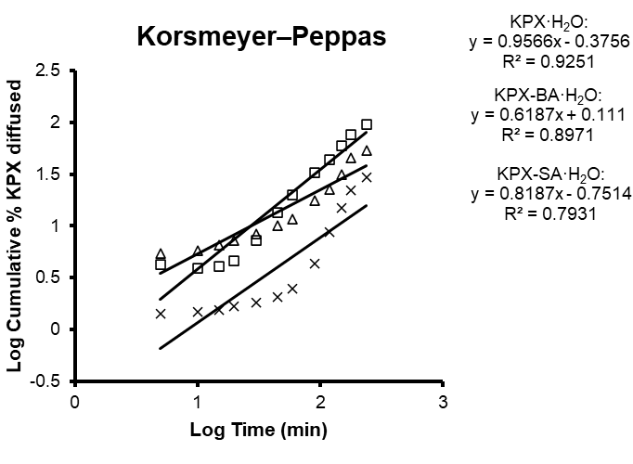
Figure S12. Kinetic analysis of drug release: A) zero-order, B) first-order, C) Higuchi, and D) Kosermayer–Peppas kinetic models (□ KPX·H₂O; △ KPX-BA·H₂O; ⨯ KPX-SA·H₂O).

