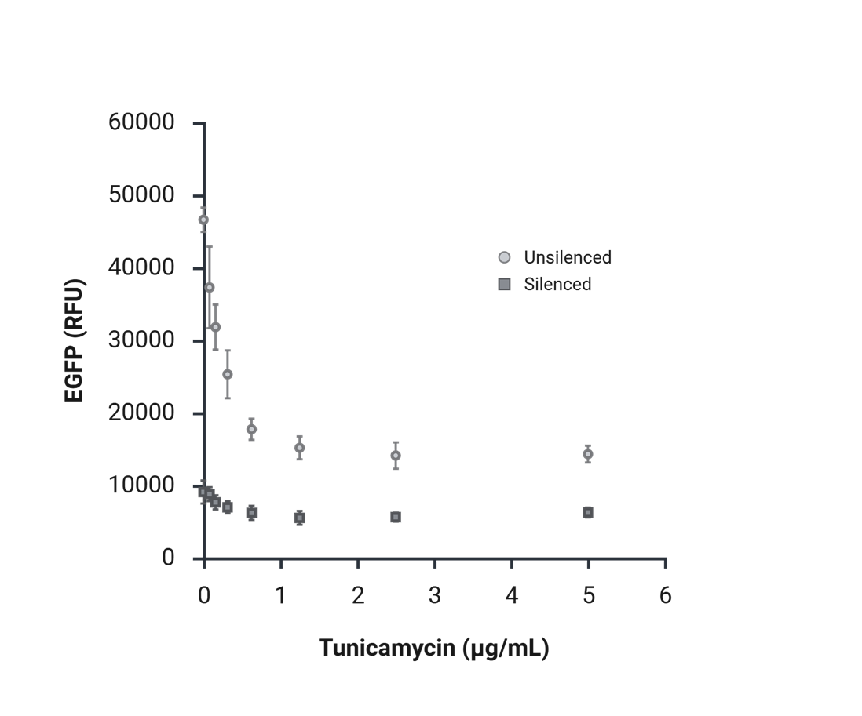
Supplemental Figure 1 EGFP expression measured in raw fluorescence units (RFU) by flow cytometry in HeLa cells constitutively expressing EGFP with increasing concentrations of tunicamycin in control cells (light grey circles) and cells exposed to siRNA (dark grey squares). All untreated cells express more EGFP than the treated cells at 0 µg/mL tunicamycin cells. Thus, the reduction in EGFP level due to siRNA silencing exceeds that due to exposure to tunicamycin alone.

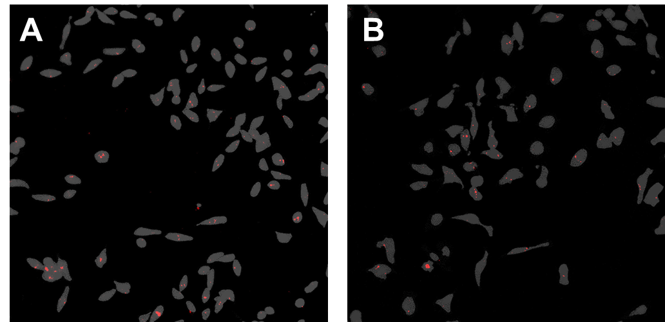
Supplemental Figure 2 Micrographs of HeLa-EGFP cells transfected with Dy547-tagged siRNA-Lipofectamine 2000 complexes taken on a Nikon Eclipse Ts2R-FL Inverted Microscope. 24 hours after cells were transfected in A) 0 µg/mL tunicamycin or B) 5 µg/mL tunicamycin, cells were washed twice with DBPS before being live-cell imaged in DBPS. Gray represents the EGFP mask of the cells and red represents the Dy547 signal. In both cases, siRNA signal is punctate within cells indicating the siRNA is localized to membrane-enclosed compartments.

Supplemental Table 1: siRNA accumulation p-values, comparisons by TM exposure during transfection/TM exposure during recovery at each time point
24 hrs | 5 µg/mL TM/ 0 µg/mL TM | 0 µg/mL TM/ 5 µg/mL TM | 5 µg/mL TM/ 5 µg/mL TM
0 µg/mL TM/ 0 µg/mL TM | 0.023072409 | 0.143992618 | 0.029313301
5 µg/mL TM/ 0 µg/mL TM |  | 0.589309205 | 0.220227406
0 µg/mL TM/ 5 µg/mL TM |  |  | 0.219844613
72 hrs | 5 µg/mL TM/ 0 µg/mL TM | 0 µg/mL TM/ 5 µg/mL TM | 5 µg/mL TM/ 5 µg/mL TM
0 µg/mL TM/ 0 µg/mL TM | 0.004653454 | 0.00241054 | 0.00223491
5 µg/mL TM/ 0 µg/mL TM |  | 0.094224384 | 0.329273153
0 µg/mL TM/ 5 µg/mL TM |  |  | 0.027311285
120 hrs | 5 µg/mL TM/ 0 µg/mL TM | 0 µg/mL TM/ 5 µg/mL TM | 5 µg/mL TM/ 5 µg/mL TM
0 µg/mL TM/ 0 µg/mL TM | 0.006631362 | 0.009402819 | 0.002016419
5 µg/mL TM/ 0 µg/mL TM |  | 0.019505464 | 0.003321534
0 µg/mL TM/ 5 µg/mL TM |  |  | 0.100401916

Supplemental Table 2: siRNA accumulation p-values, comparisons by time point for each stress case - TM exposure during transfection/TM exposure during recovery
0 µg/mL TM/ 0 µg/mL TM | 72 hrs | 120 hrs
24 hrs | 0.000636858 | 0.000385536
72 hrs |  | 0.008180459
5 µg/mL TM/ 0 µg/mL TM | 72 hrs | 120 hrs
24 hrs | 0.328039668 | 3.1722E-05
72 hrs |  | 0.004681044
0 µg/mL TM/ 5 µg/mL TM | 72 hrs | 120 hrs
24 hrs | 0.182844105 | 0.017948896
72 hrs |  | 0.054653534
5 µg/mL TM/ 5 µg/mL TM | 72 hrs | 120 hrs
24 hrs | 0.149007243 | 0.025568286
72 hrs |  | 0.019659141

Supplemental Table 3: silencing p-values, comparisons by TM exposure during transfection/TM exposure during recovery at each time point
24 hrs | 5 µg/mL TM/ 0 µg/mL TM | 0 µg/mL TM/ 5 µg/mL TM | 5 µg/mL TM/ 5 µg/mL TM
0 µg/mL TM/ 0 µg/mL TM | 2.34309E-05 | 0.004931266 | 3.19591E-05
5 µg/mL TM/ 0 µg/mL TM |  | 0.005619926 | 0.048594949
0 µg/mL TM/ 5 µg/mL TM |  |  | 0.008877474
72 hrs | 5 µg/mL TM/ 0 µg/mL TM | 0 µg/mL TM/ 5 µg/mL TM | 5 µg/mL TM/ 5 µg/mL TM
0 µg/mL TM/ 0 µg/mL TM | 0.007162321 | 0.000270762 | 0.00031916
5 µg/mL TM/ 0 µg/mL TM |  | 0.097723923 | 0.202762249
0 µg/mL TM/ 5 µg/mL TM |  |  | 0.053474072
120 hrs | 5 µg/mL TM/ 0 µg/mL TM | 0 µg/mL TM/ 5 µg/mL TM | 5 µg/mL TM/ 5 µg/mL TM
0 µg/mL TM/ 0 µg/mL TM | 0.00749265 | 0.000803959 | 0.002080227
5 µg/mL TM/ 0 µg/mL TM |  | 0.002299988 | 0.007615018
0 µg/mL TM/ 5 µg/mL TM |  |  | 0.690049421

Supplemental Table 4: silencing p-values, comparisons by time point for each stress case - TM exposure during transfection/TM exposure during recovery
0 µg/mL TM/ 0 µg/mL TM | 72 hrs | 120 hrs
24 hrs | 0.001892849 | 3.92131E-05
72 hrs |  | 6.18457E-05
5 µg/mL TM/ 0 µg/mL TM | 72 hrs | 120 hrs
24 hrs | 0.000554978 | 0.000106
72 hrs |  | 7.55522E-05
0 µg/mL TM/ 5 µg/mL TM | 72 hrs | 120 hrs
24 hrs | 0.001174129 | 0.002148554
72 hrs |  | 0.000243805
5 µg/mL TM/ 5 µg/mL TM | 72 hrs | 120 hrs
24 hrs | 9.84767E-06 | 0.01186891
72 hrs |  | 0.000856419

