Iloprost-loaded inhalable Nano into Micro (NiM) formulations for treating hyper-inflammation in a pre-clinical model of cystic fibrosis airway epithelial cells

Annalucia Carbone^{1§}, Piera Soccio^{2§}, Emanuela F. Craparo^{3#}, Pamela Vitullo⁴, Sofia Bonsignore³, Pasquale Tondo^{2,5}, Cinzia Scialabba³, Namra Sajid^{1,6}, Sobhan Jahani,¹ Salvatore Emanuele Drago³, Sante Di Gioia¹, Donato Lacedonia^{2,5}, Gennara Cavallaro³, Massimo Conese^{1#}

¹Department of Clinical and Experimental Medicine, University of Foggia, Foggia, Italy

²Department of Medical and Surgical Sciences, University of Foggia, Foggia, Italy

³Department of Biological, Chemical and Pharmaceutical Sciences and Technologies (STEBICEF), University of Palermo, Palermo, Italy

⁴Cystic Fibrosis Support Center, Ospedale “G. Tatarella”, Cerignola, Italy

⁵Institute of Respiratory Diseases, Policlinico Riuniti of Foggia, 71122 Foggia, Italy

⁶Department of Precision Medicine in Medical, Surgical and Critical Areas, University of Palermo, Palermo, Italy

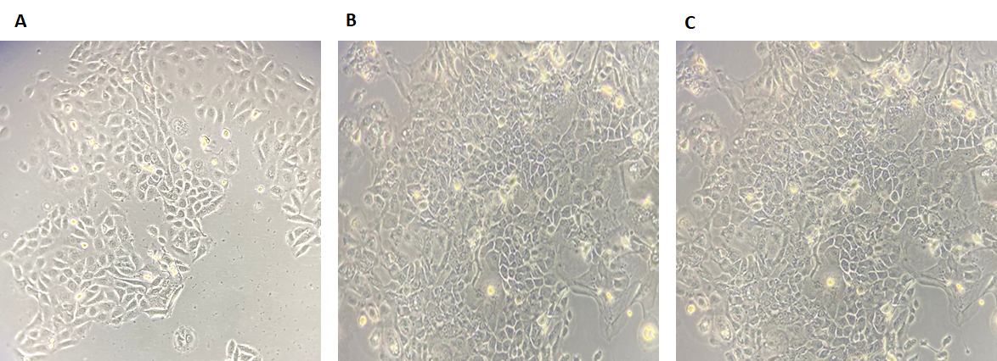
Supplementary Fig. 1 Morphology of hNECs at different passages. Representative images of hNEC captured at the isolation (A), after 2 passages (B) and after 4 passages (C). Photograohs were taken with a 20X objective.

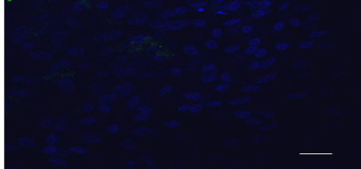
Supplementary Fig. 2 Immunofluorescence and confocal microscopy of control sample. hNEC were rown on Trasnwells for 21 days and stained only with DAPI. Bar, 20 μm.

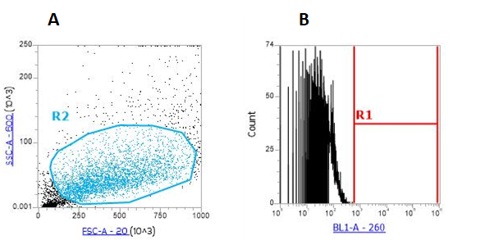

Supplementary Fig. 3 Gating strategy of NEC grown at ALI condition. The whole population of control (cells not incubated with NiMs) was gated (R2 in A) and evaluated for fluorescence intensity as BL1-A corresponding to FITC (B). In B, a marker separated negative cells (on the left) from positive cells (on the right). In the control, positive cells were set at 0.

