Tabletting of Single-Screw Hot Melt Extruded Itraconazole: HPMC-AS Amorphous Solid Dispersion by 3D Printing and Direct Compression

Rachel L. Milliken¹, Thomas Quinten², Sune K. Andersen², Dimitrios A. Lamprou^{1*}

¹ School of Pharmacy, Queen’s University Belfast, 97 Lisburn Road, Belfast BT9 7BL, UK
² Janssen Pharmaceutica, Research & Development, Turnhoutseweg 30, 2340 Beerse, Belgium.
*Corresponding author: d.lamprou@qub.ac.uk (D.A. Lamprou).

Supplementary Information

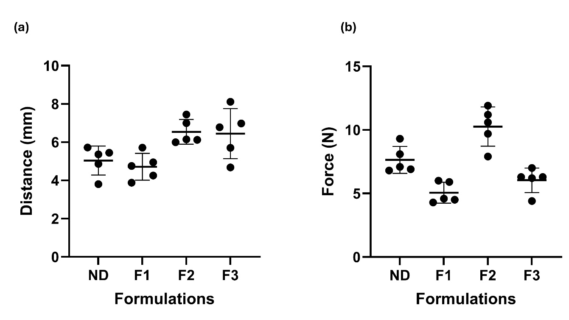
Figure S1. Raw mechanical testing data for ND, F1, F2 and F3 filaments.

Table S1. One-way ANOVA for distance at break.
ANOVA table | SS | DF | MS | F (DFn, DFd) | P value
Treatment (between columns) | 13.43 | 3 | 4.477 | F (3, 16) = 5.616 | P=0.0080
Residual (within columns) | 12.75 | 16 | 0.7971
Total | 26.18 | 19

Table S2. Tukey’s multiple comparisons test for distance at break.
Tukey's multiple comparisons test | Mean Diff. | 95 % CI | Adjusted P Value
ND vs. F1 | 0.3308 | -1.285 to 1.946 | 0.9349
ND vs. F2 | -1.501 | -3.117 to 0.1141 | 0.0733
ND vs. F3 | -1.409 | -3.025 to 0.2061 | 0.0988
F1 vs. F2 | -1.832 | -3.448 to -0.2167 | 0.0236
F1 vs. F3 | -1.74 | -3.356 to -0.1247 | 0.0326
F2 vs. F3 | 0.092 | -1.523 to 1.707 | 0.9984

Table S3. One-way ANOVA for force.
ANOVA table | SS | DF | MS | F (DFn, DFd) | P value
Treatment (between columns) | 77.36 | 3 | 25.79 | F (3, 16) = 20.08 | P<0.0001
Residual (within columns) | 20.55 | 16 | 1.284
Total | 97.91 | 19

Table S4. Tukey’s multiple comparisons test for force.
Tukey's multiple comparisons test | Mean Diff. | 95 % CI | Adjusted P Value
ND vs. F1 | 2.58 | 0.5294 to 4.631 | 0.0116
ND vs. F2 | -2.62 | -4.671 to -0.5694 | 0.0103
ND vs. F3 | 1.6 | -0.4506 to 3.651 | 0.1567
F1 vs. F2 | -5.2 | -7.251 to -3.149 | <0.0001
F1 vs. F3 | -0.98 | -3.031 to 1.071 | 0.5362
F2 vs. F3 | 4.22 | 2.169 to 6.271 | 0.0001

Table S5. Two-way ANOVA for drug release.
ANOVA table | SS | DF | MS | F (DFn, DFd) | P value
Interaction | 811.8 | 18 | 45.1 | F (18, 30) = 2.920 | P=0.0046
Row Factor | 4847 | 9 | 538.6 | F (9, 30) = 34.87 | P<0.0001
Column Factor | 34805 | 2 | 17403 | F (2, 30) = 1127 | P<0.0001
Residual | 463.4 | 30 | 15.45

Table S6. Tukey’s multiple comparisons test between formulations at each dissolution sampling timepoint.
Tukey's multiple comparisons test | Mean Diff. | 95.00% CI of diff. | Adjusted P Value
F1
5 vs. 10 | 0 | -13.41 to 13.41 | >0.9999
5 vs. 15 | -1.122 | -14.53 to 12.29 | >0.9999
5 vs. 30 | -2.704 | -16.11 to 10.70 | 0.9994
5 vs. 45 | -3.913 | -17.32 to 9.494 | 0.9903
5 vs. 60 | -5.37 | -18.78 to 8.037 | 0.9281
5 vs. 90 | -7.391 | -20.80 to 6.016 | 0.6812
5 vs. 120 | -10.41 | -23.82 to 2.997 | 0.2397
5 vs. 240 | -17.14 | -30.54 to -3.728 | 0.0047
5 vs. 360 | -24.69 | -38.10 to -11.29 | <0.0001
10 vs. 15 | -1.122 | -14.53 to 12.29 | >0.9999
10 vs. 30 | -2.704 | -16.11 to 10.70 | 0.9994
10 vs. 45 | -3.913 | -17.32 to 9.494 | 0.9903
10 vs. 60 | -5.37 | -18.78 to 8.037 | 0.9281
10 vs. 90 | -7.391 | -20.80 to 6.016 | 0.6812
10 vs. 120 | -10.41 | -23.82 to 2.997 | 0.2397
10 vs. 240 | -17.14 | -30.54 to -3.728 | 0.0047
10 vs. 360 | -24.69 | -38.10 to -11.29 | <0.0001
15 vs. 30 | -1.582 | -14.99 to 11.83 | >0.9999
15 vs. 45 | -2.791 | -16.20 to 10.62 | 0.9992
15 vs. 60 | -4.249 | -17.66 to 9.158 | 0.983
15 vs. 90 | -6.269 | -19.68 to 7.138 | 0.8402
15 vs. 120 | -9.288 | -22.70 to 4.119 | 0.3811
15 vs. 240 | -16.01 | -29.42 to -2.606 | 0.0099
15 vs. 360 | -23.57 | -36.98 to -10.16 | <0.0001
30 vs. 45 | -1.209 | -14.62 to 12.20 | >0.9999
30 vs. 60 | -2.667 | -16.07 to 10.74 | 0.9995
30 vs. 90 | -4.687 | -18.09 to 8.720 | 0.9679
30 vs. 120 | -7.706 | -21.11 to 5.701 | 0.6306
30 vs. 240 | -14.43 | -27.84 to -1.024 | 0.027
30 vs. 360 | -21.99 | -35.40 to -8.582 | 0.0002
45 vs. 60 | -1.457 | -14.86 to 11.95 | >0.9999
45 vs. 90 | -3.478 | -16.89 to 9.929 | 0.9958
45 vs. 120 | -6.497 | -19.90 to 6.910 | 0.8117
45 vs. 240 | -13.22 | -26.63 to 0.1851 | 0.0557
45 vs. 360 | -20.78 | -34.19 to -7.372 | 0.0004
60 vs. 90 | -2.021 | -15.43 to 11.39 | >0.9999
60 vs. 120 | -5.039 | -18.45 to 8.368 | 0.9502
60 vs. 240 | -11.76 | -25.17 to 1.642 | 0.1242
60 vs. 360 | -19.32 | -32.73 to -5.915 | 0.0011
90 vs. 120 | -3.019 | -16.43 to 10.39 | 0.9986
90 vs. 240 | -9.744 | -23.15 to 3.663 | 0.3188
90 vs. 360 | -17.3 | -30.71 to -3.894 | 0.0042
120 vs. 240 | -6.725 | -20.13 to 6.682 | 0.7809
120 vs. 360 | -14.28 | -27.69 to -0.8757 | 0.0296
240 vs. 360 | -7.557 | -20.96 to 5.850 | 0.6547
F2
5 vs. 10 | 0 | -13.41 to 13.41 | >0.9999
5 vs. 15 | -1.225 | -14.63 to 12.18 | >0.9999
5 vs. 30 | -5.165 | -18.57 to 8.242 | 0.9424
5 vs. 45 | -7.595 | -21.00 to 5.812 | 0.6486
5 vs. 60 | -10.92 | -24.32 to 2.491 | 0.1896
5 vs. 90 | -16.04 | -29.44 to -2.630 | 0.0097
5 vs. 120 | -19.32 | -32.73 to -5.912 | 0.0011
5 vs. 240 | -27.88 | -41.29 to -14.48 | <0.0001
5 vs. 360 | -29.36 | -42.77 to -15.96 | <0.0001
10 vs. 15 | -1.225 | -14.63 to 12.18 | >0.9999
10 vs. 30 | -5.165 | -18.57 to 8.242 | 0.9424
10 vs. 45 | -7.595 | -21.00 to 5.812 | 0.6486
10 vs. 60 | -10.92 | -24.32 to 2.491 | 0.1896
10 vs. 90 | -16.04 | -29.44 to -2.630 | 0.0097
10 vs. 120 | -19.32 | -32.73 to -5.912 | 0.0011
10 vs. 240 | -27.88 | -41.29 to -14.48 | <0.0001
10 vs. 360 | -29.36 | -42.77 to -15.96 | <0.0001
15 vs. 30 | -3.94 | -17.35 to 9.467 | 0.9898
15 vs. 45 | -6.37 | -19.78 to 7.037 | 0.8279
15 vs. 60 | -9.691 | -23.10 to 3.716 | 0.3256
15 vs. 90 | -14.81 | -28.22 to -1.405 | 0.0213
15 vs. 120 | -18.09 | -31.50 to -4.687 | 0.0025
15 vs. 240 | -26.66 | -40.07 to -13.25 | <0.0001
15 vs. 360 | -28.14 | -41.54 to -14.73 | <0.0001
30 vs. 45 | -2.43 | -15.84 to 10.98 | 0.9997
30 vs. 60 | -5.751 | -19.16 to 7.656 | 0.8959
30 vs. 90 | -10.87 | -24.28 to 2.535 | 0.1936
30 vs. 120 | -14.15 | -27.56 to -0.7464 | 0.032
30 vs. 240 | -22.72 | -36.13 to -9.312 | <0.0001
30 vs. 360 | -24.2 | -37.60 to -10.79 | <0.0001
45 vs. 60 | -3.322 | -16.73 to 10.09 | 0.997
45 vs. 90 | -8.443 | -21.85 to 4.965 | 0.5107
45 vs. 120 | -11.72 | -25.13 to 1.683 | 0.1268
45 vs. 240 | -20.29 | -33.70 to -6.882 | 0.0005
45 vs. 360 | -21.77 | -35.18 to -8.361 | 0.0002
60 vs. 90 | -5.121 | -18.53 to 8.286 | 0.9452
60 vs. 120 | -8.402 | -21.81 to 5.005 | 0.5172
60 vs. 240 | -16.97 | -30.37 to -3.560 | 0.0053
60 vs. 360 | -18.45 | -31.85 to -5.039 | 0.0019
90 vs. 120 | -3.281 | -16.69 to 10.13 | 0.9973
90 vs. 240 | -11.85 | -25.25 to 1.560 | 0.119
90 vs. 360 | -13.33 | -26.73 to 0.08184 | 0.0524
120 vs. 240 | -8.565 | -21.97 to 4.842 | 0.4911
120 vs. 360 | -10.04 | -23.45 to 3.363 | 0.2813
240 vs. 360 | -1.479 | -14.89 to 11.93 | >0.9999
ASD Tablet
5 vs. 10 | -9.163 | -22.57 to 4.245 | 0.3994
5 vs. 15 | -19.54 | -32.94 to -6.129 | 0.0009
5 vs. 30 | -26.46 | -39.86 to -13.05 | <0.0001
5 vs. 45 | -26.86 | -40.27 to -13.46 | <0.0001
5 vs. 60 | -29.47 | -42.87 to -16.06 | <0.0001
5 vs. 90 | -27.34 | -40.75 to -13.94 | <0.0001
5 vs. 120 | -33.52 | -46.93 to -20.11 | <0.0001
5 vs. 240 | -33.67 | -47.07 to -20.26 | <0.0001
5 vs. 360 | -33.48 | -46.88 to -20.07 | <0.0001
10 vs. 15 | -10.37 | -23.78 to 3.034 | 0.2437
10 vs. 30 | -17.29 | -30.70 to -3.886 | 0.0042
10 vs. 45 | -17.7 | -31.11 to -4.295 | 0.0032
10 vs. 60 | -20.3 | -33.71 to -6.897 | 0.0005
10 vs. 90 | -18.18 | -31.59 to -4.772 | 0.0023
10 vs. 120 | -24.36 | -37.76 to -10.95 | <0.0001
10 vs. 240 | -24.5 | -37.91 to -11.10 | <0.0001
10 vs. 360 | -24.31 | -37.72 to -10.91 | <0.0001
15 vs. 30 | -6.92 | -20.33 to 6.487 | 0.753
15 vs. 45 | -7.329 | -20.74 to 6.079 | 0.691
15 vs. 60 | -9.931 | -23.34 to 3.476 | 0.2951
15 vs. 90 | -7.806 | -21.21 to 5.601 | 0.6143
15 vs. 120 | -13.98 | -27.39 to -0.5771 | 0.0355
15 vs. 240 | -14.13 | -27.54 to -0.7241 | 0.0325
15 vs. 360 | -13.94 | -27.35 to -0.5333 | 0.0364
30 vs. 45 | -0.4083 | -13.82 to 13.00 | >0.9999
30 vs. 60 | -3.011 | -16.42 to 10.40 | 0.9986
30 vs. 90 | -0.8862 | -14.29 to 12.52 | >0.9999
30 vs. 120 | -7.064 | -20.47 to 6.343 | 0.7317
30 vs. 240 | -7.211 | -20.62 to 6.196 | 0.7093
30 vs. 360 | -7.02 | -20.43 to 6.387 | 0.7383
45 vs. 60 | -2.603 | -16.01 to 10.80 | 0.9996
45 vs. 90 | -0.4779 | -13.89 to 12.93 | >0.9999
45 vs. 120 | -6.656 | -20.06 to 6.751 | 0.7905
45 vs. 240 | -6.803 | -20.21 to 6.604 | 0.77
45 vs. 360 | -6.612 | -20.02 to 6.795 | 0.7964
60 vs. 90 | 2.125 | -11.28 to 15.53 | >0.9999
60 vs. 120 | -4.053 | -17.46 to 9.354 | 0.9877
60 vs. 240 | -4.2 | -17.61 to 9.207 | 0.9843
60 vs. 360 | -4.009 | -17.42 to 9.398 | 0.9885
90 vs. 120 | -6.178 | -19.58 to 7.229 | 0.851
90 vs. 240 | -6.325 | -19.73 to 7.082 | 0.8335
90 vs. 360 | -6.134 | -19.54 to 7.273 | 0.856
120 vs. 240 | -0.147 | -13.55 to 13.26 | >0.9999
120 vs. 360 | 0.04376 | -13.36 to 13.45 | >0.9999
240 vs. 360 | 0.1907 | -13.22 to 13.60 | >0.9999

