Supporting Information
Supporting Information is available from the Wiley Online Library or from the author.

In Vitro and In Vivo Evaluation of Polyelectrolyte Nanogels for Mucosal Vaccines

Angela Bonaccorso§, Annunziata Corteggio§, Luciana D’Apice, Antonio Cardamone, Barbara Tomasello, Anna Rita Coppoletta, Micaela Gliozzi, Teresa Musumeci, Daniela Melillo, Tommaso Heinzl, Cristina Carresi, Vincenzo Musolino, Vincenzo Mollace, Anam Farhan, Paola Italiani, Donato Cosco, Claudia Carbone *, Rosario Pignatello

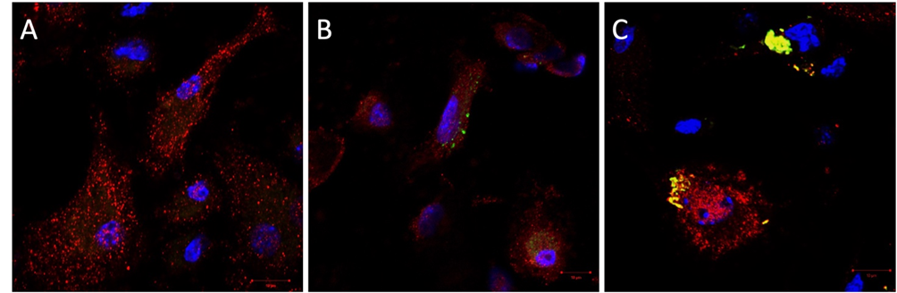
Figure S1. Confocal image of OVA-FITC_nGEL uptake by BMDCs. Characterization of the nGEL trafficking in BMDCs upon incubation for 30 min with 25μg/ml of nGEL (A); free OVA-FITC (B) or OVA-FITC_nGEL (C). Cells were stained with Hoechst (blue) to visualize the nuclei, and with EEA1 in red. Bar=10μm. Objective: 63x/1.4 NA oil-immersion objective.

