Supplementary Information
Title: Controlled Solvent Removal Dynamics During Fabrication of Microneedle Patches for the Sustained Release of Etonogestrel

Authors:
Jonathan Yuxuan Chen¹, Richard N. Terry², Jie Tang³, Tao Zheng³, Steven P. Schwendeman^{3,4}, Mark R. Prausnitz^{1,2} *
Affiliations:
¹ Wallace H. Coulter Department of Biomedical Engineering, Georgia Institute of Technology and Emory University, Atlanta, GA 30332, USA
² School of Chemical and Biomolecular Engineering, Georgia Institute of Technology, Atlanta, GA 30332, USA
³ Department of Pharmaceutical Sciences and the Biointerfaces Institute, University of Michigan, Ann Arbor, MI 48109, USA
⁴ Department of Biomedical Engineering, University of Michigan, Ann Arbor, MI 48109, USA

*Corresponding Author: Mark R. Prausnitz. Email: prausnitz@gatech.edu

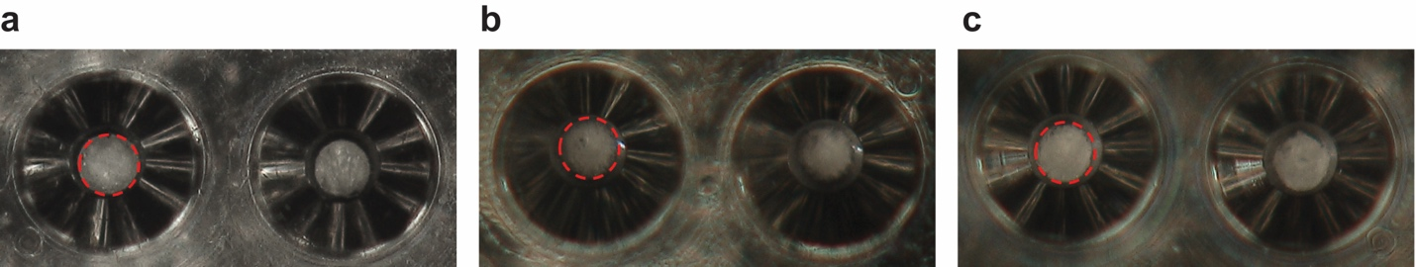
Supplementary Fig. 1 Representative images of MNs cast in PDMS molds. (a) PLA (3 wt%) and ENG (2 wt%) dissolved in anisole, (b) ENG (2 wt%) dissolved in diglyme, and (c) ENG (2 wt%) dissolved in xylene cast into PDMS molds. All three formulations, regardless of solvent selection, were tightly packed into MN molds without film formation.

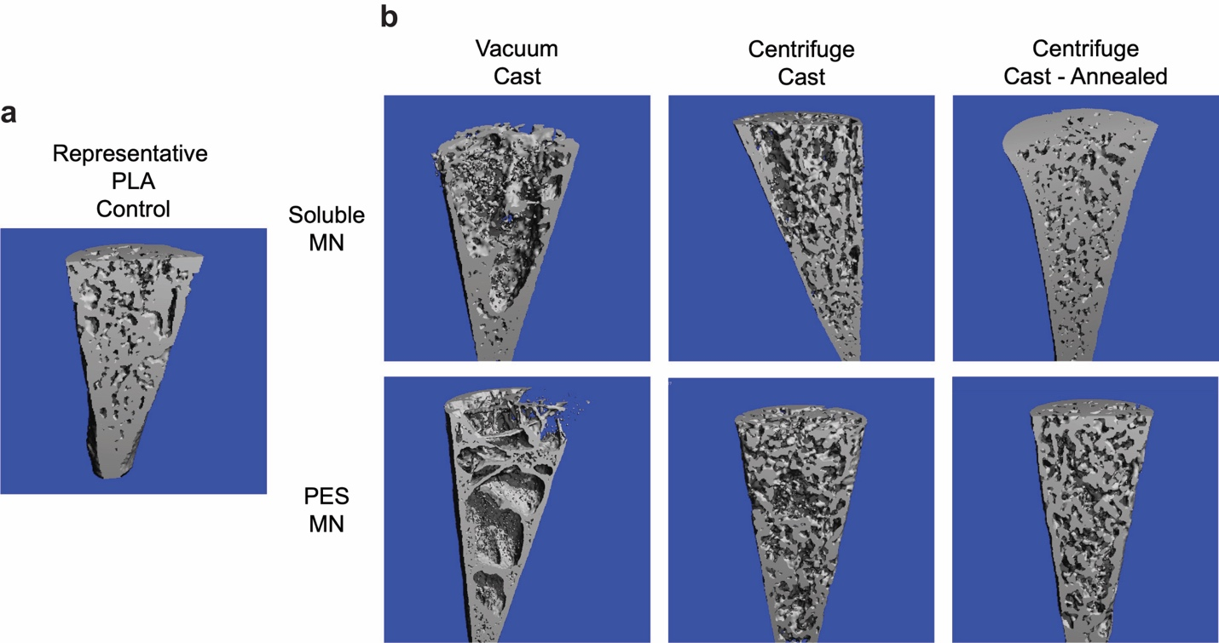
Supplementary Fig. 2 3D reconstruction images of micro-CT measurements. (a) Representative micro-CT images of PLA-only controls. Images of PLA MNs made by centrifuge- and vacuum-based casting, with or without annealing, had no notable differences. (b) Representative micro-CT images of MNs cast by soluble or PES formulations by vacuum or centrifuge casting with or without annealing. Empty regions may correspond to pores and/or ENG-rich regions.

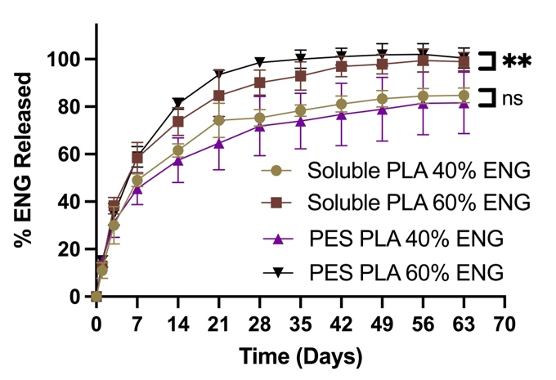
Supplementary Fig. 3 In-vitro release profile comparison of soluble-cast and PES-cast MNs after annealing. Data represent mean ± SD (n = 3). Two-way ANOVA: ns = p > 0.05, ** = P < 0.01.

