Review of nondestructive evaluation techniques for pipeline stress corrosion cracking
Yao Wang, Shengju Xie, Yi Bao *
Department of Civil, Environmental and Ocean Engineering, Stevens Institute of Technology, Hoboken, NJ 07030
* Corresponding author: yi.bao@stevens.edu
Abstract: Stress corrosion cracking (SCC) is a major type of threat to pressurized pipelines, particularly when they operate in harsh environments. Early detection of pipeline SCC and accurate evaluation of its severity enable timely reactions, thereby improving pipeline safety and reducing operation and maintenance costs. This paper presents a comprehensive review of nondestructive evaluation techniques, including sound wave-based, vision-based, electrical, and electrochemical techniques, for detecting and monitoring pipeline SCC. Their working principles, procedures, performance, strengths, and limitations are discussed. Recent advancements in machine learning and robotics for automated inspection of pipelines are reviewed. The technical and economic performance of various techniques are compared through a cost-benefit analysis. A tree-based decision approach is presented to assist pipeline decision makers to select appropriate techniques for specific projects. This paper provides practical insights and guidance for effective evaluation and monitoring of pipeline SCC, aiming to facilitate further research and applications of nondestructive evaluation and monitoring techniques for effective asset management.
Keywords: automated inspection; cost-benefit analysis; decision support; pipeline management; pipeline safety
Funding: This research was funded by the United States Department of Transportation [grant number: 693JK324NF0003].
Conflict of interest: The authors have no relevant non-financial interests to disclose.
Data availability: Data will be available upon request.

1. Introduction
Stress corrosion cracking (SCC) is a critical failure mechanism that poses a significant threat to the safety and structural integrity of pipelines, especially in harsh environments [1]. Pipeline SCC has occurred at different regions worldwide, reflecting the widespread threats to oil and gas pipelines [2]. It results from the combined effects of tensile stresses and corrosive agents, often occurring rapidly without early warning and causing catastrophic failures [3]. Given the potential consequences ranging from public safety to economic loss and environmental damage, the early detection of SCC and timely evaluation of severity are essential for timely reactions, which not only improve safety but also reduce operation and maintenance costs.
Nondestructive evaluation (NDE) techniques have been developed and applied to detect SCC. Representative techniques include, but are not limited to, acoustic emission (AE) [4], digital image correlation (DIC) [5], and electrochemical techniques [6], which have different working principles, technical strengths, and economic benefits, such as sensitivity, accuracy, and costs. Additionally, advanced signal processing and data analysis techniques have been developed.
Recently, artificial intelligence (AI) approaches have been developed to advance the abilities of NDE techniques for pipeline SCC. For example, machine learning models have been developed to automate signal processing and data analysis [7,8], and robots carrying NDE devices have been developed to automate data collection [9]. The application of machine learning models improved efficiency and accuracy, enabling the identification of initiation, localization, and quantification of SCC [7]. The utilization of robots facilitates data collection, particularly in harsh environments or hard-to-reach areas [9].
To enhance the understanding of SCC, several review papers were published. Shirazi et al. [10] discussed stress factors and their interactions that impact the development of SCC. Calabrese et al. [11] reviewed AE techniques and applications for monitoring SCC. Sarwar et al. [7] focused on predicting SCC through machine learning and finite element analysis. Table 1 provides a comparison between this study and existing review papers, highlighting differences in scope and research focus. Compared with existing reviews that primarily focused on SCC mechanisms, this paper presents a comparative, application-oriented review of NDE techniques, highlighting their capabilities, limitations, and suitability for different monitoring scenarios, with the aim of supporting engineering decision-making.
Table 1. Comparison between this study and representative review articles
Ref. | Mechanism | Recent progress | Machine learning | Robot | Techniques selection guidance | Technique evaluation
[3] | Partial | Explicit | Explicit | N.A. | N.A. | N.A.
[7] | Explicit | N.A. | Partial | N.A. | N.A. | N.A.
[8] | N.A. | N.A. | Explicit | N.A. | N.A. | N.A.
[10] | Explicit | N.A. | N.A. | N.A. | N.A. | N.A.
[11] | N.A. | Partial | N.A. | N.A. | N.A. | N.A.
[12] | Explicit | N.A. | Explicit | N.A. | N.A. | N.A.
This paper | Partial | Explicit | Explicit | Explicit | Explicit | Explicit
Note: N.A. stands for non-applicable.
This research addresses three questions: (1) What are the types of NDE techniques that can detect the initiation and monitor the development of pipeline SCC? (2) What are the principles and performance of NDE techniques for monitoring pipeline SCC? (3) How can practitioners select appropriate techniques to satisfy the requirements and constraints of specific projects?
To address these questions, this paper has three primary objectives: (1) identifying available NDE techniques for pipeline SCC and elucidating their principles and procedures; (2) reviewing the advancements in NDE techniques for monitoring pipeline SCC; (3) comparing the technical and economic performance of NDE techniques; and (4) developing a decision tree-based approach for selecting appropriate techniques, aiming to facilitate practical applications.
The remainder of this paper is organized as follows. Section 2 introduces the methodology of this review. Section 3 outlines the mechanisms of pipeline SCC and major challenges associated with the detection and monitoring of SCC. Section 4 introduces the principles, procedures, and advancements of NDE techniques, including cutting-edge research on the application of AI and robotics for pipeline inspection. Section 5 presents a comparative analysis of the performance, applications, costs, and influencing factors of the NDE techniques. Section 6 summarizes the key findings and provides an outlook for future research.

2. Methodology
To ensure a comprehensive and structured review, a systematic methodology was employed to select pertinent studies. The methodology was structured according to the Preferred Reporting Items for Systematic Reviews and Meta-Analyses (PRISMA) guidelines, ensuring systematic and replicable literature selection and analysis (Fig. 1). For the literature search strategy, peer-reviewed research on pipeline SCC inspection and monitoring was systematically retrieved from major academic databases, including Web of Science, IEEE Xplore, Scopus, and ScienceDirect. The search was conducted using relevant keywords and Boolean operators to ensure a comprehensive targeted search. Considering the scope of this review and the availability of references, keywords “pipe”, “stress corrosion cracking”, “monitoring”, “inspection”, and “detection” were selected to screen relevant references.
A stringent screening process was adopted to ensure the selection of relevant, high-quality studies. First, studies were selected if they were published in peer-reviewed journals or reputable conference proceedings. Second, the study had to explicitly focus on the application of monitoring technologies in SCC inspection or monitoring. Third, only studies that specifically focused on SCC in pipes or relevant steel specimens were included. Studies focusing on unrelated topics, such as dent or buckling detection, were excluded. Additionally, review papers lacking substantial new insights, studies without detailed methodological descriptions, and papers with restricted full-text access were excluded from consideration. An initial search across the academic databases retrieved 2,185 publications. Following a rigorous screening and evaluation process, 224 peer-reviewed articles and 14 website resources were selected for in-depth analysis and discussion.
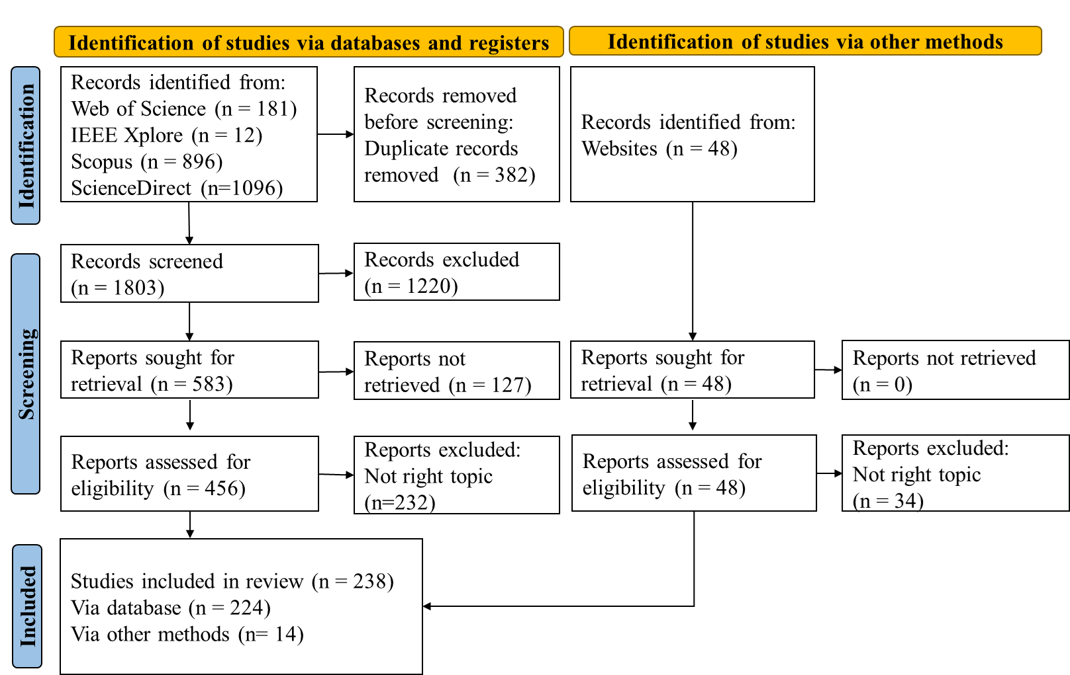
Fig. 1. PRISMA flow diagram for the selection of relevant publications.

3. Stage evolution and mechanisms of pipeline SCC
Pipeline SCC results from the combined effects of environmental conditions, metallurgical factors, and pressure fluctuations. Pipeline SCC often initiates at regions involving coating damage, where corrosive agents cumulate, creating an electrochemically active environment. Metallurgical defects increase susceptibility to corrosion and cause stress concentration, thereby promoting crack initiation. Pressure fluctuations during pipeline operation drive crack propagation and accelerate the development of SCC. The development of pipeline SCC exhibits time-dependent behaviors, and the different stages involve varying crack growth rates and dominant factors.
According to the electrochemical corrosion environment, pipeline SCC are categorized into near-neutral-pH and high-pH SCC, and their characteristics of crack growth rate can be described using bathtub models (Fig. 2).
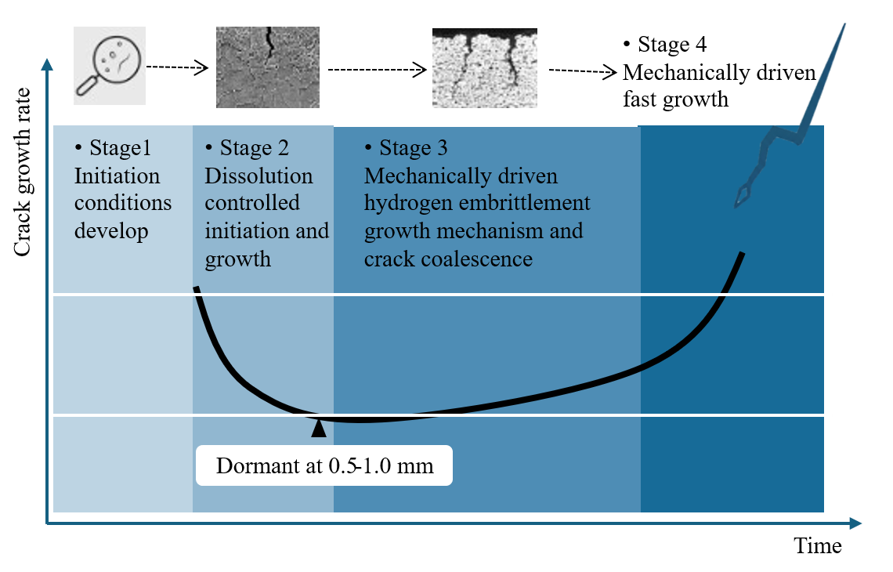
(a)
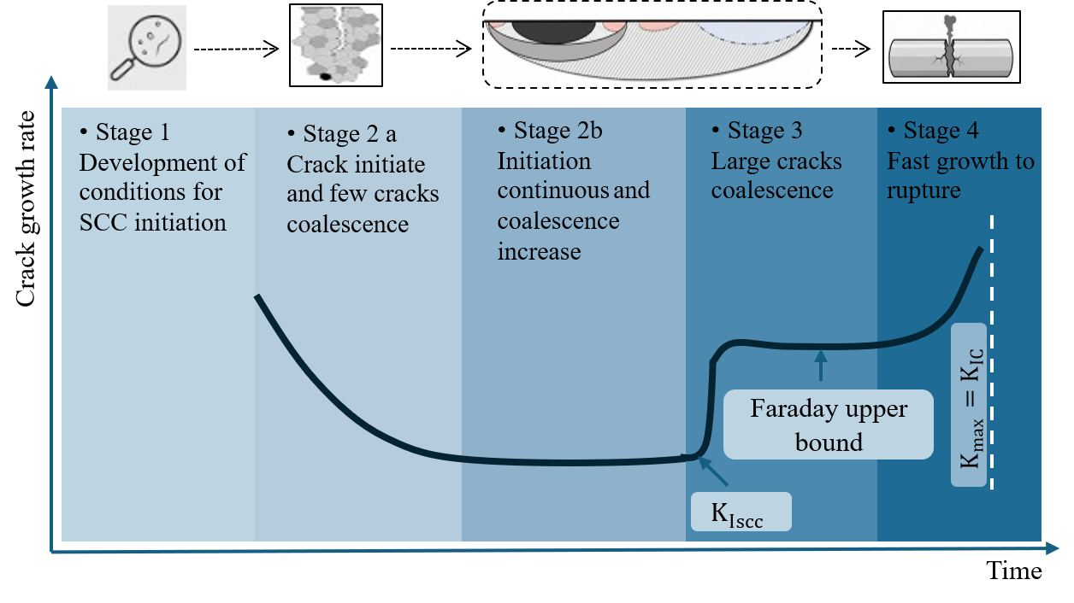
(b)
Fig. 2. Bathtub models of: (a) near-neutral-pH SCC [13], and (b) high-pH SCC [14].
Near-neutral-pH (5.5-7.5) SCC involves four stages: incubation, crack initiation, crack propagation, and rapid crack growth. The initial stage is primarily governed by anodic dissolution. The dissolution rate along the crack wall is higher than the crack tip [15]. In addition, the reduction in residual tensile stress toward the inner surface of the pipeline contributes to a blunted morphology at the crack tip, promoting crack dormancy [16,17]. Prior studies indicated that approximately 95% of cracks become dormant at a depth of 0.5 to 1.0 mm, and about 5% continue to propagate, potentially resulting in pipeline failure [18,19]. The propagation stage is driven by the combination effect of mechanical loading and hydrogen embrittlement (HE) within the fracture process zone ahead of the crack tip. The material’s toughness was reduced due to HE, making the cracks more prone to propagation [20,21]. The contribution of anodic dissolution is minimal at this stage, accounting for an order of magnitude less in the overall crack growth rate [17,22,23].
High-pH SCC typically occurs in environments with high pH value (>9.3) and is associated with buried pipelines exposed to concentrated carbonate-bicarbonate solutions or under cathodic protection [24,25]. High-pH SCC involves five stages: incubation stage, crack initiation stage, microcrack nucleation and coalescence stage, sustainable crack growth stage, and rapid crack growth to rupture stage [14]. The crack initiation stage is governed by selective anodic dissolution at grain boundaries and film rupture induced by localized stress. In this stage, cracks are typically sharp and appear as closely spaced microcracks. The microcrack nucleation and coalescence stage depend on the initiation and spatial distribution of new cracks, making corrosion pitting a preferred site for crack initiation and coalescence [12]. This stage is sensitive to mechanical loads [26], which promote secondary cracks and coalescence toward the sustainable crack growth stage when crack propagation rate is controlled by the stress intensity factor. When the stress intensity factor exceeds the threshold, continuous crack propagation will occur [27].
The above stages and mechanisms cause complex behaviors and challenges in monitoring pipeline SCC: (1) Pipelines are often buried, imposing physical constraints on the implementation of sensors. (2) Pipeline SCC often occurs beneath disbonded coatings where electrolyte solutions accumulate. The presence of coatings interferes with some sensors. (3) The development of SCC is affected by various factors and involves complex mechanisms. Although there are empirical standards for assessing high-risk regions, the exact initiation locations remain uncertain. (4) SCC is a long-term progressive process, and the crack propagation rate varies across different stages. There is a lack of unified standards for identifying and classifying the stages. In addition, providing effective early warning before rapid crack growth occurs remains a significant challenge. (5) Crack clustering often occurs during the progression of SCC. Distinguishing cracks remains challenging.

4. Nondestructive evaluation techniques
This section focuses on the working principles, procedures, applications, and functions of existing NDE techniques related to SCC detection. These techniques are categorized into sound wave-based (Section 4.1), vision-based (Section 4.2), electrical (Section 4.3), electrochemical (Section 4.4), and automation techniques (Section 4.5).

4.1 Sound wave-based techniques
Representative sound wave-based techniques (Fig. 3) include AE and ultrasonic testing (UT), which have been used to detect and evaluate the severity of SCC. As a passive technique, AE detects high-frequency stress waves (20 kHz - 1 MHz) emitted during the SCC process, such as hydrogen gas evolution [28], metal dissolution [29], plastic deformation at the crack tip [30], and cracking of corrosion products [31]. As an active technique, UT emits and receives ultrasonic waves (typically 0.5-25 MHz). When the ultrasonic wave propagates, it is partially reflected upon encountering discontinuities such as cracks or interfaces with differing acoustic impedances. The received signals are then analyzed to evaluate the presence and characteristics of defects.
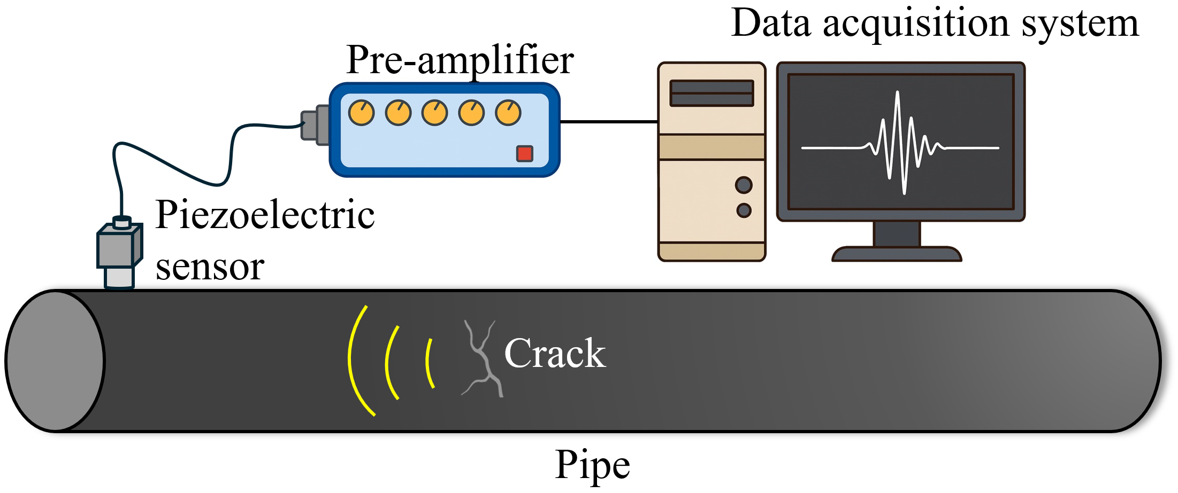
(a)
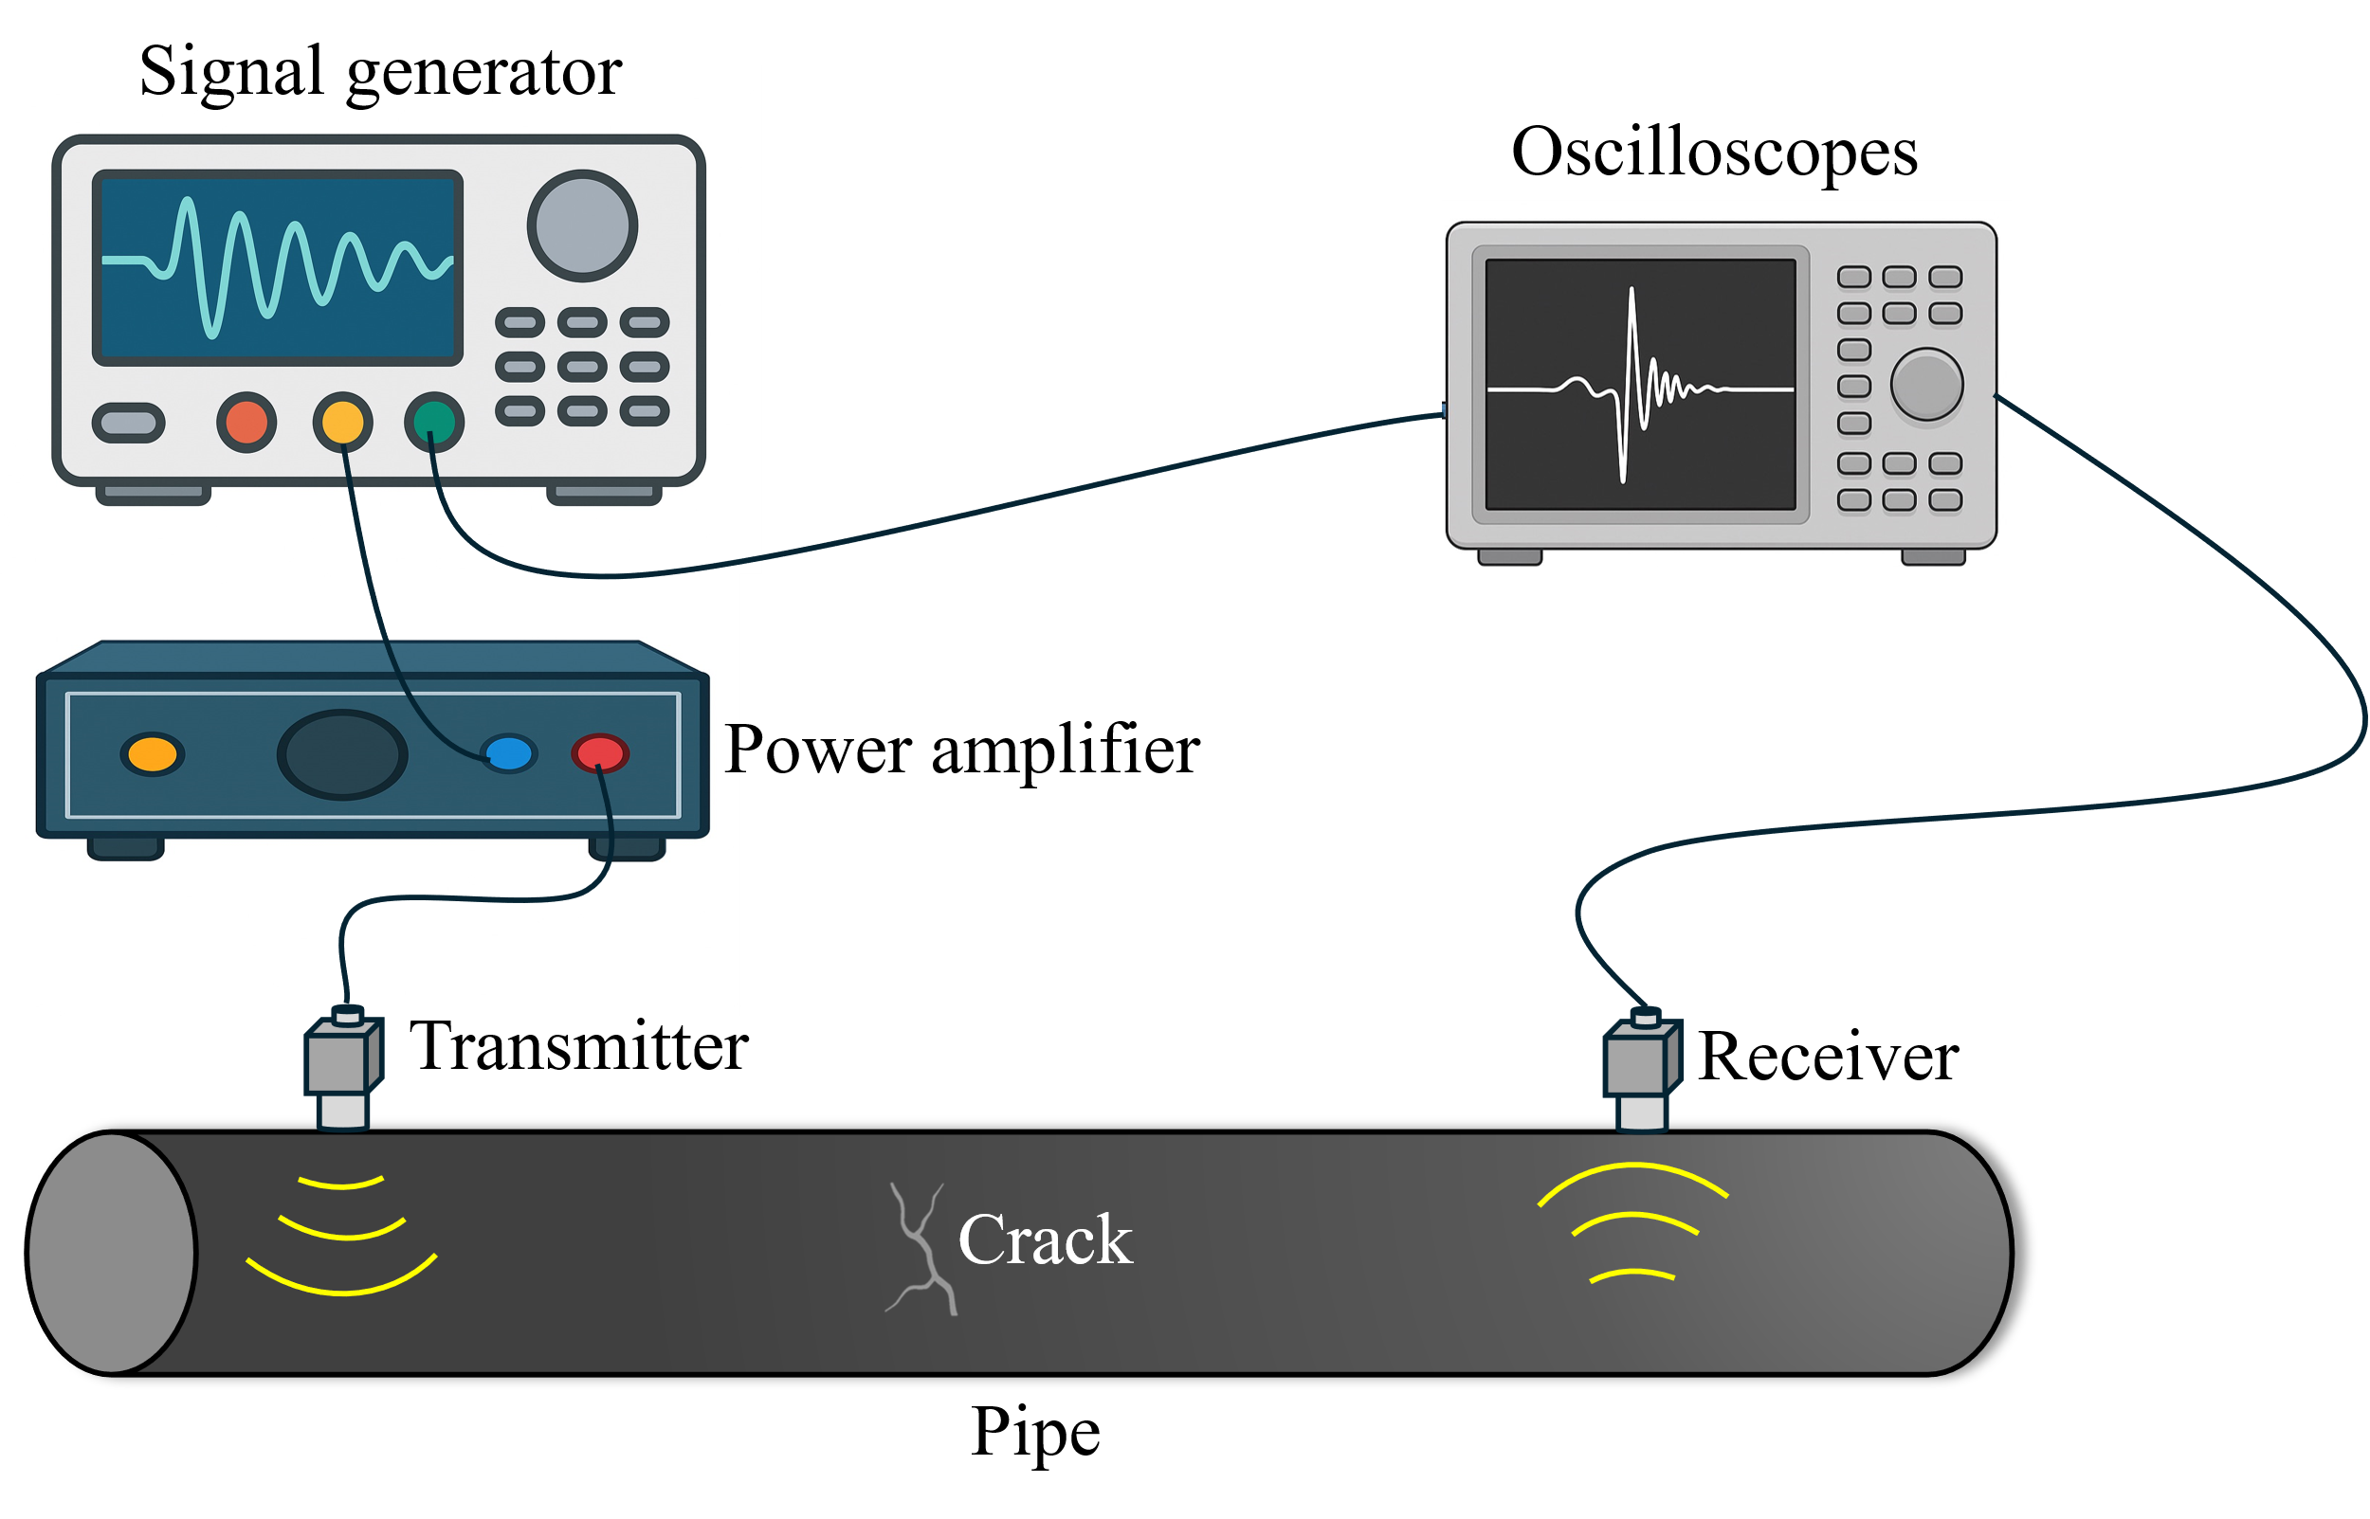
(b)
Fig. 3. Experiment setup for pipeline SCC (a) acoustic emission; and (b) ultrasonic testing.

4.1.1 Acoustic emission
The working principle of AE is passive detection of transient elastic waves generated by material. When the material is subjected to stress, processes like crack initiation and growth cause a rapid redistribution of stress, which releases stored strain energy. This energy propagates through the material as high-frequency stress waves. By capturing these spontaneously generated signals with sensors, the method allows for real-time monitoring of active structural damage.
The procedure of AE involves four steps: (1) Clean pipe surface. Debris or coatings are removed. (2) Sensor deployment. After applying the couplant at the designated locations, AE sensors are deployed on the pipe surface by using adhesives or magnetic holder. (3) Data collection. The sensors continuously record acoustic signals. (4) Data analysis. Acoustic signals are post-processed and analyzed.
In the post-processing stage, acoustic signals (Fig. 4) received by the transducers are analyzed to detect and locate cracks. Amplitude is the maximum voltage (unit: dB), which reflects the energy released by the crack event. Risetime is defined as the time interval from the start of the signal to its peak. Risetime is closely related to the crack type and propagation speed. Duration is the time from the start to the end of the signal, reflecting the energy release process and the complexity of the crack event. Energy represents the squared integral of the signal amplitude, reflecting the total energy released by the source event. Counts are used to measure the number of times the signal exceeds a threshold, reflecting the oscillation intensity and frequency characteristics of the signal.
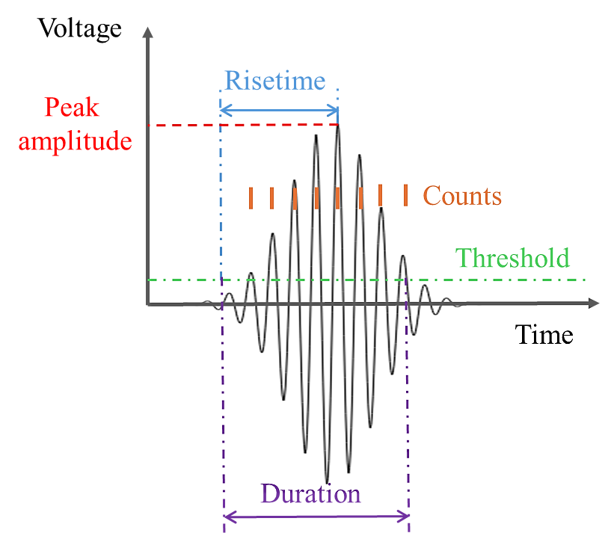
Fig. 4. Schematic of an acoustic emission event and related parameters.
These parameters were utilized to identify and characterize cracks. The signal duration, when combined with frequency and risetime, can be used to distinguish SCC from other types of cracks [32]. The amplitude and energy reflect the severity of the crack [33], while the time of peak and risetime can assist in the estimation of the crack initiation time and location [34]. AE hit energy is the energy associated with individual AE events at the hit level [11]. Based on these parameters, various AE indices, such as monitoring indicator [4], cumulative hits rate [35], and AE energy [36], were proposed to assess the initiation and development of SCC.
In laboratory testing, AE has detected pipeline SCC, as elaborated in references [4,37,38]. Piezo ceramic sensors were deployed on pipelines to measure AE signals, and the AE signals were analyzed to detect SCC. The pipeline diameters ranged from 19 mm [37] to 203.2 mm [4], and pipeline material included 304 stainless steel [4,37] and API 5L grade X65, X80, and X100 [38]. The SCC detected in those studies ranged from 100 μm [38] to 25 mm [37]. Moreover, AE was utilized to monitor SCC of other specimens such as steel plates [39–44].
In addition to crack detection, AE signals have been utilized to classify the SCC process into four stages [11,45]: (1) Stage 1 involves homogenization and chemical stabilization in corrosive environments, with low AE hit energy. (2) Stage 2 features the initiation and propagation of SCC, with cumulative AE energy. (3) Stage 3 involves passive film rupture, plastic deformation, and dissolution, with high AE energy. (4) Stage 4 features catastrophic cracks and high-amplitude AE signals with a short risetime. In these stages, AE signals are generated in crack initiation, sub-critical crack extension, and stable crack propagation [46,47].
Further research has shown that AE signals can be used to differentiate intergranular SCC (IG-SCC) and transgranular SCC (TG-SCC). Attributed to the interaction of electrochemical and mechanical actions, IG-SCC emit relatively strong AE signals [48,49]. In contrast, TG-SCC involves stable propagation within the grain interiors, lacking abrupt energy release; thus the AE signal may be weak or undetectable [37,50]. To distinguish IG-SCC and TG-SCC, the ratio of the number of burst and continuous signal were introduced. One for pure TG-SCC and zero for pure IG-SCC. For a mixture of TG-SCC and IG-SCC, the ratio is between zero and one [42].
In summary, the findings in existing studies demonstrate that AE provides an effective method for the real-time monitoring of SCC initiation and propagation based on the different phenomenon which emits transient elastic waves. Furthermore, characteristic analysis of the passively acquired signals can be used to differentiate among the distinct stages of SCC progression.

4.1.2 Ultrasonic testing
The working principle of UT is the active transmission and reception of ultrasonic waves. An ultrasonic wave, introduced by a transducer, propagates through the material until it reflects off a boundary or discontinuity, such as cracks and voids. The captured echoes are then analyzed based on the time of flight and amplitude to determine the presence, location, and size of the defect.
The procedure of UT involves five steps: (1) Clean pipe surface. The surface is cleaned to ensure effective coupling between the transducers and the structure. (2) Transducer deployment. One transducer is placed for signal transmission and another for reception [51]. Alternatively, a single transducer may serve both functions [3], or one transmitter may be paired with multiple receivers [52]. (3) Ultrasonic wave generation. A pulse signal is generated and transmitted into the pipe, exciting ultrasonic waves in the pipe. (4) Data acquisition. The ultrasonic signals are received by receiver and recorded using an oscilloscope. (5) Data analysis. The location, size, and nature of defects can be determined by analyzing the time and the amplitude of the signals.
In laboratory testing, UT has been utilized to detect and monitor the development of pipeline SCC [53–55]. Various transducers, such as laser acoustic transducer (LAT) [54], electromagnetic acoustic transducer (EMAT) [54], electromagnetic-acoustic transducer [55], and others [56], operated at different frequencies, such as 400-1100 kHz [53] and 400-1200 kHz [56]. Ultrasonic signals were analyzed to monitor cracks as deep as 5 mm [55] at high spatial resolution (mm-scale or sub-mm-scale). The lengths of the inspected pipes ranged from 50 mm [54] to 700 mm [53,56], and the diameters ranged from 35 mm [55] to 966 mm [53].
The UT approaches can be further categorized into gas-coupled UT, liquid-coupled UT, laser UT, and EMAT approaches. Gas-coupled UT employs high-pressure gas as the acoustic coupling medium to excite and sense guided ultrasonic waves in pipeline walls [53]. Broadband ultrasonic waves are transmitted through pressurized gas and transmitted into the pipe wall, where guided wave modes propagate along the pipeline [56]. Defects, especially SCC, cause scattering, mode conversion, and attenuation of the guided waves, resulting in reduced acoustic energy that leaked back into the gas and detected by receivers [57,58]. Liquid-coupled UT employs a liquid medium to achieve acoustic coupling, allowing ultrasonic shear waves to interrogate pipeline walls with high sensitivity to SCC. In in-line inspection applications, it has been shown to reliably detect and size axially oriented SCC longer than 30 mm and deeper than 1 mm [59]. Laser doppler vibrometers captured time-space wavefield data for monitoring SCC [60]. Using a dense distribution of EMAT sensors on the pipe achieved high-resolution imaging of the pipe wall for monitoring the growth of cracks. Laser UT and EMAT were combined to enhance crack detection accuracy and resolution for crack size and shape [54]. These UT approaches not only detected cracks in pipelines but also improved the ability to determine crack shape, size, and distribution.
Conventional linear UT is effective in detecting major cracks but has limited sensitivity to microcracks. To enhance the ability to monitor microcracks, nonlinear UT has been developed and applied to monitor SCC [61,62]. In those studies, Rayleigh waves with a center frequency of 2.25 MHz were generated and received using PZT transducers, and nonlinearity parameter $β$ was used to assess the initiation of microcracks.
In summary, existing research demonstrates that UT can be effectively utilized to detect, localize, and quantify the size of SCC. The integration of advanced techniques, such as laser ultrasonics, EMAT, and gas-coupled sensors, has further enabled non-contact SCC detection. Concurrently, linear and nonlinear UT provide complementary capabilities, allowing for the inspection of cracks at macroscopic and microscopic scales, respectively.

4.1.3 Summary
Representative studies on AE or UT for pipeline SCC are listed in Table 2. AE is sensitive to microcracks and thus it allows early-stage detection and continuous monitoring. However, it struggles to achieve high accuracy due to the low signal-to-noise ratios, and it is also difficult to precisely locate flaws unless multiple sensors are used. UT provides superior spatial resolution, allowing for accurately locating, quantifying, and visualizing cracks. In summary, AE is capable of real-time monitoring, UT is capable of precise, on-demand inspection.
Table 2. Summary of sound wave-based methods
Ref. | Material | Specimen type | Dimension | Method | Sensors | Crack size | Function
[37] | Stainless steel | Pipe | PD: 19 mm | AE | PZT | L: 25 mm | Detect SCC
[45] | Stainless steel | Pipe | OD: 86 mm  W: 7.6 mm  L: 150 mm | AE | PZT | - | Detect SCC
[4] | Stainless steel | Pipe | OD: 203.2 mm  T: 12.7 mm  L: 205 mm | AE | PZT | - | Monitor SCC
[63] | Cold drawn steel | Strand | - | AE | PZT | - | Detect SCC
[44] | Stainless steel | Plate | 173$×$16$×$2 mm | AE | PZT | - | Monitor SCC
[30] | Stainless steel | Plate | 37.5$×$36$×$10 mm | AE | PZT | - | Detect SCC
[64] | Stainless steel | Plate | 280$×$12$×$2 mm | AE | - | - | Detect SCC
[41] | Stainless steel | Plate | 24$×$20$×$10 mm | AE | - | - | Detect SCC
[39] | Steel | Plate | 150$×$65$×$5 mm | AE | PZT | - | Detect SCC
[29] | Steel | Strand | PD: 5.2, 5.4 mm | AE | PZT | - | Monitor SCC
[42] | Stainless steel | Plate | 31.3$×$30$×$12.5 mm | AE | PZT | - | Detect SCC
[65] | - | Pipe | OD: 762 mm,  T: 8 mm,  L: 1000 mm | UT | EMAT | L: 25.4 mm, 76.2 mm | Detect SCC
[66] | Steel | Pipe | OD: 1016, 1422.4 mm  T: 16.5, 18.7 mm | UT | PZT | D: 8 mm | Detect, quantify SCC
[54] | Stainless steel | Pipe | OD: 160.2 mm  T: 3.9 mm  L: 270, 50 mm | UT | EMAT | - | Detect, locate, quantify SCC
[55] | Stainless steel | Pipe | T: 35 mm | UT | EMAT | D: 0.5-5.0 mm | Detect, locate SCC
[56] | - | Pipe | OD: 910 mm  T: 12.7 mm  L: 700mm | UT | - | D: 4.3 mm | Detect, locate SCC
[67] | Stainless steel | Pipe | L: 127 mm | UT | PZT | - | Detect SCC
[68] | Stainless steel | Pipe | OD: 559 mm  T: 33 mm  L: 290 mm | UT | PZT | D: 13 mm | Detect, locate SCC
[53] | - | Pipe | OD: 914.4, 966 mm  T: 12.7, 13.0 mm  L: N/A | UT | - | L: 60 mm  W: 40 mm  D: 3.7 mm | Detect SCC
[62] | Carbon steel | Dog-bone | L: 254 mm  W: 18.5 mm  T: 5.1, 3.8 mm | UT | PZT | - | Detect, quantify SCC
[69] | Stainless steel | Washer | 50$×$25$×$1.4 mm | UT | PZT | L: 830 μm | Detect, locate, quantify SCC
Note: T stands for thickness, OD for outer diameter, PD for diameter, L for length, W for width, and D for depth.

4.2 Vision-based techniques
Vision-based methods focus on visual features of SCC imaged using optical cameras, infrared cameras, or microscopes (Fig. 5). Advanced techniques, such as DIC [70–72] and infrared thermography (IRT) [73,74], were developed to detect major crack and microcracks at surface.
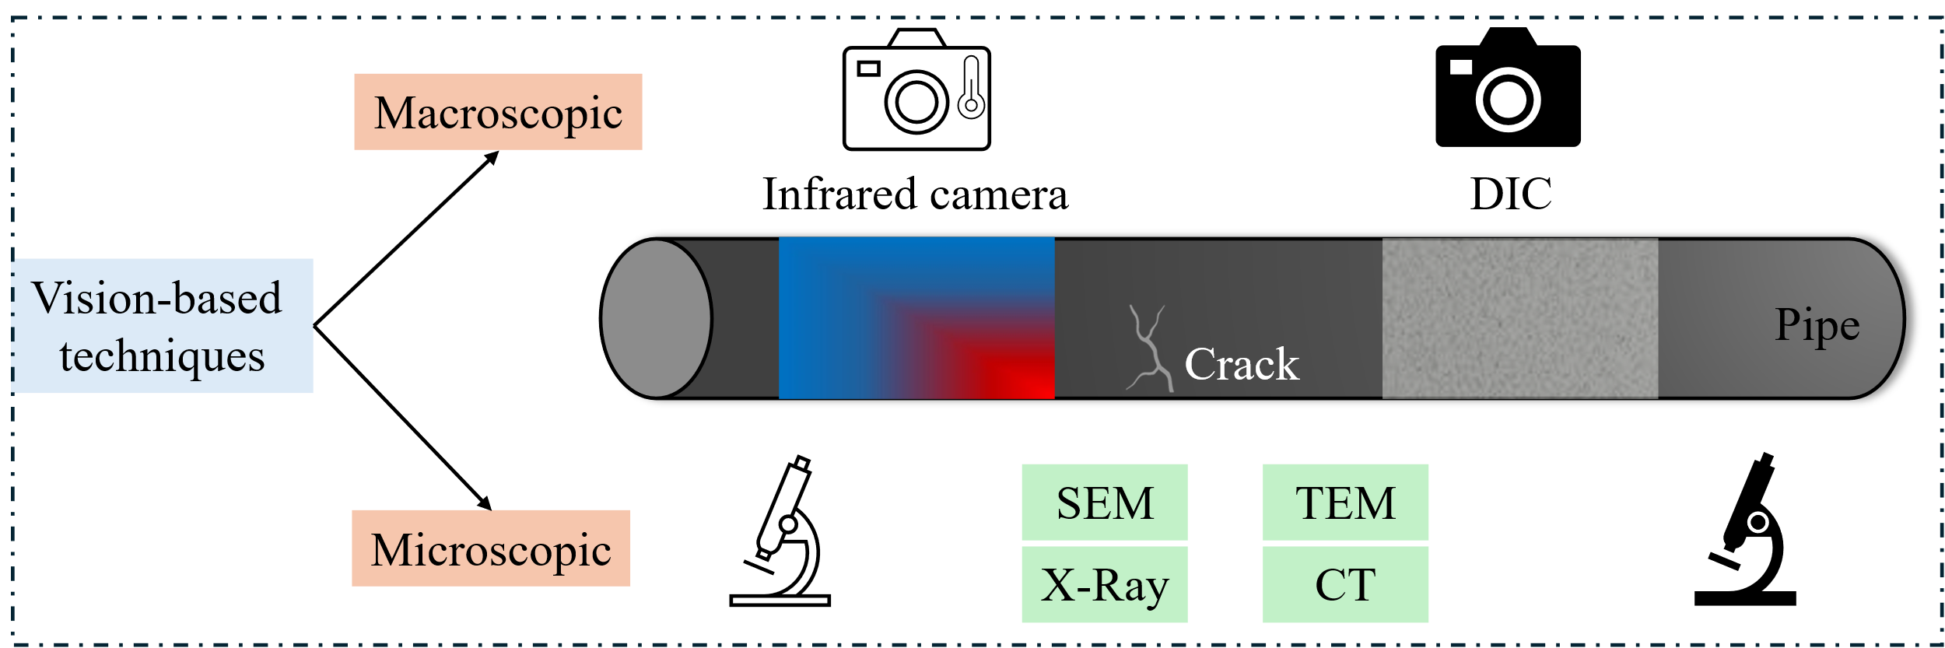
Fig. 5. Vision-based techniques.

4.2.1 Digital image correlation
The principle of DIC is tracking the geometric displacement of surface features across a series of digital images. With a random, high-contrast speckle pattern on the surface of a pipe, the camera captures a reference image before deformation and a sequence of subsequent images. By dividing the reference image into pixel windows and using a correlation algorithm to track the new position of each window in the deformed images, DIC generates a full-field displacement map, which is mathematically differentiated to provide a detailed strain map of the entire surface.
The procedure of using DIC involves four steps: (1) Surface preparation. A stochastic speckle pattern is applied to the pipe surface. (2) Image acquisition. Cameras with high resolution or high frame rates are positioned to capture sequential images of the speckled surface during loading. (3) Data processing. The captured images are analyzed using digital correlation algorithms to track the movement of the speckles and compute displacement fields. (4) Strain evaluation. The resulting displacement data is used to generate high-resolution strain maps, which facilitate the assessment of crack initiation and propagation [75–77].
In the laboratory, DIC has been applied to monitor SCC from specimens extracted from pipes. For instance, SCC was identified from a specimen extracted from a steel pipe (API-5L Gr.X52) which measured 406.4 mm in outer diameter and 9.2 mm in wall thickness [78]. In addition to pipeline steel, DIC was applied to identify cracks from various materials, such as stainless steel [79], aluminum alloys [80], and nickel-based alloys [81]. With high sensitivity and resolution, DIC identified surface microcracks as short as 250 µm and as narrow as 5 µm [70,82]. More relevant studies on evaluating SCC using DIC are available in references [64,71,83].
In addition to crack detection, DIC was used to investigate the mechanisms of crack initiation and propagation during SCC. With microscopy images, DIC identified early signs of cracking and evaluated the effect of grain boundary angles and dislocation channels on crack initiation [72][110]. The findings suggest that large-angle grain boundaries [84] and the grain boundaries with higher maximum normal strain are preferred crack initiation sites. While discontinuous dislocation channels may increase local stresses, promoting crack formation [85].
In summary, DIC has been used for the detection of SCC and for studying its underlying mechanisms. This method operates by tracking the displacement of surface feature points using correlation algorithms. When paired with advanced, high-resolution cameras, DIC can detect micro-cracks at the micrometer level. The primary limitations of DIC are the requirement of the speckle pattern and the performance is heavily dependent on the camera's specifications.

4.2.2 Infrared thermography
The principle of IRT is capturing the thermal energy emitted from the surface. When a material is subjected to stress or corrosion, localized temperature variations occur due to physical and chemical processes such as friction between crack faces. An infrared camera detects thermal radiation and converts it into a visual map of the surface temperature, known as a thermogram. By analyzing thermal patterns, such as localized hot or cold spots, the method allows for the detection and real-time monitoring of damage initiation and progression. Prior research showed that IRT could monitor the initiation of SCC [86,87].
The procedure of IRT involves four steps: (1) Clean pipe surface. Debris or coatings are removed. (2) Thermal excitation. Passive or active thermography can be employed. Passive IRT records the natural thermal emission of the object, while active IRT applies an external thermal stimulus, such as halogen lamp, to generate thermal gradients. (3) Image acquisition. A thermal camera captures a sequence of infrared images over time during or after thermal excitation. (4) Data analysis. The temperature distribution is analyzed to identify surface or subsurface defects.
In the laboratory, IRT has been applied to pipes and steel plates extracted from pipes. With infrared cameras (e.g., FLIR T640 and Silver 480 M), the presence of SCC can be detected by identifying heat intensity difference, which appeared as temperature difference compared to defect-free areas [88]. Cracks measuring 10 μm in width and over 25 mm in length were detected [86]. Furthermore, IRT combined with ultrasonic excitation (Sonic-IR) has demonstrated strong capability for detecting closed SCC by capturing localized frictional heating at crack interfaces. Experimental studies have shown that this approach can successfully detect SCC with depths on the order of a few millimeters. For example, a crack with a depth of approximately 3.7 mm was detected under laboratory conditions [87]. This sensitivity makes Sonic-IR particularly effective for tight or closed cracks that are challenging for conventional UT. IRT can be utilized to detect the presence of SCC by monitoring the thermal variance of a material's surface. The resulting thermograms allow for a preliminary estimate of the SCC's location and size.

4.2.3 Summary
Representative studies on SCC monitoring using vision-based methods are listed in Table 3. Vision-based techniques, such as DIC and IRT, can detect, locate, and quantify SCC via measuring displacement, temperature distributions, or microstructures from specimens with varying materials, shapes, and dimensions. Unlike DIC, which necessitates the application of the speckle pattern onto the specimen's surface, IRT does not require a tracking pattern. In terms of localizing and quantifying the geometric dimensions of cracks, DIC typically offers higher accuracy than IRT. A weakness of DIC is that the monitoring is confined to the surface. In contrast, active IRT can detect subsurface defects, which alter the material's thermal conductivity and create identifiable thermal anomalies on the surface, thereby enabling the possibility of early damage detection.
With high-speed cameras (e.g., 10,000 frames per second), the rapid development of SCC was observed from steel plates [89] and aluminum bars [90]. The initiation and growth of SCC were visualized [91,92]. This is particularly useful in studying dynamic failure like crack coalescence [93] and pit-to-crack transition [94]. Additionally, microscale images from various microscopes, such as optical microscopy [95], scanning electron microscope (SEM) [96], and transmission electron microscopy (TEM) [97,98], have also been used to examine SCC in small samples.
Table 3. Summary of research using vision-based methods
Ref. | Material | Specimen type | Dimension | Method | Imaging devices | Crack size | Function
[70] | Alloy | Plate | 117×8×2 mm | DIC | Optical camera | W: 0.45 μm, L: 55 μm | Detect, locate, quantify SCC
[71] | Stainless steel | Plate | 36×10×1 mm | DIC | - | - | Detect SCC
[82] | Stainless steel | Plate | 42.8×13×0.914 mm | DIC | Optical camera | W: 5 μm, L: 250 µm | Detect, locate, quantify SCC
[99] | Aluminum alloy | Plate | 10×51.46×N/A mm | DIC | Microscope | - | Detect, locate, quantify SCC
[85] | Alloy | Plate | 21×2×1.5 mm | DIC | - | - | Detect, locate, quantify SCC
[100] | Aluminum alloy | Plate | N/A×N/A× 8 mm | DIC | - | - | Detect, locate, quantify SCC
[86] | Carbon steel  Stainless steel | Pipe | OD: 89 mm  T: 7.6 mm  L: 150 mm | IRT | Infrared camera, | - | Detect, locate, quantify SCC
[87] | Stainless steel | Plate | - | IRT | Infrared camera | D: 2.0-4.5mm | Detect, locate, quantify SCC
Note: T stands for thickness, OD for outer diameter, PD for diameter, L for length, W for width, and D for depth. Plate dimensions are presented in the format of length × width × thickness. N/A indicates that the corresponding information was not reported in the original reference.

4.3 Electrical techniques
Electrical techniques measure electrical resistance, conductivity, capacitance, and potential, which reflect the initiation and development of cracks and corrosion. Eddy Current Testing (ECT) and Direct Current Potential Drop (DCPD) are two representative methods for detecting pipeline SCC with high sensitivity, high stability, and environmental adaptability. The setups for ECT and DCPD are shown in Fig. 6.
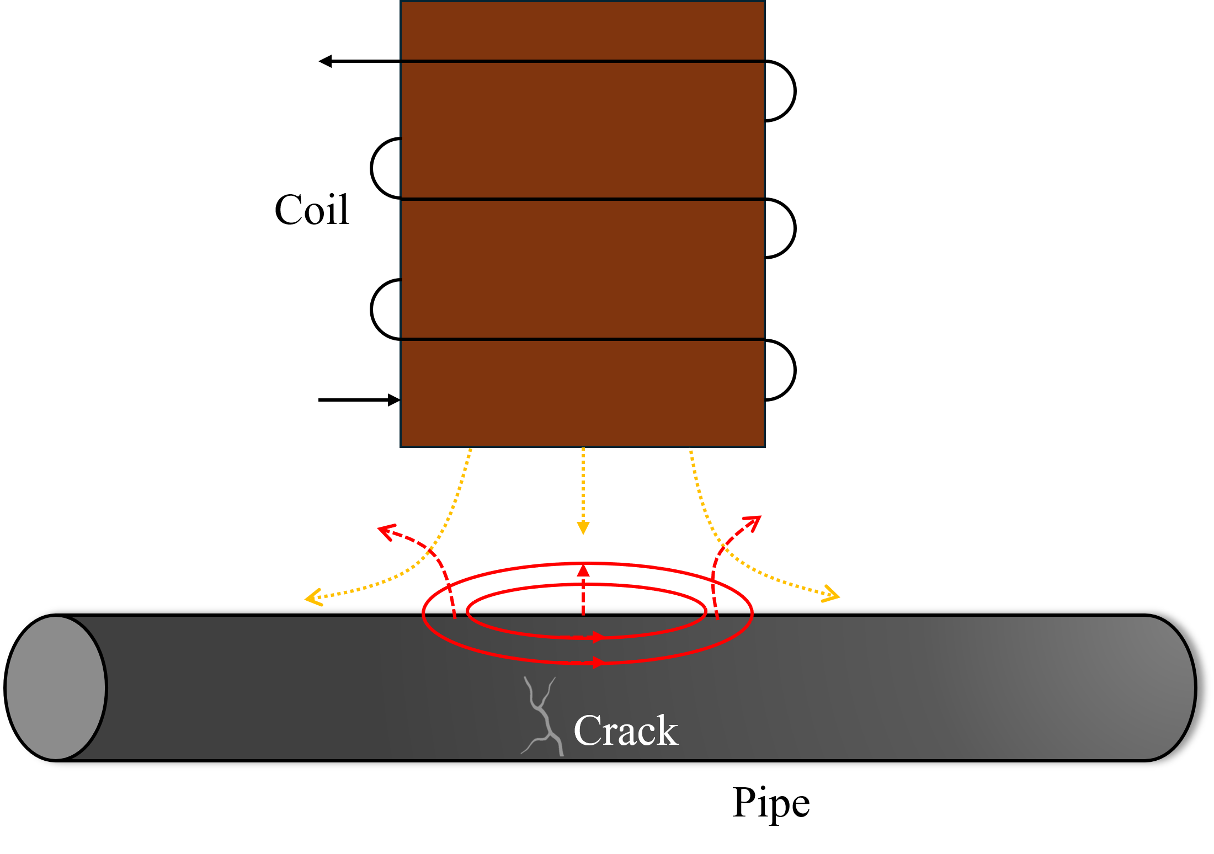
(a)
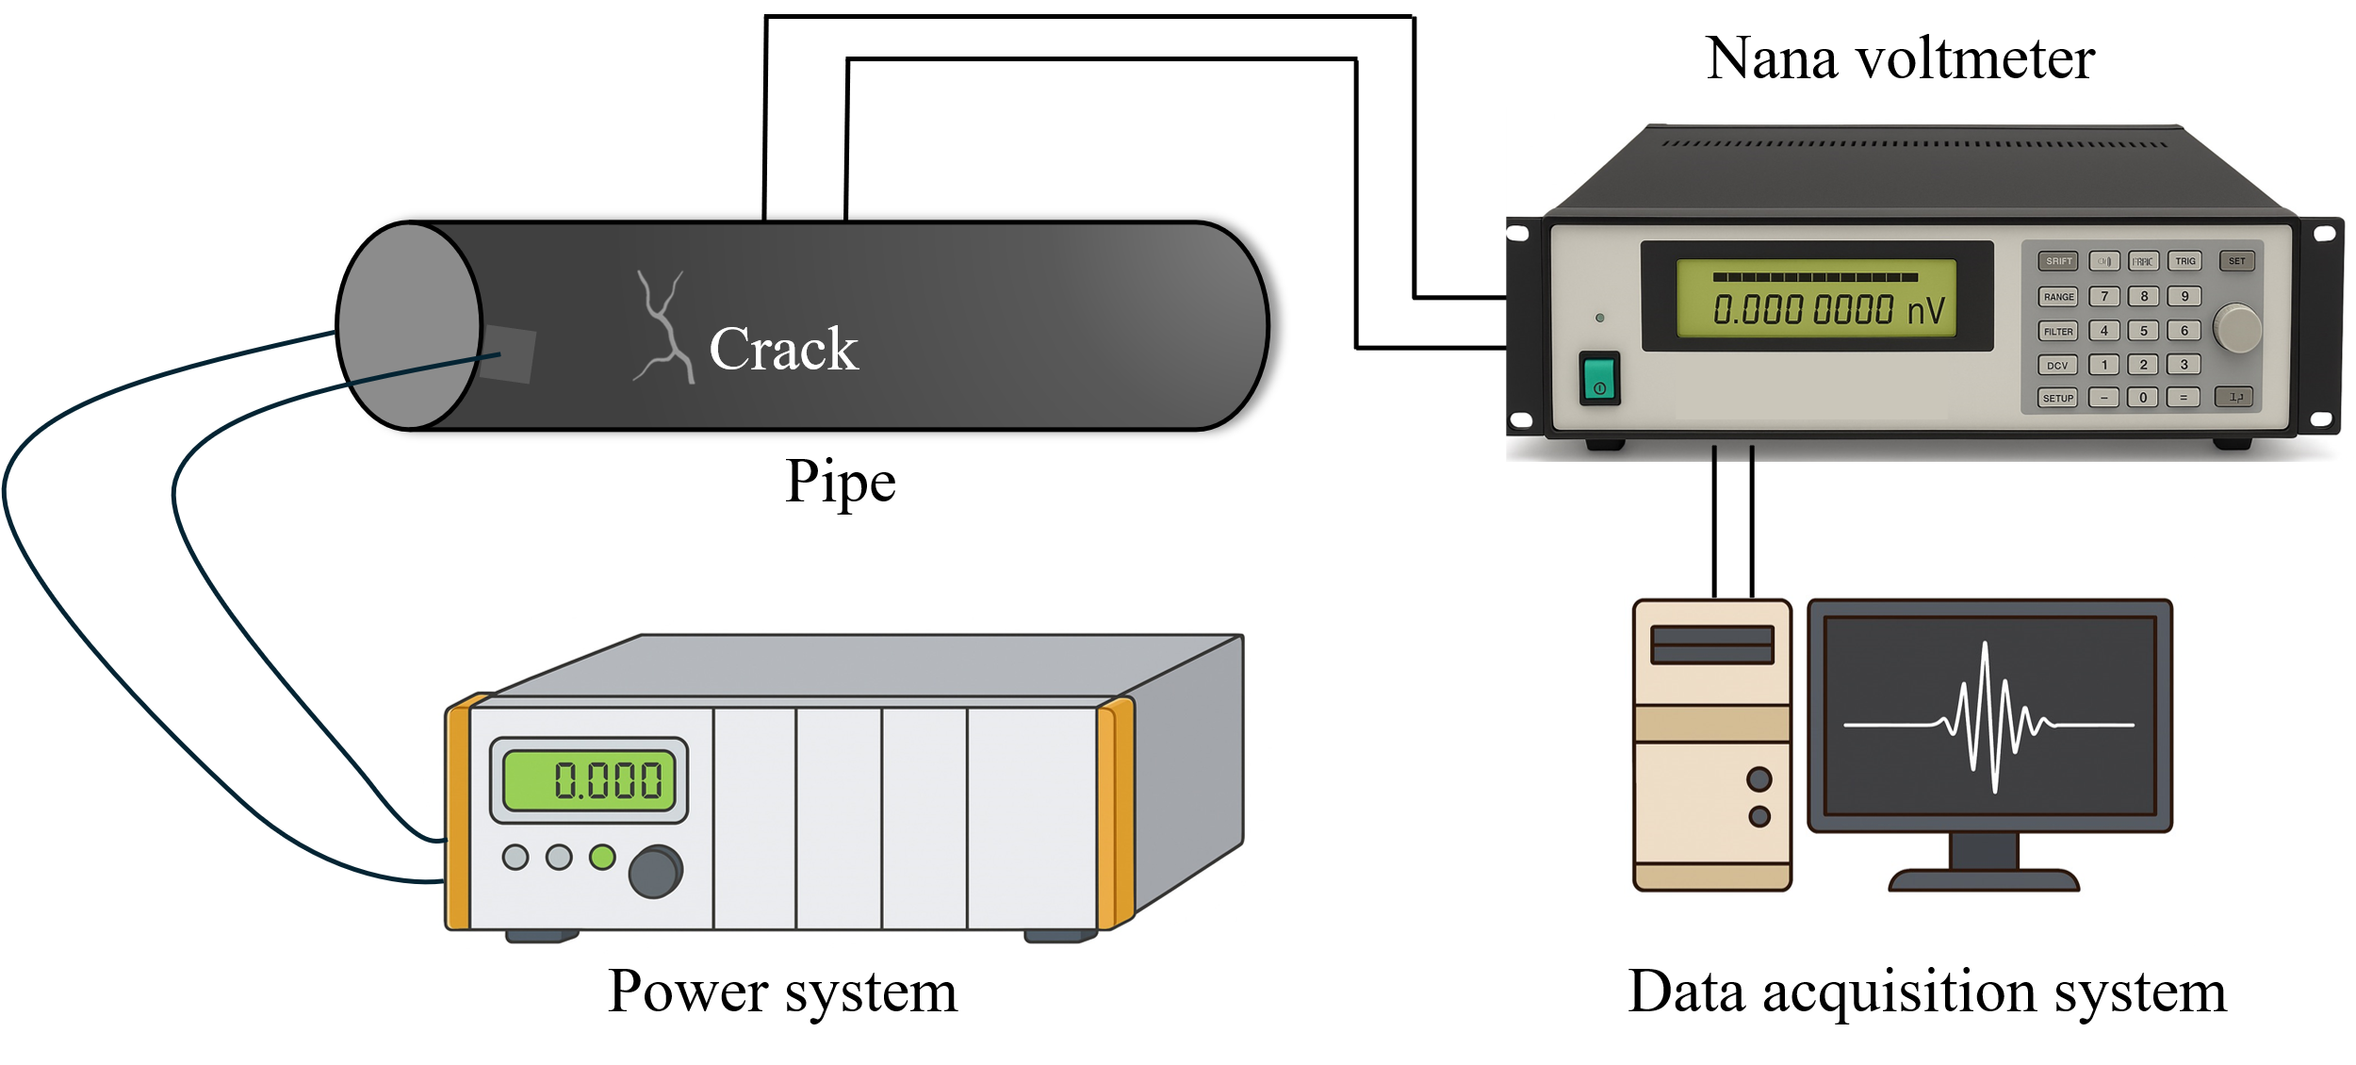
(b)
Fig. 6. Test setup for detecting pipeline SCC using: (a) ECT, and (b) DCPD.

4.3.1 Eddy current testing
The principle of ECT involves inducing eddy currents via alternating electromagnetic fields [101]. The presence of defects alters the distribution, amplitude, and phase of eddy currents, resulting in detectable variations [102]. The procedure of ECT involves five steps: (1) Clean pipe surface. Debris or coatings are removed. (2) Sensor deployment. An eddy current probe is placed at a fixed distance from the pipe. (3) Excitation. The instrument drives an alternating current through the probe coil, generating a time-varying primary magnetic field. According to Faraday’s law of electromagnetic induction, the associated change in magnetic flux induces an electromotive force in the conductive pipe wall, leading to the formation of closed-loop eddy currents. (4) Data collection. The instrument continuously records the changes in the probe coil’s impedance. (5) Data analysis. Signals are processed and analyzed to identify defects.
In laboratory testing, ECT was applied to detect SCC from pipe specimens [103] or specimens extracted from pipelines [104,105]. The detected cracks were as short as 40 mm, as narrow as 0.2 mm, and as deep as 10 mm. Additionally, ECT detected SCC in the incubation stage [106]. More research on using ECT to evaluate pipeline SCC is available in references [107–114].
In addition to crack detection, ECT was used to quantify the crack size and depth. Experiments showed that SCC caused heterogenous conductivity distributions within the material [115]. Due to complex conductivity distribution, reconstructing SCC using single-frequency signals presents an ill-posed inverse problem, leading to errors in crack size [116] and crack depth assessment [117,118]. It is promising to reconstruct SCC using multi-frequency signals. High-frequency signals reflect surface conductivity and crack length, while low-frequency signals offer information about crack depth [118,119]. Crack length influences the phase, and crack depth and conductivity affect the amplitude [117]. Furthermore, applying regularization methods to process multi-frequency ECT signals effectively improves SCC shape reconstruction accuracy and reduces the impact of multiple solutions [120]. Moreover, numerical methods have been used to study the relationship between conductivity and SCC [121–123]. A finite element-boundary element model was used to simulate eddy current signals for calibrating and testing the equipment [122].
In summary, ECT is effective for detecting SCC in conductive pipes. This technique provides early warning for SCC and allows for the estimation of crack size and depth. Its primary limitations are the inapplicability to non-conductive materials and the high sensitivity of its detection signal to the probe-to-surface distance, which makes it unsuitable for long-distance inspection.

4.3.2 Direct current potential drop
The principle of DCPD method is assessing cracks based on the change of electrical resistance in metallic materials. The presence or the propagation of a crack results in a reduction in the cross-sectional area and an increase in the electrical resistance [124]. The procedure of DCPD involves five steps: (1) Clean pipe surface. Debris or coatings are removed. (2) Electrode placement. A pair of current electrodes is attached to the pipe. A separate pair of voltage probes is positioned across the monitored region. (3) Current application. A constant direct current is applied through the current electrodes to establish a stable electrical field. (4) Voltage monitoring. Voltage drops across the probes are continuously recorded. (5) Data analysis. As a crack propagates, electrical resistance increases, resulting in a detectable voltage change.
In laboratory testing, DCPD has been applied to monitor pipeline SCC. Pipe diameters ranged from 112 mm [125] to 914 mm [126], with wall thicknesses between 5.8 mm [127] and 45.5 mm [128]. Crack depth detection ranged from 1.5 mm [126] to over 40% of the pipe wall thickness [129], and crack lengths ranged from 11 mm [128] to 100 mm [126]. When the crack depth was deeper than 4 mm [130], DCPD can monitor cracks, including cracks located in base metal and seam welds [127]. Not only the front wall, the DCPD technique could also monitor back wall SCC propagation, starting from a fatigue pre-crack at a depth of approximately 4 mm and extending until the crack propagates beyond 80% of the specimen thickness [130].
In addition to practical applications, DCPD has been employed to investigate the mechanisms of SCC crack propagation. Several studies quantified crack growth rates under high mechanical stress conditions, such as loads approaching 95% of the pipeline's yield strength [126]. The crack growth rate decreased with increasing relative humidity and crack depth [131]. Prior research also showed that the electrical conductivity distribution in SCC regions increased linearly along both crack depth and length directions [132], with conductivity becoming larger near the crack tip and reaching its minimum at the crack opening position [115].
In summary, DCPD detects SCC by measuring changes in electrical resistance. Existing research shows that DCPD can estimate crack depth and quantify crack growth rate. However, the DCPD method demands precise control over experimental conditions, such as temperature, probe contact, and requires a high degree of environmental and operational stability. Consequently, it is challenging to widespread practical applied for the on-site detection of pipelines SCC.

4.3.3 Summary
Representative studies on monitoring SCC using electrical methods are summarized in Table 4. Existing research indicates that ECT can detect SCC and estimate the size and depth of shallow, surface-breaking cracks based on the analysis of eddy currents. In contrast, the DCPD method can detect SCC, quantify crack depths, and monitor crack growth rate. However, ECT and DCPD are inapplicable to non-conductive (e.g., polyethylene) pipelines. Moreover, due to the complexity of wiring and the requirement for stable electrodes, ECT and DCPD face barriers for deployment in the field, and the applications are limited to experimental validation and laboratory-scale testing.
Table 4. Summary of research using electrical methods
Ref. | Material | Specimen type | Dimension | Method | Crack size | Function
[133] | Stainless steel | Plate | 200×100×10 mm | ECT | - | Detect SCC
[134] | Alloy, stainless steel | Welded specimen | 300×100 mm | ECT | D: 9 mm  L: 10 mm  W: 0.3 mm | Detect, and quantify SCC
[105] | Low carbon steel | Plate | 600×150×3 mm | ECT | L: 5-20 mm | Detect, and quantify SCC
[106] | Low carbon steel | Plate | - | ECT | - | Detect SCC
[109] | Stainless steel | Plate | 600×270×25 mm | ECT | W: 0.01-1.2 mm | Detect, quantify SCC crack width
[103] | - | Pipe | OD: 215.9 mm  T: 4.7625 mm  L: N/A | ECT | D: 0.952-3.81 mm | Detect, quantify SCC crack depth
[130] | Stainless steel | Dog-bone | L: 118 mm  W: 8, 40 mm  T: 2.8 mm | DCPD | D: 106 µm | Detect, quantify SCC crack depth
[130] | Stainless steel | Plate | 300×150×20 mm | DCPD | D: 0.12-9.59 mm | Detect SCC, quantify crack depth
[132] | Stainless steel | Plate | 200×100×10 mm | DCPD | W: 0.024 mm  D: 3.5 mm | Detect, locate SCC
Note: T stands for thickness, OD for outer diameter, PD for diameter, L for length, W for width, and D for depth. Plate dimensions are presented in the format of length × width × thickness. N/A indicates that the corresponding information was not reported in the original reference.

4.4. Electrochemical approaches
Electrochemical approaches provide critical insights into early-stage crack and corrosion. As two representative techniques (Fig. 7), electrochemical noise (EN) and electrochemical impedance spectroscopy (EIS) are widely used to evaluate the development of SCC.
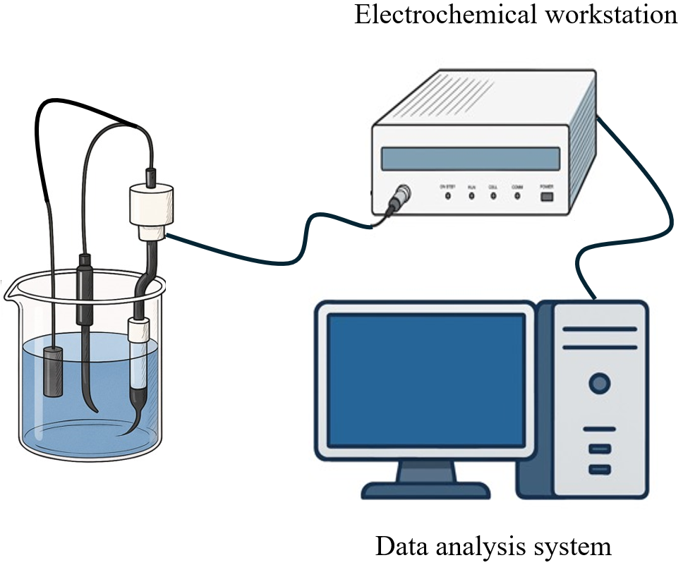
Fig. 7. Representative test setup of EN and EIS approaches.

4.4.1 Electrochemical noise
The principle of EN is monitoring the spontaneous fluctuations of potential and current on the electrode surface. A three-electrode or two-electrode system is typically used to record potential noise and current noise in the absence of external perturbation. These noise signals reflect dynamic changes in the corrosion process, such as the initiation and growth of pitting corrosion, uniform corrosion, and the breakdown of passive films. Information related to corrosion mechanisms is extracted to identify different corrosion types and growth rates.
The procedure of EN involves five steps: (1) Clean pipe surface. Debris or coatings are removed. (2) Electrode installation. At least two working electrodes and one reference electrode are mounted on the pipe surface or immersed in the test solution. (3) System stabilization. The system will reach electrochemical equilibrium under open circuit conditions without external current or voltage. (4) Signal acquisition. The spontaneous fluctuations in potential and current between electrodes are recorded over time using a high-impedance data acquisition system. (5) Data analysis. Time-domain and frequency-domain analyses are performed to assess SCC based on noise amplitude, standard deviation, and spectral features.
In laboratory testing, EN has been used to identify early-stage corrosion and cracking via analyzing the evolution of EN signals [6]. Under different pH conditions, EN has proven its ability to detect transient activation-passivation events associated with cracking phenomenon [135]. However, while the transient nature of EN signals is a key parameter for differentiating SCC, the initiation of pitting also exhibits similar transient characteristics [136]. Furthermore, although EN effectively captured the electrochemical activity linked to SCC development, the dimensions of cracks were not quantified, suggesting that EN is primarily suitable for qualitative monitoring and early detection rather than quantitative crack characterization.
By detecting crack initiation and propagation, EN has been applied to various materials [137,138]. In stainless steel, EN detected early-stage SCC [139] and applied to H₂S environments and welded structures [140]. EN is often combined with AE techniques for enhanced accuracy [44,141,142]. For aluminum alloys, EN detected localized SCC [143]. In low-carbon steels like pipeline steel (X52), EN monitored the development of SCC in synthetic soil solutions [144]. Titanium alloys, such as Ti-6Al-4V, benefited from EN monitoring in welded joints, enhanced SCC resistance by altering microstructure [145]. Meanwhile, nuclear industry materials, like Alloy 690, leveraged EN signal intensity and frequency shifts to assess SCC initiation [146].
Furthermore, EN has been used to advance the understanding of crack initiation mechanisms, crack propagation behavior, and crack interactions. By analyzing the EN signal, specifically the amplitude [64,147] and frequency [44,148], crack initiation, propagation, and final failure can be identified [148–150]. Similar to AE, EN identifies the initiation and propagation of SCC into four stages. First, the passive film breakdown with pitting or localized corrosion, and the EN signals present as low current (typically 0-5 nA) and potential fluctuations (below 50 mV), with signal energy concentrate in a low-frequency band (1×10⁻³ Hz to 2×10⁻² Hz). Then, the initiation of SCC with pitting and micro-crack formation causes high-amplitude current pulses (reaching up to 100 nA) and increased potential (below 200 mV). The dominant frequency also increases, centering around 5×10⁻² Hz. Next, the propagation of SCC causes high-intensity EN signals. Current levels increase significantly (0.1-2 μA) and potential amplitudes rise (up to 300 mV). The associated frequency spectrum ranges from the 5 × 10⁻² Hz to 3 × 10⁻¹ Hz. Finally, material failure causes EN signals with high-amplitude, low-frequency fluctuations.
In summary, EN is primarily used to monitor the corrosion, crack initiation and propagation of SCC through the analysis of electrochemical characteristics, specifically the fluctuations in potential and current. However, it does not possess the capability to locate cracks or quantify the dimensions of cracks. Furthermore, its application is significantly limited by specimen size and is predominantly used for corrosion monitoring and mechanism studies in laboratory settings.

4.4.2 Electrochemical impedance spectroscopy
The principle of EIS involves applying a small amplitude, sinusoidal AC voltage to a material in corrosive environment and measuring the resulting current response across a frequency range. The impedance, which is the frequency-dependent ratio of voltage to current, is used to reflect magnitude and phase shifts. By analyzing impedance, electrochemical processes like breakdown of the passive film, the initiation of corrosion, and crack propagation can be detected.
The procedure of EIS involves five steps: (1) Clean pipeline surface. Debris or coatings are removed. (2) Electrode setup. A working electrode, a reference electrode, and a counter electrode are placed in contact with the pipeline surface or immersed in the test solution. (3) AC perturbation. A low-amplitude sinusoidal voltage (5-10 mV) is applied over a frequency range (e.g., 10⁻² to 10⁵ Hz). (4) Impedance measurement. Voltage and current are measured at each frequency to obtain the impedance spectrum. (5) Data interpretation. The impedance data is analyzed to assess SCC.
In laboratory testing, EIS has been applied to pipeline steel with SCC. The SCC behavior of pipeline steels X70 [151], X80 [152], and X100 [153] were studied via slow strain rate test (SSRT) and EIS. The specimens were primarily small dog-bone samples [154]. Mechanical strains created electrochemically active sites that influenced corrosion processes which were detected by EIS [155]. Under disbonded coatings, the charge transfer resistance diminished with increasing distance from the coating openings [156]. As stress associated with cracking increased in X70 steel in high-pH bicarbonate solutions, the resistance derived from equivalent circuit models decreased [157]. These investigations revealed that the impedance signature of cracks was most effectively detected at low frequencies, typically below 10 Hz [158].
The applications of EIS extended from detecting pipeline SCC to studying the mechanisms. Various material including 304 stainless steel [159], supermartensitic steel [160], and alloy 182 [161] were tested using different specimen geometries such as dog-bone [159], rod [162], and U-bend [163] samples. By coupling EIS with static tensile [162] or SSRT [159], the onset of SCC was monitored in aggressive environments, such as high-temperature water [161], acidic chlorides [159], and sulfides [160]. EIS detected the initiation of SCC [162,164], and in the subsequent propagation stage, the impedance phase shift was correlated with crack length [159].
Equivalent circuit models (ECM) are the primary analytical methodology in EIS studies of SCC, deconvoluting complex interfacial behaviors into physical parameters. In practice, experimental spectra are most commonly fitted to the classical Randles circuit [157] or to the variation R(QR) [156], in which the double-layer capacitance is replaced by a constant phase element to capture non-ideal interface behavior. These models are primarily used to extract the charge-transfer resistance (R_{ct}), which is correlated with corrosion rate [156] and applied stress [157]. When mass-transport limitations arise, such as during cathodic polarization, the circuit can be expanded by adding a Warburg diffusion element [155]. Beyond these empirical fits, the transmission line model can distinguish the electrochemical contributions of the crack tip, crack wall, and external surface [165]. In addition, the ECM analyses have further been expanded to extract additional descriptors, such as interfacial capacitance for probing passive-film semiconducting behavior and relaxation times as indicators of SCC susceptibility [166]. Parallel circuit structures, such as separating Z_{surface} and Z_{crack}, have been introduced to isolate the impedance of the crack for independent assessment [158].
In summary, EIS enables effective monitoring of early-stage corrosion prior to SCC initiation. By analyzing impedance, EIS contributes to understanding SCC mechanisms and has been applied to classify different stages of SCC development. However, EIS is highly sensitive to environmental conditions, making it unsuitable for large-scale field monitoring.

4.4.3 Summary
Representative studies on monitoring SCC using electrochemical approaches are summarized in Table 5. EN and EIS enabled early detection of SCC by monitoring electrochemical parameters, particularly during the corrosion and crack initiation stages. Both EN and EIS are widely used in laboratory SCC mechanism studies. However, these electrochemical methods are incapable of quantifying or locating cracks. Their inherent limitations in spatial scale confine their application primarily to laboratory studies focused on SCC development and mechanistic analysis.
Table 5. Summary of research using electrochemical approaches
Ref. | Material | Specimen type | Dimension | Method | Equipment | Crack size | Function
[64] | Stainless steel | Plate | 280×12×2 mm | EN | - | - | Monitor early-stage SCC
[44] | Stainless steel | Plate | 173×16×2 mm | EN | Potentiostat | - | Detect SCC
[147] | Stainless steel | Rod | L: 95 mm  PD: 6 mm | EN | - | L: 2-420 μm | Detect SCC
[167] | Stainless steel | - | - | EN | Potentiostat | - | Detect SCC
[135] | Low carbon steel | - | - | EN | Potentiostat | - | Detect SCC
[148] | Stainless steel | Dog-bone | - | EN | Potentiostat | - | Detect SCC
[159] | Stainless steel | - | - | EIS | Potentiostat |  | Detect SCC
[158] | Pipeline steel | - | - | EIS | Potentiostat | - | Detect SCC
[164] | Stainless steel | Tensile specimen | - | EIS | Potentiostat | - | Detect SCC
[157] | Pipeline steel | - | - | EIS | Potentiostat |  | Detect SCC
[163] | Stainless steel | U-bend | R: 16 mm  X: 25 mm  Y: 38 mm | EIS | Potentiostat | - | Detect SCC
[168] | Pipeline steel | U-bend | L: 59.07 mm  Radius: 15 mm  W: 4.9 mm  T: 10.4 mm | EIS | Potentiostat | - | Detect SCC
[169] | Stainless steel | Cylindrical | L: 25 mm,  PD: 5 mm | EIS | - | D: 20 μm | Detect SCC
[170] | Pipeline steel | - | - | EIS | Potentiostat | - | Detect SCC
Note: T stands for thickness, OD for outer diameter, PD for diameter, L for length, W for width, and D for depth.

4.5 Automation techniques based on robots and machine learning
Advancements in robotics and machine learning have provided innovative solutions (Fig. 8) for data collection and analysis, overcoming the limitations of manual inspection and enhancing accuracy, efficiency, and cost-effectiveness. Robots can access complex environments, and remote terminals receive data that are subsequently analyzed automatically using machine learning models.
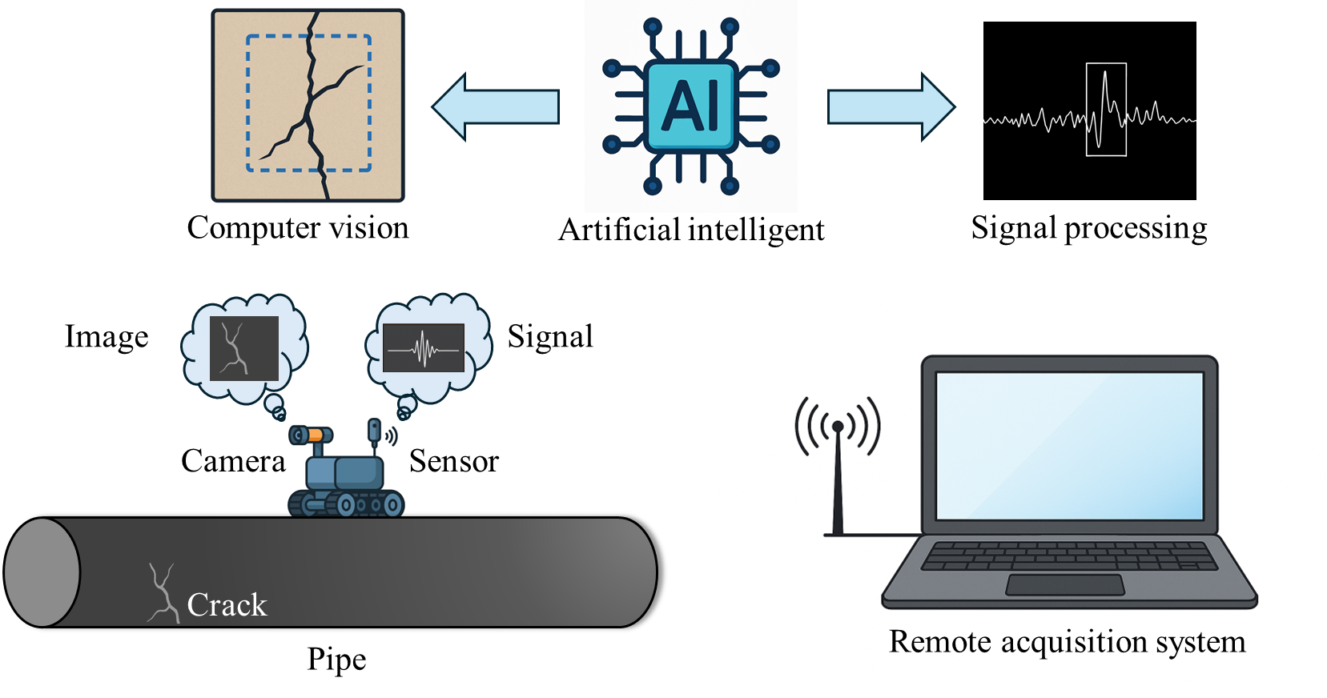
Fig. 8. Robots and machine learning techniques.

4.5.1 Robot-assisted data collection
Pipeline SCC tends to occur in extreme or corrosive regions. Robots carrying NDE devices facilitate data collection in hard-to-access or hazardous environments, such as oil and gas pipelines [171], nuclear facilities [172,173], bridges [174], and aerospace structures [175]. Climbing robots carrying sensors autonomously detected corrosion and crack [176]. Laser ultrasonic technology was integrated into robots to detect SCC [177]. By combining robots with NDE techniques (Fig. 9), the evaluation of pipeline SCC has become more reliable, efficient, and scalable.
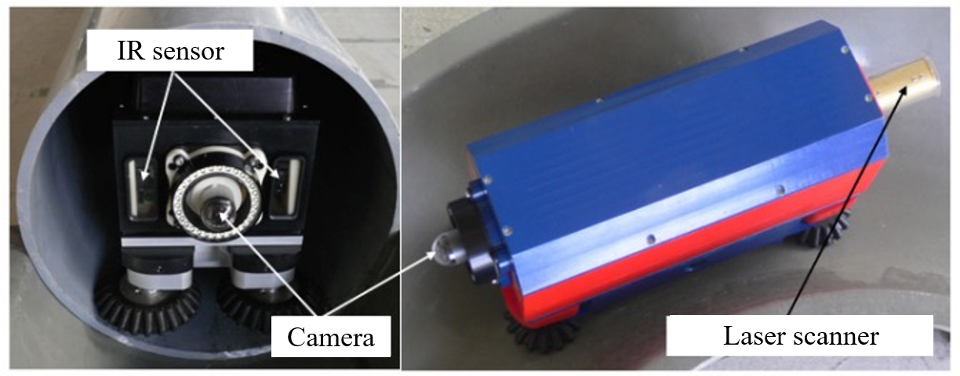
Fig. 9. Pipeline inspection gauge for in-line inspection [178].

4.5.2 Machine learning-based data analysis
Evaluation of SCC, particularly real-time monitoring using DIC or AE, often generates large volumes of data [179]. Data processing is labor-intensive and time-consuming. Machine learning offers an effective solution by enabling automatic analysis, prediction [8], classification [180], and clustering [181], significantly reducing manual effort and overall costs.
Unsupervised learning which is a type of machine learning that identifies patterns or structures in data without relying on labels [182]. This is especially valuable for NDE signals like AE signals [183], where no universally accepted criteria exist for crack or corrosion identification [31,44]. To ensure that no signals generated by microcrack initiation is missed, researchers often adopt high sampling rates, resulting in data volumes typically reaching the gigabyte range [184]. Although various AE features, such as counts and risetime, have been developed, the post-processing stage involves analyzing millions of data. Unsupervised machine learning techniques such as K-means clustering [185] have proven effective in reducing post-processing workload while also uncovering latent features of SCC [183]. The primary applications include distinguishing different stages of SCC development [183] and clustering various AE sources [185].
Supervised learning leverages labeled data to train models that map inputs to known outputs, enabling accurate prediction, classification, or regression, when reliable labels are available [186,187]. With UT signals [188], EMAT signals [189], or images, such as X-ray [190], SEM [191], of SCC cracks, researchers have constructed datasets with a size from 166 [192] to 37,719 samples [193] and applied supervised learning algorithms, such as neural networks [188], residual neural networks [193], and backpropagation networks [194], to develop SCC classification models. The application scenarios include the identification of SCC crack tips [190] as well as corrosion and cracking [191]. These models achieved high accuracy (96.97% [191]), reduced the cost associated with manual data analysis, and minimized the subjectivity and errors of manual analysis. More representative studies on monitoring SCC combined with machine learning are listed in Table 6.
Table 6. Summary of research using machine-learning
Ref. | Type | Data type | Dataset size | Algorithms | Target | Function
[183] | Clustering | AE signals | 25,000 | Self-organizing map | SCC evolution stage | Identify the evolution of SCC
[188] | Classification | UT signals | - | Neural network | IGSCC or intact | Detect SCC
[189] | Classification | EMAT signals | - | Supervised machine learning | SCC or intact | Detect SCC
[191] | Classification | SEM image | 830 | Encoder-decoder neural networks | SCC or intact | Detect SCC
[192] | Classification | Image | 166 | Residual neural networks | Corroded or intact | Detect SCC
[193] | Classification | Image | 37,719 | Residual neural networks | SCC or intact | Detect SCC
[194] | Classification | X-ray image | 1,924 | Artificial neural network | Background, undercut, and crack | Detect SCC
[195] | Regression | UT signals | 26,624 | Convolutional neural network | Angle and length | Quantify SCC
[196] | Classification | Features | 160 | Tree-based ensemble methods and kernel-based methods | Inhibition efficiencies | Detect SCC
One critical unaddressed issue is the generalizability of machine-learning models from laboratory datasets to field applications [8]. Laboratory SCC tests are typically conducted under controlled chemistry, temperature, and loading, whereas field SCC evolves under heterogeneous environmental conditions. These discrepancies can significantly affect model robustness and therefore represent essential future research directions, including the use of field monitoring data for validation, transfer learning strategies, and physics-informed machine-learning frameworks.

4.5.3 Summary
The deployment of robots reduces the risk of human exposure to hazards and facilitate the inspection of buried and subsea pipelines. Existing research on pipeline robots primarily focused on the detection of corrosion and cracks. The development of robots for monitoring pipeline SCC, particularly those capable of integrating NDE techniques, remains limited. This gap presents both a technical challenge and a promising opportunity for advancing autonomous, in-situ monitoring of pipeline SCC. Machine learning has been used to analyze the vast amounts of data for pipeline SCC. These applications have alleviated the labor-intensive burden of signal processing, reducing manpower and operational costs. However, the difficulty of acquiring in-situ field data has resulted in a shortage of publicly available, high-quality datasets. Distinguishing SCC-related signals from those associated with conventional cracking remains a challenge for machine learning approaches.

5. Selection of appropriate techniques
The different capabilities and features of the various techniques cause difficulties in selecting appropriate techniques. To provide guidance for the selection of techniques in practice, this section focuses on comparing the features of various techniques regarding their technical and economic performance. Then, a technique selection approach is presented for practitioners.

5.1 Technical features
Although conventional monitoring techniques have been proven to be effective for SCC detection, those techniques involve significant variations in applicability, sensitivity, accuracy, and effectiveness. This section provides a comparative analysis of the NDE techniques reviewed in prior sections, offering insights into selecting appropriate techniques.
First, the applications can be categorized into small-scale or large-scale applications. Small-scale applications focus on localized defect detection [197], microscopic material degradation [198], or laboratory research [105], emphasizing high sensitivity and high resolution. Localized industrial applications, such as weld inspections [199] or specific corrosion-prone areas [200], also fall under this category. In contrast, large-scale applications focus on large structures [69,199], long-term monitoring [201], or industrial field applications [202], prioritizing monitoring coverage [203], remote detection capabilities [172], and adaptability to complex environments [3].
Second, the techniques can be categorized into corrosion detection [142] and crack detection [204]. Although electrochemical methods are not effective in accurately measuring crack size, they excel at detecting early-stage corrosion and providing early warnings [205], which is useful as SCC initiates by electrochemical corrosion processes before major crack formation. In contrast, DIC, AE, and UT primarily focus on detecting and monitoring crack formation and propagation in SCC. To some extent, these methods can measure crack dimensions, with DIC being suitable for surface analysis, AE for crack propagation monitoring, and UT for crack depth measurement.
Third, the techniques can be classified based on whether they are intrusive or non-intrusive. While AE, UT, and ECT require sensors to be attached to the material surface, DIC and IRT are non-contact monitoring techniques. These techniques do not require sensors to be embedded inside the structure. Sensors can be placed on the material surface [4] or at a distance [115], with little impact on operational performance. In contrast, DCPD, EN, and EIS are intrusive monitoring techniques, as they require sensor placement within or on the material [132,206,207]. These methods may influence the integrity of pipeline material or alter operational characteristics.
Fourth, the monitoring techniques can be compared based on their effective monitoring range and suitability for long-distance pipeline monitoring versus local inspection. Techniques such as AE and UT are suitable for long-distance pipeline monitoring, as elastic waves can propagate over considerable distances along the pipeline. However, the effective range of soundwave-based techniques are influenced by wave attenuation, background noise, and sensor spacing. In contrast, ECT and DCPD are local inspection techniques with limited inspection ranges around the sensor location, as their sensing mechanisms rely on near-field electromagnetic or electrical interactions. Vision-based methods, including DIC and IRT, are limited to local regions due to the finite field of view and scanning area of imaging systems. Although larger areas can be covered through sequential scanning, the monitoring capability at any given time remains confined to a localized region. Electrochemical techniques such as EN and EIS are inherently localized, as they require direct access to the monitored area and are mainly used for point-wise assessment of corrosion activity. Therefore, from a practical perspective, long-distance pipeline monitoring generally relies on soundwave-based sensing techniques, whereas other methods are better suited for localized inspection and characterization.
Each technique exhibits technical limitations. AE struggles with accurately locating [208] and quantifying cracks [142], although it is sensitive to microcrack initiation [32] and capable of real-time monitoring [4]. The large volumes of data recorded pose challenges for post processing. UT involves a trade-off between sensitivity and robustness. Linear UT is effective for detecting major cracks [68], but is insensitive to microcracks; and nonlinear UT is sensitive to microcracks [62], yet it is less accurate for major cracks. As a vision-based technique, DIC can quantify cracks with low-cost devices [209], but it relies on high-quality images and is sensitive to lighting conditions. IRT is limited by its susceptibility to environmental factors like humidity [210], which restricts its use in uncontrolled fields. As an electrical technique, ECT is confined to conductive materials and exhibits limited capability for detecting deep-seated defects [211]. Although DCPD has shown promise in tracking crack growth, it remains reliant on calibration for depth estimation [212] and has rarely been validated for precise quantification [130]. For electrochemical techniques, EN is sensitive to early corrosion activity [213], but it is constrained by specimen size [214], rendering it unsuitable for large-scale field monitoring. Although EIS enables real-time NDE of SCC progression [215], it requires stable environmental conditions and is challenging to apply in field applications due to specimen size and setup limitations [216]. The crack measurement sensitivity, strength, and weakness of various techniques are listed in Table 7.
Table 7. Comparison between SCC monitoring techniques
Techniques | Strengths | Weaknesses | Sensitivity
DIC | - Low-cost cameras  - Robustness to materials  - High resolution | - Limited to surface defects  - Sensitive to surface textures  - Sensitive to lighting conditions | - Defects longer than 55 μm and wider than 0.45 μm
IRT | - Robustness to materials  - High resolution  - Full-field measurement | - Limited to surface defects  - Sensitive to environmental variables (temperature, humidity) | - Cracks wider than 10 μm and longer than 25 mm
AE | - Real-time monitoring  - Passive measurements | - Low signal-to-noise ratio  - Complex post-processing  - Limited ability to quantify | - Sensitive to the presence of SCC  - Unable to quantify SCC
UT | - High sensitivity to fine SCC  - Detect, locate, quantify SCC | - Expensive devices  - Unable to real-time monitoring  - Low accuracy for closed SCC | - Slit defects deeper than 0.05 mm
ECT | - High sensitivity to fine SCC | - Limited to smooth surfaces  - Limited to conductive mater | - Slit defects deeper than 0.1 mm
DCPD | - Simple and low cost  - Can detect hidden cracks  - Quantify the crack depth | - Limited to conductive materials  - Low spatial resolution | - Slit defects deeper than 3 mm
EN | - High sensitivity to fine SCC  - Sensitive to corrosion and early-stage SCC | - Limited to conductive materials  - Limited specimen sizes  - Sensitive to solution resistance and electrical charges | - Sensitive to the presence of SCC  - Unable to quantify SCC
EIS | - High sensitivity to fine SCC  - Sensitive to corrosion and early-stage SCC | - Limited specimen sizes  - Susceptible to environmental variables (e.g., electromagnetic, temperature) | - Sensitive to the presence of SCC  - Unable to quantify SCC

5.2 Cost, operability, robustness, and automation potential
In practical applications, decision-making often hinges not only on sensitivity or detection capability, but also on economic feasibility, operational complexity and safety, and the effort required for signal interpretation and data processing. Moreover, robustness against external disturbance, such as temperature fluctuation, noise, or environmental interference, is another key metric of reliability, especially in field deployments. Additionally, the potential of automation and system integration is also an essential factor for monitoring pipelines.
The costs of techniques include equipment, labor, and transportation costs. Most techniques, such as UT, IRT, and ECT, require skilled labor. Due to the differences in labor and transportation costs between each state and country, this paper focuses on comparing the costs of equipment. The assessment of equipment cost (Table 8) is based on quotations from representative manufacturers and procurement records, reflecting the costs of major components such as the data acquisition system and sensors. The range of equipment cost reflects variations in system configurations like the number of channels or precision. For example, a basic 2-channel AE system starts at around $5,000, while 96-channel systems can exceed $100,000. Similarly, DCPD systems customized for large-diameter pipe inspection were quoted as high as $450,000. In contrast, EN and EIS systems are quoted with narrow ranges.
The investigation results indicate that UT, IRT, and ECT systems are relatively mature, with standardized products available from NDT manufacturers based on performance specifications. Notably, certain ECT systems have functionalities designed for detecting SCC. In contrast, AE, DCPD, EN, and EIS systems are primarily used in laboratory settings and often require customized solutions. For DIC, the selection of the system is dependent on the applications, involving choices between ordinary cameras and specialized high-speed imaging systems.
Table 8. Cost of SCC monitoring equipment
Techniques | Price range ($) | Primary pricing factors
AE | 5,000 - 100,000 | - Number of channels
UT | 2,000 - 35,000 | - Number of channels  - Phased array support  - Maximum active aperture
DIC | 2,000 - 150,000 | - Camera resolution  - Frame rate
IRT | 1,000 - 57,000 | - Temperature range  - Frame rate
ECT | 8,780 - 150,000 | - Number of channels  - Acquisition rate  - Array support
DCPD | 100,000 - 450,000 | - Customized by sample size
EN | 10,000 - 27,000 | - Number of channels  - Range of current and voltage
EIS | 10,000 - 27,000 | • Number of channels  • Range of current and voltage
To better evaluate the operational safety, operability, robustness, post-processing efficiency, and automation potential of NDE of SCC, each indicator was evaluated using a structured rating system. The scoring criteria are listed in Table 9. Each metric was categorized into five levels (Level 1 to Level 5), representing a progression from poor to moderate to excellent performance.
Table 9. Scoring criteria for evaluation
Level | Operational safety | Operability | Environmental robustness | Post-processing efficiency | Automation potential
1 | - Involve high-risk components  - Require extensive safety precautions | - Require special expertise  - Intricate setup  - Frequent manual calibration | - Highly sensitive to environmental conditions | - Large data volume  - No standard method  - Highly manual and time-consuming | - Manual-only operation  - Challenging to integrate with automation system
2 | - Contain potentially hazardous elements | - Demand trained personnel and careful operation  - Setup or adjustment may involve multiple steps | - Sensitive to external disturbance  - Require environmental control | - Large data volume  - Have standard method | - Limited automation  - Require significant customization
3 | - Present manageable risks under standard protocols  - Localized hazards may exist but are controllable | - Standard procedures are established but require some technical background | - Degrade under adverse conditions but remain operational with adjustments | - Large data volume  - Software tools are mature and accessible | - Partial automation, with environmental constraints or human oversight
4 | - Generally safe to operate with basic precautions  - No major risk in typical use | - Easy to operate with minimal training  - Setup procedures are straightforward and repeatable | - Stable performance under a range of environmental variations | - Moderate data volume  - Software are mature | - Technically compatible with automation  - Can be integrated into robots or programmable platforms
5 | - Safe under normal conditions | - Highly user-friendly  - With minimal intervention or technical skill | - Consistent reliability across harsh or variable environments | - Minimal processing required  - Results are ready-to-use | - Highly suited for full automation  - Support integration in autonomous systems
Based on the proposed scoring criteria and analysis, Table 10 are presented to compare the different techniques. For operational safety, AE, DIC, EN, and EIS systems are safe under normal conditions since they pose minimal risks due to passive sensing and low-voltage electronics. Similarly, passive IRT is safe, while active IRT may pose risks due to the use of external thermal excitation. As active detection, UT involves pulsed voltages, and the energy is extremely low and confined to short-duration bursts, posing low risks in typical use. Although ECT and DCPD involve localized electromagnetic fields or conductive paths under loading, both pose minimal risks due to the non-ionizing nature and the low current levels.
Table 10. Evaluation of inspection techniques
Techniques | Operational safety | Operability | Environmental robustness | Post-processing efficiency | Automation potential
AE | 5 | 4 | 1 | 1 | 1
UT | 4 | 1 | 4 | 1 | 5
DIC | 5 | 4 | 3 | 2 | 2
IRT | 3 | 3 | 3 | 5 | 5
ECT | 4 | 2 | 4 | 2 | 4
DCPD | 3 | 2 | 4 | 2 | 1
EN | 5 | 3 | 1 | 2 | 1
EIS | 5 | 3 | 1 | 2 | 1
For operability, AE is relatively straightforward because it only require sensor attachment and threshold setting, while UT is relatively complex as it demands skilled handling of probes, angle adjustments, and ultrasonic exicitation. DIC presents lower complexity since it involves stochastic speckle pattern preparation. IRT ranges from low to moderate in operability, allowing simple use in passive modes but requiring precise thermal excitation in active setups. ECT typically requires a moderate to high level of expertise, due to its sensitivity to material properties, surface conditions, and geometric effects. DCPD demands trained personnel and careful operation because it involves mechanical loading coordination and precise electrode placement. EN and EIS generally exhibit moderate operational complexity, because they follow standardized electrode configurations and benefiting from mature software support.
For post-processing efficiency, acoustic, electrical, and electrochemical techniques involve analyzing large volumes of electrical or chemical signals, often in the absence of standardized interpretation criteria. Particularly, UT presents significant post-processing complexity because it requires not only analyzing echo patterns [217] but also characterizing and controling transmitted waveforms [54]. Tasks such as calibrating time-of-flight [218], compensating for material-dependent wave velocities [219], and deconvolving overlapping reflections [220] demand a deep understanding of wave propagation [221]. As for DIC, the post-processing stage involves handling large volumes of images [222]. Recently, this complexity has been mitigated with the development of commercial software and deep learning techniques. In contrast, IRT requires less post-processing, as thermal anomalies are often directly visualized [223].
For environmental robustness, passive methods, active inspection techniques, such as UT, ECT, and DCPD are generally more robust than passive methods, such as AE, EN, and EIS, which are more sensitive to environmental noise [224,225]. However, active inspection techniques are still subject to surface conditions [226], coupling quality [227], or external vibrations [228]. For the vision-based techniques, DIC and IRT are susceptible to lighting changes [229], cameras [230], and temperature drift [231], requiring controlled environments for optimal performance.
For automation potential, techniques based on ultrasonic or thermal imaging can be integrated with robots [232–234], allowing programmable scanning paths and adaptive control [235,236]. The non-contact nature of ECT makes it compatible with automated structural monitoring [237]. Due to the long-term stability requirements of the imaging system during the measurement process, DIC faces significant challenges in integrating with robotic or other automated platforms [230]. Similarly, DCPD is constrained by the need for stable electrode contact and cable management, which makes its integration with robotic or mobile systems equally challenging [238]. Moreover, AE and electrochemical techniques are difficult to integrate with robots due to their susceptibility to vibrations and noise associated with robotic systems [225].

5.3 Technique selection
A decision support tree (Fig. 11) is created to support practical and context-specific selection of appropriate techniques. The decision tree presented in this study is a conceptual, rule-based framework constructed from engineering considerations and practical constraints. This framework is different from machine-learning decision trees, which are data-driven models learned from labeled datasets for classification or prediction tasks. This framework serves not only as a summary of comparative analysis but also as a practical tool for strategy design of the monitoring system for pipeline SCC. Previous literature review confirms that the major monitoring technologies are broadly applicable to both carbon steel and stainless steel. As the decision tree focuses on the discussion of application scenarios and needs, it does not further subdivide materials. The decision tree begins with judging whether large-scale pipeline testing is required. For on-site pipeline monitoring techniques, the decision layer first divides techniques based on subsurface detectability. Since IRT and ECT are incapable of deep-seated detection, when subsurface detection is required, UT or AE will be considered. Furthermore, UT can not only locate but also quantify the cracks, while AE supports real-time monitoring of cracking and provide early warning. Moreover, UT can be further classified into linear UT and nonlinear UT based on their sensing principle and sensitivity to microcracks and macrocracks, respectively. When subsurface detectability is not required, IRT and ECT are distinguished based on their sensitivity to closed or tight cracks. From the perspective of crack conditions, ECT is sensitive to open, surface-breaking cracks, whereas IRT exhibits higher sensitivity to closed or tightly contacting cracks when combined with active thermal stimulation.
In the other branch, which focuses on laboratory-based techniques, electrochemical methods such as EN and EIS are preferred when corrosion sensitivity is prioritized. Real-time monitoring of corrosion or SCC activity is generally achieved using EN, whereas EIS is used for quantitative characterization of electrochemical kinetics and interfacial properties. In contrast, for techniques that are sensitive to cracks but not specifically to corrosion, the selection is further distinguished by contact-dependency. The DCPD method excels at quantifying crack depth and crack growth rates, but it requires contact to the pipe surface. In contrast, DIC is a non-contact optical technique that can be applied without physical contact when adequate optical access and surface visibility are available.
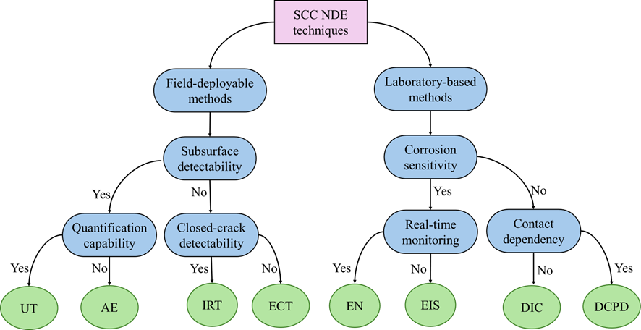
Fig. 10. Tree-based decision flow for selecting SCC monitoring techniques.
In addition to conventional classification criteria, the feasibility of applying a technique to buried pipeline inspection represents a crucial consideration in practical field deployments. Among the methods reviewed, only UT, which operates based on ultrasound wave propagation, demonstrates the capacity for detecting SCC in buried environments. This is primarily enabled through the integration of UT sensors with pipeline inspection robots or via installation on the internal or external surfaces of the pipeline. Although AE also utilizes elastic wave propagation, its high sensitivity to mechanical noise and vibrational disturbances during robotic movement or external disturbance significantly limits its applicability in buried pipeline inspection. Other techniques rely on surface accessibility, consistent lighting, or wired electrical configurations, making them inherently unsuitable for buried pipeline inspection.

6. Challenges and opportunities
Although various techniques have been developed to detect pipeline SCC, significant challenges remain. In this section, the challenges and opportunities are discussed from four main perspectives: (1) multi-scale sensing capability, (2) real-time and long-term monitoring, (3) data-driven analysis and machine learning, and (4) system integration and automation. These aspects reflect the key technical barriers and research directions for advancing practical SCC monitoring.
First, effective techniques for monitoring multi-scale SCC from micro-scale to macro-scale are yet to be developed. Linear UT techniques have high resolution and sensitivity to macrocracks, but they exhibit low sensitivity to microcracks. Nonlinear UT techniques achieve higher sensitivity to microcracks, but their performance in monitoring macrocracks still requires improvement.
Second, real-time monitoring of pipeline SCC remains challenging. Although AE offers real-time data acquisition, its capabilities in crack localization and quantitative evaluation are limited. Some vision-based techniques also provide real-time data, but their performance is strongly affected by lighting conditions. For electrical and electrochemical methods, conducting large-scale on-site monitoring remains difficult. The applications of electrochemical and electrical methods are generally limited to short-term or laboratory-based measurements. Even for UT and AE techniques capable of long-term monitoring, periodic maintenance is required to ensure stable coupling between sensors and the pipe surface. The development of low-maintenance monitoring systems therefore represents an important opportunity for future research.
Third, for machine learning techniques, the effectiveness and availability of high-quality datasets remain major challenges. The complexity of material characteristics and environmental conditions leads to a lack of well-labeled data. Moreover, current machine learning research in SCC monitoring lacks on-site industrial validation, making it difficult to assess its effectiveness. Therefore, obtaining representative datasets from real-world environments and validating machine-learning-based predictive models remain critical challenges. In addition, real-time signal processing represents an important topic for future research. For high-sampling-rate monitoring techniques such as AE and DIC, it remains challenging to process signals in real time and generate timely feedback or early warnings using machine-learning models. Advancing real-time processing capabilities could reduce the need for continuous human supervision and alleviate data storage burdens through immediate filtering or data compression.
Furthermore, prior research on hybrid monitoring techniques has mainly focused on laboratory studies combining AE and EN for mechanism interpretation and characterization of crack growth stages. Future applications may benefit from hybrid systems that emphasize real-time monitoring and high-resolution localization, such as the integration of AE with UT. Hybridization across different sensing scales is also promising, for example, by combining linear UT with nonlinear UT.
Finally, research on robot-assisted monitoring is still at an early stage. Developing robotic systems tailored to different pipeline inspection scenarios remains challenging. Integrating NDE techniques with robotic platforms for inspecting inaccessible areas and enabling real-time SCC monitoring represents a key future research direction. In addition, incorporating SCC mitigation and repair strategies into robotic systems is also promising for future development.

7. Conclusions
This paper reviews NDE techniques for assessing pipeline SCC, including sound wave-based, vision-based, electrical, and electrochemical techniques. Based on the above review, the following conclusions can be drawn:
- Sound-wave based techniques are effective in detecting and monitoring crack formation of pipeline SCC. Real-time monitoring of SCC initiation and propagation can be achieved using AE for early warning. UT can be used to locate and quantify cracks, allowing for the reconstruction of crack morphology, and UT is sensitive to multi-scale cracks.
- By capturing changes in the strain and thermal fields, DIC and IRT are able to generate strain or temperature images, which can be utilized to detect, locate, and quantify pipeline SCC. Furthermore, the strain or temperature images can be reconstructed to characterize the state and morphology of surface cracks.
- Electrical techniques are effective for detecting SCC in conductive materials. ECT is sensitive to surface and shallow cracks. DCPD can detect deeper cracks and quantify SCC depth. However, DCPD faces limitations in accurately sizing SCC and ensuring reliable performance in field applications.
- Electrochemical techniques are effective for detecting the initiation of SCC. Both EN and EIS demonstrate strong sensitivity to corrosion. However, their reliance on controlled conditions and limitations in specimen size restrict their applicability in field applications, positioning them as tools for mechanistic studies and early-stage evaluation in laboratory.
- Robots facilitate data collection from complex or hazardous environments, and machine learning algorithms accelerate data processing and analysis and enhance analysis accuracy. Machine learning methods suffer from the availability of extensive, high-quality datasets and successful on-site implementation.
- A decision tree is presented to guide the selection of appropriate techniques. The resulting decision model incorporates critical considerations such as testing scale, early warning needs, real-time monitoring capability, contact dependency, and damage quantification requirements, offering a structured framework to support informed and context-specific technology selection.
Acknowledgement
This research was funded by the United States Department of Transportation [award number 693JK32450002CAAP]. The authors appreciate the valuable comments and the consistent support provided by Dr. Jianmin Qu from Stevens Institute of Technology and Dr. Zhongquan Zhou and Dr. Nusnin Akter from the Pipeline and Hazardous Materials Safety Administration.
Disclaimer
This paper was prepared as an account of work sponsored by an agency of the United States Government. Neither the United States Government nor any agency thereof, nor any of their employees, makes any warranty, express or implied, or assumes any legal liability or responsibility for the accuracy, completeness, or usefulness of any information, apparatus, product, or process disclosed, or represents that its use would not infringe privately owned rights. Reference herein to any specific commercial product, process, or service by trade name, trademark, manufacturer, or otherwise does not necessarily constitute or imply its endorsement, recommendation, or favoring by the United States Government or any agency thereof. The views and opinions of authors expressed herein do not necessarily state or reflect those of the United States Government or any agency thereof.

References
[1] Fang, B.Y., Atrens, A., Wang, J.Q., Han, E.H., Zhu, Z.Y. and Ke, W., 2003. Review of stress corrosion cracking of pipeline steels in “low” and “high” pH solutions. Journal of Materials Science, 38, pp.127-132. https://doi.org/10.1023/A:1021126202539.
[2] Cheng, Y.F., 2013. Stress corrosion cracking of pipelines. John Wiley & Sons. https://doi.org/10.1002/9781118537022.
[3] Hamdan, H., Alsit, A., Al Tahhan, A.B., Mughieda, O., Mourad, A.H.I., Shehadeh, M.A. and Alkhedher, M., 2024. Prognosis methods of stress corrosion cracking under harsh environmental conditions. Heliyon, 10(3). https://doi.org/10.1016/j.heliyon.2024.e25276.
[4] Park, J., Kim, J.S., Lee, D.Y. and Lee, S.H., 2022. Real-time monitoring of stress corrosion cracking in 304 L stainless steel pipe using acoustic emission. Journal of Nuclear Materials, 571, p.154009. https://doi.org/10.1016/j.jnucmat.2022.154009.
[5] Clark, B.N., Rentz, R., McColskey, J.D. and Sowards, J.W., 2017, March. Using digital image correlation to improve stress-corrosion cracking evaluation by NACE TM0177-B∗. Nace Corrosion (pp. NACE-2017). NACE. https://doi.org/10.5006/c2017-08992.
[6] Li, X., Song, J., Gan, K., Xia, D.H., Gao, Z., Liu, C. and Liu, Y., 2020. Identifying sulfide stress cracking stages on a HSLA pipeline steel in H2S environment by electrochemical noise. Journal of Electroanalytical Chemistry, 876, p.114480. https://doi.org/10.1016/j.jelechem.2020.114480.
[7] Sarwar, U., Mokhtar, A.A., Muhammad, M., Wassan, R.K., Soomro, A.A., Wassan, M.A. and Kaka, S., 2024. Enhancing pipeline integrity: a comprehensive review of deep learning-enabled finite element analysis for stress corrosion cracking prediction. Engineering Applications of Computational Fluid Mechanics, 18(1), p.2302906. https://doi.org/10.1080/19942060.2024.2302906.
[8] Hussain, M., Zhang, T., Chaudhry, M., Jamil, I., Kausar, S. and Hussain, I., 2024. Review of prediction of stress corrosion cracking in gas pipelines using machine learning. Machines, 12(1), p.42. https://doi.org/10.3390/machines12010042.
[9] Mohammed, M.N., Nadarajah, V.S., Lazim, N.F.M., Zamani, N.S., Al-Sanjary, O.I., Ali, M.A. and Al-Youif, S., 2018. Design and development of pipeline inspection robot for crack and corrosion detection. 2018 IEEE Conference on Systems, Process and Control (ICSPC) (pp. 29-32). IEEE. https://doi.org/10.1109/SPC.2018.8704127.
[10] Shirazi, H., Eadie, R. and Chen, W., 2023. A review on current understanding of pipeline circumferential stress corrosion cracking in near-neutral PH environment. Engineering Failure Analysis, 148, p.107215. https://doi.org/10.1016/j.engfailanal.2023.107215.
[11] Calabrese, L. and Proverbio, E., 2020. A review on the applications of acoustic emission technique in the study of stress corrosion cracking. Corrosion and Materials Degradation, 2(1), pp.1-30. https://doi.org/10.3390/cmd2010001.
[12] Niazi, H., Eadie, R., Chen, W. and Zhang, H., 2021. High pH stress corrosion cracking initiation and crack evolution in buried steel pipelines: A review. Engineering Failure Analysis, 120, p.105013. https://doi.org/10.1016/j.engfailanal.2020.105013.
[13] Crack growth behavior of pipeline steels under variable pressure fluctuations in a near-neutral pH environment. Doctoral dissertation, University of Alberta. https://doi.org/10.7939/R3J679788.
[14] Niazi, H., Chevil, K., Gamboa, E., Lamborn, L., Chen, W. and Zhang, H., 2020. Effects of loading spectra on high pH crack growth behavior of X65 pipeline steel. Corrosion, 76(6), pp.601-615. https://doi.org/10.5006/3472.
[15] Chen, W., 2016. An overview of near-neutral pH stress corrosion cracking in pipelines and mitigation strategies for its initiation and growth. Corrosion, 72(7), pp.962-977. https://doi.org/10.5006/1967.
[16] Chen, W., Sutherby, R., 2007. Crack growth behavior of pipeline steel in near-neutral pH soil environments. Metallurgical and Materials Transactions A, 38, 1260–1268. https://doi.org/10.1007/s11661-007-9184-8.
[17] Zhao, J., Chen, W., Yu, M., Chevil, K., Eadie, R., Been, J., Van Boven, G., Kania, R. and Keane, S., 2017. Crack growth modeling and life prediction of pipeline steels exposed to near-neutral pH environments: stage II crack growth and overall life prediction. Metallurgical and Materials Transactions A, 48, pp.1641-1652. https://doi.org/10.1007/s11661-016-3939-z.
[18] Zhao, J., Chen, W., Yu, M., Chevil, K., Eadie, R., Van Boven, G., Kania, R., Been, J. and Keane, S., 2017. Crack growth modeling and life prediction of pipeline steels exposed to near-neutral pH environments: dissolution crack growth and occurrence of crack dormancy in stage I. Metallurgical and Materials Transactions A, 48, pp.1629-1640. https://doi.org/10.1007/s11661-016-3951-3.
[19] Van Boven, G., Chen, W. and Rogge, R., 2007. The role of residual stress in neutral pH stress corrosion cracking of pipeline steels. Part I: Pitting and cracking occurrence. Acta Materialia, 55(1), pp.29-42. https://doi.org/10.1016/j.actamat.2006.08.037.
[20] Bueno, A.H.S., Moreira, E.D. and Gomes, J.A.C.P., 2014. Evaluation of stress corrosion cracking and hydrogen embrittlement in an API grade steel. Engineering Failure Analysis, 36, pp.423-431. https://doi.org/10.1016/j.engfailanal.2013.11.012.
[21] Barrera, O., Bombac, D., Chen, Y., Daff, T.D., Galindo-Nava, E., Gong, P., Haley, D., Horton, R., Katzarov, I., Kermode, J.R. and Liverani, C., 2018. Understanding and mitigating hydrogen embrittlement of steels: a review of experimental, modelling and design progress from atomistic to continuum. Journal of Materials Science, 53(9), pp.6251-6290. https://doi.org/10.1007/s10853-017-1978-5.
[22] Cui, Z., Wang, L., Liu, Z., Du, C., Li, X. and Wang, X., 2016. Anodic dissolution behavior of the crack tip of X70 pipeline steel in near-neutral pH environment. Journal of Materials Engineering and Performance, 25, pp.5468-5476. https://doi.org/10.1007/s11665-016-2394-8.
[23] Lu, B.T., 2013. Crack growth model for pipeline steels exposed to near‐neutral pH groundwater. Fatigue & Fracture of Engineering Materials & Structures, 36(7), pp.660-669. https://doi.org/10.1111/ffe.12033.
[24] Beavers, J.A. and Harle, B.A., 1996. Mechanisms of high-pH and near-neutral-pH SCC of underground pipelines. International Pipeline Conference (Vol. 1, pp. 555-568). New York: American Society of Mechanical Engineers. https://doi.org/10.1115/ipc1996-1860.
[25] Lu, B.T., 2014. Further study on crack growth model of buried pipelines exposed to concentrated carbonate–bicarbonate solution. Engineering Fracture Mechanics, 131, pp.296-314. https://doi.org/10.1016/j.engfracmech.2014.08.006.
[26] Wang, S., Lamborn, L. and Chen, W., 2022. Pre-cyclic-loading-enhanced stage-1b stress corrosion crack growth of pipeline steels. Corrosion Science, 208, p.110693. https://doi.org/10.1016/j.corsci.2022.110693.
[27] Chen, W., 2017. Modeling and prediction of stress corrosion cracking of pipeline steels. Trends in Oil and Gas Corrosion Research and Technologies, pp.707-748. https://doi.org/10.1016/b978-0-08-101105-8.00030-9.
[28] Yonezu, A., Cho, H. and Takemoto, M., 2006. Monitoring of stress corrosion cracking in stainless steel weldments by acoustic and electrochemical measurements. Measurement Science and Technology, 17(9), p.2447. https://doi.org/10.1088/0957-0233/17/9/011.
[29] Djeddi, L., Khelif, R., Benmedakhene, S. and Favergeon, J., 2013. Reliability of acoustic emission as a technique to detect corrosion and stress corrosion cracking on prestressing steel strands. International Journal of Electrochemical Science, 8(6), pp.8356-8370. https://doi.org/10.1016/S1452-3981(23)12894-X.
[30] Shaikh, H., Amirthalingam, R., Anita, T., Sivaibharasi, N., Jaykumar, T., Manohar, P. and Khatak, H.S., 2007. Evaluation of stress corrosion cracking phenomenon in an AISI type 316LN stainless steel using acoustic emission technique. Corrosion Science, 49(2), pp.740-765. https://doi.org/10.1016/j.corsci.2006.06.007.
[31] Wu, K., Ito, K., Shinozaki, I., Chivavibul, P. and Enoki, M., 2019. A comparative study of localized corrosion and stress corrosion cracking of 13Cr martensitic stainless steel using acoustic emission and X-ray computed tomography. Materials, 12(16), p.2569. https://doi.org/10.3390/ma12162569.
[32] Kovač, J., Legat, A., Zajec, B., Kosec, T. and Govekar, E., 2015. Detection and characterization of stainless steel SCC by the analysis of crack related acoustic emission. Ultrasonics, 62, pp.312-322. https://doi.org/10.1016/j.ultras.2015.06.005.
[33] Joseph, R., Mei, H., Migot, A. and Giurgiutiu, V., 2021. Crack-length estimation for structural health monitoring using the high-frequency resonances excited by the energy release during fatigue-crack growth. Sensors, 21(12), p.4221. https://doi.org/10.3390/s21124221.
[34] Hamstad, M.A., Downs, K.S. and O’Gallagher, A., 2003. Practical aspects of acoustic emission source location by a wavelet transform. Journal of Acoustic Emission, 21, pp.70-94. https://tsapps.nist.gov/publication/get_pdf.cfm?pub_id=851335.
[35] Zhang, Z., Zhang, Z., Tan, J. and Wu, X., 2019. Quantitatively related acoustic emission signal with stress corrosion crack growth rate of sensitized 304 stainless steel in high-temperature water. Corrosion science, 157, pp.79-86. https://doi.org/10.1016/j.corsci.2019.05.030.
[36] Shao, Y., Yu, Y., Zhang, Y., Wei, S. and Li, X., 2016. Analysis of acoustic emission signal characteristics based on the crack pattern of stress corrosion cracking. 2016 10th International Conference on Sensing Technology (ICST) (pp. 1-5). IEEE. https://doi.org/10.1109/icsenst.2016.7796216.
[37] Cho, H. and Takemoto, M., 2004. Acoustic emission from rust in stress corrosion cracking. Proceeding of the 26th European Conference on Acoustic Emission Testing (pp. 605-615). https://www.ndt.net/?id=2752.
[38] Budano, S., Giunta, G. and Lucci, A., 2011. Acoustic emission data analysis to evaluate damage mechanisms in pipeline carbon steels. NDT. net, 24. https://www.ndt.net/?id=10207.
[39] Bi, H., Li, H., Zhang, W., Wang, L., Zhang, Q., Cao, S. and Toku-Gyamerah, I., 2020. Evaluation of the acoustic emission monitoring method for stress corrosion cracking on aboveground storage tank floor steel. International Journal of Pressure Vessels and Piping, 179, p.104035. https://doi.org/10.1016/j.ijpvp.2019.104035.
[40] Goldaran, R., Turer, A., Kouhdaragh, M. and Ozlutas, K., 2020. Identification of corrosion in a prestressed concrete pipe utilizing acoustic emission technique. Construction and Building Materials, 242, p.118053. https://doi.org/10.1016/j.conbuildmat.2020.118053.
[41] Xu, J., Wu, X. and Han, E.H., 2013. Acoustic emission response of sensitized 304 stainless steel during intergranular corrosion and stress corrosion cracking. Corrosion Science, 73, pp.262-273. https://doi.org/10.1016/j.corsci.2013.04.014.
[42] Zhang, Z., Wu, X. and Tan, J., 2019. In-situ monitoring of stress corrosion cracking of 304 stainless steel in high-temperature water by analyzing acoustic emission waveform. Corrosion Science, 146, pp.90-98. https://doi.org/10.1016/j.corsci.2018.10.022.
[43] Matsuo, T., Sano, K., Sakakibara, Y. and Nakayama, G., 2015. Estimation of stress corrosion cracking initiation and propagation in high-pressure, high-temperature water environment utilizing acoustic emission. Materials Transactions, 56(3), pp.327-332. https://doi.org/10.2320/matertrans.M2014357.
[44] Du, G., Li, J., Wang, W.K., Jiang, C. and Song, S.Z., 2011. Detection and characterization of stress-corrosion cracking on 304 stainless steel by electrochemical noise and acoustic emission techniques. Corrosion Science, 53(9), pp.2918-2926. https://doi.org/10.1016/j.corsci.2011.05.030.
[45] Hwang, W., Bae, S., Kim, J., Kang, S., Kwag, N. and Lee, B., 2015. Acoustic emission characteristics of stress corrosion cracks in a type 304 stainless steel tube. Nuclear Engineering and Technology, 47(4), pp.454-460. https://doi.org/10.1016/j.net.2015.04.001.
[46] Megel, M., Kumosa, L., Ely, T., Armentrout, D. and Kumosa, M., 2001. Initiation of stress-corrosion cracking in unidirectional glass/polymer composite materials. Composites Science and Technology, 61(2), pp.231-246. https://doi.org/10.1016/s0266-3538(00)00208-6.
[47] Calabrese, L., Bonaccorsi, L., Proverbio, E., Di Pietro, D. and Cappuccini, F., 2015. SCC damage evolution on martensitic stainless steel by using acoustic emission technique. Corrosion Engineering, Science and Technology, 50(5), pp.364-371. https://doi.org/10.1179/1743278214y.0000000230.
[48] Jones, R.H., Friesel, M.A. and Pathania, R., 1990. Evaluation of stress-corrosion crack initiation using acoustic emission. Corrosion 1990 (pp. 1-18). Association for Materials Protection and Performance. https://doi.org/10.5006/c1990-90499.
[49] Yonezu, A., Kusano, R. and Chen, X., 2013. On the mechanism of intergranular stress corrosion cracking of sensitized stainless steel in tetrathionate solution. Journal of Materials Science, 48, pp.2447-2453. https://doi.org/10.1007/s10853-012-7032-8.
[50] Fujimoto, S., Takemoto, M. and Ono, K., 2000. AE monitoring of chloride stress corrosion cracking of austenitic stainless steel. Japan.
[51] Shah, J., El-Hawwat, S. and Wang, H., 2023. Guided wave ultrasonic testing for crack detection in polyethylene pipes: laboratory experiments and numerical modeling. Sensors, 23(11), p.5131. https://doi.org/10.3390/s23115131.
[52] Zang, X., Xu, Z.D., Lu, H., Zhu, C. and Zhang, Z., 2023. Ultrasonic guided wave techniques and applications in pipeline defect detection: A review. International Journal of Pressure Vessels and Piping, 206, p.105033. https://doi.org/10.1016/j.ijpvp.2023.105033.
[53] Norli, P., Vallée, E., Aanes, M., Prieur, F., Bjåstad, T.G., Standal, Ø.K.V., Brende, O.M. and Frijlink, M., 2019. Ultrasonic detection of stress corrosion cracks in pipe samples in gaseous atmosphere. 2019 IEEE International Ultrasonics Symposium (IUS) (pp. 1624-1627). IEEE. https://doi.org/10.1109/ULTSYM.2019.8925831.
[54] Hernandez-Valle, F., Clough, A.R. and Edwards, R.S., 2014. Stress corrosion cracking detection using non-contact ultrasonic techniques. Corrosion Science, 78, pp.335-342. https://doi.org/10.1016/j.corsci.2013.10.018.
[55] Nakamura, N., Ashida, K., Takishita, T., Ogi, H. and Hirao, M., 2016. Inspection of stress corrosion cracking in welded stainless steel pipe using point-focusing electromagnetic-acoustic transducer. Ndt & E International, 83, pp.88-93. https://doi.org/10.1016/j.ndteint.2016.06.005.
[56] Norli, P., Frijlink, M., Standal, Ø.K.V., Bjåstad, T.G., Prieur, F. and Vallée, E., 2018. Ultrasonic detection of stress corrosion cracks in pipe samples using guided waves. 2018 IEEE international ultrasonics symposium (IUS) (pp. 1-4). IEEE. https://doi.org/10.1109/ULTSYM.2018.8579864.
[57] Norli, P., Vallée, E., Aanes, M., Spilde, A., Duerud, H., Prieur, F., Bjåstad, T., Standal, Ø. and Frijlink, M., 2019. Ultrasonic detection of stress corrosion cracks in gaseous atmosphere using Broadband transducers. Proceedings of Meetings on Acoustics (Vol. 38, No. 1). AIP Publishing. https://doi.org/10.1121/2.0001334.
[58] Norli, P., Vallée, E., Aanes, M., Prieur, F., Bjåstad, T.G., Standal, Ø.K.V., Brende, O.M. and Frijlink, M., 2020, September. Ultrasonic detection of crack defects in pipe samples with a 132-channel test scanner in gas. 2020 IEEE International Ultrasonics Symposium (IUS) (pp. 1-4). IEEE. https://doi.org/10.1109/ius46767.2020.9251474.
[59] Ashworth, B., Uzelac, N., Willems, H. and Barbian, O.A., 2000, October. Detection and verification of SCC in a gas transmission pipeline. International Pipeline Conference (Vol. 40252, p. V002T06A004). American Society of Mechanical Engineers. https://doi.org/10.1115/ipc2000-184.
[60] Ma, Z., Yu, L., Chao, Y.J., Lam, P.S., Sindelar, R.L., Duncan, A.J., Truong, T.T., Verst, C., Sun, P.K. and Campbell, A., 2022. Nondestructive evaluation of stress corrosion cracking in a welded steel plate using guided ultrasonic waves. Journal of Nondestructive Evaluation, Diagnostics and Prognostics of Engineering Systems, 5(3), p.031003. https://doi.org/10.1115/1.4053653.
[61] Doerr, C., Lakocy, A., Kim, J.Y., Singh, P.M., Wall, J.J., Qu, J. and Jacobs, L.J., 2017. Evaluation of the heat-affected zone (HAZ) of a weld joint using nonlinear Rayleigh waves. Materials Letters, 190, pp.221-224. https://doi.org/10.1016/j.matlet.2017.01.021.
[62] Zeitvogel, D.T., Matlack, K.H., Kim, J.Y., Jacobs, L.J., Singh, P.M. and Qu, J., 2014. Characterization of stress corrosion cracking in carbon steel using nonlinear Rayleigh surface waves. Ndt & E International, 62, pp.144-152. https://doi.org/10.1016/j.ndteint.2013.12.005.
[63] Ramadan, S., Gaillet, L., Tessier, C. and Idrissi, H., 2008. Detection of stress corrosion cracking of high-strength steel used in prestressed concrete structures by acoustic emission technique. Applied surface science, 254(8), pp.2255-2261. https://doi.org/10.1016/j.apsusc.2007.09.011.
[64] Kovac, J., Alaux, C., Marrow, T.J., Govekar, E. and Legat, A., 2010. Correlations of electrochemical noise, acoustic emission and complementary monitoring techniques during intergranular stress-corrosion cracking of austenitic stainless steel. Corrosion Science, 52(6), pp.2015-2025. https://doi.org/10.1016/j.corsci.2010.02.035.
[65] Aron, J., Jia, J., Vance, B., Chang, W., Pohler, R., Gore, J., Eaton, S., Bowles, A. and Jarman, T., 2005. Development of an EMAT in-line inspection system for detection, discrimination, and grading of stress corrosion cracking in pipelines. Tuboscope Pipeline Services (US). https://doi.org/10.2172/840950.
[66] Ryakhovskikh, I.V. and Bogdanov, R.I., 2021. Model of stress corrosion cracking and practical guidelines for pipelines operation. Engineering Failure Analysis, 121, p.105134. https://doi.org/10.1016/j.engfailanal.2020.105134.
[67] Hogg, S.M., Anderson, B.E., Le Bas, P.Y. and Remillieux, M.C., 2019. Nonlinear resonant ultrasound spectroscopy of stress corrosion cracking in stainless steel rods. NDT & E International, 102, pp.194-198. https://doi.org/10.1016/j.ndteint.2018.12.007.
[68] Ohara, Y., Shintaku, Y., Horinouchi, S., Hashimoto, M., Yamaguchi, Y., Tagami, M. and Yamanaka, K., 2010, July. Ultrasonic imaging of stress corrosion crack formed in high temperature pressurized water using subharmonic phased array. Proceedings of Meetings on Acoustics (Vol. 10, No. 1). AIP Publishing. https://doi.org/10.1121/1.3533836.
[69] Remillieux, M.C., Kaoumi, D., Ohara, Y., Geesey, M.A.S., Xi, L., Schoell, R., Bryan, C.R., Enos, D.G., Summa, D.A., Ulrich, T.J. and Anderson, B.E., 2020. Detecting and imaging stress corrosion cracking in stainless steel, with application to inspecting storage canisters for spent nuclear fuel. NDT & E International, 109, p.102180. https://doi.org/10.1016/j.ndteint.2019.102180.
[70] Bolivar, J., Fregonese, M., Réthoré, J., Duret-Thual, C. and Combrade, P., 2017. Evaluation of multiple stress corrosion crack interactions by in-situ Digital Image Correlation. Corrosion Science, 128, pp.120-129. https://doi.org/10.1016/j.corsci.2017.09.001.
[71] Fujii, T., Hisada, Y., Tohgo, K. and Shimamura, Y., 2020. Investigation on nucleation of intergranular stress corrosion cracking in austenitic stainless steel by in situ strain measurement. Materials Science and Engineering: A, 773, p.138858. https://doi.org/10.1016/j.msea.2019.138858.
[72] Shin, J.H., Kim, S.W. and Kim, D.J., 2024. In-situ analysis of SCC initiation on Alloy 600 surface in primary water environment using digital image correlation with electron backscatter diffraction. Nuclear Engineering and Design, 421, p.113095. https://doi.org/10.1016/j.nucengdes.2024.113095.
[73] Cadelano, G., Bortolin, A., Ferrarini, G., Molinas, B., Giantin, D., Zonta, P. and Bison, P., 2016. Corrosion detection in pipelines using infrared thermography: Experiments and data processing methods. Journal of Nondestructive Evaluation, 35(3), p.49. https://doi.org/10.1007/s10921-016-0365-5.
[74] Rao, B.P.C. and Raj, B., 2019. NDE methods for monitoring corrosion and corrosion‐assisted cracking: case studies II. Non‐Destructive Evaluation of Corrosion and Corrosion‐assisted Cracking, pp.101-121. https://doi.org/10.1002/9781118987735.ch4.
[75] Ghorbani, R., Matta, F. and Sutton, M.A., 2015. Full-field deformation measurement and crack mapping on confined masonry walls using digital image correlation. Experimental Mechanics, 55, pp.227-243. https://doi.org/10.1007/s11340-014-9906-y.
[76] Yates, J.R., Zanganeh, M. and Tai, Y.H., 2010. Quantifying crack tip displacement fields with DIC. Engineering Fracture Mechanics, 77(11), pp.2063-2076. https://doi.org/10.1016/j.engfracmech.2010.03.025.
[77] Jiang, R., Pierron, F., Octaviani, S. and Reed, P.A.S., 2017. Characterisation of strain localisation processes during fatigue crack initiation and early crack propagation by SEM-DIC in an advanced disc alloy. Materials Science and Engineering: A, 699, pp.128-144. https://doi.org/10.1016/j.msea.2017.05.091.
[78] Shirazi, H., Wang, S., Chen, W. and Eadie, R., 2024. Pipeline circumferential corrosion fatigue failure under the influence of bending residual stress in the near-neutral pH environment. Engineering Failure Analysis, 166, p.108887. https://doi.org/10.1016/j.engfailanal.2024.108887.
[79] Sriba, A., Bouquerel, J. and Vogt, J.B., 2022. DIC-aided analysis of the fatigue behaviour of a welded 316L stainless steel. Welding in the World, 66(9), pp.1915-1927. https://doi.org/10.1007/s40194-022-01355-9.
[80] Chen, Y., Ji, C., Zhang, C. and Sun, S., 2019. The application of DIC technique to evaluate residual tensile strength of aluminum alloy plates with multi-site damage of collinear and non-collinear cracks. Metals, 9(2), p.118. https://doi.org/10.3390/met9020118.
[81] Jiang, J., Yang, J., Zhang, T., Zou, J., Wang, Y., Dunne, F.P.E. and Britton, T.B., 2016. Microstructurally sensitive crack nucleation around inclusions in powder metallurgy nickel-based superalloys. Acta Materialia, 117, pp.333-344. https://doi.org/10.1016/j.actamat.2016.07.023.
[82] Cook, A.B., Duff, J., Stevens, N., Lyon, S., Sherry, A. and Marrow, J., 2010. Preliminary evaluation of digital image correlation for in-situ observation of low temperature atmospheric-induced chloride stress corrosion cracking in austenitic stainless steels. ECS Transactions, 25(37), p.119. https://doi.org/10.1149/1.3407553.
[83] Kovač, J., Marrow, T.J., Govekar, E. and Legat, A., 2012. Detection and characterisation of intergranular stress‐corrosion cracking on austenitic stainless steel. Materials and Corrosion, 63(8), pp.664-673. https://doi.org/10.1002/maco.201106182.
[84] Fujii, T., Yamakawa, R., Tohgo, K. and Shimamura, Y., 2019. Strain-based approach to investigate intergranular stress corrosion crack initiation on a smooth surface of austenitic stainless steel. Materials Science and Engineering: A, 756, pp.518-527. https://doi.org/10.1016/j.msea.2019.04.083.
[85] McMurtrey, M.D., Cui, B., Robertson, I., Farkas, D. and Was, G.S., 2015. Mechanism of dislocation channel-induced irradiation assisted stress corrosion crack initiation in austenitic stainless steel. Current Opinion in Solid State and Materials Science, 19(5), pp.305-314. https://doi.org/10.1016/j.cossms.2015.04.001.
[86] Park, H., Choi, M., Park, J. and Kim, W., 2014. A study on detection of micro-cracks in the dissimilar metal weld through ultrasound infrared thermography. Infrared Physics & Technology, 62, pp.124-131. https://doi.org/10.1016/j.infrared.2013.10.006.
[87] Sakagami, T., Kuroki, K., Kubo, S., Katsumata, R., Matsumoto, Y. and Harada, Y., 2009. Detection of stress corrosion cracking by sonic-IR technique. In Proceedings of 7th International Conference on NDE in Relation to Structural Integrity for Nuclear and Pressurized Components, Yokohama, Japan (Vol. 1215). https://www.ndt.net/?id=8945.
[88] Jama, B., Wilson, G.J. and Gryzagoridis, J., Benchmarking induction thermography with magnetic particle and dye penetrant NDT techniques. e-Journal of Nondestructive Testing. https://www.ndt.net/?id=21546.
[89] Ren, X., Xu, X., Jiang, C., Huang, Z. and He, X., 2020. Strain distribution and fatigue life estimation for steel plate weld joint low cycle fatigue based on DIC. Optics and Lasers in Engineering, 124, p.105839. https://doi.org/10.1016/j.optlaseng.2019.105839.
[90] Pierron, F., Sutton, M.A. and Tiwari, V., 2011. Ultra high speed DIC and virtual fields method analysis of a three point bending impact test on an aluminium bar. Experimental Mechanics, 51, pp.537-563. https://doi.org/10.1007/s11340-010-9402-y.
[91] Everton, S.K., Hirsch, M., Stravroulakis, P., Leach, R.K. and Clare, A.T., 2016. Review of in-situ process monitoring and in-situ metrology for metal additive manufacturing. Materials & Design, 95, pp.431-445. https://doi.org/10.1016/j.matdes.2016.01.099.
[92] Moore, S., Burrows, R., Kumar, D., Kloucek, M.B., Warren, A.D., Flewitt, P.E.J., Picco, L., Payton, O.D. and Martin, T.L., 2021. Observation of stress corrosion cracking using real-time in situ high-speed atomic force microscopy and correlative techniques. npj Materials Degradation, 5(1), p.3. https://doi.org/10.1038/s41529-020-00149-y.
[93] Zhu, L.K., Yan, Y., Li, J.X., Qiao, L.J. and Volinsky, A.A., 2014. Stress corrosion cracking under low stress: Continuous or discontinuous cracks?. Corrosion science, 80, pp.350-358. https://doi.org/10.1016/j.corsci.2013.11.057.
[94] Chen, X., Karasz, E., Badwe, N. and Sieradzki, K., 2021. Dynamic fracture and dealloying induced stress-corrosion cracking. Corrosion Science, 187, p.109503. https://doi.org/10.1016/j.corsci.2021.109503.
[95] Nisbet, W.J., Lorimer, G.W. and Newman, R.C., 1993. A transmission electron microscopy study of stress corrosion cracking in stainless steels. Corrosion science, 35(1-4), pp.457-469. https://doi.org/10.1016/0010-938X(93)90178-J.
[96] Meresht, E.S., Farahani, T.S. and Neshati, J., 2011. Failure analysis of stress corrosion cracking occurred in a gas transmission steel pipeline. Engineering Failure Analysis, 18(3), pp.963-970. https://doi.org/10.1016/j.engfailanal.2010.11.014.
[97] Sennour, M., Laghoutaris, P., Guerre, C. and Molins, R., 2009. Advanced TEM characterization of stress corrosion cracking of Alloy 600 in pressurized water reactor primary water environment. Journal of Nuclear Materials, 393(2), pp.254-266. https://doi.org/10.1016/j.jnucmat.2009.06.014.
[98] Thomas, L.E. and Bruemmer, S.M., 2000. High-resolution characterization of intergranular attack and stress corrosion cracking of Alloy 600 in high-temperature primary water. Corrosion, 56(6), pp.572-587. https://doi.org/10.5006/1.3280561.
[99] Esteves, R., Ghosh, R. and Raghavan, S., 2024. Quantifying stress corrosion cracking performance of additively manufactured aluminum alloys via micro digital image correlation. Available at SSRN 4896387. https://doi.org/10.2139/ssrn.4896387.
[100] Stermann, L., Simon, G., Fulcrand, R., Vanel, L. and Tanguy, D., 2019. An experimental set up to study the micro-mechanisms of stress corrosion cracking. Congrès Français de Mécanique. https://hal.science/hal-02401897.
[101] Machado, M.A., 2024. Eddy currents probe design for NDT applications: A review. Sensors, 24(17), p.5819. https://doi.org/10.3390/s24175819.
[102] Sophian, A., Tian, G.Y., Taylor, D. and Rudlin, J., 2001. Electromagnetic and eddy current NDT: a review. Insight, 43(5), pp.302-306.
[103] Kim, D., Udpa, L. and Udpa, S., 2004. Remote field eddy current testing for detection of stress corrosion cracks in gas transmission pipelines. Materials Letters, 58(15), pp.2102-2104. https://doi.org/10.1016/j.matlet.2004.01.006.
[104] Moskovkina, V.N. and Zagidulin, R.V., 2020. The study of possibility of stress-corrosion cracks group resolution by eddy-current flaw detector. IOP Conference Series: Earth and Environmental Science (Vol. 459, No. 4, p. 042010). IOP Publishing. https://doi.org/10.1088/1755-1315/459/4/042010.
[105] Taheri, H., Jones, C. and Taheri, M., 2022. Assessment and detection of stress corrosion cracking by advanced eddy current array nondestructive testing and material characterization. Journal of Natural Gas Science and Engineering, 102, p.104568. https://doi.org/10.1016/j.jngse.2022.104568.
[106] Butusova, Y.N., Mishakin, V.V. and Kachanov, M., 2020. On monitoring the incubation stage of stress corrosion cracking in steel by the eddy current method. International Journal of Engineering Science, 148, p.103212. https://doi.org/10.1016/j.ijengsci.2019.103212.
[107] Dobmann, G. ed., 2006. Electromagnetic Nondestructive Evaluation (VII) (Vol. 26). IOS Press. https://www.iospress.com/node15242/books/electromagnetic-nondestructive-evaluation-vii.
[108] Lutfallah, M.H., Hammali, A.Y., Felemban, T.O. and Alismail, M.A., 2023. Digital generation of eddy current testing (ECT) for inspection of surface and near-surface defects. AMPP Middle East Corrosion Conference and Exhibition (pp. AMPP-MECC). AMPP. https://doi.org/10.5006/mecc2023-20114.
[109] Yusa, N. and Hashizume, H., 2009. Evaluation of stress corrosion cracking as a function of its resistance to eddy currents. Nuclear Engineering and Design, 239(12), pp.2713-2718. https://doi.org/10.1016/j.nucengdes.2009.08.032.
[110] Chen, Z., Janousek, L., Yusa, N. and Miya, K., 2007. A nondestructive strategy for the distinction of natural fatigue and stress corrosion cracks based on signals from eddy current testing. Journal of Pressure Vessel Technology, 129(4):719-728. https://doi.org/10.1115/1.2767365.
[111] Sirois, M. and Bouchard, M., 2022. Recent advances in depth assessment of stress corrosion cracking using tangential eddy current array on carbon steel pipelines. AMPP Corrosion, p.D031S029R011. https://doi.org/10.5006/c2022-17983.
[112] Sirois, M., Bouchard, M. and Sweedy, A., 2020. Advanced eddy current array tools for stress corrosion cracking direct assessment on pipelines. International Pipeline Conference (Vol. 84447, p. V001T03A038). American Society of Mechanical Engineers. https://doi.org/10.1115/IPC2020-9335.
[113] Raude, A., Sirois, M. and Bouchard, M., 2018. Stress corrosion cracking direct assessment of carbon steel pipeline using advanced eddy current array technology. The NACE International Annual Conference (pp. 1-15). NACE International. https://doi.org/10.5006/c2018-11150.
[114] Yusa, N., Chen, Z. and Miya, K., 2005. Sizing of stress corrosion cracking on austenitic stainless piping in a nuclear power plant from eddy current NDT signals. Nondestructive Testing and Evaluation, 20(2), pp.103-114. https://doi.org/10.1080/10589750500209554.
[115] Cai, W., Jomdecha, C., Zhao, Y., Wang, L., Xie, S. and Chen, Z., 2020. Quantitative evaluation of electrical conductivity inside stress corrosion crack with electromagnetic NDE methods. Philosophical Transactions of the Royal Society A, 378(2182), p.20190589. https://doi.org/10.1098/rsta.2019.0589.
[116] Wang, L., 2021. III-posedness of reconstruction of stress corrosion cracking and a regularization method using multifrequency eddy current signals. AIP Advances, 11(5). https://doi.org/10.1063/5.0052897.
[117] Cheng, W., Kanemoto, S., Komura, I. and Shiwa, M., 2006. Depth sizing of partial-contact stress corrosion cracks from ECT signals. Ndt & E International, 39(5), pp.374-383. https://doi.org/10.1016/j.ndteint.2005.10.007.
[118] Wang, L., Xie, S., Chen, Z., Li, Y., Wang, X. and Takagi, T., 2013. Reconstruction of stress corrosion cracks using signals of pulsed eddy current testing. Nondestructive Testing and Evaluation, 28(2), pp.145-154. https://doi.org/10.1080/10589759.2012.716435.
[119] Wang, L. and Chen, Z., 2009. A multiple frequency strategy for reconstruction of stress corrosion crack from ECT signals. Electromagnetic Nondestructive Evaluation (XII) (pp. 313-320). IOS Press. https://doi.org/10.3233/978-1-60750-023-0-313.
[120] Wang, L. and Chen, Z., 2018. Reconstruction of stress corrosion cracking based on a regularization method using multi-frequency eddy current signals. Electromagnetic Non-Destructive Evaluation (XXI) (pp. 229-236). IOS Press. https://doi.org/10.3233/978-1-61499-836-5-229.
[121] Chen, Z., Rebican, M., Yusa, N. and Miya, K., 2006. Fast simulation of ECT signal due to a conductive crack of arbitrary width. IEEE Transactions on Magnetics, 42(4), pp.683-686. https://doi.org/10.1109/tmag.2006.870973.
[122] Jomdecha, C., Cai, W., Xie, S., Chen, Z. and Li, P., 2017. A numerical study on eddy current signal characteristics of imitative stress corrosion cracks. International Journal of Applied Electromagnetics and Mechanics, 55(2), pp.257-269. https://doi.org/10.3233/jae-170066.
[123] Jomdecha, C., Cai, W., Xie, S., Li, Y. and Chen, Z., 2019. Analysis of magnetic flux perturbation due to conductivity variation in equivalent stress-corrosion crack. International Journal of Applied Electromagnetics and Mechanics, 59(4), pp.1385-1392. https://doi.org/10.3233/jae-171140.
[124] Arrieta, S., Perosanz, F.J., Barcala, J.M., Ruiz, M.L. and Cicero, S., 2022. Using direct current potential drop technique to estimate fatigue crack growth rates in solid bar specimens under environmental assisted fatigue in simulated pressurized water reactor conditions. Metals, 12(12), p.2091. https://doi.org/10.3390/met12122091.
[125] Ji, C., Zheng, Z., Qin, Z. and Xue, H., 2024. Investigation of multi-factor stress corrosion cracking failure of safe-end feedwater lines of submarine power system. Materials, 17(6), p.1381. https://doi.org/10.3390/ma17061381.
[126] Kang, J., Bibby, D., Blanchard, R. and Zheng, W., 2016. Full-scale stress corrosion crack growth testing of an X70 spiral-welded pipe in near-neutral pH soil environment. International Pipeline Conference (Vol. 50251, p. V001T03A022). American Society of Mechanical Engineers. https://doi.org/10.1115/IPC2016-64443.
[127] Sun, H., Yan, L., Bibby, D., Gravel, J.P., Kang, J. and Zhou, W., 2024. Full‐scale testing of near‐neutral pH stress corrosion cracking growth behavior of a vintage X52 oil pipe. Fatigue & Fracture of Engineering Materials & Structures, 47(5), pp.1638-1655. https://doi.org/10.1111/ffe.14261.
[128] Zhu, R., Zhang, L., Wang, J., Zhang, Z. and Han, E., 2018. Stress corrosion crack propagation behavior of elbow pipe of nuclear grade 316LN stainless steel in high temperature high pressure water. Journal of Chinese Society for Corrosion and protection, 38(1), pp.54-61. https://doi.org/10.11902/1005.4537.2017.006.
[129] Yoon, J.Y., Kim, Y., Choi, S., Nam, W.C., Hwang, I.S., Bromberg, L., Stahle, P.W. and Ballinger, R.G., 2016. On-line monitoring of environment-assisted cracking in nuclear piping using array probe direct current potential drop. Journal of Nondestructive Evaluation, 35, pp.1-11. https://doi.org/10.1007/s10921-015-0330-8.
[130] Sato, Y., Atsumi, T. and Shoji, T., 2007. Continuous monitoring of back wall stress corrosion cracking growth in sensitized type 304 stainless steel weldment by means of potential drop techniques. International Journal of Pressure Vessels and Piping, 84(5), pp.274-283. https://doi.org/10.1016/j.ijpvp.2007.01.004.
[131] Zhang, Y., Cook, A.J.M.C., Padovani, C., Zhou, S. and Turnbull, A., 2020. Atmospheric stress corrosion crack growth rates of 316 L stainless steel for nuclear waste containment. Corrosion Science, 177, p.109008. https://doi.org/10.1016/j.corsci.2020.109008.
[132] Cai, W., Xie, S., Jomdecha, C., Wang, X., Pei, C., Li, Y., Chen, Z. and Yusa, N., 2017. Assessment of local conductivity distribution in stress corrosion crack region using direct current potential drop method. Corrosion Science, 123, pp.197-208. https://doi.org/10.1016/j.corsci.2017.01.019.
[133] Yusa, N., Perrin, S., Mizuno, K., Chen, Z. and Miya, K., 2007. Eddy current inspection of closed fatigue and stress corrosion cracks. Measurement Science and Technology, 18(11), p.3403. https://doi.org/10.1088/0957-0233/18/11/021.
[134] Yusa, N., Janousek, L., Rebican, M., Chen, Z., Miya, K., Dohi, N., Chigusa, N. and Matsumoto, Y., 2006. Caution when applying eddy current inversion to stress corrosion cracking. Nuclear Engineering and Design, 236(2), pp.211-221. https://doi.org/10.1016/j.nucengdes.2005.06.016.
[135] Contreras, A., Salazar, M., Carmona, A. and Galván-Martínez, R., 2017. Electrochemical noise for detection of stress corrosion cracking of low carbon steel exposed to synthetic soil solution. Materials Research, 20(5), pp.1201-1210. https://doi.org/10.1590/1980-5373-MR-2016-0183.
[136] Kovač, J., Leban, M. and Legat, A., 2007. Detection of SCC on prestressing steel wire by the simultaneous use of electrochemical noise and acoustic emission measurements. Electrochimica Acta, 52(27), pp.7607-7616. https://doi.org/10.1016/j.electacta.2006.12.085.
[137] Watanabe, Y., Shoji, T. and Kondo, T., 1998, March. Electrochemical noise characteristics of IGSCC in stainless steels in pressurized high-temperature water. NACE Corrosion (pp. NACE-98129). NACE. https://doi.org/10.5006/c1998-98129.
[138] Luo, J.L. and Qiao, L.J., 1999. Application and evaluation of processing methods of electrochemical noise generated during stress corrosion cracking. Corrosion, 55(9), pp.870-876. https://doi.org/10.5006/1.3284043.
[139] Zhao, R., Zhang, Z., Shi, J.B., Tao, L. and Song, S.Z., 2010. Characterization of stress corrosion crack growth of 304 stainless steel by electrochemical noise and scanning Kelvin probe. Journal of Central South University of Technology, 17, pp.13-18. https://doi.org/10.1007/s11771-010-0003-9.
[140] Alonso, C.O., Lucio-Garcia, M.A., Hermoso-Diaz, I.A., Chacon-Nava, J.G., Martínez-Villafañe, A. and Gonzalez-Rodriguez, J.G., 2014. Detection of sulfide stress cracking in a supermartensitic stainless steel by using electrochemical noise. International Journal of Electrochemical Science, 9(12), pp.6717-6733. https://doi.org/10.1016/s1452-3981(23)10925-4.
[141] Zhang, W., Dunbar, L. and Tice, D., 2008. Monitoring of stress corrosion cracking of sensitised 304H stainless steel in nuclear applications by electrochemical methods and acoustic emission. Energy Materials, 3(2), pp.59-71. https://doi.org/10.1179/174892408x394164.
[142] Calabrese, L., Bonaccorsi, L., Galeano, M., Proverbio, E., Di Pietro, D. and Cappuccini, F., 2015. Identification of damage evolution during SCC on 17-4 PH stainless steel by combining electrochemical noise and acoustic emission techniques. Corrosion Science, 98, pp.573-584. https://doi.org/10.1016/j.corsci.2015.05.063.
[143] Rathod, R.C., Sapate, S.G., Raman, R. and Rathod, W.S., 2013. Stress corrosion cracking study of aluminum alloys using electrochemical noise analysis. Journal of materials engineering and performance, 22, pp.3801-3809. https://doi.org/10.1007/s11665-013-0705-x.
[144] Quej-Ake, L.M., Rivera-Olvera, J.N., Domínguez-Aguilar, Y.D.R., Avelino-Jiménez, I.A., Garibay-Febles, V. and Zapata-Peñasco, I., 2020. Analysis of the physicochemical, mechanical, and electrochemical parameters and their impact on the internal and external SCC of carbon steel pipelines. Materials, 13(24), p.5771. https://doi.org/10.3390/ma13245771.
[145] Liu, Y., Feng, J., Tan, S., Cheng, Y. and Hu, J., 2021. Application of electrochemical noise to investigate role of microstructural evolution on inhibiting stress corrosion cracking of Ti–6Al–4V weldment. Metals and Materials International, 27, pp.5034-5045. https://doi.org/10.1007/s12540-020-00799-2.
[146] Gonzalez-Rodriguez, J.G., Casales, M., Salinas-Bravo, V.M., Espinosa-Medina, M.A. and Martinez-Villafañe, A., 2004. Electrochemical noise generated during the stress corrosion cracking of sensitized alloy 690. Journal of Solid State Electrochemistry, 8, pp.290-295. https://doi.org/10.1007/s10008-003-0450-4.
[147] Breimesser, M., Ritter, S., Seifert, H.P., Suter, T. and Virtanen, S., 2012. Application of electrochemical noise to monitor stress corrosion cracking of stainless steel in tetrathionate solution under constant load. Corrosion Science, 63, pp.129-139. https://doi.org/10.1016/j.corsci.2012.05.017.
[148] Calabrese, L., Galeano, M. and Proverbio, E., 2023. Data mining applied to the electrochemical noise technique in the time/frequency domain for stress corrosion cracking recognition. Corrosion and Materials Degradation, 4(4), pp.659-679. https://doi.org/10.3390/cmd4040034.
[149] Liu, Y., Feng, J., Tan, S., Cheng, Y. and Hu, J., 2020. Investigation of inhibition of stress corrosion cracking of welded Ti-6Al-4V alloy using electrochemical noise. International Journal of Electrochemical Science, 15(9), pp.9204-9222. https://doi.org/10.20964/2020.09.102.
[150] Zhang, Z. and Wu, X., 2022. Interpreting electrochemical noise signal arising from stress corrosion cracking of 304 stainless steel in simulated PWR primary water environment by coupling acoustic emission. Journal of Materials Research and Technology, 20, pp.3807-3817. https://doi.org/10.1016/j.jmrt.2022.08.129.
[151] Liu, Z.Y., Lu, L., Huang, Y.Z., Du, C.W. and Li, X.G., 2014. Mechanistic aspect of non-steady electrochemical characteristic during stress corrosion cracking of an X70 pipeline steel in simulated underground water. Corrosion, 70(7), pp.678-685. https://doi.org/10.5006/1153.
[152] Li, X., Xie, F., Wang, D., Xu, C., Wu, M., Sun, D. and Qi, J., 2018. Effect of residual and external stress on corrosion behaviour of X80 pipeline steel in sulphate-reducing bacteria environment. Engineering Failure Analysis, 91, pp.275-290. https://doi.org/10.1016/j.engfailanal.2018.04.016.
[153] Cui, H., Wang, L., Zhang, J., Zhang, Z., Pan, Y., Liu, Z. and Li, X., 2024. SCC quick-evaluation model of high-strength pipeline steel in the typical external environment. Electrochimica Acta, 498, p.144629. https://doi.org/10.1016/j.electacta.2024.144629.
[154] Xie, F., Li, J., Zou, T., Wang, D., Wu, M. and Sun, X., 2021. Stress corrosion cracking behavior induced by sulfate-reducing bacteria and cathodic protection on X80 pipeline steel. Construction and Building Materials, 308, p.125093. https://doi.org/10.1016/j.conbuildmat.2021.125093.
[155] Galván-Martínez, R., Orozco-Cruz, R., Carmona-Hernández, A., Mejía-Sánchez, E., Morales-Cabrera, M.A. and Contreras, A., 2019. Corrosion study of pipeline steel under stress at different cathodic potentials by EIS. Metals, 9(12), p.1353. https://doi.org/10.3390/met9121353.
[156] Maocheng, Y.A.N., Jin, X.U., Libao, Y.U., Tangqing, W.U., Cheng, S.U.N. and Wei, K.E., 2016. EIS analysis on stress corrosion initiation of pipeline steel under disbonded coating in near-neutral pH simulated soil electrolyte. Corrosion Science, 110, pp.23-34. https://doi.org/10.1016/j.corsci.2016.04.006.
[157] Shahriari, A., Shahrabi, T. and Oskuie, A.A., 2013. A study on stress corrosion cracking of X70 pipeline steel in carbonate solution by EIS. Journal of materials engineering and performance, 22, pp.1459-1470. https://doi.org/10.1007/s11665-012-0418-6.
[158] Oskuie, A.A., Shahrabi, T., Shahriari, A. and Saebnoori, E., 2012. Electrochemical impedance spectroscopy analysis of X70 pipeline steel stress corrosion cracking in high pH carbonate solution. Corrosion Science, 61, pp.111-122. https://doi.org/10.1016/j.corsci.2012.04.024.
[159] Bosch, R.W., 2005. Electrochemical impedance spectroscopy for the detection of stress corrosion cracks in aqueous corrosion systems at ambient and high temperature. Corrosion Science, 47(1), pp.125-143. https://doi.org/10.1016/j.corsci.2004.05.018.
[160] Ortiz-Alonso, C.J., Gonzalez-Rodriguez, J.G., Uruchurtu-Chavarin, J. and Chacon-Nava, J.G., 2015. A study of the sulfide stress corrosion cracking in a supermartensitic stainless steel by using EIS. International Journal of Electrochemical Science, 10(7), pp.5249-5263. https://doi.org/10.1016/s1452-3981(23)17252-x.
[161] Bosch, R.W. and Vankeerberghen, M., 2021. Differentiation of SCC susceptibility with EIS of alloy 182 in high temperature water. Corrosion and Materials Degradation, 2(3), pp.341-359. https://doi.org/10.3390/cmd2030018.
[162] Darowicki, K., Orlikowski, J. and Arutunow, A., 2004. Dynamic electrochemical impedance spectroscopy measurements of passive layer cracking under static tensile stresses. Journal of Solid State Electrochemistry, 8, pp.352-359. https://doi.org/10.1007/s10008-003-0470-0.
[163] Neshati, J., Adib, B. and Sardashti, A., 2012. Stress corrosion cracking detection of sensitized stainless steel 304 in chloride media by using electrochemical impedance spectroscopy (EIS). Journal of Petroleum Science and Technology, 2(1), pp.55-60. https://doi.org/10.22078/jpst.2012.94.
[164] Darowicki, K., Orlikowski, J. and Arutunow, A., 2003. Investigations of the passive layer cracking by means of dynamic electrochemical impedance spectroscopy. Electrochimica acta, 48(28), pp.4189-4196. https://doi.org/10.1016/S0013-4686(03)00604-2.
[165] Lou, X. and Singh, P.M., 2011. Phase angle analysis for stress corrosion cracking of carbon steel in fuel-grade ethanol: experiments and simulation. Electrochimica Acta, 56(4), pp.1835-1847. https://doi.org/10.1016/j.electacta.2010.07.024.
[166] Baek, J.S., Kim, J.G., Hur, D.H. and Kim, J.S., 2003. Anodic film properties determined by EIS and their relationship with caustic stress corrosion cracking of Alloy 600. Corrosion science, 45(5), pp.983-994. https://doi.org/10.1016/S0010-938X(02)00183-X.
[167] Anita, T., Pujar, M.G., Shaikh, H., Dayal, R.K. and Khatak, H.S., 2006. Assessment of stress corrosion crack initiation and propagation in AISI type 316 stainless steel by electrochemical noise technique. Corrosion science, 48(9), pp.2689-2710. https://doi.org/10.1016/j.corsci.2005.09.007.
[168] Li, M.C. and Cheng, Y.F., 2008. Corrosion of the stressed pipe steel in carbonate–bicarbonate solution studied by scanning localized electrochemical impedance spectroscopy. Electrochimica Acta, 53(6), pp.2831-2836. https://doi.org/10.1016/j.electacta.2007.10.077.
[169] Monnot, M., Roche, V., Estevez, R., Mantel, M. and Nogueira, R.P., 2017. Molybdenum effect on the Sulfide Stress Corrosion of a super martensitic stainless steel in sour environment highlighted by Electrochemical Impedance Spectroscopy. Electrochimica Acta, 252, pp.58-66. https://doi.org/10.1016/j.electacta.2017.08.165.
[170] Mishra, P., Yavas, D., Bastawros, A.F. and Hebert, K.R., 2020. Electrochemical impedance spectroscopy analysis of corrosion product layer formation on pipeline steel. Electrochimica Acta, 346, p.136232. https://doi.org/10.1016/j.electacta.2020.136232.
[171] Daniyan, I., Balogun, V., Ererughurie, O.K., Daniyan, L. and Oladapo, B.I., 2022. Development of an inline inspection robot for the detection of pipeline defects. Journal of Facilities Management, 20(2), pp.193-217. https://doi.org/10.1108/JFM-01-2021-0010.
[172] Lissenden, C.J., Jovanovic, I., Motta, A.T., Xiao, X., Le Berre, S., Fobar, D., Cho, H. and Choi, S., 2018. Remote detection of stress corrosion cracking: Surface composition and crack detection. AIP Conference Proceedings (Vol. 1949, No. 1). AIP Publishing. https://doi.org/10.1063/1.5031582.
[173] Iqbal, J., Tahir, A.M. and ul Islam, R., 2012, September. Robotics for nuclear power plants—challenges and future perspectives. In 2012 2nd international conference on applied robotics for the power industry (CARPI) (pp. 151-156). IEEE. https://doi.org/10.1109/CARPI.2012.6473373.
[174] La, H.M., Dinh, T.H., Pham, N.H., Ha, Q.P. and Pham, A.Q., 2019. Automated robotic monitoring and inspection of steel structures and bridges. Robotica, 37(5), pp.947-967. https://doi.org/10.1017/S0263574717000601.
[175] da Silva Santos, K.R., Villani, E., de Oliveira, W.R. and Dttman, A., 2022. Comparison of visual servoing technologies for robotized aerospace structural assembly and inspection. Robotics and Computer-Integrated Manufacturing, 73, p.102237. https://doi.org/10.1016/j.rcim.2021.102237.
[176] Rui, W., 2016. Study on non-destructive testing system for corrosion and crack inspection of steel bridge based on magnetic sensor and climbing robot. Doctoral dissertation, University of Tsukuba. https://tsukuba.repo.nii.ac.jp/record/39161/file_preview/DA07709.pdf.
[177] Hasanian, M., Choi, S. and Lissenden, C., 2019. Laser ultrasonics toward remote detection of stress corrosion cracking. Materials Evaluation, 77(9), pp.1089-1098. https://source.asnt.org/laser-ultrasonics-toward-remote-detection-of-stress-corrosion-cracking/1.
[178] Nassiraei, A.A., Kawamura, Y., Ahrary, A., Mikuriya, Y. and Ishii, K., 2007. Concept and design of a fully autonomous sewer pipe inspection mobile robot" KANTARO". Proceedings 2007 IEEE international conference on robotics and automation (pp. 136-143). IEEE. https://doi.org/10.1109/ROBOT.2007.363777.
[179] Sun, X., Huang, L., Li, J., Xia, Z., Ding, Y., Fang, Q., Liu, B., He, W. and Xie, H., 2025. Intelligent localization method of fatigue crack tips in enormous high-temperature DIC images. Optics & Laser Technology, 186, p.112666. https://doi.org/10.1016/j.optlastec.2025.112666.
[180] Hakimian, S., Pourrahimi, S., Bouzid, A.H. and Hof, L.A., 2023. Application of machine learning for the classification of corrosion behavior in different environments for material selection of stainless steels. Computational Materials Science, 228, p.112352. https://doi.org/10.1016/j.commatsci.2023.112352.
[181] Wang, P., Wu, H., Liu, X. and Xu, C., 2024. Machine learning-assisted prediction of stress corrosion crack growth rate in stainless steel. Crystals, 14(10), p.846. https://doi.org/10.3390/cryst14100846.
[182] Ghahramani, Z., 2003. Unsupervised learning. summer school on machine learning (pp. 72-112). Berlin, Heidelberg: Springer Berlin Heidelberg. https://doi.org/10.1007/978-3-540-28650-9_5.
[183] Calabrese, L., Campanella, G.I.U.S.E.P.P.E. and Proverbio, E., 2013. Identification of corrosion mechanisms by univariate and multivariate statistical analysis during long term acoustic emission monitoring on a pre-stressed concrete beam. Corrosion Science, 73, pp.161-171. https://doi.org/10.1016/j.corsci.2013.03.032.
[184] Vicuña, C.M. and Höweler, C., 2017. A method for reduction of acoustic emission (AE) data with application in machine failure detection and diagnosis. Mechanical Systems and Signal Processing, 97, pp.44-58. https://doi.org/10.1016/j.ymssp.2017.04.040.
[185] Li, J., Du, G., Jiang, C. and Jin, S., 2012. The classification of acoustic emission signals of 304 stainless steel during stress corrosion process based on K‐means clustering. Anti-Corrosion Methods and Materials, 59(2), pp.76-80. https://doi.org/10.1108/00035591211210848.
[186] Hastie, T., Tibshirani, R., Friedman, J., Hastie, T., Tibshirani, R. and Friedman, J., 2009. Overview of supervised learning. The Elements of Statistical Learning: Data Mining, Inference, and Prediction, pp.9-41. https://doi.org/10.1007/978-0-387-84858-7_2.
[187] Jing, S., Li, X., Maru, M.B., Yu, B., Cha, G. and Park, S., 2025. Occlusion-aware hybrid learning framework for point cloud understanding in building mechanical, electrical, and plumbing systems. Energy and Buildings, p.115955. https://doi.org/10.1016/j.enbuild.2025.115955.
[188] Spanner, J., Udpa, L., Polikar, R. and Ramuhalli, P., 2000. Neural networks for ultrasonic detection of intergranular stress corrosion cracking. American Society of Mechanical Engineers, Pressure Vessels and Piping Division, 409, pp.215-221. https://www.ndt.net/?id=528.
[189] Smith, M., Blenkinsop, A., Capewell, M. and Kerrigan, B., 2020. Now you SCC me, now you don’t: using machine learning to find stress corrosion cracking. International Pipeline Conference (Vol. 84447, p. V001T03A078). American Society of Mechanical Engineers. https://doi.org/10.1115/IPC2020-9624.
[190] Bale, H., Kothari, M., Holwell, A., Phaneuf, M., Gray, S. and Legget, J., 2022. Investigation of stress corrosion cracking in CMSX-4 turbine blade alloys using deep learning assisted X-ray microscopy. Microscopy and Microanalysis, 28(S1), pp.2052-2053. https://doi.org/10.1017/s1431927622007942.
[191] Haboub, A., Tariq, M., De Sa, J.D.S., Aljaradli, M. and Farhat, H., 2024. Deep learning for automated identification of quasi-brittle fractures in 316l stainless steel. Available at SSRN 5012225. https://doi.org/10.2139/ssrn.5012225.
[192] Papamarkou, T., Guy, H., Kroencke, B., Miller, J., Robinette, P., Schultz, D., Hinkle, J., Pullum, L., Schuman, C., Renshaw, J. and Chatzidakis, S., 2021. Automated detection of corrosion in used nuclear fuel dry storage canisters using residual neural networks. Nuclear Engineering and Technology, 53(2), pp.657-665. https://doi.org/10.1016/j.net.2020.07.020.
[193] Papamarkou, T., Guy, H., Kroencke, B., Miller, J., Robinette, P., Schultz, D., Hinkle, J., Pullum, L., Schuman, C., Renshaw, J. and Chatzidakis, S., 2020. Automated detection of pitting and stress corrosion cracks in used nuclear fuel dry storage canisters using residual neural networks. arXiv preprint arXiv:2003.03241. https://doi.org/10.48550/arXiv.2003.03241.
[194] Jacobsen, C., Zscherpel, U. and Perner, P., 1999, September. A comparison between neural networks and decision trees. International Workshop on Machine Learning and Data Mining in Pattern Recognition (pp. 144-158). Berlin, Heidelberg: Springer Berlin Heidelberg. https://doi.org/10.1007/3-540-48097-8_12.
[195] Pyle, R.J., Bevan, R.L., Hughes, R.R., Rachev, R.K., Ali, A.A.S. and Wilcox, P.D., 2020. Deep learning for ultrasonic crack characterization in NDE. IEEE Transactions on Ultrasonics, Ferroelectrics, and Frequency Control, 68(5), pp.1854-1865. https://doi.org/10.1109/TUFFC.2020.3045847.
[196] Jiang, P., 2018. Machine learning methods for corrosion and stress corrosion cracking risk analysis of engineered systems. Doctoral dissertation, UNSW Sydney. https://doi.org/10.26190/unsworks/20675.
[197] Mazille, H. and Rothea, R., 1994. The use of acoustic emission for the study and monitoring of localized corrosion phenomena. Modelling Aqueous Corrosion: From Individual Pits to System Management, pp. 103-127. https://doi.org/10.1007/978-94-011-1176-8_5.
[198] Bond, L.J., Doctor, S.R., Griffin, J.W., Hull, A.B. and Malik, S.N., 2011. Damage assessment technologies for prognostics and proactive management of materials degradation. Nuclear Technology, 173(1), pp.46-55. https://doi.org/10.13182/NT173-46.
[199] Meyer, R.M., Ramuhalli, P., Toloczko, M.B., Bond, L.J. and Montgomery, R.O., 2012. Assessment of NDE technologies for detection and characterization of stress corrosion cracking in LWRs (No. IAEA-CN--194). https://inis.iaea.org/records/3ev86-q5379.
[200] Ma, Z., Yu, L., Lam, P.S., Sindelar, R.L., Duncan, A.J., Truong, T.T. and Chao, Y.J., 2020, August. Ultrasonic nondestructive evaluation of stress corrosion crack in welded steel plate. Pressure Vessels and Piping Conference (Vol. 83860, p. V006T06A021). American Society of Mechanical Engineers. https://doi.org/10.1115/PVP2020-21794.
[201] Trampus, P., 2019. Role and importance of NDE in nuclear power plant life extension. Procedia Structural Integrity, 16, pp.161-168. https://doi.org/10.1016/j.prostr.2019.07.036.
[202] Tandon, S., Gao, M., Krishnamurthy, R., Kania, R. and Piazza, M., 2014. SCC in-field inspection technology evaluation and its application to EMAT based pipeline integrity management programs. International Pipeline Conference (Vol. 46117, p. V002T06A079). American Society of Mechanical Engineers. https://doi.org/10.1115/IPC2014-33479.
[203] Meyer, R.M., Pardini, A.F., Cuta, J.M., Adkins, H.E., Casella, A.M., Qiao, H., Larche, M.R., Diaz, A.A. and Doctor, S.R., 2013. NDE to manage atmospheric SCC in canisters for dry storage of spent fuel: an assessment (No. PNNL-22495). Pacific Northwest National Lab.(PNNL), Richland, WA (United States). https://doi.org/10.2172/1183635.
[204] Pörtzgen, N., Volker, A.W.F., Fingerhut, M., Tomar, M. and Wassink, C., 2006. Finite difference simulation of ultrasonic NDE methods for the detection and sizing of Stress Corrosion Cracking (SCC). AIP Conference Proceedings (Vol. 820, No. 1, pp. 1902-1909). American Institute of Physics. https://doi.org/10.1063/1.2184751.
[205] Clark, R.N., Knapp, J., Laferrère, A., Moore, S., Payton, O., Picco, L., Walters, W.S. and Burrows, R., 2018. Development of an adapted electrochemical noise technique for in-situ corrosion monitoring of spent nuclear fuel aqueous storage environments. NACE CORROSION (pp. NACE-2018). NACE. https://doi.org/10.5006/c2018-11196.
[206] Cottis, R.A. and Loto, C.A., 1990. Electrochemical noise generation during SCC of a high-strength carbon steel. Corrosion, 46(1), pp.12-19. https://doi.org/10.5006/1.3585059.
[207] Bosch, R.W., Moons, F., Zheng, J.H. and Bogaerts, W.F., 1999. Application of electrochemical impedance spectroscopy (EIS) for monitoring of SCC-cracks. NACE CORROSION (pp. NACE-99151). NACE. https://doi.org/10.5006/c1999-99151.
[208] Jones, R.H., Friesel, M.A. and Gerberich, W.W., 1989. Acoustic emission from integranular subcritical crack growth. Metallurgical Transactions A, 20, pp.637-648. https://doi.org/10.1007/BF02667582.
[209] Rossi, M., Lava, P., Pierron, F., Debruyne, D. and Sasso, M., 2015. Effect of DIC spatial resolution, noise and interpolation error on identification results with the VFM. Strain, 51(3), pp.206-222. https://doi.org/10.1111/str.12134.
[210] Tran, Q.H., Han, D., Kang, C., Haldar, A. and Huh, J., 2017. Effects of ambient temperature and relative humidity on subsurface defect detection in concrete structures by active thermal imaging. Sensors, 17(8), p.1718. https://doi.org/10.3390/s17081718.
[211] Li, Y., Bai, Z., Xing, L., Zhang, Q., Ding, S., Zhang, Y., Gao, P., Yu, Z. and Xu, D., 2024. Corrosion monitoring techniques in subcritical and supercritical water environments. Applied Sciences, 14(6), p.2350. https://doi.org/10.3390/app14062350.
[212] Turnbull, A., Zhou, S., Mccormick, N. and Lukaszewicz, M., 2013. An approach to measurement of environmentally assisted small crack growth. NACE CORROSION (pp. NACE-2013). NACE. https://doi.org/10.5006/c2013-02270.
[213] Ritter, S. and Seifert, H.P., 2013. Detection of SCC initiation in austenitic stainless steel by electrochemical noise measurements. Materials and Corrosion, 64(8), pp.683-690. https://doi.org/10.1002/maco.201206700.
[214] Eden, D.A., 1998. Electrochemical Noise-The first two octaves. NACE CORROSION (pp. NACE-98386). NACE. https://doi.org/10.5006/c1998-98386.
[215] Zhong, X., He, Y., Eliaz, N., Campbell, K.S. and Hu, J., 2021. Hydrogen effect on phase angle shift in electrochemical impedance spectroscopy during corrosion fatigue crack emanation. International Journal of Hydrogen Energy, 46(80), pp.40175-40184. https://doi.org/10.1016/j.ijhydene.2021.09.205.
[216] Khan, A., Qurashi, A., Badeghaish, W., Noui-Mehidi, M.N. and Aziz, M.A., 2020. Frontiers and challenges in electrochemical corrosion monitoring; surface and downhole applications. Sensors, 20(22), p.6583. https://doi.org/10.3390/s20226583.
[217] Raj, B., Kalyanasundaram, P. and Dewangan, S.K., 2002. Corrosion detection and monitoring in austenitic stainless steels using nondestructive testing and evaluation techniques. Corrosion of Austenitic Stainless Steels (pp. 287-313). Woodhead Publishing. https://doi.org/10.1533/9780857094018.314.
[218] Nishikawa, A., Nagahama, N., Umeda, K., Sakai, T. and Oya, S.I., 2005. Industrial applications of ultrasonic time-of-flight-diffraction (TOFD) techniques for various field targets. Welding in the World, 49(9), pp.68-74. https://doi.org/10.1007/BF03266491.
[219] Schallert, R., Heilmann, P., Scholz, H., Schubert, F., Barth, M. and Fröhlich, M., 2011. Phased array techniques for an optimized inspection of dissimilar welds. In Proc. 6th NDT Prog. Int. Workshop NDT Experts (pp. 1-7). https://www.ndt.net/?id=12202.
[220] Svilainis, L., Lukoseviciute, K. and Liaukonis, D., 2017. Reiterative deconvolution: New technique for time of flight estimation errors reduction in case of close proximity of two reflections. Ultrasonics, 76, pp.154-165. https://doi.org/10.1016/j.ultras.2017.01.003.
[221] Olisa, S.C., Khan, M.A. and Starr, A., 2021. Review of current guided wave ultrasonic testing (GWUT) limitations and future directions. Sensors, 21(3), p.811. https://doi.org/10.3390/s21030811.
[222] Hassan, G.M., 2021. Deformation measurement in the presence of discontinuities with digital image correlation: A review. Optics and Lasers in Engineering, 137, p.106394. https://doi.org/10.1016/j.optlaseng.2020.106394.
[223] Waqar, M., Memon, A.M., Sabih, M. and Alhems, L.M., 2024. Composite pipelines: Analyzing defects and advancements in non-destructive testing techniques. Engineering Failure Analysis, 157, p.107914. https://doi.org/10.1016/j.engfailanal.2023.107914.
[224] Alvarez, M.G., Lapitz, P. and Ruzzante, J., 2012. Analysis of acoustic emission signals generated from SCC propagation. Corrosion Science, 55, pp.5-9. https://doi.org/10.1016/j.corsci.2011.08.014.
[225] Wang, J., Zheng, C., Qiu, J., Zhong, X.C., Bi, Z., Liu, D., Zhang, S. and Wang, Q., 2025. An optimized VMD-wavelet denoising method for leakage detection in water supply networks from acoustic emission signals. International Journal of Pressure Vessels and Piping, p.105535. https://doi.org/10.1016/j.ijpvp.2025.105535.
[226] Jeon, M., Choi, M., Choi, W., Ha, J.M. and Oh, H., 2025. Near-surface defect detection in ultrasonic testing using domain-knowledge-informed self-supervised learning. Ultrasonics, 147, p.107528. https://doi.org/10.1016/j.ultras.2024.107528.
[227] Tang, D., Rao, S., Ding, C. and Qin, C., 2025. Ultrasonic dry-coupling detection with gradient acoustic impedance match layer. Applied Acoustics, 228, p.110355. https://doi.org/10.1016/j.apacoust.2024.110355.
[228] Zhao, G., Huang, Y., Zhang, W., Wang, C. and Chen, J., 2024. Advances in high-precision displacement and thickness measurement based on eddy current sensors: A review. Measurement, p.116410. https://doi.org/10.1016/j.measurement.2024.116410.
[229] König, K., Reis, M., Vielhaber, M. and Jung, A., 2022. Application of ultraviolet (uv) radiation and fluorescence for dic measurements-quality improvement. Optics and Lasers in Engineering, 158, p.107140. https://doi.org/10.1016/j.optlaseng.2022.107140.
[230] Yuan, F., Xia, Z., Tang, B., Yin, Z., Shao, X. and He, X., 2025. Calibration accuracy evaluation method for multi-camera measurement systems. Measurement, 242, p.116311. https://doi.org/10.1016/j.measurement.2024.116311.
[231] Bagavathiappan, S., Lahiri, B.B., Saravanan, T., Philip, J. and Jayakumar, T., 2013. Infrared thermography for condition monitoring–A review. Infrared Physics & Technology, 60, pp.35-55. https://doi.org/10.1016/j.infrared.2013.03.006.
[232] Kulkarni, N.N., Raisi, K., Valente, N.A., Benoit, J., Yu, T. and Sabato, A., 2023. Deep learning augmented infrared thermography for unmanned aerial vehicles structural health monitoring of roadways. Automation in Construction, 148, p.104784. https://doi.org/10.1016/j.autcon.2023.104784.
[233] Ge, L. and Sadhu, A., 2025. Deep learning-enhanced smart ground robotic system for automated structural damage inspection and mapping. Automation in Construction, 170, p.105951. https://doi.org/10.1016/j.autcon.2024.105951.
[234] Tian, Y., Chen, C., Sagoe-Crentsil, K., Zhang, J. and Duan, W., 2022. Intelligent robotic systems for structural health monitoring: Applications and future trends. Automation in construction, 139, p.104273. https://doi.org/10.1016/j.autcon.2022.104273.
[235] Chakrobarty, A., Sultan, T. and Cetinkaya, C., 2025. Machine learning-driven ultrasonic monitoring for quality assurance in additive manufacturing employing 2D phononic coupons. Journal of Manufacturing Processes, 141, pp.416-430. https://doi.org/10.1016/j.jmapro.2025.02.083.
[236] Chai, Y., Wu, Q., Yan, J., Liu, Q. and Qing, X., 2025. Failure monitoring and localization of wind turbine blades using ultrasonic guided waves and multi-index fusion imaging. Engineering Failure Analysis, p.109326. https://doi.org/10.1016/j.engfailanal.2025.109326.
[237] Kasai, N., Le, M. and Sekino, K., 2025. Predicting actual crack size through crack signal obtained by advanced Flexible Eddy Current Sensor using ResNet integrated with CBAM and Huber loss function. NDT & E International, 149, p.103249. https://doi.org/10.1016/j.ndteint.2024.103249.
[238] Ren, X., Li, F., Wen, Z., Cheng, H. and Yue, Z., 2024. Calibrated the direct current potential drop method for fatigue crack propagation testing of nickel-based superalloy with film cooling hole. Theoretical and Applied Fracture Mechanics, 134, p.104706. https://doi.org/10.1016/j.tafmec.2024.104706.

