A simple modification of PCR thermal profile applied to evade persisting contamination
Journal of Applied Genetics
Michał Banasik¹, Anna Stanisławska-Sachadyn², Paweł Sachadyn¹
¹Department of Molecular Biotechnology and Microbiology, Gdańsk University of Technology, Gdańsk, Poland
²Department of Biology and Genetics, Medical University of Gdańsk, Gdańsk, Poland
*to whom correspondence should be addressed: e-mail: psach@pg.gda.pl

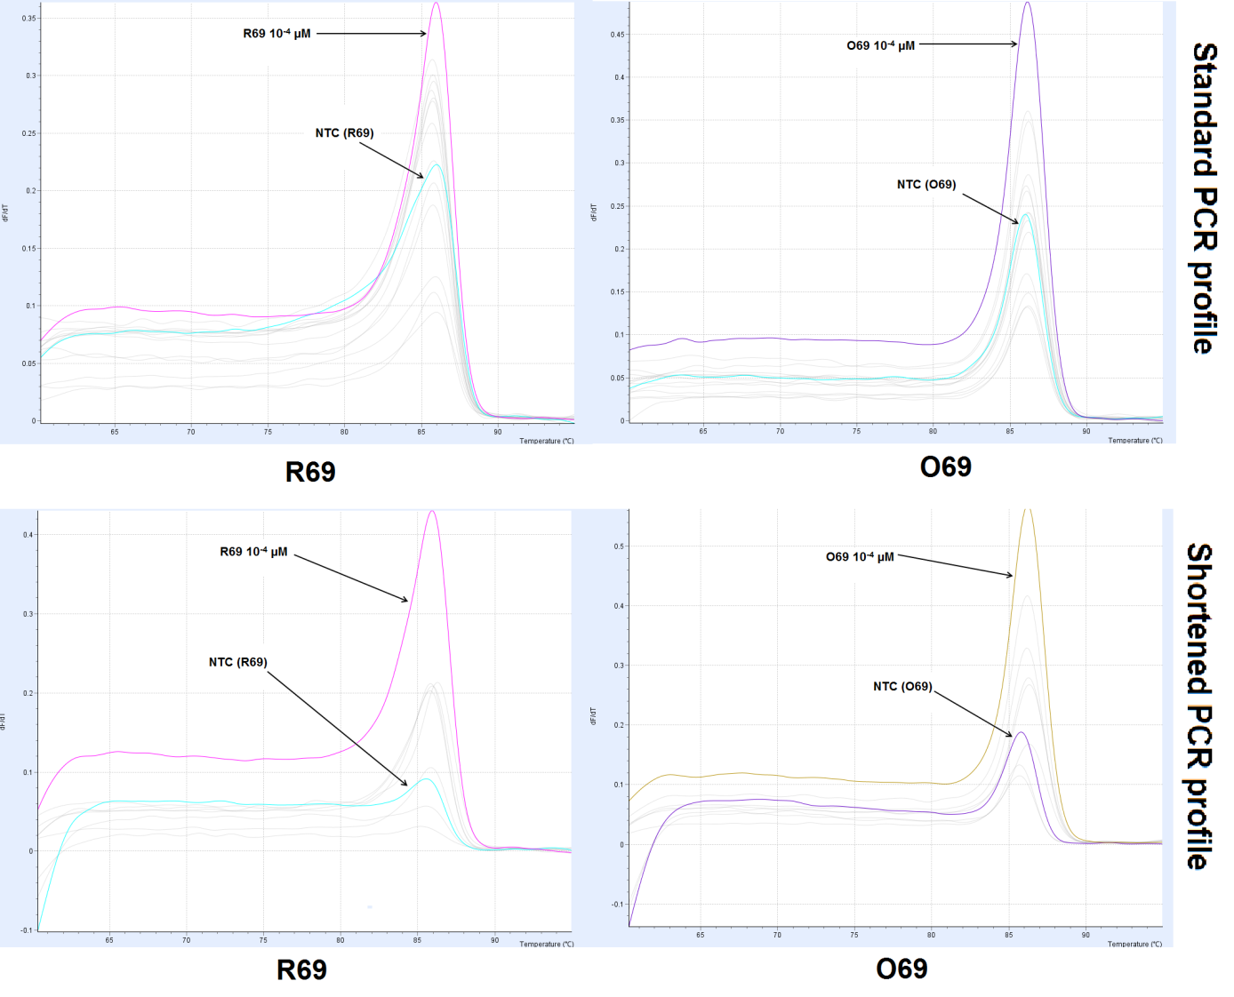
Fig. S3. The representative melting profiles obtained for the R69 and O69 amplicons and the corresponding no-template controls (NTC).
0.5 µM primer concentrations were used in PCR amplification.

