SUPPLEMENTARY INFORMATION
Manuscript title
Genome-wide association analysis of stripe rust resistance loci in wheat accessions from southwestern China
Content
Supplementary Figure S1. ....…….….…………………………….………………..........................2
Supplementary Figure S2. ....…….….…………………………….………………..........................3
Supplementary Table S2. ....…….….…………………………….………………..........................4

Supplementary Figure S1. A heatmap showing the kinship and phylogenetic relationships of 120 wheat landraces. The same phylogeny is shown in the left and above the heatmap. The red color represent strong relationships, while lighter colors indicate progressively weaker relationships.
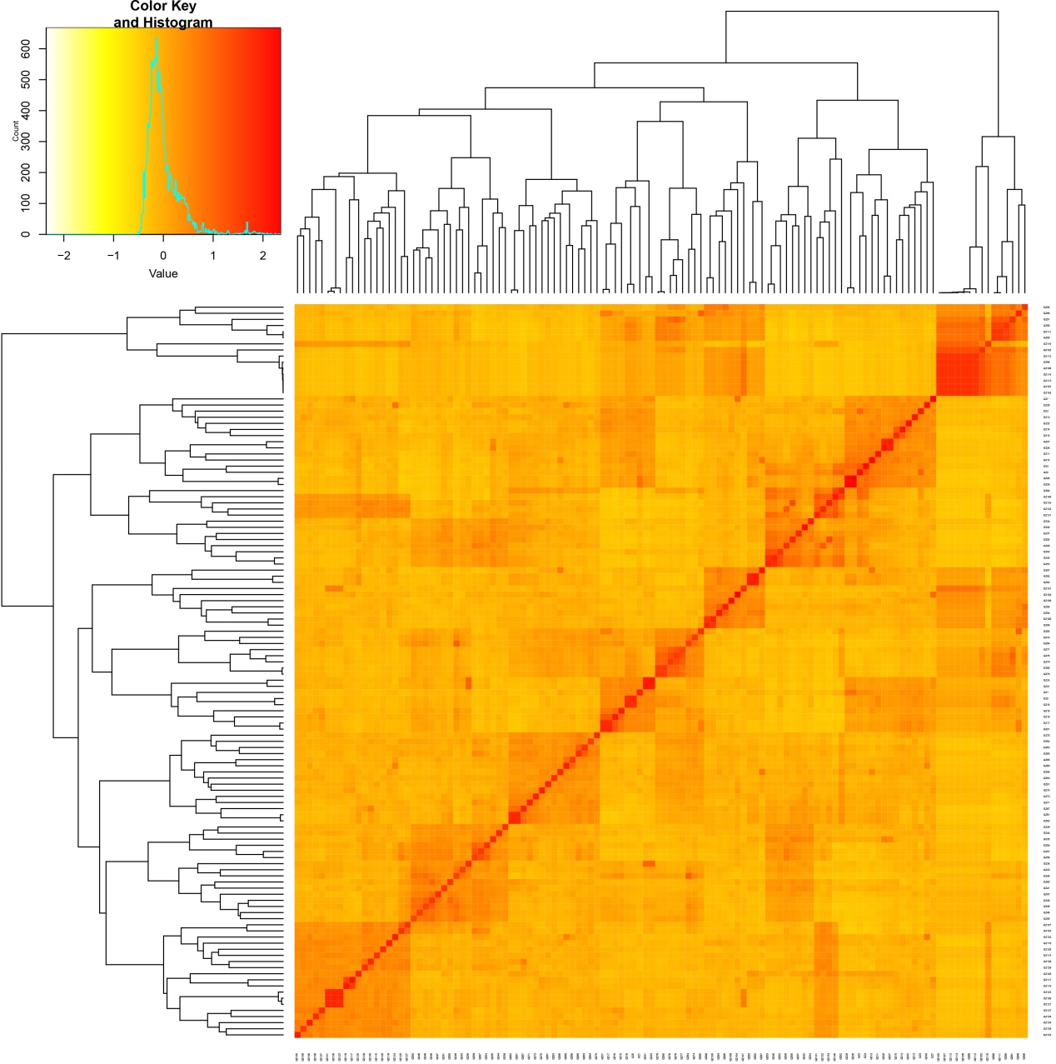

Supplementary Figure S2. Comparison between Q-Q plots of wheat stripe rust data from four field experiments (2013 GY, 2013 HZ, 2014 GY and 2014 MY) and two greenhouse experiments (CRY32, CRY33 seedlings).
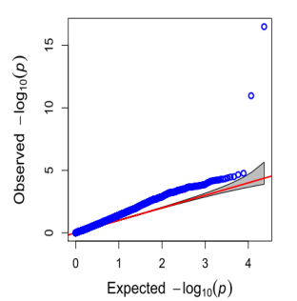
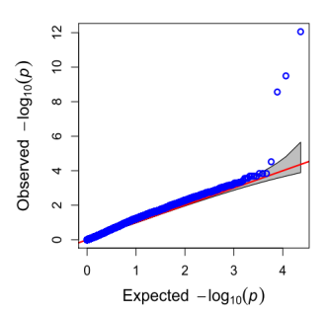
2013 GY
2013 HZ

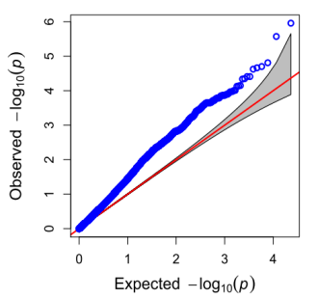
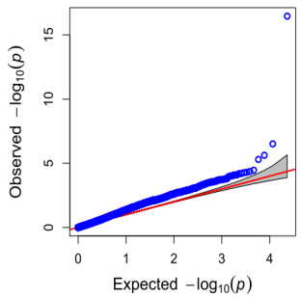
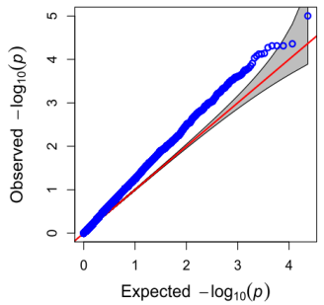
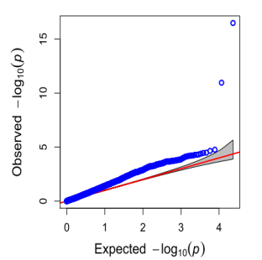
2014 MY

CRY33
CRY32
2014 GY
Supplementary Table S2. Molecular markers for stripe rust resistance genes
Yr Gene | Primer | Primer sequence (5’→3’) | Genetic distance (cM) | Amplicon length (bp) | Reference
Yr5 | STS9/10 | AAAGAATACTTTAATGAA | Completely linked | 289 | (Chen et al., 2003)
Yr5 | STS9/10 | CAAACTTATCAGGATTAC | Completely linked | 289 | (Chen et al., 2003)
Yr9 | AF1/AF4 | GGAGACATCATGAAACATTTG | Rye specific | 1500 | (Francis et al., 1995)
Yr9 | AF1/AF4 | CTGTTGTTGGGCAGAAAG | Rye specific | 1500 | (Francis et al., 1995)
Yr10 | SC200 | CTGCAGAGTGACATCATACA | 0.5 | 200 | (Shao et al., 2001)
Yr10 | SC200 | TCGAACTAGTAGATGCTGGC | 0.5 | 200 | (Shao et al., 2001)
Yr15 | Barc8 | GCGGGAATCATGCATAGGAAAACAGAA | linked | 576 | (Peng et al., 2000)
Yr15 | Barc8 | GCGGGGGCGAAACATACACATAAAAACA | linked | 576 | (Peng et al., 2000)
Yr17 | SC372 | ATG TCCGCCCTTCCACAACTC | Completely linked | 372 | (Jia et al., 2011)
Yr17 | SC372 | CACTTGCCTATAAGCACAGAG | Completely linked | 372 | (Jia et al., 2011)
Yr26 | We173 | GGGACAAGGGGAGTTGAAGC | 1.4 | 551 | (Wang et al., 2008)
Yr26 | We173 | GAGAGTTCCAAGCAGAACAC | 1.4 | 551 | (Wang et al., 2008)
Yr29 | Wmc44 | GGTCTTCTGGGCTTTGATCCTG | 5.6 | 242 | (William et al., 2003)
Yr29 | Wmc44 | TGTTGCTAGGGACCCGTAGTGG | 5.6 | 242 | (William et al., 2003)

The English in this document has been checked by at least two professional editors, both native speakers of English. For a certificate, please see:

http://www.textcheck.com/certificate/q9SIuQ

