The application of deep learning for the classification of correct and incorrect SNP genotypes from whole genome DNA sequencing pipelines

Krzysztof Kotlarz¹, Magda Mielczarek^{1,2}, Tomasz Suchocki^{1,2}, Bartosz Czech¹, Bernt Guldbrandtsen³, Joanna Szyda^{1,2}

Figures in the Supplementary material
Each figure contains the following metrics:
Loss: the classification loss score.
AUC: area under the receiver operating characteristic curve.
Precision: $\frac{TP}{TP+FP}$
Recall: $\frac{TP}{TP+FN}$

Figure 1A. Optimisation of the NAÏVE algorithm. Train – the training data set, Val – the validation data set.
Figure 2A. Optimisation of the WEIGHTED algorithm. Train – the training data set, Val – the validation data set.
Figure 3A. Optimisation of the OVERSAMPLED30 algorithm. Train – the training data set, Val – the validation data set.
Figure 4A. Optimisation of the OVERSAMPLED60 algorithm. Train – the training data set, Val – the validation data set.
Figure 5A. Optimisation of the OVERSAMPLED100 algorithm. Train – the training data set, Val – the validation data set.

Figure 1A

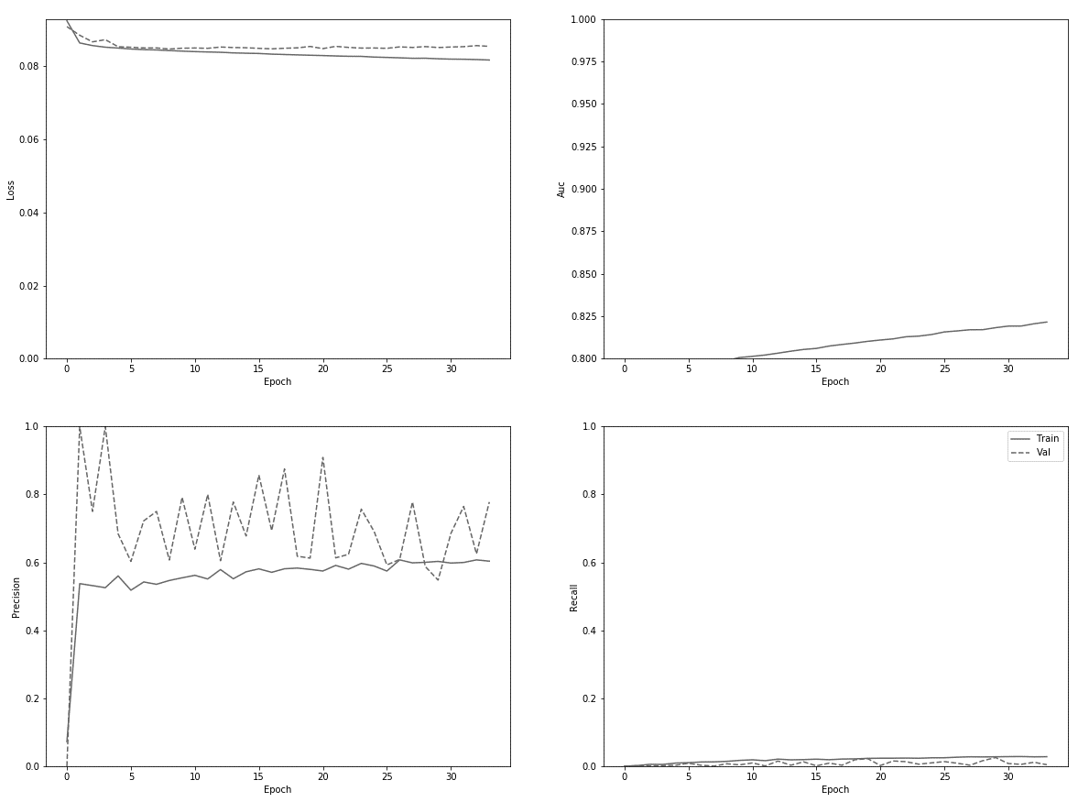

Figure 2A

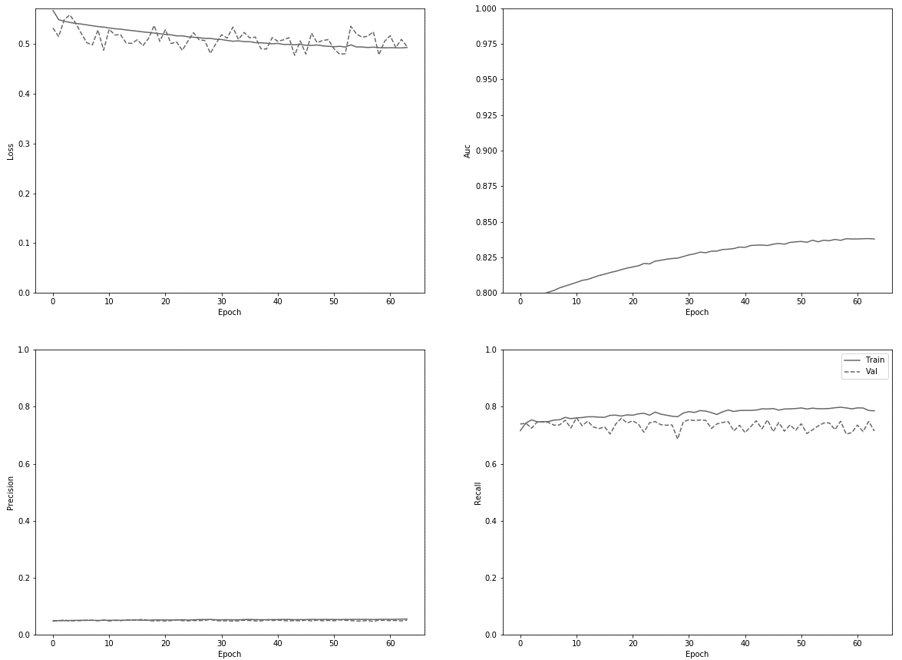

Figure 3A
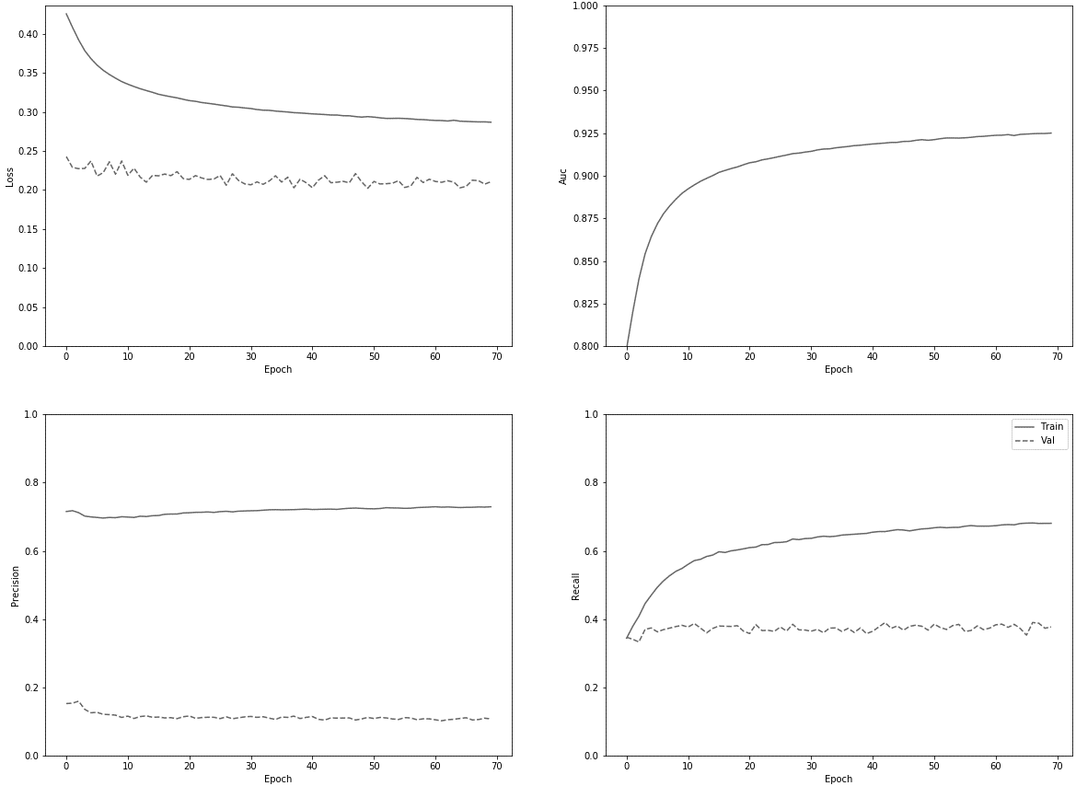

Figure 5A

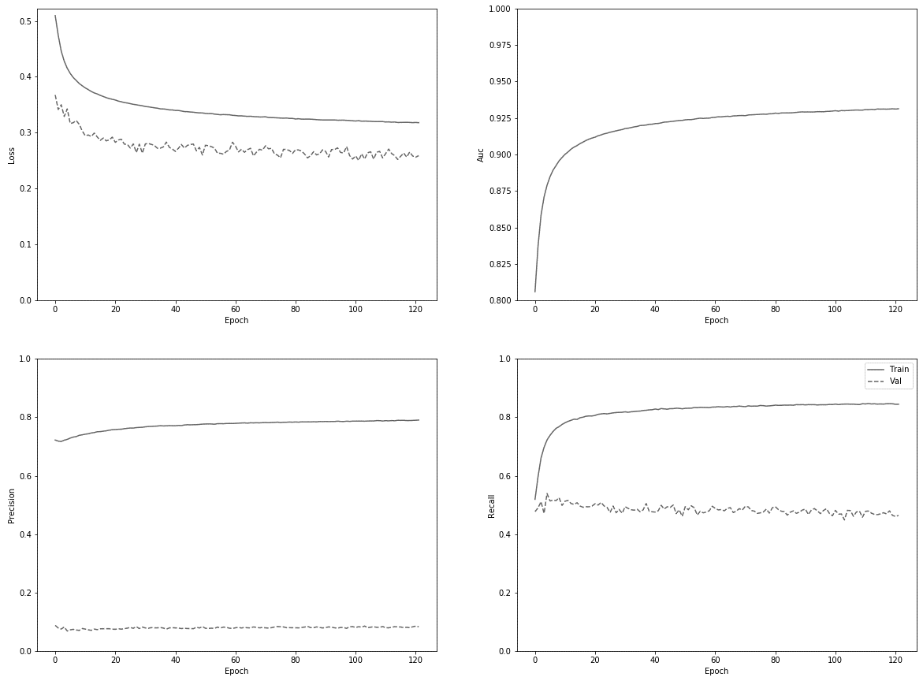

Figure 6A

