(1a)
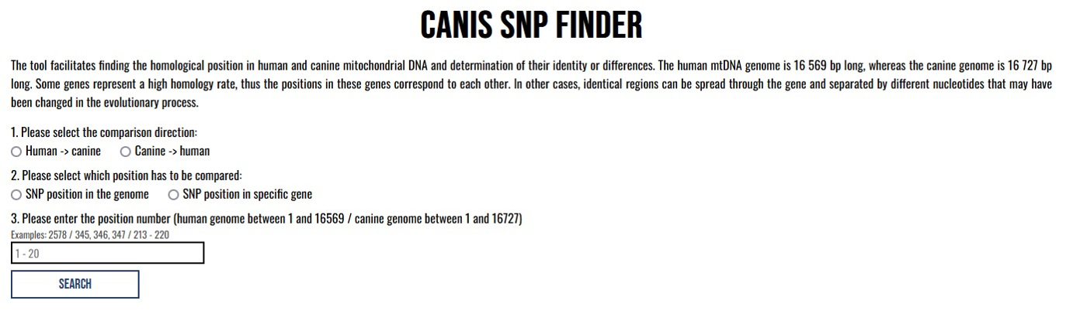

(1b)
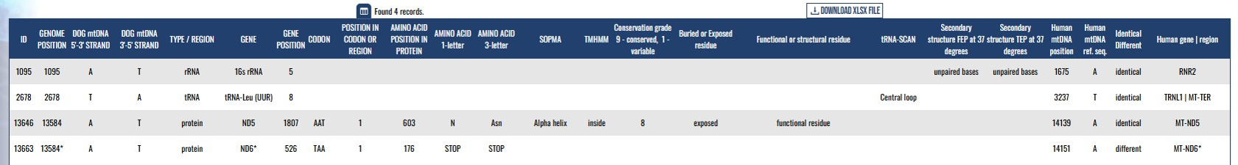
Supplementary figures 1a. Presentation of data after choosing the SNP position in a specific gene. 1b. The Results window for three genomic (1095, 2678, 13584) positions in the canine mitochondrial genome.

(2a)
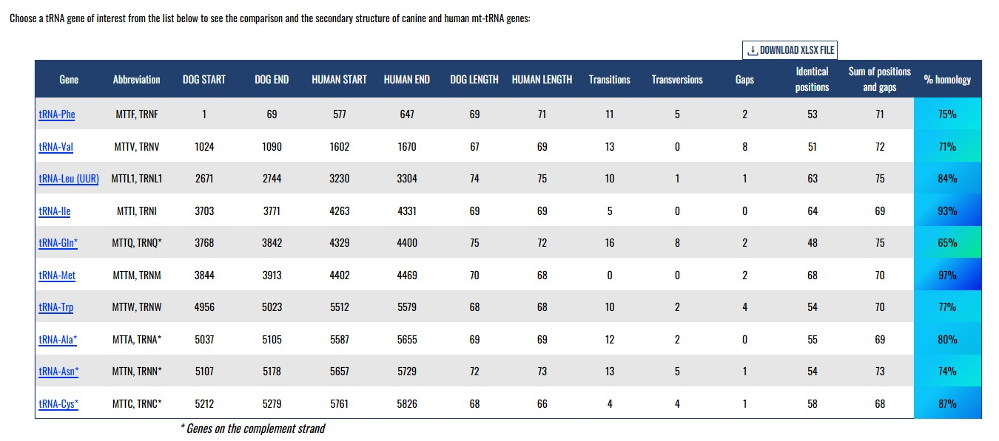

(2b)
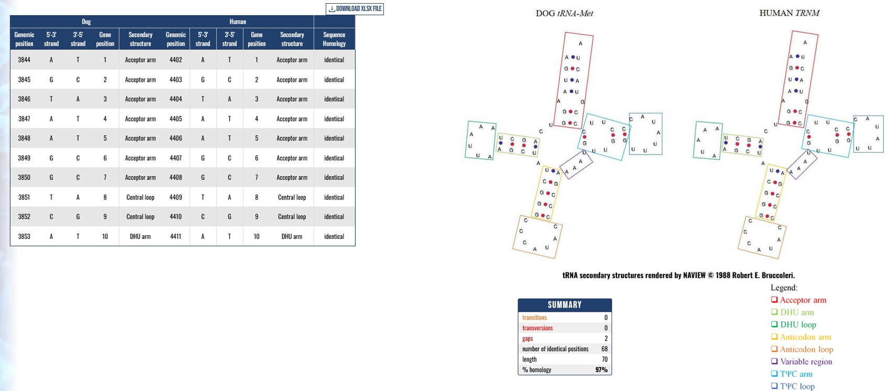
Supplementary figures 2a. tRNA properties website screen. 2b. Example of a report for one of the tRNA-coding genes

(3a)
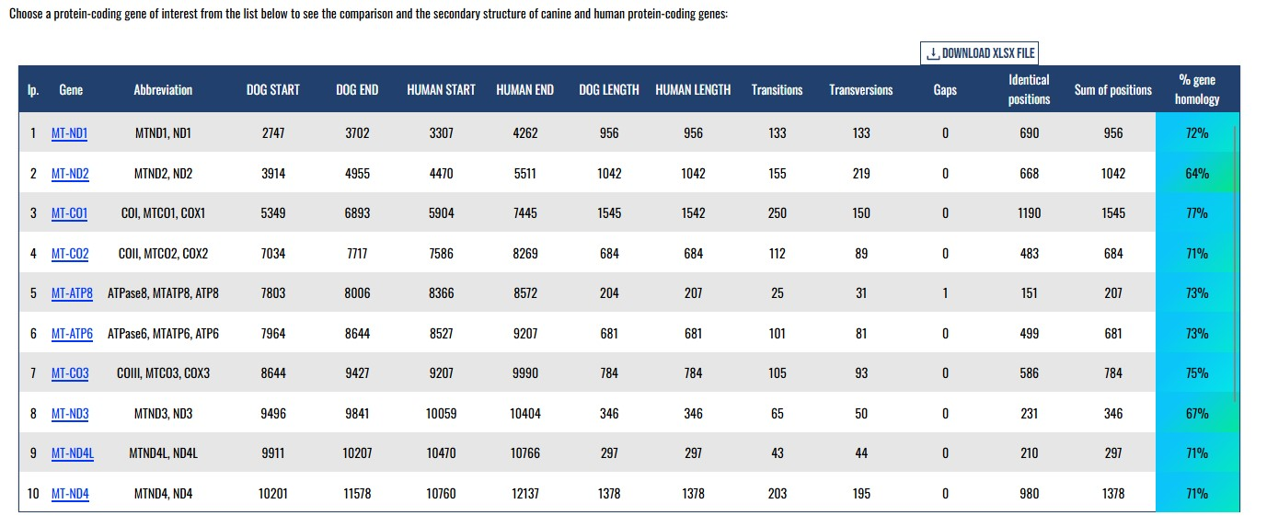
(3b)
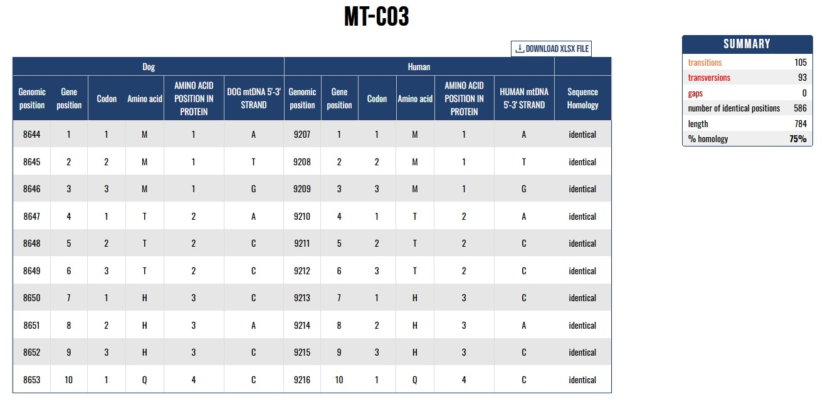
Supplementary figures 3a. Summary of mRNA properties for one of the protein-coding genes.
3b. Detailed comparison between human and dog mRNA sequences with the summary information

(4a)
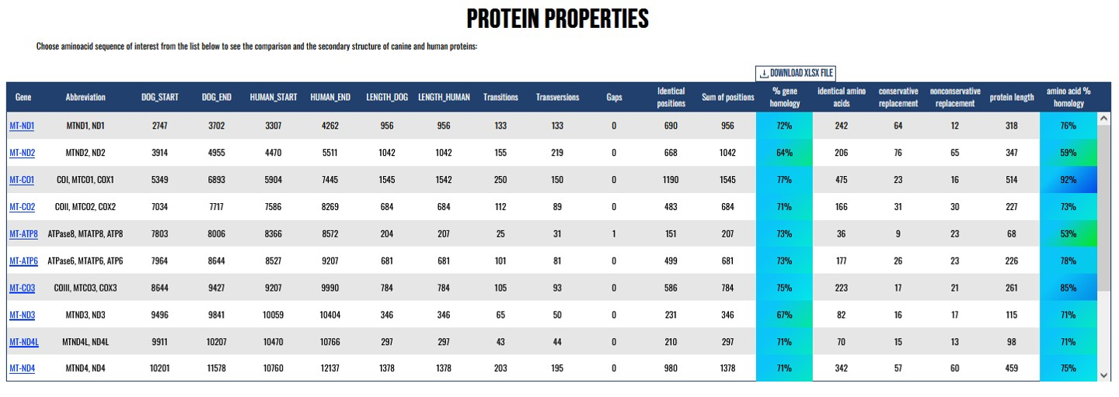
(4b)
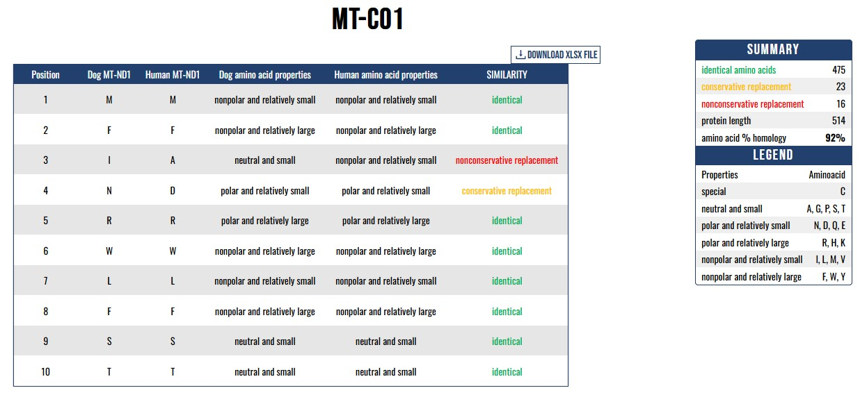
Supplementary figures 4a. Protein properties website screen. 4b. Summary of protein properties for one of the proteins

