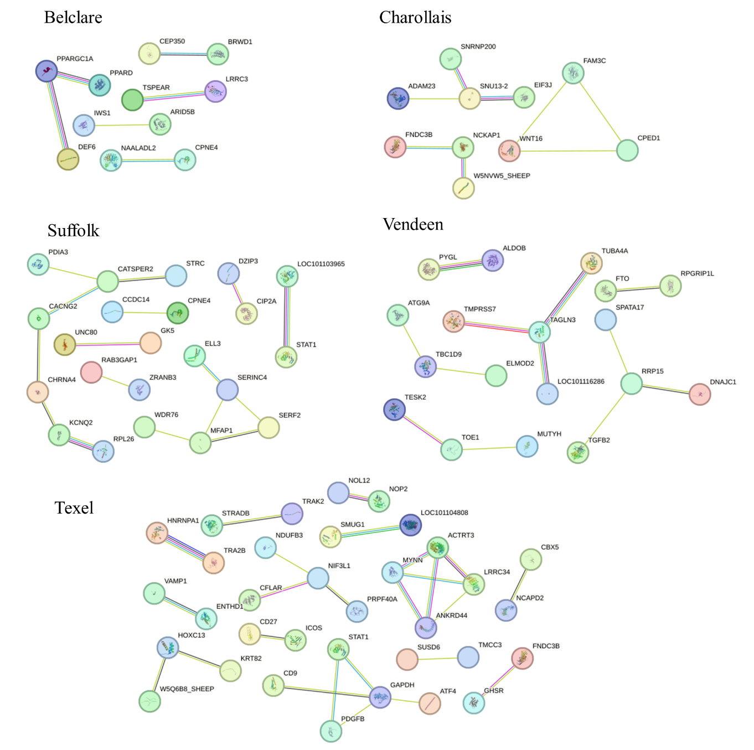
Supplementary Figure S3. Network analysis of genes detected by iHS for five sheep populations.
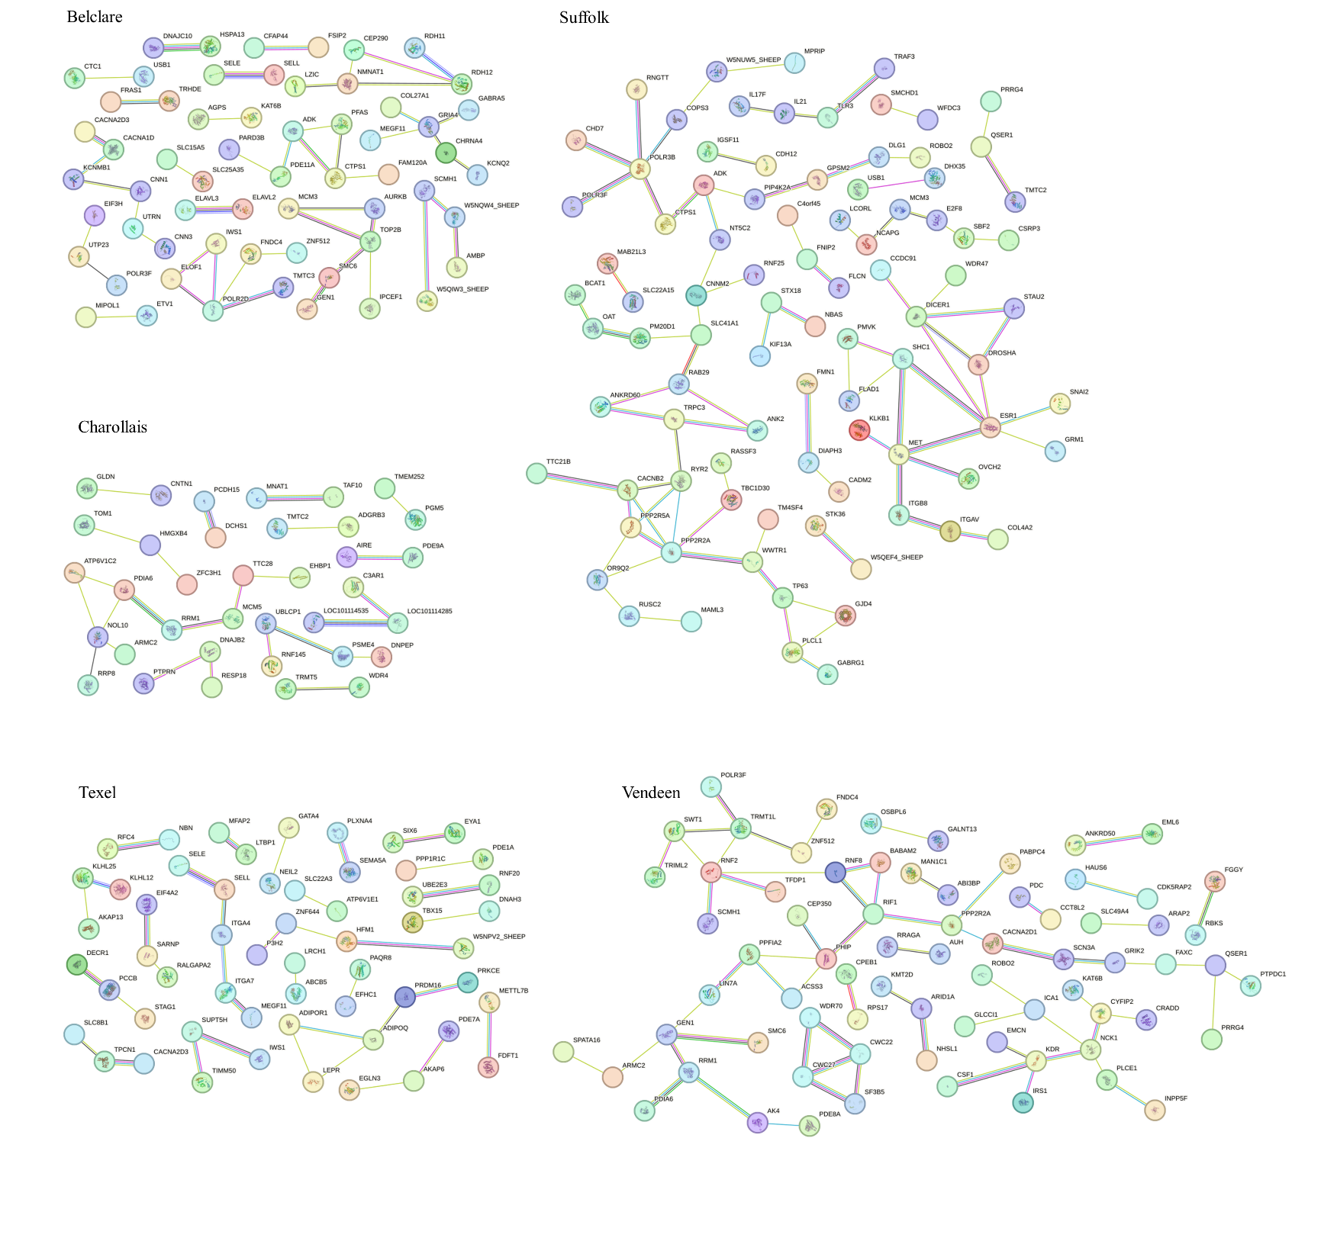
Supplementary Figure S4. Network analysis of genes detected by Tajima’s D for five sheep populations.

